EL NIÑO/SOUTHERN OSCILLATION (ENSO) DIAGNOSTIC DISCUSSION

issued by

CLIMATE PREDICTION CENTER/NCEP/NWS
4 August 2011

ENSO Alert System Status: La Niña Watch

Synopsis: ENSO-neutral is expected to continue into the Northern Hemisphere fall 2011, with ENSO-neutral or La Niña equally likely thereafter.
During July 2011, ENSO-neutral was reflected in the overall pattern of small sea surface temperature (SST) anomalies across the equatorial Pacific Ocean (Fig. 1). All of the latest weekly Niño index values were generally near average (Fig. 2), ranging from –0.2°C (Niño-3.4) to 0.5°C (Niño-1+2). However, the subsurface oceanic heat content anomaly (average temperature anomalies in the upper 300m of the ocean, Fig. 3) continued to weaken and is currently near zero, which reflects the strengthening of the below-average temperatures at depth in the east-central Pacific Ocean (Fig. 4). The atmospheric circulation anomalies were more variable during the past month, but the monthly means still reflect aspects of La Niña. For example, convection continued to be enhanced over eastern Indonesia and Papua New Guinea, and generally suppressed over the central equatorial Pacific, mainly south of the equator (Fig. 5). Also, anomalous low-level easterly and upper-level westerly winds persisted over the central tropical Pacific. Thus, while tropical Pacific oceanic anomalies indicate ENSO-neutral, the atmospheric patterns continue to reflect La Niña-like conditions.
The majority of ENSO models, and all multi-model average forecasts (indicated by thicker lines, Fig. 6), indicate ENSO-neutral will continue into the Northern Hemisphere fall 2011 (three-month average in the Nino-3.4 index between –0.5°C and +0.5°C). Beyond the early fall, the forecasts are less certain with half of the models persisting ENSO-neutral conditions continuously through early 2012. Along with a few other models, the latest runs from the NCEP Climate Forecast System (CFS) models predict La Niña to re-develop during the fall (Fig. 7). This forecast is also supported by the ongoing La Niña-like tropical atmosphere, subsurface temperature trends, and the historical tendency for significant wintertime La Niña episodes to be followed by relatively weaker La Niña episodes the following winter. Therefore, ENSO-neutral is expected to continue into the Northern Hemisphere fall 2011, with ENSO-neutral or La Niña equally likely thereafter.
This discussion is a consolidated effort of the National Oceanic and Atmospheric Administration (NOAA), NOAA’s National Weather Service, and their funded institutions. Oceanic and atmospheric conditions are updated weekly on the Climate Prediction Center web site (El Niño/La Niña Current Conditions and Expert Discussions). Forecasts for the evolution of El Niño/La Niña are updated monthly in the Forecast Forum section of CPC's Climate Diagnostics Bulletin. The next ENSO Diagnostics Discussion is scheduled for 8 September 2011. To receive an e-mail notification when the monthly ENSO Diagnostic Discussions are released, please send an e-mail message to: ncep.list.enso-update@noaa.gov.
Climate Prediction Center
National Centers for Environmental Prediction
NOAA/National Weather Service
Camp Springs, MD 20746-4304

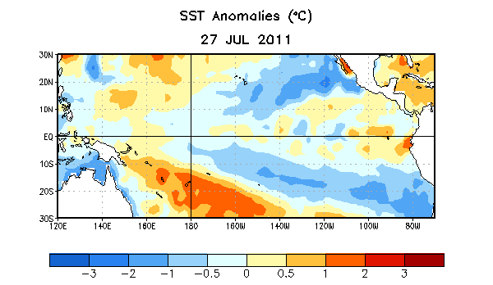
Figure 1. Average sea surface temperature (SST) anomalies (°C) for the week centered on 27 July 2011. Anomalies are computed with respect to the 1971-2000 base period weekly means (Xue et al. 2003, J. Climate, 16, 1601-1612).

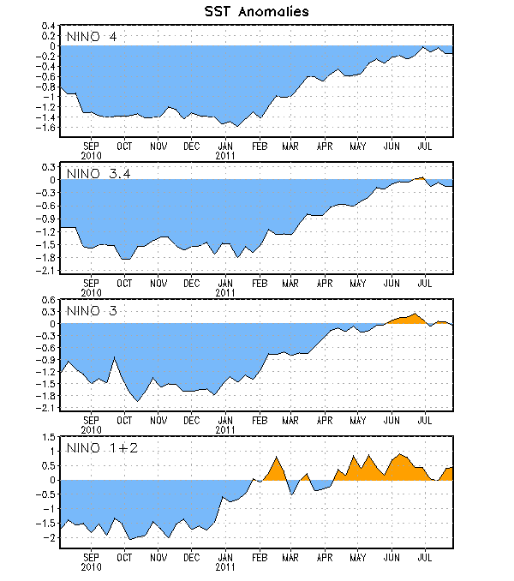
Figure 2. Time series of area-averaged sea surface temperature (SST) anomalies (°C) in the Niño regions [Niño-1+2 (0°-10°S, 90°W-80°W), Niño 3 (5°N-5°S, 150°W-90°W), Niño-3.4 (5°N-5°S, 170°W-120°W), Niño-4 (150ºW-160ºE and 5ºN-5ºS)]. SST anomalies are departures from the 1971-2000 base period weekly means (Xue et al. 2003, J. Climate, 16, 1601-1612).

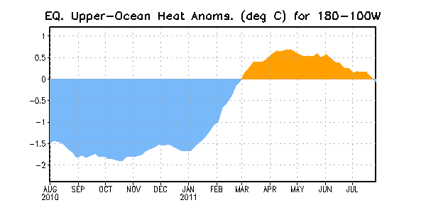
Figure 3. Area-averaged upper-ocean heat content anomalies (°C) in the equatorial Pacific (5°N-5°S, 180º-100ºW). Heat content anomalies are computed as departures from the 1982-2004 base period pentad means.

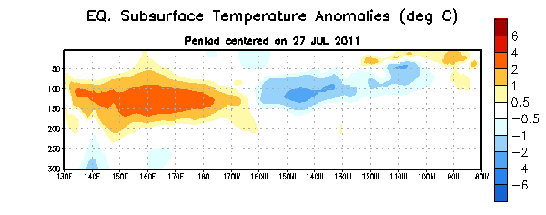
Figure 4. Depth-longitude section of equatorial Pacific upper-ocean (0-300m) temperature anomalies (°C) centered on the week of 27 July 2011. The anomalies are averaged between 5°N-5°S. Anomalies are departures from the 1982-2004 base period pentad means.

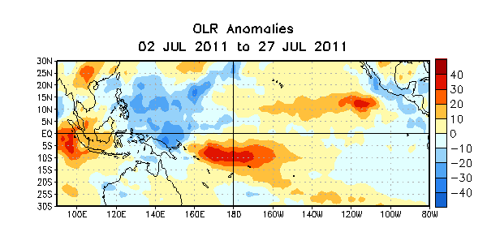

Figure 5. Average outgoing longwave radiation (OLR) anomalies (W/m²) for the four-week period 2 – 27 July 2011. OLR anomalies are computed as departures from the 1979-1995 base period pentad means.

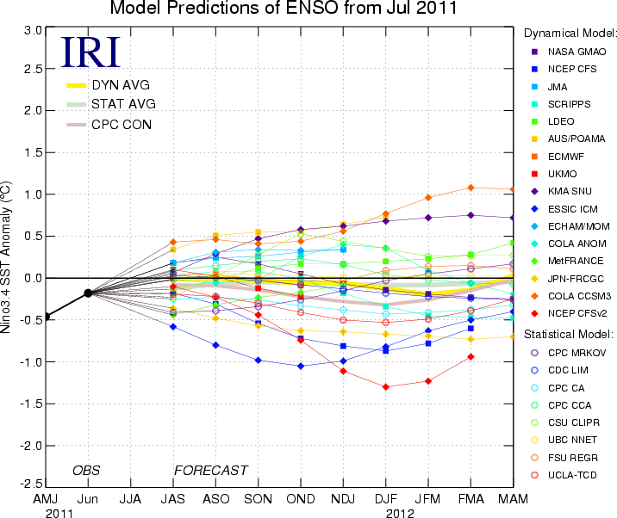
Figure 6. Forecasts of sea surface temperature (SST) anomalies for the Niño 3.4 region (5°N-5°S, 120°W-170°W). Figure courtesy of the International Research Institute (IRI) for Climate and Society. Figure updated 19 July 2011.

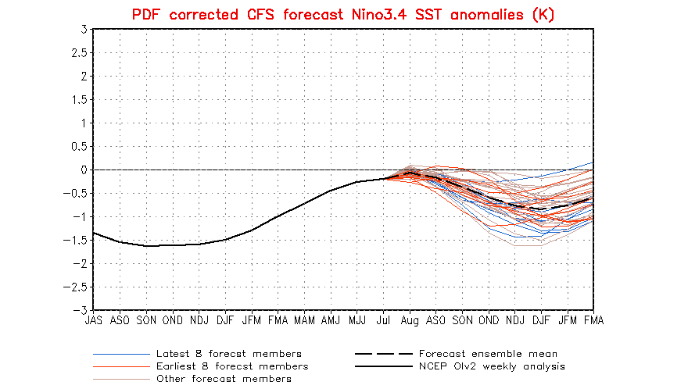

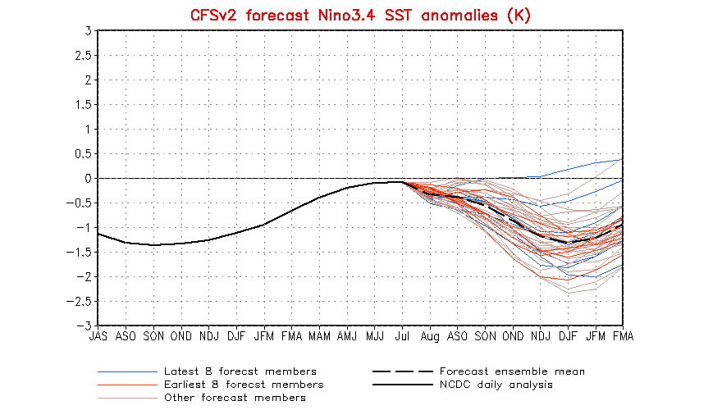
Figure 7. Forecasts of sea surface temperature (SST) anomalies for the Niño 3.4 region (5°N-5°S, 120°W-170°W) from version 1 of the NCEP Climate Forecast System (top panel) and version 2 of the CFS (bottom panel). Figure updated 3 August 2011.

