EL NIÑO/SOUTHERN OSCILLATION (ENSO) DIAGNOSTIC DISCUSSION

issued by

CLIMATE PREDICTION CENTER/NCEP/NWS

and the International Research Institute for Climate and Society

9 August 2018

ENSO Alert System Status: El Niño Watch

Synopsis: There is ~60% chance of El Niño in the Northern Hemisphere fall 2018 (September-November), increasing to ~70% during winter 2018-19.

ENSO-neutral continued during July, as indicated by near-average sea surface temperatures (SSTs) across the central and eastern equatorial Pacific at the end of the month (Fig. 1). The latest weekly Niño indices were 0.0°C for the Niño-3 index, +0.1°C for the Niño-3.4 and Niño1+2 indices, and +0.4°C for the Niño-4 index (Fig. 2). Positive subsurface temperature anomalies (averaged across 180°-100°W) continued over the past month (Fig. 3), and the volume of anomalous warmth extended to the surface in the eastern part of the basin (Fig. 4). Convection remained suppressed near the Date Line and over western Indonesia (Fig. 5). Low-level winds were near average across most of the equatorial Pacific Ocean, while upper-level wind anomalies were westerly over the eastern Pacific and near the International Date Line. Overall, the oceanic and atmospheric conditions reflected ENSO-neutral.
The majority of models in the IRI/CPC plume predict ENSO-neutral to continue during the remainder of the Northern Hemisphere summer 2018, with El Niño most likely thereafter (Fig. 6). Model predictions for El Niño have not wavered despite the recent decrease in the positive SST anomalies in portions of the eastern Pacific. Because of the consistency of forecasts and the expected eventual resurgence in the low-level westerly wind anomalies, the forecasters still favor the onset of El Niño in the coming months. In summary, there is ~60% chance of El Niño in the Northern Hemisphere fall 2018 (September-November), increasing to ~70% during winter 2018-19 (click CPC/IRI consensus forecast for the chance of each outcome for each 3-month period).
This discussion is a consolidated effort of the National Oceanic and Atmospheric Administration (NOAA), NOAA’s National Weather Service, and their funded institutions. Oceanic and atmospheric conditions are updated weekly on the Climate Prediction Center web site (El Niño/La Niña Current Conditions and Expert Discussions). Forecasts are also updated monthly in the Forecast Forum of CPC's Climate Diagnostics Bulletin. Additional perspectives and analysis are also available in an ENSO blog. The next ENSO Diagnostics Discussion is scheduled for 13 September 2018. To receive an e-mail notification when the monthly ENSO Diagnostic Discussions are released, please send an e-mail message to: ncep.list.enso-update@noaa.gov.

Climate Prediction Center
National Centers for Environmental Prediction
NOAA/National Weather Service
College Park, MD 20740

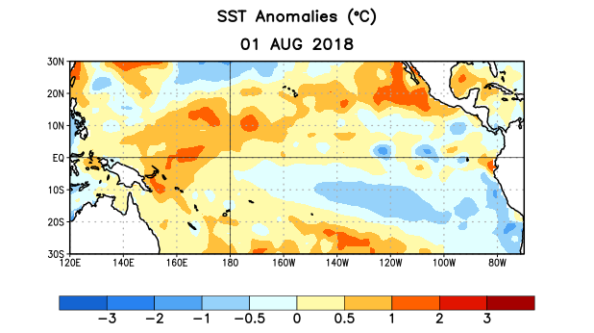
Figure 1. Average sea surface temperature (SST) anomalies (°C) for the week centered on 1 August 2018. Anomalies are computed with respect to the 1981-2010 base period weekly means.

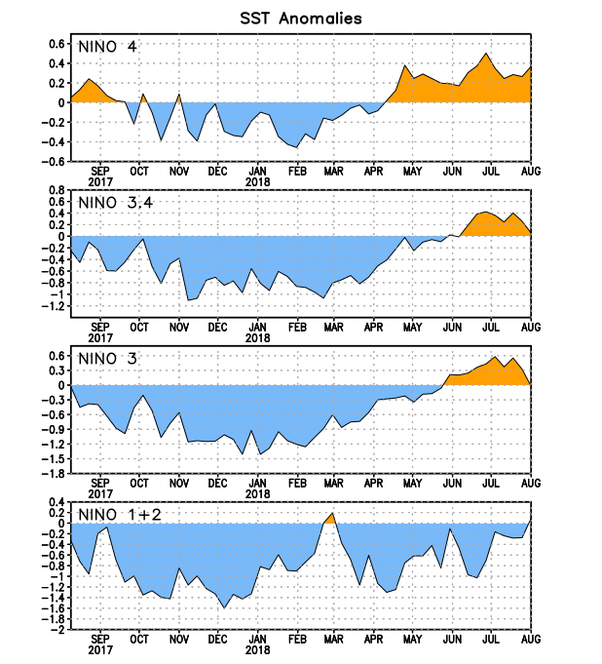
Figure 2. Time series of area-averaged sea surface temperature (SST) anomalies (°C) in the Niño regions [Niño-1+2 (0°-10°S, 90°W-80°W), Niño-3 (5°N-5°S, 150°W-90°W), Niño-3.4 (5°N-5°S, 170°W-120°W), Niño-4 (5ºN-5ºS , 150ºW-160ºE)]. SST anomalies are departures from the 1981-2010 base period weekly means.
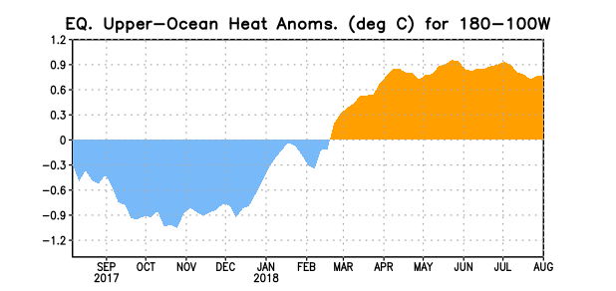
Figure 3. Area-averaged upper-ocean heat content anomaly (°C) in the equatorial Pacific (5°N-5°S, 180º-100ºW). The heat content anomaly is computed as the departure from the 1981-2010 base period pentad means.

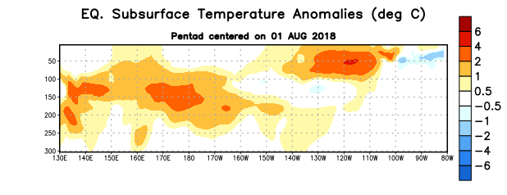
Figure 4. Depth-longitude section of equatorial Pacific upper-ocean (0-300m) temperature anomalies (°C) centered on the pentad of 1 August 2018. Anomalies are departures from the 1981-2010 base period pentad means.

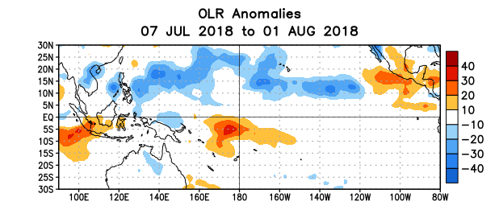
Figure 5. Average outgoing longwave radiation (OLR) anomalies (W/m²) for the period 7 July – 1 August 2018. OLR anomalies are computed as departures from the 1981-2010 base period pentad means.

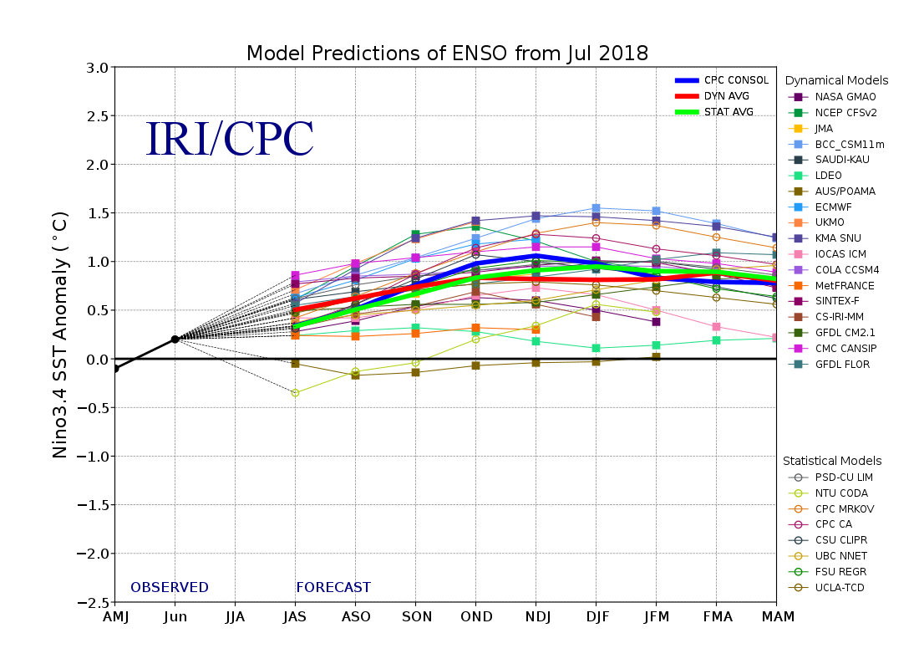
Figure 6. Forecasts of sea surface temperature (SST) anomalies for the Niño 3.4 region (5°N-5°S, 120°W-170°W). Figure updated 19 July 2018.

