EL NIÑO/SOUTHERN OSCILLATION (ENSO) DIAGNOSTIC DISCUSSION

issued by

CLIMATE PREDICTION CENTER/NCEP/NWS
and the International Research Institute for Climate and Society
5 January 2012

ENSO Alert System Status: La Niña Advisory

Synopsis: La Niña is expected to continue into the Northern spring 2012.
During December 2011, below-average sea surface temperatures (SST) associated with La Niña continued across the eastern and central equatorial Pacific Ocean (Fig. 1). The weekly SST index in the Niño-3.4 region remained near –1.0°C throughout the month (Fig. 2), indicating a weak to moderate La Niña. The oceanic heat content (average temperature in the upper 300m of the ocean) anomalies strengthened across the eastern Pacific (Fig. 3), reflecting a large area of below-average temperatures in the subsurface (Fig. 4). In the atmosphere, anomalous low-level easterly and upper-level westerly winds strengthened over the central and west-central Pacific. Convection remained suppressed in the western and central Pacific and enhanced over northern Australia and parts of Indonesia and the Philippine Islands (Fig. 5). Consistent with these conditions, the Southern Oscillation Index (SOI) also strengthened. This evolution is consistent with past events, in which the atmospheric components of La Niña become strongest and most well-defined during the Northern Hemisphere winter. Collectively, the ongoing oceanic and atmospheric patterns reflect the continuation of a weak to moderate La Niña.
A majority of models predict a weak or moderate strength La Niña to peak during the December – February season, and then to continue into early Northern Hemisphere spring season before dissipating during the March to May period (Fig. 6). A slight majority of models predict La Niña to remain weak (3-month average SST anomaly in the Niño-3.4 region between -0.5 and -0.9°C) this winter, while several others predict a moderate-strength episode (anomaly in the Niño-3.4 region between -1.0 and -1.4°C). The latest observations, combined with model forecasts, suggest that La Niña will be of weak-to-moderate strength this winter, and will continue thereafter as a weak event until it likely dissipates sometime between March and May.
During January - March 2012, there is an increased chance of above-average temperatures across the south-central and southeastern U.S., and below-average temperatures over the western and the northwest-central U.S. Also, above-average precipitation is favored across most of the northern tier of states and in the Ohio and Tennessee Valleys, and drier-than-average conditions are more likely across the southern tier of the U.S. (see 3-month seasonal outlook released on 15 December 2011).
This discussion is a consolidated effort of the National Oceanic and Atmospheric Administration (NOAA), NOAA’s National Weather Service, and their funded institutions. Oceanic and atmospheric conditions are updated weekly on the Climate Prediction Center web site (El Niño/La Niña Current Conditions and Expert Discussions). Forecasts for the evolution of El Niño/La Niña are updated monthly in the Forecast Forum section of CPC's Climate Diagnostics Bulletin. The next ENSO Diagnostics Discussion is scheduled for 9 February 2012. To receive an e-mail notification when the monthly ENSO Diagnostic Discussions are released, please send an e-mail message to: ncep.list.enso-update@noaa.gov.

Climate Prediction Center
National Centers for Environmental Prediction
NOAA/National Weather Service
Camp Springs, MD 20746-4304
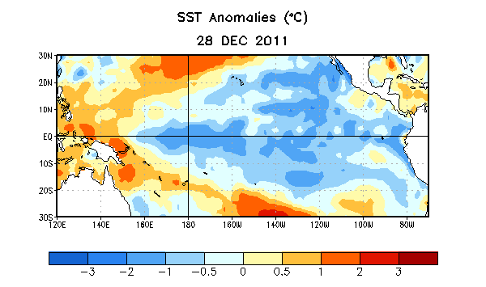
Figure 1. Average sea surface temperature (SST) anomalies (°C) for the week centered on 28 December 2011. Anomalies are computed with respect to the 1971-2000 base period weekly means (Xue et al. 2003, J. Climate, 16, 1601-1612).

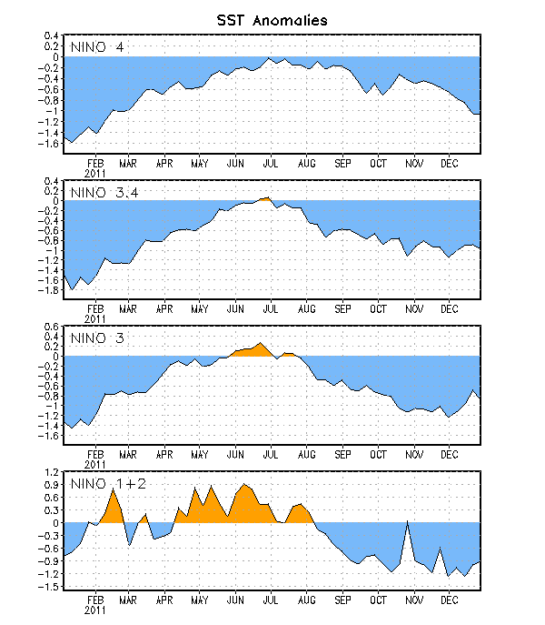
Figure 2. Time series of area-averaged sea surface temperature (SST) anomalies (°C) in the Niño regions [Niño-1+2 (0°-10°S, 90°W-80°W), Niño 3 (5°N-5°S, 150°W-90°W), Niño-3.4 (5°N-5°S, 170°W-120°W), Niño-4 (150ºW-160ºE and 5ºN-5ºS)]. SST anomalies are departures from the 1971-2000 base period weekly means (Xue et al. 2003, J. Climate, 16, 1601-1612).

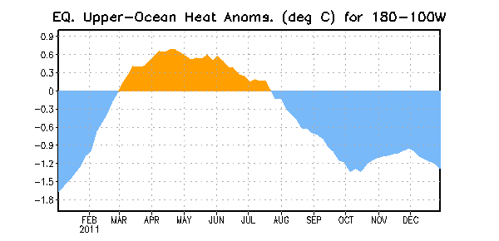

Figure 3. Area-averaged upper-ocean heat content anomaly (°C) in the equatorial Pacific (5°N-5°S, 180º-100ºW). The heat content anomaly is computed as the departure from the 1982-2004 base period pentad means.

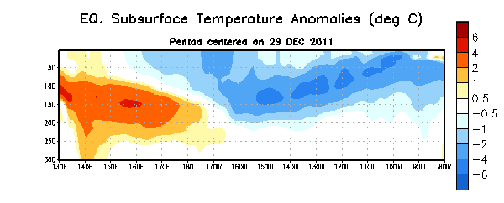
Figure 4. Depth-longitude section of equatorial Pacific upper-ocean (0-300m) temperature anomalies (°C) centered on the week of 29 December 2011. The anomalies are averaged between 5°N-5°S. Anomalies are departures from the 1982-2004 base period pentad means.

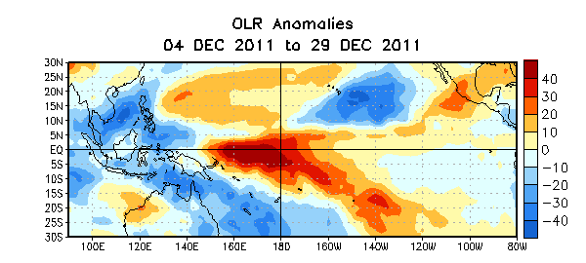

Figure 5. Average outgoing longwave radiation (OLR) anomalies (W/m²) for the four-week period 4– 29 December 2011. OLR anomalies are computed as departures from the 1979-1995 base period pentad means.

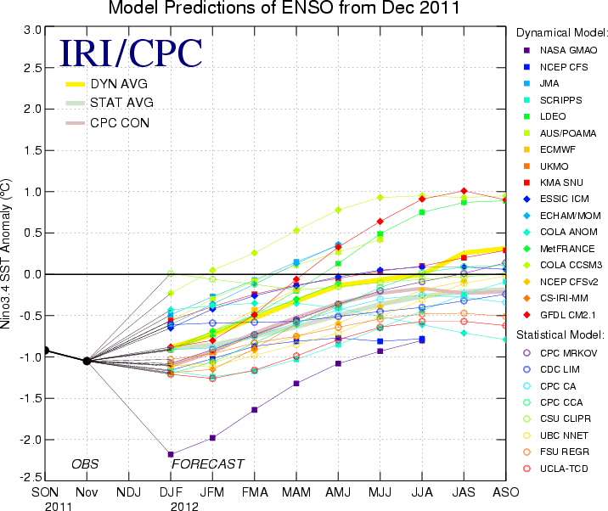
Figure 6. Forecasts of sea surface temperature (SST) anomalies for the Niño 3.4 region (5°N-5°S, 120°W-170°W). Figure courtesy of the International Research Institute (IRI) for Climate and Society. Figure updated 13 December 2011.

