EL NIÑO/SOUTHERN OSCILLATION (ENSO) DIAGNOSTIC DISCUSSION

issued by

CLIMATE PREDICTION CENTER/NCEP/NWS
3 June 2010

ENSO Alert System Status: La Niña Watch / Final El Niño Advisory

Synopsis: Conditions are favorable for a transition to La Niña conditions during June – August 2010.
El Niño dissipated during May 2010 as positive surface temperature (SST) anomalies decreased rapidly across the equatorial Pacific Ocean and negative SST anomalies emerged across the eastern half of the Pacific (Fig. 1). All of the Niño indices decreased between 0.5°C to 1.0°C during the month (Fig. 2). Since the end of February, subsurface heat content anomalies (average temperatures in the upper 300m of the ocean, Fig. 3) have decreased steadily. Below-average temperatures have strengthened at depth and currently extend to the surface in parts of the eastern Pacific (Fig. 4). Also during May, enhanced convection persisted over Indonesia, while the area of suppressed convection strengthened and expanded over the tropical central Pacific (Fig. 5). The low-level easterly trade winds strengthened over the western and central equatorial Pacific, and anomalous upper-level westerly winds prevailed over the east-central Pacific. Collectively, these oceanic and atmospheric anomalies reflect the demise of El Niño and return of ENSO-neutral conditions.
The majority of models predict ENSO-neutral conditions (between -0.5°C to +0.5°C in the Niño-3.4 region) through early 2011 (Fig. 6). However, over the last several months, a growing number of models, including the NCEP Climate Forecast System (CFS), indicate the onset of La Niña conditions during June-August 2010. There is an increasing confidence in these colder model forecasts, which is supported by recent observations that show cooling trends in the Pacific Ocean and signs of coupling with the atmospheric circulation. Therefore, conditions are favorable for a transition to La Niña conditions during June-August 2010.
This discussion is a consolidated effort of the National Oceanic and Atmospheric Administration (NOAA), NOAA’s National Weather Service, and their funded institutions. Oceanic and atmospheric conditions are updated weekly on the Climate Prediction Center web site (El Niño/La Niña Current Conditions and Expert Discussions). Forecasts for the evolution of El Niño/La Niña are updated monthly in the Forecast Forum section of CPC's Climate Diagnostics Bulletin. The next ENSO Diagnostics Discussion is scheduled for 8 July 2010. To receive an e-mail notification when the monthly ENSO Diagnostic Discussions are released, please send an e-mail message to: ncep.list.enso-update@noaa.gov.
Climate Prediction Center
National Centers for Environmental Prediction
NOAA/National Weather Service
Camp Springs, MD 20746-4304
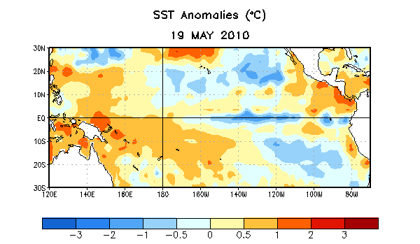
Figure 1. Average sea surface temperature (SST) anomalies (°C) for the week centered on 19 May 2010. Anomalies are computed with respect to the 1971-2000 base period weekly means (Xue et al. 2003, J. Climate, 16, 1601-1612).

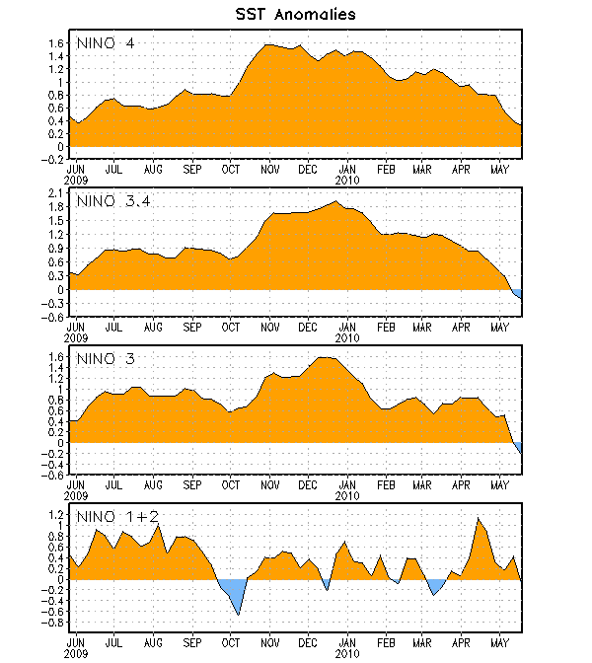
Figure 2. Time series of area-averaged sea surface temperature (SST) anomalies (°C) in the Niño regions [Niño-1+2 (0°-10°S, 90°W-80°W), Niño 3 (5°N-5°S, 150°W-90°W), Niño-3.4 (5°N-5°S, 170°W-120°W), Niño-4 (150ºW-160ºE and 5ºN-5ºS)]. SST anomalies are departures from the 1971-2000 base period weekly means (Xue et al. 2003, J. Climate, 16, 1601-1612).

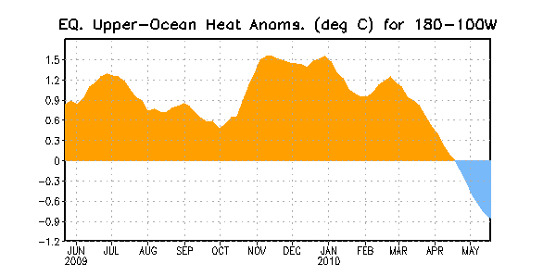
Figure 3. Area-averaged upper-ocean heat content anomalies (°C) in the equatorial Pacific (5°N-5°S, 180º-100ºW). Heat content anomalies are computed as departures from the 1982-2004 base period pentad means.

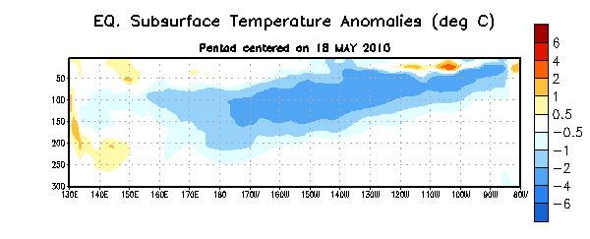
Figure 4. Depth-longitude section of equatorial Pacific upper-ocean (0-300m) temperature anomalies (°C) centered on the week of 28 April 2010. The anomalies are averaged between 5°N-5°S. Anomalies are departures from the 1982-2004 base period pentad means.

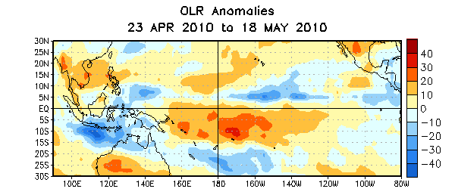
Figure 5. Average outgoing longwave radiation (OLR) anomalies (W/m²) for the four-week period 23 April – 18 May 2010. OLR anomalies are computed as departures from the 1979-1995 base period pentad means.

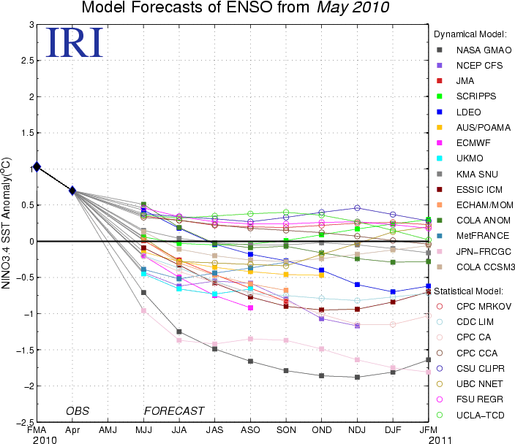
Figure 6. Forecasts of sea surface temperature (SST) anomalies for the Niño 3.4 region (5°N-5°S, 120°W-170°W). Figure courtesy of the International Research Institute (IRI) for Climate and Society. Figure updated 19 May 2010.

