MADDEN-JULIAN OSCILLATION (MJO)
DIAGNOSTIC DISCUSSION

issued by

CLIMATE PREDICTION CENTER/NCEP
January 11, 2005

Synopsis: Enhanced (suppressed) convection will shift toward the central Pacific during the next 10-14 days.

Through most of 2004 MJO activity has resulted in week-to-week and month-to-month variability in many atmospheric and oceanic indices. This activity has been associated with periods of westerlies in the western Pacific and weaker-than-average easterlies in the central Pacific (Fig. 1) that initiated eastward-propagating oceanic Kelvin waves, which contributed to a deeper-than-average oceanic thermocline (Fig. 2) and an increase in surface and subsurface temperature anomalies in the central and eastern equatorial Pacific. Intraseasonal variations in SST anomalies associated with MJO activity are clearly evident in the Niño indices (Fig. 3), especially for the Niño 4 and Niño 3.4 regions.

The MJO activity weakened considerably during early November 2004 and remained weak through mid-December. Time-longitude sections of anomalous Outgoing Longwave Radiation (OLR) (Fig. 4) and velocity potential (Fig. 5) showed little eastward propagation during this period. However, during the last half of December the MJO strengthened, as enhanced convection and precipitation over the Indian Ocean shifted eastward across Indonesia (Fig. 4). By early January 2005, enhanced convection extended into the western tropical Pacific. The Climate Prediction Center will continue to closely monitor the evolution of this activity over the next several weeks as it shifts eastward over the abnormally warm waters in the central equatorial Pacific.

Based on the recent evolution of the MJO and on the latest statistical model forecasts, it is most likely that the area of enhanced (suppressed) convection will continue to shift eastward toward the central Pacific during the next 1-2 weeks. The forecasts indicate considerable uncertainty in the rate of eastward propagation of these features.

This discussion is a consolidated effort of NOAA and its funded institutions. Weekly updates for SST, 850-hPa wind, OLR and features of the equatorial subsurface thermal structure are available on the Climate Prediction Center web page at http://www.cpc.ncep.noaa.gov. The next MJO Diagnostics Discussion is scheduled for 18 January 2005.

Climate Prediction Center
National Centers for Environmental Prediction
NOAA/National Weather Service
Camp Springs, MD 20746-4304

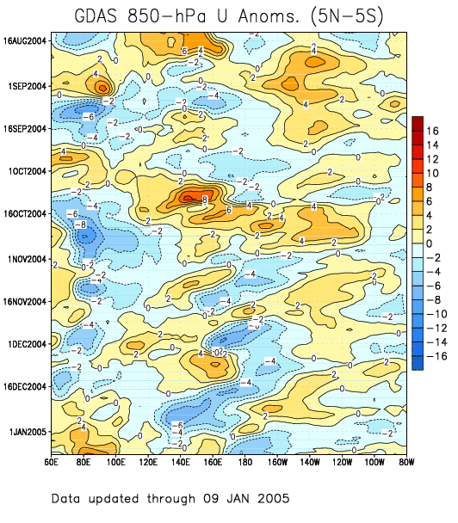

Figure 1: Time-longitude section (5°N-5°S) of anomalous 850-hPa zonal wind (m s⁻¹) (GDAS).
Contour interval is 2 m s⁻¹. Dashed contours indicate negative anomalies. The base period for computing anomalies is 1979-1995. Stronger-than-average easterlies are indicated by blue shading and weaker-than-average easterlies by orange/red shading.

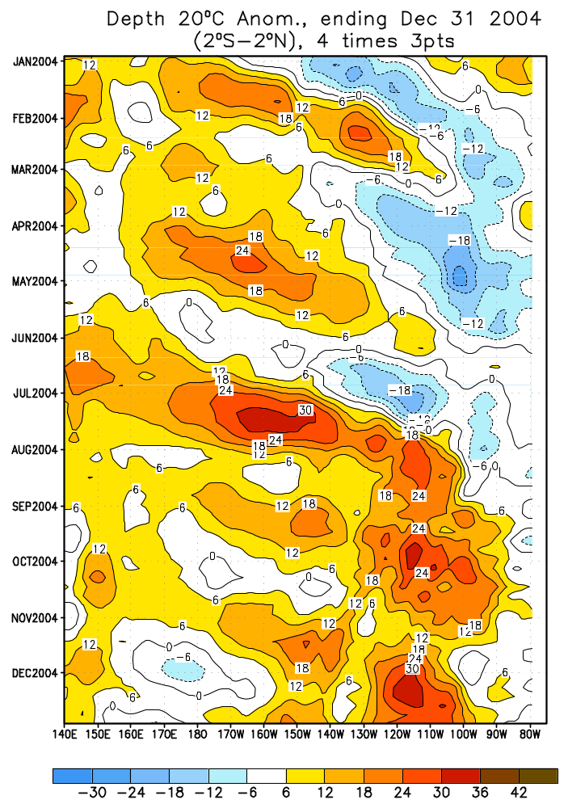

Figure 2: Time-longitude section (2°N-2°S) of anomalous depth of the 20ºC isotherm in the Pacific Ocean taken from GODAS (Global Ocean Data Assimilation System). Contour interval is 6 meters with shallower (deeper) depths indicated by blue (orange/red) shading.

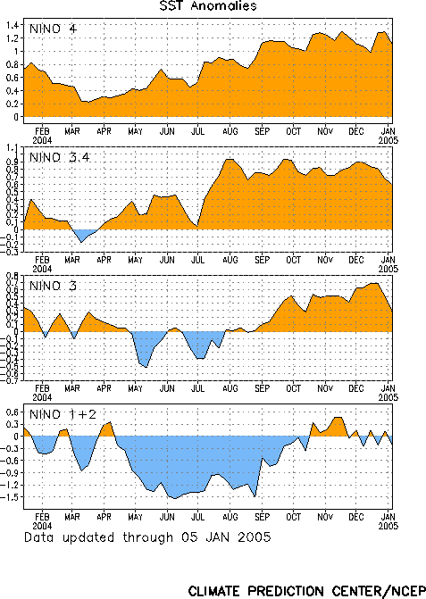

Figure 3: Time series of the four standard Niño indices during the past year.

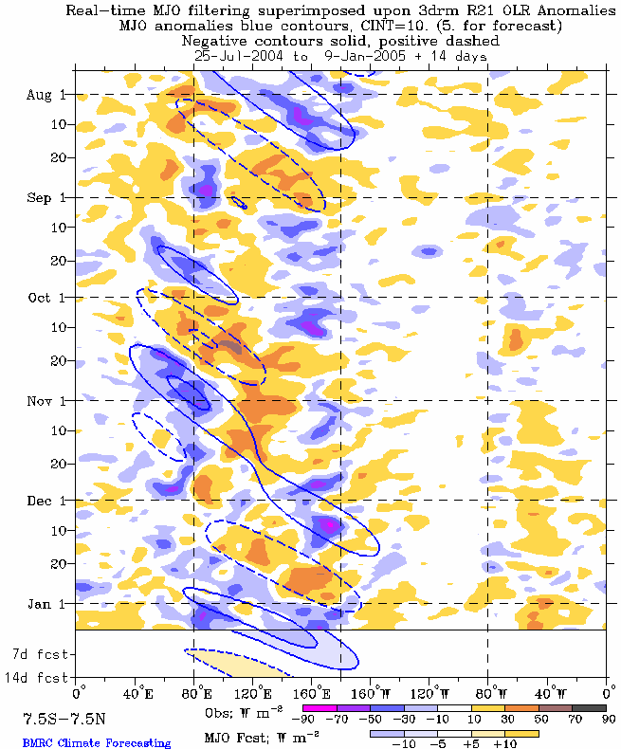

Figure 4: Time-longitude section (7.5°N-7.5°S) of anomalous Outgoing Longwave Radiation (OLR) (W m⁻²). Negative OLR anomalies (wetter-than-normal conditions) are indicated by blue shading while positive OLR anomalies (drier-than-normal conditions) are indicated by orange/red shading.

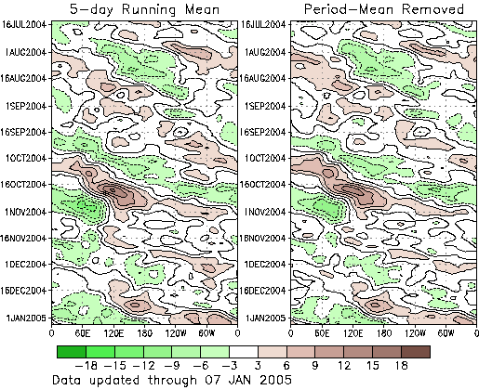

Figure 5: Five day running mean time longitude sections of the 200-hPa velocity potential anomaly (5°N-5°S) calculated from daily anomalies: left) total anomaly, right) period mean removed at each longitude. Anomalies are departures from the 1979-95 base period daily means. Contour interval is 3 x 10⁶ m²s⁻¹ with the green and brown shading indicating areas of divergent and convergent winds respectively.

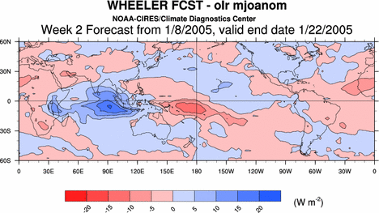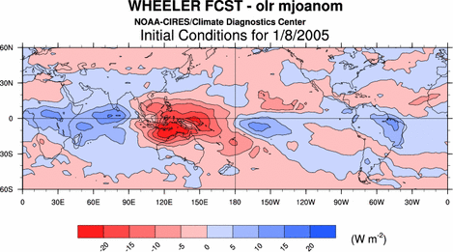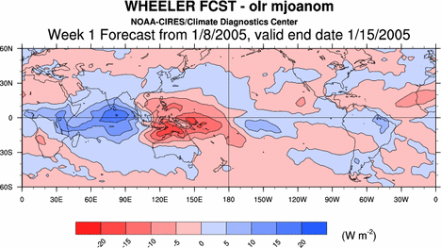

Figure 6: Anomalous OLR (Wm⁻²) from the Wheeler MJO forecast. Analysis (top), 1 week forecast (center), and two week forecast (bottom). Red (blue) shading indicates enhanced (suppressed) convection.

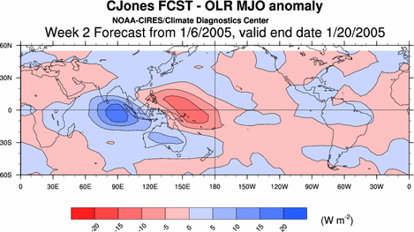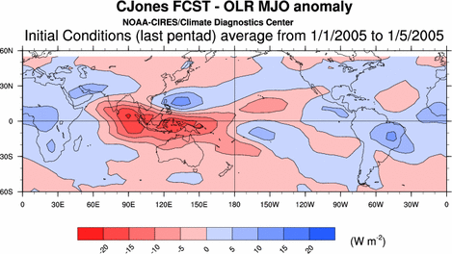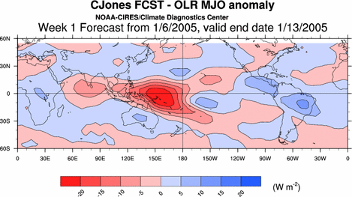

Figure 7: Anomalous OLR (Wm⁻²) from the Jones MJO forecast. Analysis (top), 1 week forecast (center), and two week forecast (bottom). Red (blue) shading indicates enhanced (suppressed) convection.

