EL NIÑO/SOUTHERN OSCILLATION (ENSO) DIAGNOSTIC DISCUSSION
issued by
CLIMATE PREDICTION CENTER/NCEP
5 April 2007

Synopsis: A transition from ENSO-neutral to La Niña conditions is possible within the next 3 months.

The pattern of anomalous sea surface temperatures (SSTs) during March 2007 was consistent with ENSO-neutral conditions in the tropical Pacific, with average to slightly below-average SSTs extending from the date line to the west coast of South America (Fig. 1). The latest weekly SST departures are near 0ºC in the Niño 3.4 region, and below -0.5ºC in the Niño 3 and Niño 1+2 regions (Fig. 2). An area of anomalously warm SSTs persisted well west of the date line (near 165ºE), and an area of SSTs exceeding 30°C was centered between 150°E and 165°E.
The upper-ocean heat content (average temperature departures in the upper 300 m of the ocean) remains below-average across the central and east-central equatorial Pacific (Fig. 3), with temperatures at thermocline depth generally 3°-5°C below average (Fig. 4). Consistent with the surface and sub-surface temperature patterns, stronger than-average low-level easterly winds persisted throughout the month of March over the central equatorial Pacific, and convection was enhanced over the western equatorial Pacific and Indonesia and suppressed near the date line. Collectively, these atmospheric and oceanic conditions are consistent with a trend towards a Pacific cold (La Niña) episode.
Most of the statistical and coupled model forecasts, including those from the NCEP Climate Forecast System (CFS) (Fig. 5), indicate additional anomalous surface cooling during the next several months. Some forecast models, especially the CFS, indicate a transition to La Niña during May-July 2007. This forecast is consistent with the observed trends in atmospheric and oceanic conditions. However, the spread of the most recent statistical and coupled model forecasts (ENSO-neutral to La Niña) indicates considerable uncertainty as to when La Niña might develop and how strong it might be.
This discussion is a consolidated effort of NOAA and its funded institutions. Oceanic and atmospheric conditions are updated weekly on the Climate Prediction Center web site (El Niño/La Niña Current Conditions and Expert Discussions). Forecasts for the evolution of El Niño/La Niña are updated monthly in the Forecast Forum section of CPC's Climate Diagnostics Bulletin. The next ENSO Diagnostics Discussion is scheduled for 10 May 2007. To receive an e-mail notification when the monthly ENSO Diagnostic Discussions are released, please send an e-mail message to: ncep.list.enso-update@noaa.gov.
Climate Prediction Center
National Centers for Environmental Prediction
NOAA/National Weather Service
Camp Springs, MD 20746-4304

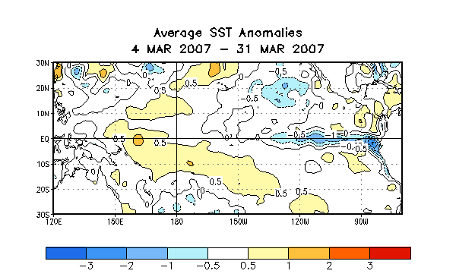
Figure 1. Average SST anomalies (°C) for the four-week period 4-31 March 2007. The SST anomalies are computed with respect to the 1971-2000 base period means
(Xue et al. 2003, J. Climate, 16, 1601-1612).

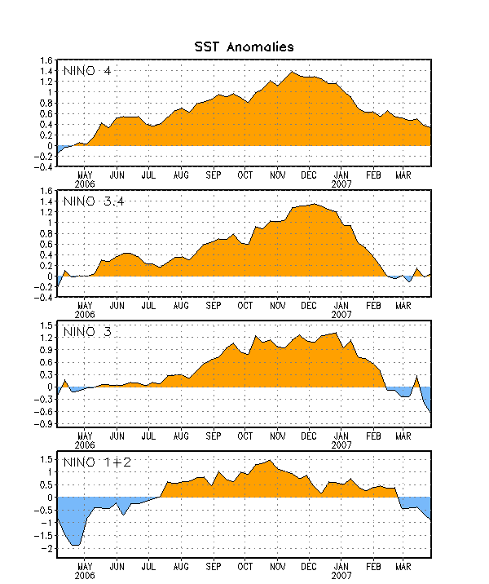
Figure 2. Time series of SST departures (°C) for the Niño regions. The SST departures are
computed with respect to the 1971-2000 base period means (Xue et al. 2003, J. Climate, 16, 1601-1612).

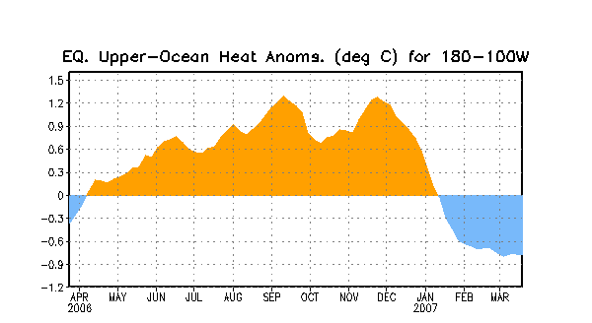
Figure 3. Anomalous equatorial upper-ocean heat content averaged over the longitude band
180º-100ºW. Heat content anomalies are computed as departures from the 1982-2004
base period means.

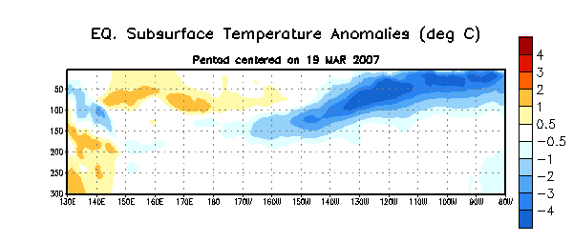
Figure 4. Time-longitude section of upper-ocean (0-300m) temperatures for the equatorial Pacific. Anomalies are departures from the 1982-2004 base period means.

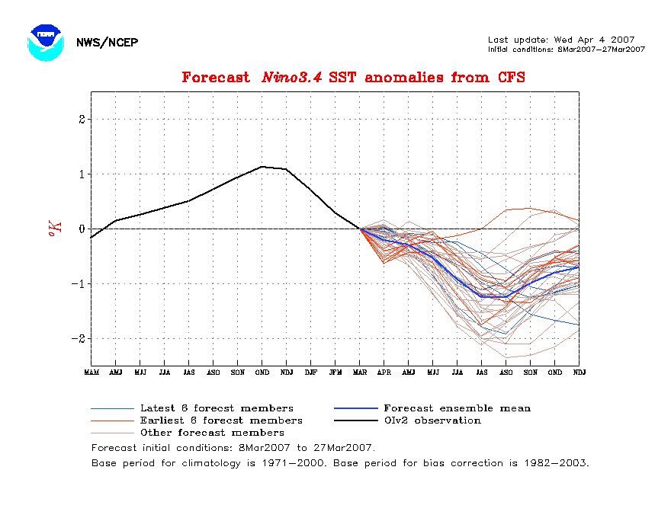
Figure 5. Forecasts of the SST anomalies for the Niño 3.4 region, derived from the NCEP/ Climate Forecast System (CFS).

