EL NIÑO/SOUTHERN OSCILLATION (ENSO) DIAGNOSTIC DISCUSSION
issued by
CLIMATE PREDICTION CENTER/NCEP/NWS
10 April 2008

Synopsis: La Niña is expected to continue for the next 3 months.
La Nina declined to moderate-strength during March 2008 as negative sea surface temperature (SST) anomalies weakened across the central and east-central equatorial Pacific. The latest weekly SSTs are more than 1.0°C below average in areas between 160°E and 120°W (Fig. 1). All of the Niño indices warmed during March (Fig. 2), with only the westernmost Niño-4 and Niño-3.4 regions having values nearly 1.0°C below average. Above-average SSTs remained restricted to the far eastern equatorial Pacific in association with a significant warming trend that began in mid-December. In the central Pacific, the subsurface temperature anomalies also lessened (averaging −1°C to −4°C at thermocline depth), and became increasingly confined to the surface region (Fig. 3). This evolution led to a significant weakening of the negative ocean heat content anomalies (average temperatures in the upper 300m of the ocean; Fig 4). Despite this oceanic trend, the atmospheric conditions continue to strongly reflect La Niña. Enhanced low-level easterly winds and upper-level westerly winds persisted across the central equatorial Pacific, convection remained suppressed throughout the central equatorial Pacific, and enhanced convection covered the far western Pacific. Collectively, these atmospheric and oceanic conditions indicate an ongoing, but weaker, La Niña.
The recent dynamical and statistical SST forecasts for the Niño 3.4 region indicate La Niña will become weak and persist through May-June-July 2008 (Fig. 5). Thereafter, there is considerable spread in the forecasts, with nearly one-half indicating La Niña could continue well into the second half of the year. Based on current atmospheric and oceanic conditions and recent trends, La Niña is expected to continue for the next 3 months.
Expected La Niña impacts during April- June include a continuation of above-average precipitation over Indonesia and below-average precipitation over the central equatorial Pacific. Compared to the Northern Hemisphere winter, La Niña impacts over the United States in spring are typically less pronounced. The main April- June signal for the contiguous United States is an increased probability of below-average precipitation over parts of the Southwest extending from Texas to Nevada.
This discussion is a consolidated effort of the National Atmospheric and Oceanic Administration (NOAA), NOAA’s National Weather Service, and their funded institutions. Oceanic and atmospheric conditions are updated weekly on the Climate Prediction Center web site (El Niño/La Niña Current Conditions and Expert Discussions). Forecasts for the evolution of El Niño/La Niña are updated monthly in the Forecast Forum section of CPC's Climate Diagnostics Bulletin. The next ENSO Diagnostics Discussion is scheduled for 8 May 2008. To receive an e-mail notification when the monthly ENSO Diagnostic Discussions are released, please send an e-mail message to: ncep.list.enso-update@noaa.gov.
Climate Prediction Center
National Centers for Environmental Prediction
NOAA/National Weather Service
Camp Springs, MD 20746-4304

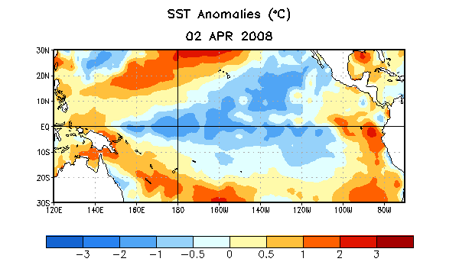
Figure 1. Weekly sea surface temperature (SST) anomalies (°C) centered on 2 April 2008. Anomalies are computed with respect to the 1971-2000 base period weekly means (Xue et al. 2003, J. Climate, 16, 1601-1612).

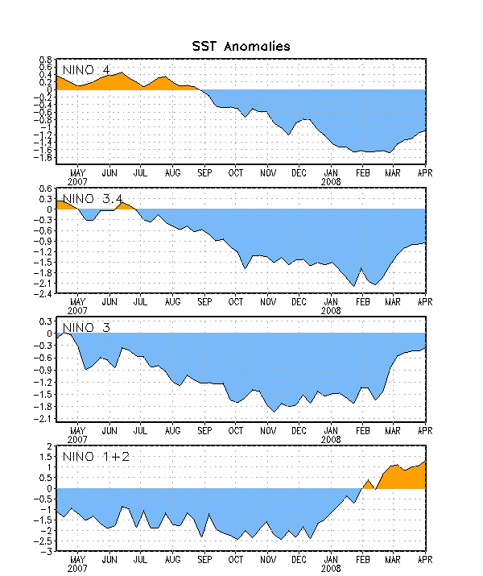
Figure 2. Time series of area-averaged sea surface temperature (SST) anomalies (°C) in the Niño regions [Niño-1+2 (0°-10°S, 90°-80°W), Niño 3 (5°N-5°S, 150°W-90°W), Niño-3.4 (5°N-5°S, 170°W-120°W), Niño-4 (150ºW-160ºE and 5ºN-5ºS)]. SST anomalies are departures are from the 1971-2000 base period weekly means (Xue et al. 2003, J. Climate, 16, 1601-1612).

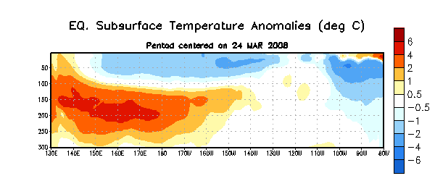

Figure 3. Depth-longitude section of equatorial Pacific upper-ocean (0-300m) temperature anomalies (°C) centered on the week of 24 March 2008. The anomalies are averaged between 5°N-5°S. Anomalies are departures from the 1982-2004 base period weekly means.

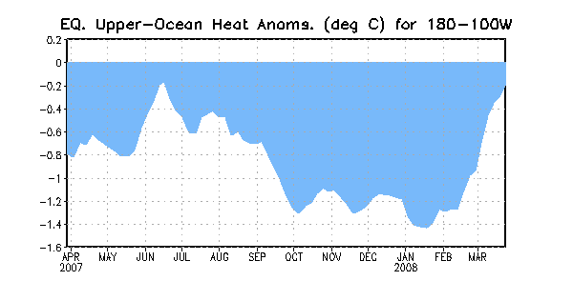
Figure 4. Area-averaged upper-ocean heat content anomalies (°C) in the equatorial Pacific (5°N-5°S, 180º-100ºW). Heat content anomalies are computed as departures from the 1982-2004 base period weekly means.

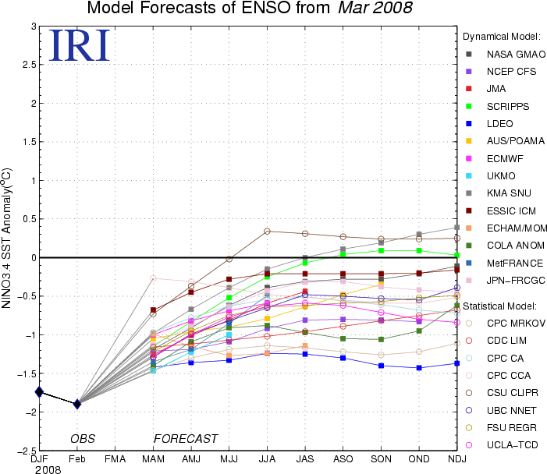

Figure 5. Forecasts of sea surface temperature (SST) anomalies for the Niño 3.4 region (5°N-5°S, 120°W-170°W). Figure courtesy of the International Research Institute (IRI) for Climate and Society. Figure updated 19 March 2008.

