EL NIÑO/SOUTHERN OSCILLATION (ENSO) DIAGNOSTIC DISCUSSION
issued by
CLIMATE PREDICTION CENTER/NCEP/NWS
9 April 2009

ENSO Alert System Status: La Niña Advisory

Synopsis: A transition to ENSO-neutral conditions is expected during April 2009.
Atmospheric and oceanic conditions during March 2009 continued to reflect weak La Niña conditions. The monthly sea surface temperatures (SST) remain below-average across parts of the east-central and eastern Pacific Ocean (Fig. 1). The Niño-3.4 SST index value persisted near −0.5°C during the month (Fig. 2). Negative subsurface oceanic heat content anomalies (average temperatures in the upper 300m of the ocean, Fig. 3) weakened further across the eastern half of the equatorial Pacific Ocean. At thermocline depth, positive temperature anomalies in the western and central Pacific expanded eastward, while negative temperature anomalies became confined to the far eastern Pacific (Fig. 4). Convection remained suppressed near the Date Line, and enhanced across Indonesia, but weakened during the later part of the month due to Madden-Julian Oscillation (MJO) activity. Enhanced low-level easterly winds and upper-level westerly winds also decreased across the equatorial Pacific Ocean. Collectively, these oceanic and atmospheric anomalies are consistent with a weakening La Niña.
A majority of model forecasts for the Niño-3.4 region show that once ENSO-neutral conditions are reached, it will continue through the remainder of 2009. Several models indicate La Niña will continue through March-May 2009 (Fig. 5). Based on current observations, recent trends, and model forecasts, a transition to ENSO-neutral conditions is expected during April 2009.
Over the equatorial Pacific Ocean, La Niña-like impacts are expected to linger during April-June 2009, including above-average precipitation over Indonesia, and below-average precipitation over the central Pacific. Over the United States, La Niña impacts are strongest during the Northern Hemisphere winter and typically weaken during the spring. During December 2008-February 2009, tropical precipitation anomalies reflected La Niña, characterized by a westward retraction of deep tropical convection towards Indonesia, suppressed precipitation centered on the Date Line, and enhanced rainfall over northeastern South America (Fig. 6). In the United States, La Niña was associated with drier-than-average conditions across the southern tier of states (extending into California and the mid-Atlantic), and wetter-than-average conditions over the Ohio/Tennessee Valleys and northern Intermountain West (Fig. 7).
This discussion is a consolidated effort of the National Oceanic and Atmospheric Administration (NOAA), NOAA’s National Weather Service, and their funded institutions. Oceanic and atmospheric conditions are updated weekly on the Climate Prediction Center web site (El Niño/La Niña Current Conditions and Expert Discussions). Forecasts for the evolution of El Niño/La Niña are updated monthly in the Forecast Forum section of CPC's Climate Diagnostics Bulletin. The next ENSO Diagnostics Discussion is scheduled for 7 May 2009. To receive an e-mail notification when the monthly ENSO Diagnostic Discussions are released, please send an e-mail message to: ncep.list.enso-update@noaa.gov.
Climate Prediction Center
National Centers for Environmental Prediction
NOAA/National Weather Service
Camp Springs, MD 20746-4304

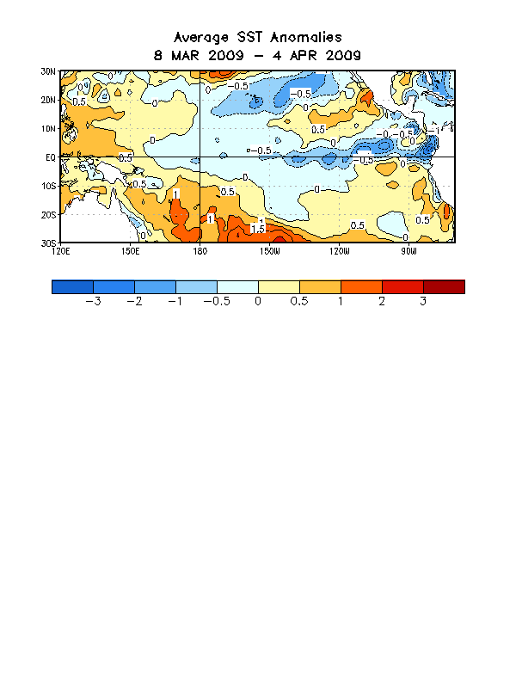

Figure 1. Average sea surface temperature (SST) anomalies (°C) for the four-week period 8 March - 4 April 2009. Anomalies are computed with respect to the 1971-2000 base period weekly means (Xue et al. 2003, J. Climate, 16, 1601-1612).

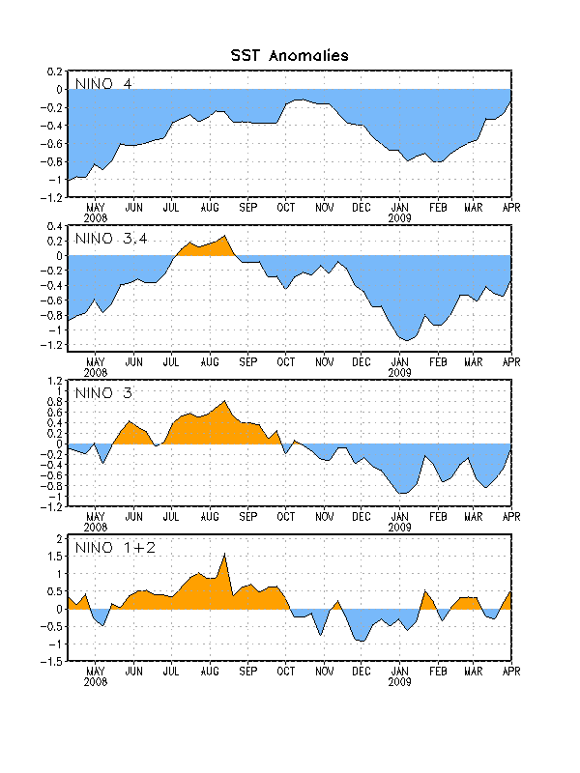
Figure 2. Time series of area-averaged sea surface temperature (SST) anomalies (°C) in the Niño regions [Niño-1+2 (0°-10°S, 90°W-80°W), Niño 3 (5°N-5°S, 150°W-90°W), Niño-3.4 (5°N-5°S, 170°W-120°W), Niño-4 (150ºW-160ºE and 5ºN-5ºS)]. SST anomalies are departures from the 1971-2000 base period weekly means (Xue et al. 2003, J. Climate, 16, 1601-1612).

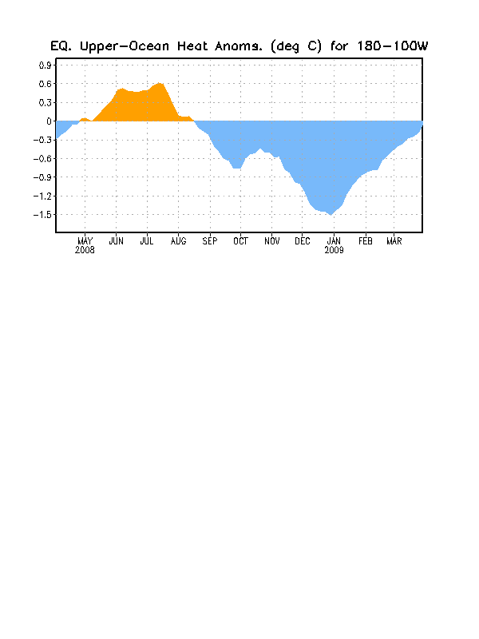
Figure 3. Area-averaged upper-ocean heat content anomalies (°C) in the equatorial Pacific (5°N-5°S, 180º-100ºW). Heat content anomalies are computed as departures from the 1982-2004 base period pentad means.

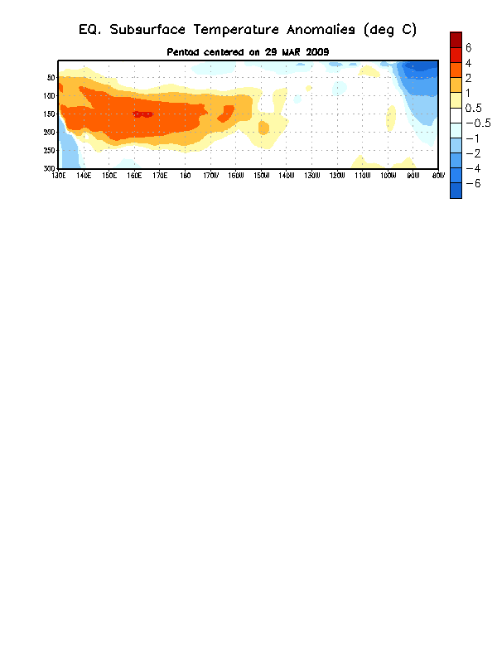
Figure 4. Depth-longitude section of equatorial Pacific upper-ocean (0-300m) temperature anomalies (°C) centered on the week of 29 March 2009. The anomalies are averaged between 5°N-5°S. Anomalies are departures from the 1982-2004 base period pentad means.

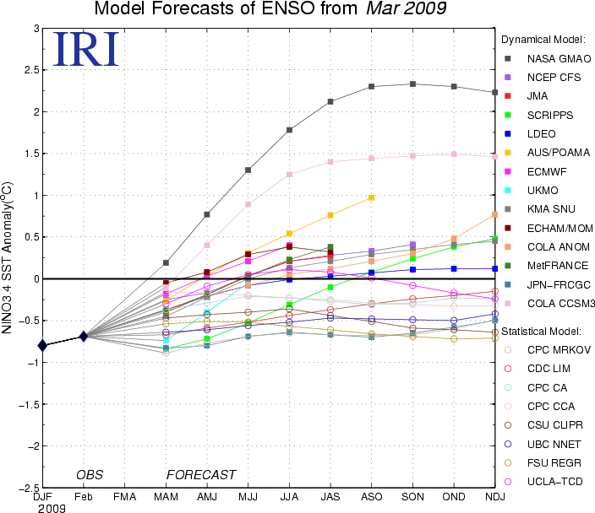

Figure 5. Forecasts of sea surface temperature (SST) anomalies for the Niño 3.4 region (5°N-5°S, 120°W-170°W). Figure courtesy of the International Research Institute (IRI) for Climate and Society. Figure updated 16 March 2009.

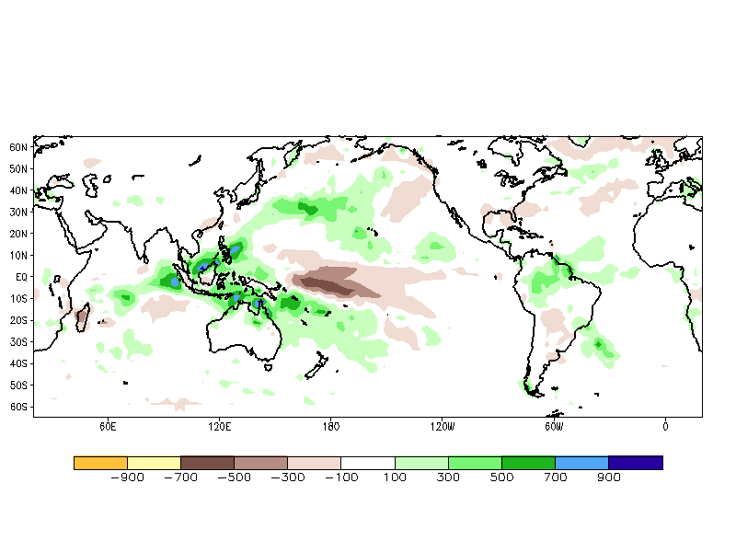
Figure 6. Global precipitation anomalies (mm) for the period 1 December 2008 - 28 February 2009. Anomalies are computed with respect to the 1979-1995 base period pentad means (Xie et al. 2003, J. Climate, 16, 2197-2214).

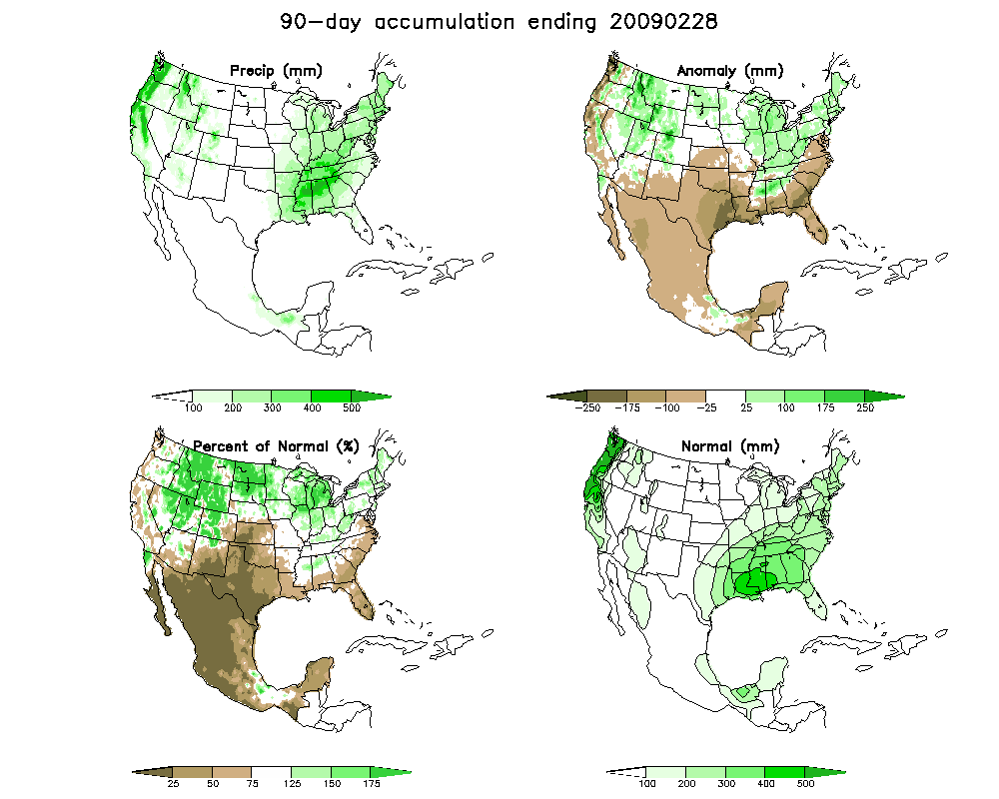

Figure 7. United States-Mexico precipitation anomalies (mm) for the period 1 December 2008 - 28 February 2009. Anomalies are computed with respect to the 1971-2000 base period daily means (Higgins et al., 2000, NCEP/Climate Prediction Center ATLAS No.7).

