EL NIÑO/SOUTHERN OSCILLATION (ENSO) DIAGNOSTIC DISCUSSION

issued by

CLIMATE PREDICTION CENTER/NCEP/NWS
8 April 2010

ENSO Alert System Status: El Niño Advisory

Synopsis: El Niño is expected to continue through the Northern Hemisphere spring 2010 and transition to ENSO-neutral conditions by Northern Hemisphere summer 2010.
El Niño weakened to moderate strength during March 2010, with sea surface temperature (SST) anomalies decreasing slightly, but still exceeding +1°C across much of the central and eastern equatorial Pacific Ocean at the end of the month (Figs. 1 and 2). Subsurface heat content anomalies (average temperatures in the upper 300m of the ocean, Fig. 3) decreased during March in response to the eastward expansion of below-average temperature anomalies at depth (100-200m) into the east-central Pacific (Fig. 4). Anomalous tropical convection remained consistent with El Niño, with enhanced convection over the central and eastern Pacific and suppressed convection over Indonesia (Fig. 5). The equatorial low-level easterly trade winds strengthened near the Date Line, while upper-level easterly wind anomalies became confined to the eastern Pacific. Collectively, these oceanic and atmospheric anomalies reflect an ongoing, but weakening El Niño.
Nearly all models predict decreasing SST anomalies in the Niño-3.4 region through 2010, with the model spread increasing at longer lead times (Fig. 6). The majority of models predict the 3-month Niño-3.4 SST anomaly will drop below +0.5°C by May-June-July 2010, indicating a transition to ENSO-neutral conditions that will likely persist through Northern Hemisphere summer. Over the last couple months, an increasing number of models, including the latest runs from the NCEP Climate Forecast System (CFS), are predicting below-average temperatures in the Niño-3.4 region by Northern Hemisphere fall, with some forecasts meeting thresholds for La Niña. However, it should be noted that model skill is at a minimum during this time of year, and also that the majority of models continue to indicate the persistence of ENSO-neutral conditions through 2010.
Expected El Niño impacts during April-June 2010 include drier-than-average conditions over Indonesia and enhanced convection over the central and eastern equatorial Pacific Ocean. For the contiguous United States, potential El Niño impacts include above-average precipitation for the southeastern states, while above-average temperatures are most likely for the Pacific Northwest.
This discussion is a consolidated effort of the National Oceanic and Atmospheric Administration (NOAA), NOAA’s National Weather Service, and their funded institutions. Oceanic and atmospheric conditions are updated weekly on the Climate Prediction Center web site (El Niño/La Niña Current Conditions and Expert Discussions). Forecasts for the evolution of El Niño/La Niña are updated monthly in the Forecast Forum section of CPC's Climate Diagnostics Bulletin. The next ENSO Diagnostics Discussion is scheduled for 6 May 2010. To receive an e-mail notification when the monthly ENSO Diagnostic Discussions are released, please send an e-mail message to: ncep.list.enso-update@noaa.gov.
Climate Prediction Center
National Centers for Environmental Prediction
NOAA/National Weather Service
Camp Springs, MD 20746-4304
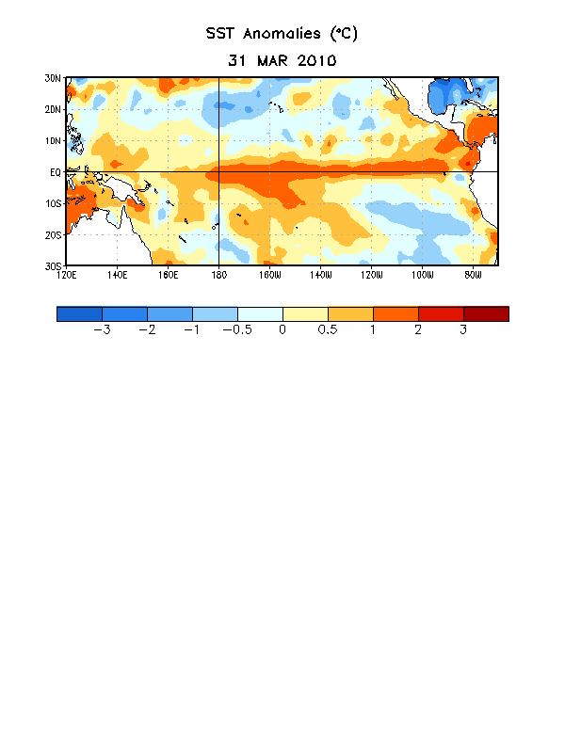
Figure 1. Average sea surface temperature (SST) anomalies (°C) for the week centered on 31 March 2010. Anomalies are computed with respect to the 1971-2000 base period weekly means (Xue et al. 2003, J. Climate, 16, 1601-1612).

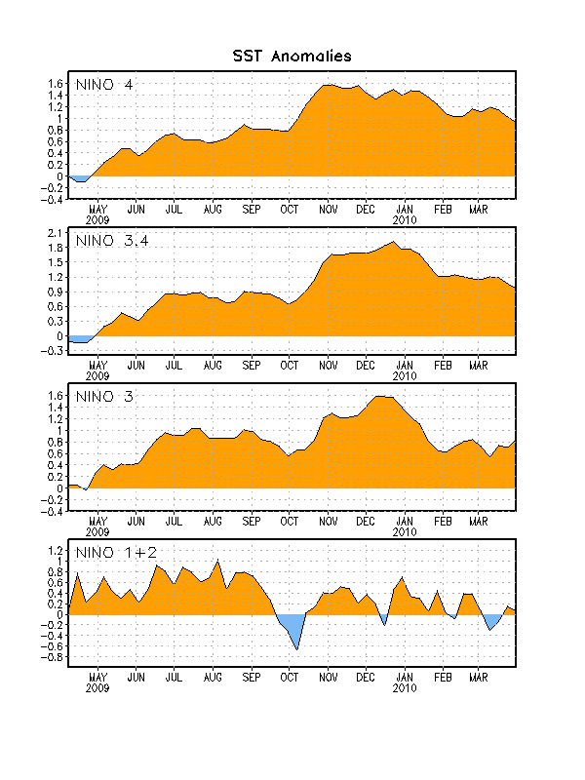
Figure 2. Time series of area-averaged sea surface temperature (SST) anomalies (°C) in the Niño regions [Niño-1+2 (0°-10°S, 90°W-80°W), Niño 3 (5°N-5°S, 150°W-90°W), Niño-3.4 (5°N-5°S, 170°W-120°W), Niño-4 (150ºW-160ºE and 5ºN-5ºS)]. SST anomalies are departures from the 1971-2000 base period weekly means (Xue et al. 2003, J. Climate, 16, 1601-1612).

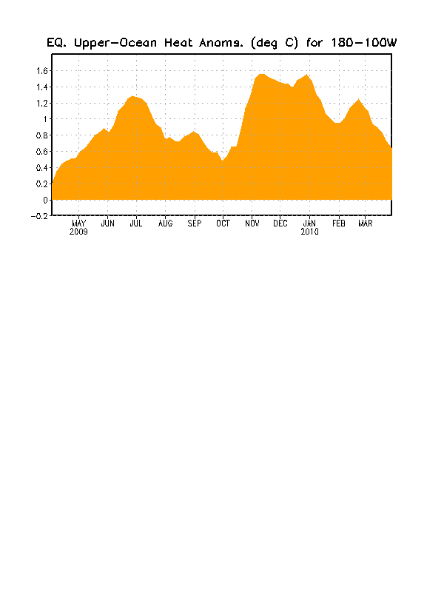
Figure 3. Area-averaged upper-ocean heat content anomalies (°C) in the equatorial Pacific (5°N-5°S, 180º-100ºW). Heat content anomalies are computed as departures from the 1982-2004 base period pentad means.

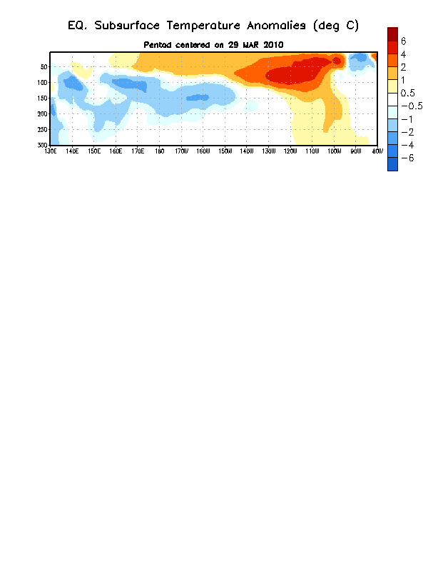
Figure 4. Depth-longitude section of equatorial Pacific upper-ocean (0-300m) temperature anomalies (°C) centered on the week of 29 March 2010. The anomalies are averaged between 5°N-5°S. Anomalies are departures from the 1982-2004 base period pentad means.

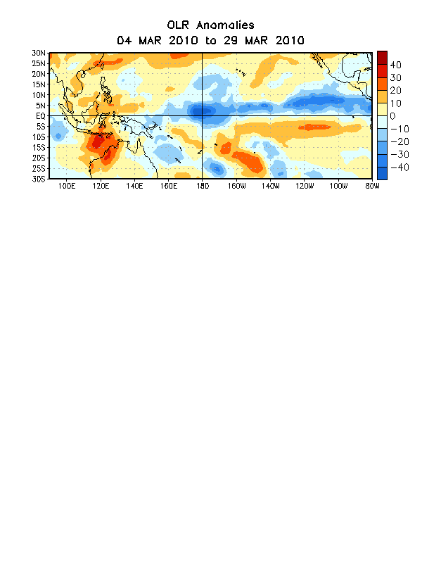
Figure 5. Average outgoing longwave radiation (OLR) anomalies (W/m²) for the four-week period 4 March – 29 March 2010. OLR anomalies are computed as departures from the 1979-1995 base period pentad means.

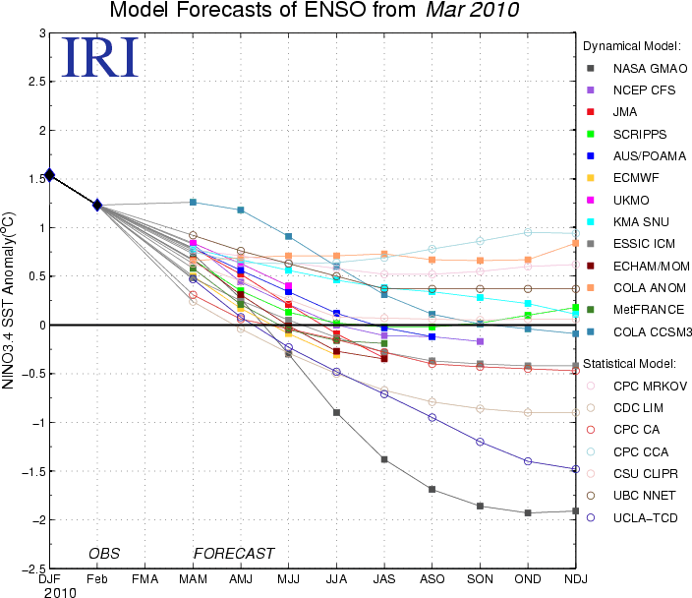
Figure 6. Forecasts of sea surface temperature (SST) anomalies for the Niño 3.4 region (5°N-5°S, 120°W-170°W). Figure courtesy of the International Research Institute (IRI) for Climate and Society. Figure updated 16 March 2010.

