EL NIÑO/SOUTHERN OSCILLATION (ENSO) DIAGNOSTIC DISCUSSION

issued by

CLIMATE PREDICTION CENTER/NCEP/NWS
and the International Research Institute for Climate and Society
5 April 2012

ENSO Alert System Status: La Niña Advisory

Synopsis: La Niña is expected to transition to ENSO-neutral conditions during April 2012.
La Niña continued to weaken during March 2012, as below-average SSTs persisted primarily in the central Pacific (Fig. 1). All of the Niño indices have warmed considerably during the last two months, and the Niño 4 and Niño 3.4 indices averaged only near -0.5 in March (Fig.2). The oceanic heat content (average temperature in the upper 300m of ocean) anomalies also continued to warm (Fig. 3), with alternating pockets of negative and positive temperature anomalies observed within the upper 100 m in the central and eastern Pacific (Fig. 4). Significant anomalous low-level westerly winds developed in the western tropical Pacific in late March, associated with the MJO (Fig. 5). This wind event could further warm the central and eastern Pacific within the coming few months. Presently, however, the larger scale atmospheric circulation anomalies and the Southern Oscillation Index retain their La Niña characteristics. Accordingly, convection remains suppressed in the western and central Pacific, and enhanced over Indonisia, Malaysia and the Philippines (Fig. 6). Collectively, these oceanic and atmospheric patterns indicate that a transition from La Niña to ENSO-neutral conditions is underway.
A majority of models predict ENSO-neutral conditions for March-May 2012, continuing through the Northern Hemisphere summer 2012 (Fig. 7). Based on the continued weakening of the negative SST anomalies during March 2012, and on the historical tendency for La Niña to dissipate during the Northern Hemisphere spring, we continue to expect La Niña to dissipate during April 2012. ENSO-neutral conditions are then expected to persist through the summer. Thereafter, there is considerable uncertainty in the forecast, which slightly favors ENSO-neutral or developing El Niño conditions over a return to La Niña conditions during the remainder of 2012 (see CPC/IRI consensus forecast).
Because atmospheric impacts often lag the demise of an ENSO episode, aspects of La Niña are reflected in the coming season. Over the U.S. during April - June 2012, La Niña has the following weak influences on the climate outlook: There is an increased chance of above-average temperatures in the south-central U.S., and below-average temperatures in the Northwest. Also, drier-than-average conditions are more likely across Utah and Colorado, and along the western Gulf of Mexico (see 3-month seasonal outlook released on 15 March 2012).
This discussion is a consolidated effort of the National Oceanic and Atmospheric Administration (NOAA), NOAA’s National Weather Service, and their funded institutions. Oceanic and atmospheric conditions are updated weekly on the Climate Prediction Center web site (El Niño/La Niña Current Conditions and Expert Discussions). Forecasts for the evolution of El Niño/La Niña are updated monthly in the Forecast Forum section of CPC's Climate Diagnostics Bulletin. The next ENSO Diagnostics Discussion is scheduled for 3 May 2012. To receive an e-mail notification when the monthly ENSO Diagnostic Discussions are released, please send an e-mail message to: ncep.list.enso-update@noaa.gov.

Climate Prediction Center
National Centers for Environmental Prediction
NOAA/National Weather Service
Camp Springs, MD 20746-4304

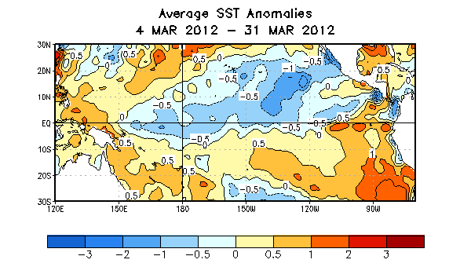
Figure 1. Average sea surface temperature (SST) anomalies (°C) for the period 4 – 31 March 2012. Anomalies are computed with respect to the 1971-2000 base period weekly means (Xue et al. 2003, J. Climate, 16, 1601-1612).

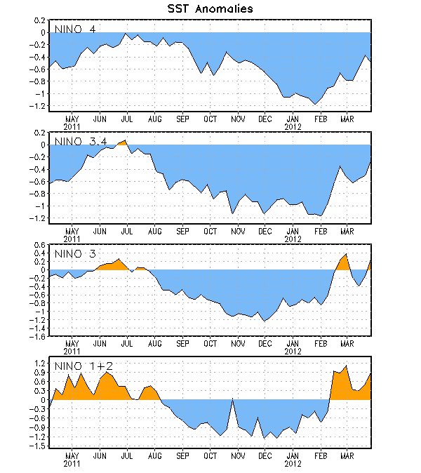
Figure 2. Time series of area-averaged sea surface temperature (SST) anomalies (°C) in the Niño regions [Niño-1+2 (0°-10°S, 90°W-80°W), Niño 3 (5°N-5°S, 150°W-90°W), Niño-3.4 (5°N-5°S, 170°W-120°W), Niño-4 (150ºW-160ºE and 5ºN-5ºS)]. SST anomalies are departures from the 1971-2000 base period weekly means (Xue et al. 2003, J. Climate, 16, 1601-1612).

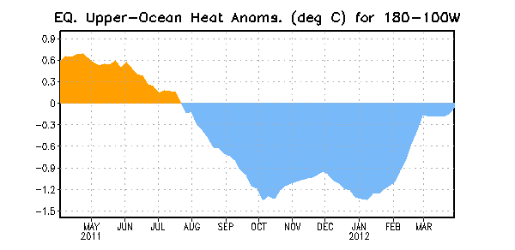
Figure 3. Area-averaged upper-ocean heat content anomaly (°C) in the equatorial Pacific (5°N-5°S, 180º-100ºW). The heat content anomaly is computed as the departure from the 1982-2004 base period pentad means.

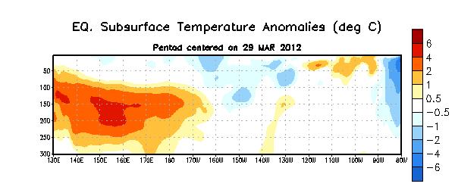
Figure 4. Depth-longitude section of equatorial Pacific upper-ocean (0-300m) temperature anomalies (°C) centered on the pentad of 29 March 2012. The anomalies are averaged between 5°N-5°S. Anomalies are departures from the 1982-2004 base period pentad means.

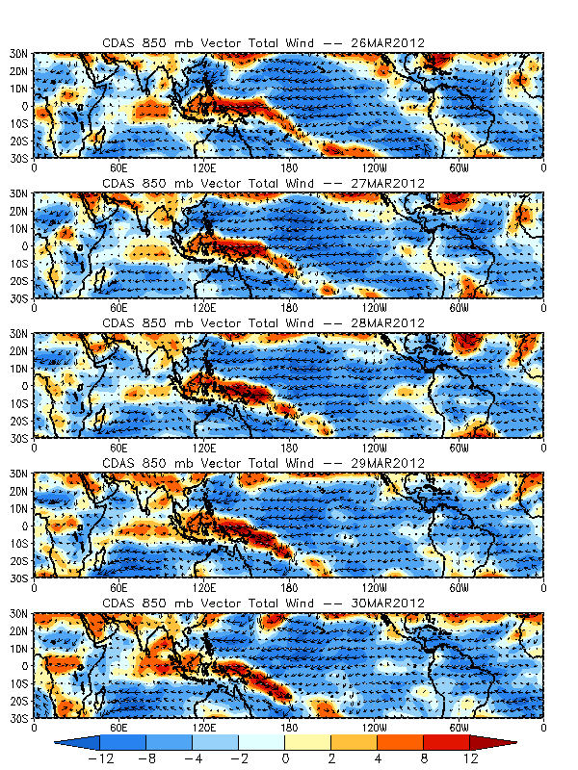
Figure 5. 850-hPa total wind (vectors) and zonal wind anomalies (shading) for daily averages from 26 – 30 March 2012. Wind anomalies are computed as departures from the 1971-2000 base period.

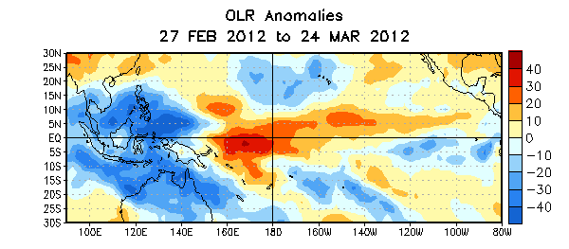

Figure 6. Average outgoing longwave radiation (OLR) anomalies (W/m²) for the four-week period 27 February – 24 March 2012. OLR anomalies are computed as departures from the 1979-1995 base period pentad means.

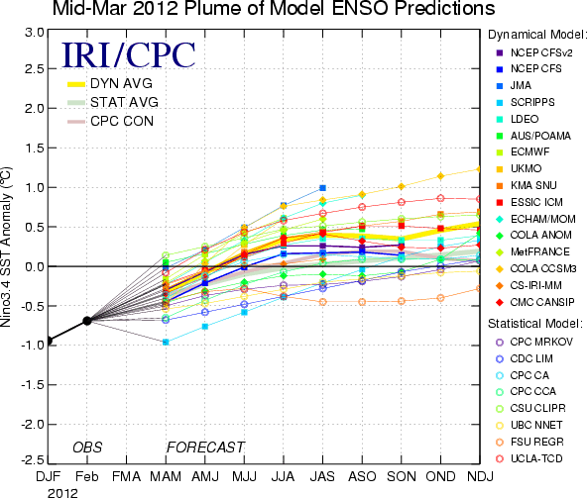
Figure 7. Forecasts of sea surface temperature (SST) anomalies for the Niño 3.4 region (5°N-5°S, 120°W-170°W). Figure courtesy of the International Research Institute (IRI) for Climate and Society. Figure updated 15 March 2012.

