EL NIÑO/SOUTHERN OSCILLATION (ENSO) DIAGNOSTIC DISCUSSION

issued by

CLIMATE PREDICTION CENTER/NCEP/NWS
and the International Research Institute for Climate and Society
4 April 2013

ENSO Alert System Status: Not Active

Synopsis: ENSO-neutral is favored into the Northern Hemisphere summer 2013.
During March 2013, ENSO-neutral continued, with slightly above average SSTs in the eastern portion of the basin (Fig. 1). Weekly values of all the Nino indices were between -0.5°C and +0.5°C during the month (Fig. 2). The oceanic heat content (average temperature in the upper 300m of the ocean) increased to near-average during the month (Fig. 3) as an area of above-average temperatures at depth moved eastward into portions of the eastern basin (Fig. 4). The Madden-Julian Oscillation (MJO) again contributed to increased atmospheric variability over the tropical Pacific. Low-level winds were near average, and upper-level winds were anomalously westerly across the equatorial Pacific. Convection was enhanced over the western equatorial Pacific and suppressed in the central basin (Fig. 5). Collectively, these features indicate the continuation of ENSO-neutral.
Most models forecast Niño-3.4 SSTs to remain ENSO-neutral through the Northern Hemisphere fall (Fig. 6), with dynamical models tending to predict warmer conditions (0°C to 0.5°C) than the statistical models (-0.5°C to 0°C). There is less confidence in the forecasts for the last half of the year, partly because of the so-called “spring barrier,” which historically leads to lower model skill beginning in late spring. Thus, ENSO-neutral is favored into the Northern Hemisphere summer 2013 (see CPC/IRI consensus forecast).
This discussion is a consolidated effort of the National Oceanic and Atmospheric Administration (NOAA), NOAA’s National Weather Service, and their funded institutions. Oceanic and atmospheric conditions are updated weekly on the Climate Prediction Center web site (El Niño/La Niña Current Conditions and Expert Discussions). Forecasts for the evolution of El Niño/La Niña are updated monthly in the Forecast Forum section of CPC's Climate Diagnostics Bulletin. The next ENSO Diagnostics Discussion is scheduled for 9 May 2013. To receive an e-mail notification when the monthly ENSO Diagnostic Discussions are released, please send an e-mail message to: ncep.list.enso-update@noaa.gov.
Climate Prediction Center
National Centers for Environmental Prediction
NOAA/National Weather Service
College Park, MD 20740

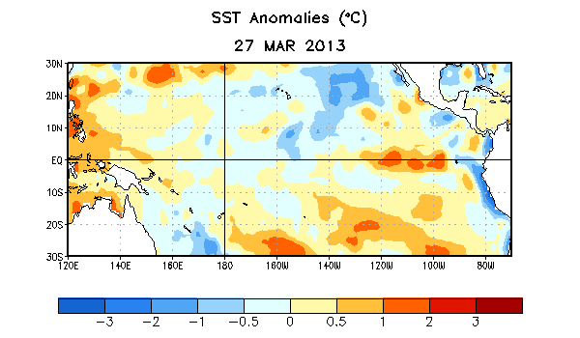
Figure 1. Average sea surface temperature (SST) anomalies (°C) for the week centered on 27 March 2013. Anomalies are computed with respect to the 1981-2010 base period weekly means.

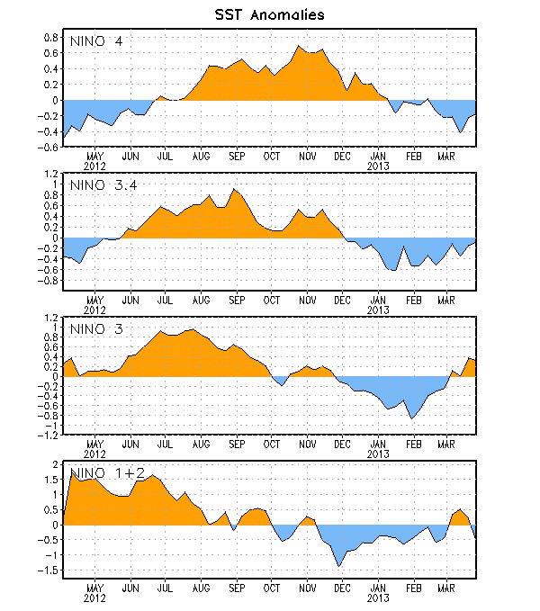
Figure 2. Time series of area-averaged sea surface temperature (SST) anomalies (°C) in the Niño regions [Niño-1+2 (0°-10°S, 90°W-80°W), Niño 3 (5°N-5°S, 150°W-90°W), Niño-3.4 (5°N-5°S, 170°W-120°W), Niño-4 (150ºW-160ºE and 5ºN-5ºS)]. SST anomalies are departures from the 1981-2010 base period weekly means.

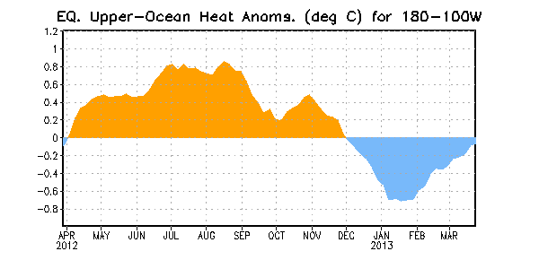
Figure 3. Area-averaged upper-ocean heat content anomaly (°C) in the equatorial Pacific (5°N-5°S, 180º-100ºW). The heat content anomaly is computed as the departure from the 1981-2010 base period pentad means.

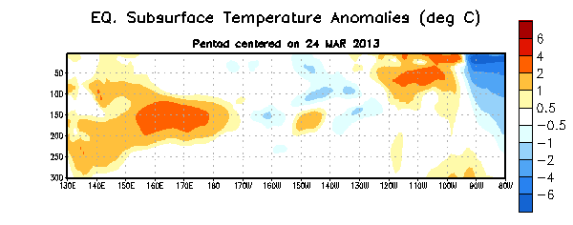
Figure 4. Depth-longitude section of equatorial Pacific upper-ocean (0-300m) temperature anomalies (°C) centered on the pentad of 24 March 2013. The anomalies are averaged between 5°N-5°S. Anomalies are departures from the 1981-2010 base period pentad means.

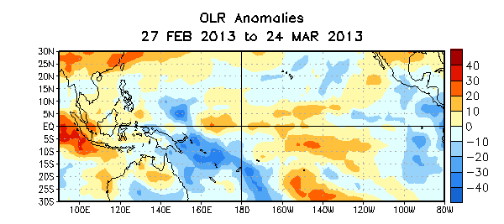

Figure 5. Average outgoing longwave radiation (OLR) anomalies (W/m²) for the four-week period 27 February – 24 March 2013. OLR anomalies are computed as departures from the 1979-1995 base period pentad means.

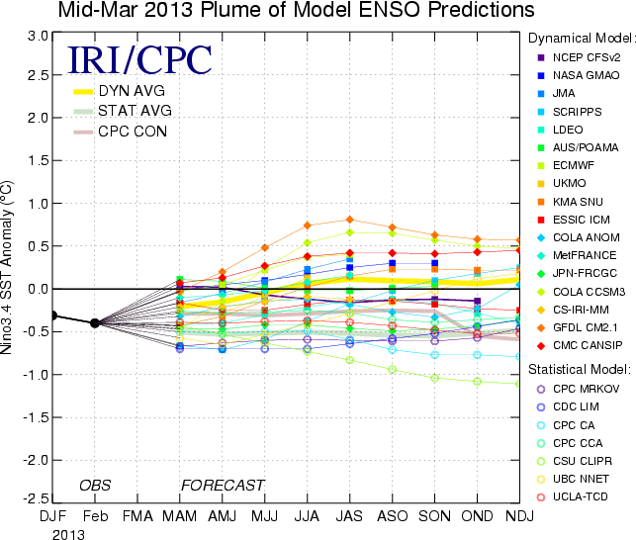
Figure 6. Forecasts of sea surface temperature (SST) anomalies for the Niño 3.4 region (5°N-5°S, 120°W-170°W). Figure courtesy of the International Research Institute (IRI) for Climate and Society. Figure updated 19 March 2013.

