EL NIÑO/SOUTHERN OSCILLATION (ENSO) DIAGNOSTIC DISCUSSION

issued by

CLIMATE PREDICTION CENTER/NCEP/NWS
and the International Research Institute for Climate and Society
10 April 2014

ENSO Alert System Status: El Niño Watch

Synopsis: While ENSO-neutral is favored for Northern Hemisphere spring, the chances of El Niño increase during the remainder of the year, exceeding 50% by summer.
ENSO-neutral continued during March 2014, but with above-average sea surface temperatures (SST) developing over much of the eastern tropical Pacific as well as near the International Date Line (Fig. 1). The weekly SSTs were below average in the Niño1+2 region, near average but rising in Niño3 and Niño3.4 regions, and above average in the Niño4 region (Fig. 2). A significant downwelling oceanic Kelvin wave that was initiated in January greatly increased the oceanic heat content to the largest March value in the historical record back to 1979 (Fig. 3) and produced large positive subsurface temperature anomalies across the central and eastern Pacific (Fig. 4). Also during March, low-level westerly wind anomalies were observed over the central equatorial Pacific. Convection was suppressed over western Indonesia, and enhanced over the central equatorial Pacific (Fig. 5). Although these atmospheric and oceanic conditions collectively reflect ENSO-neutral, they also reflect a clear evolution toward an El Niño state.
The model predictions of ENSO for this summer and beyond are indicating an increased likelihood of El Niño this year compared with last month. Most of the models indicate that ENSO-neutral (Niño-3.4 index between -0.5°C and 0.5°C) will persist through much of the remainder of the Northern Hemisphere spring 2014 (Fig. 6), with many models predicting the development of El Niño sometime during the summer or fall. Despite this greater model consensus, there remains considerable uncertainty as to when El Niño will develop and how strong it may become. This uncertainty is amplified by the inherently lower forecast skill of the models for forecasts made in the spring. While ENSO-neutral is favored for Northern Hemisphere spring, the chances of El Niño increase during the remainder of the year, and exceed 50% by the summer (click CPC/IRI consensus forecast for the chance of each outcome).
This discussion is a consolidated effort of the National Oceanic and Atmospheric Administration (NOAA), NOAA’s National Weather Service, and their funded institutions. Oceanic and atmospheric conditions are updated weekly on the Climate Prediction Center web site (El Niño/La Niña Current Conditions and Expert Discussions). Forecasts for the evolution of El Niño/La Niña are updated monthly in the Forecast Forum section of CPC's Climate Diagnostics Bulletin. The next ENSO Diagnostics Discussion is scheduled for 8 May 2014. To receive an e-mail notification when the monthly ENSO Diagnostic Discussions are released, please send an e-mail message to: ncep.list.enso-update@noaa.gov.
Climate Prediction Center
National Centers for Environmental Prediction
NOAA/National Weather Service
College Park, MD 20740

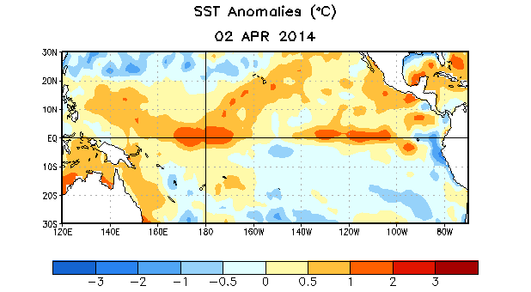

Figure 1. Average sea surface temperature (SST) anomalies (°C) for the week centered on 2 April 2014. Anomalies are computed with respect to the 1981-2010 base period weekly means.

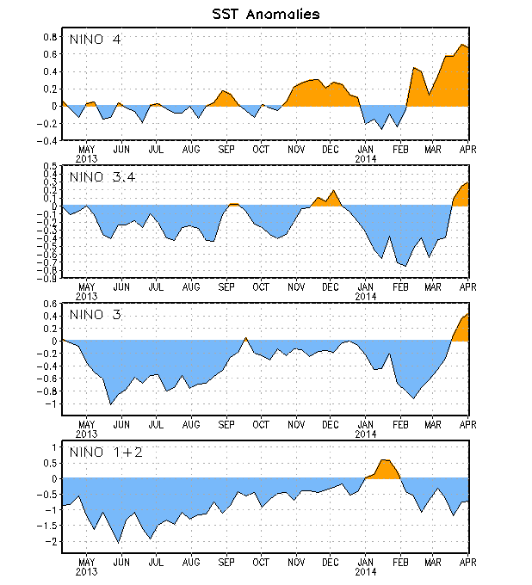
Figure 2. Time series of area-averaged sea surface temperature (SST) anomalies (°C) in the Niño regions [Niño-1+2 (0°-10°S, 90°W-80°W), Niño 3 (5°N-5°S, 150°W-90°W), Niño-3.4 (5°N-5°S, 170°W-120°W), Niño-4 (5ºN-5ºS , 150ºW-160ºE]. SST anomalies are departures from the 1981-2010 base period weekly means.

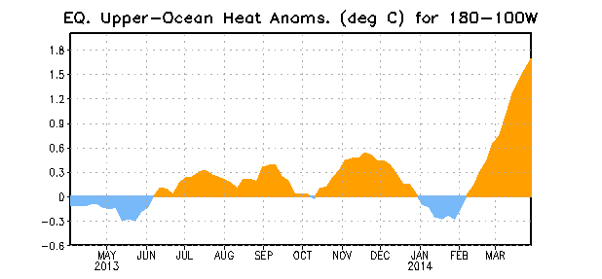
Figure 3. Area-averaged upper-ocean heat content anomaly (°C) in the equatorial Pacific (5°N-5°S, 180º-100ºW). The heat content anomaly is computed as the departure from the 1981-2010 base period pentad means.

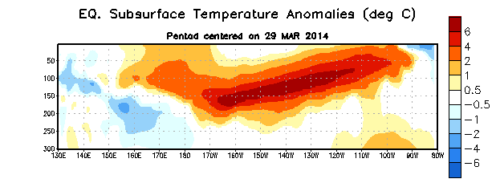
Figure 4. Depth-longitude section of equatorial Pacific upper-ocean (0-300m) temperature anomalies (°C)
centered on the pentad of 29 March 2014. The anomalies are averaged between 5°N-5°S. Anomalies are departures from the 1981-2010 base period pentad means.

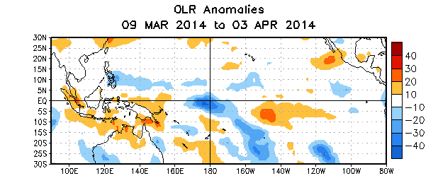

Figure 5. Average outgoing longwave radiation (OLR) anomalies (W/m²) for the period 9 March – 3
April 2014. OLR anomalies are computed as departures from the 1979-1995 base period pentad means.

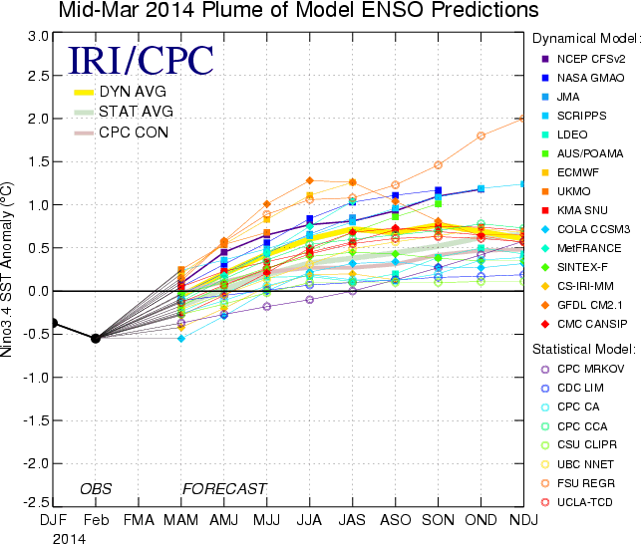
Figure 6. Forecasts of sea surface temperature (SST) anomalies for the Niño 3.4 region (5°N-5°S, 120°W-170°W). Figure updated 18 March 2014.

