EL NIÑO/SOUTHERN OSCILLATION (ENSO) DIAGNOSTIC DISCUSSION

issued by

CLIMATE PREDICTION CENTER/NCEP/NWS
and the International Research Institute for Climate and Society
14 April 2016

ENSO Alert System Status: El Niño Advisory/ La Niña Watch

Synopsis: A transition to ENSO-neutral is likely during late Northern Hemisphere spring or early summer 2016, with an increasing chance of La Niña during the second half of the year.
Sea surface temperature (SST) anomalies were between 1.0° and 1.5°C across most of the central and eastern equatorial Pacific Ocean during early April (Fig. 1), having weakened appreciably over the last month. The latest weekly values for all of the Niño indices dropped to below 1.5°C (Fig. 2). The subsurface temperature anomaly in the central and eastern Pacific decreased to negative values (Fig. 3) in association with a significant expansion of below-average temperatures at depth (Fig. 4). Low-level westerly wind anomalies and upper-level easterly wind anomalies weakened compared to February. The equatorial Southern Oscillation Index (SOI) remained negative but weakened, while the traditional SOI was near zero. Enhanced convection continued over the central tropical Pacific but weakened east of the Date Line, and was suppressed over northern Indonesia and the Philippines (Fig. 5). Collectively, these anomalies reflect a weakening El Niño.
Nearly all models predict further weakening of El Niño, with a transition to ENSO-neutral likely during late spring or early summer 2016 (Fig. 6). Then, the chance of La Niña increases during the late summer or early fall. The official forecast is consistent with the model forecasts, also supported by a historical tendency for La Niña to follow strong El Niño events. A transition to ENSO-neutral is likely during late Northern Hemisphere spring or early summer 2016, with an increasing chance of La Niña during the second half of the year (click CPC/IRI consensus forecast for the chance of each outcome for each 3-month period).
This discussion is a consolidated effort of the National Oceanic and Atmospheric Administration (NOAA), NOAA’s National Weather Service, and their funded institutions. Oceanic and atmospheric conditions are updated weekly on the Climate Prediction Center web site (El Niño/La Niña Current Conditions and Expert Discussions). Forecasts are also updated monthly in the Forecast Forum of CPC's Climate Diagnostics Bulletin. Additional perspectives and analysis are also available in an ENSO blog. The next ENSO Diagnostics Discussion is scheduled for 12 May 2016. To receive an e-mail notification when the monthly ENSO Diagnostic Discussions are released, please send an e-mail message to: ncep.list.enso-update@noaa.gov.

Climate Prediction Center
National Centers for Environmental Prediction
NOAA/National Weather Service
College Park, MD 20740

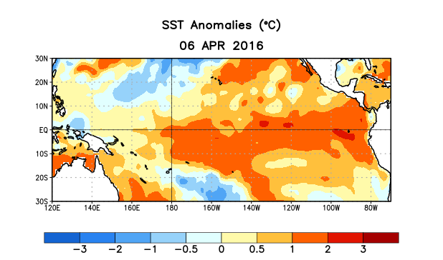
Figure 1. Average sea surface temperature (SST) anomalies (°C) for the week centered on 6 April 2016. Anomalies are computed with respect to the 1981-2010 base period weekly means.

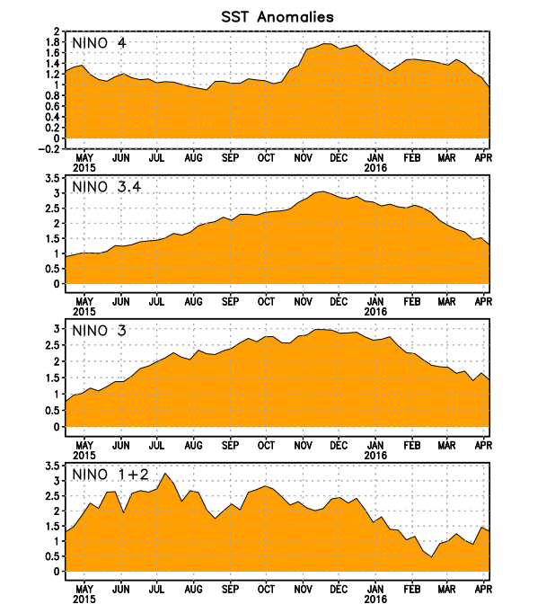
Figure 2. Time series of area-averaged sea surface temperature (SST) anomalies (°C) in the Niño regions [Niño-1+2 (0°-10°S, 90°W-80°W), Niño 3 (5°N-5°S, 150°W-90°W), Niño-3.4 (5°N-5°S, 170°W-120°W), Niño-4 (5ºN-5ºS , 150ºW-160ºE]. SST anomalies are departures from the 1981-2010 base period weekly means.
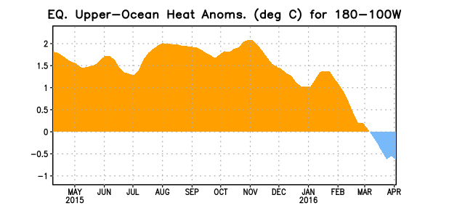
Figure 3. Area-averaged upper-ocean heat content anomaly (°C) in the equatorial Pacific (5°N-5°S, 180º-100ºW). The heat content anomaly is computed as the departure from the 1981-2010 base period pentad means.

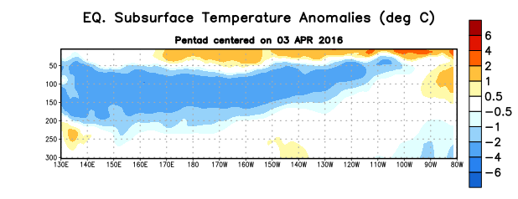
Figure 4. Depth-longitude section of equatorial Pacific upper-ocean (0-300m) temperature anomalies (°C)
centered on the pentad of 3 April 2016. The anomalies are averaged between 5°N-5°S. Anomalies are departures from the 1981-2010 base period pentad means.

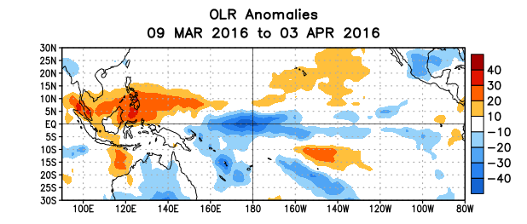
Figure 5. Average outgoing longwave radiation (OLR) anomalies (W/m²) for the period 9 March – 3 April 2016. OLR anomalies are computed as departures from the 1981-2010 base period pentad means.

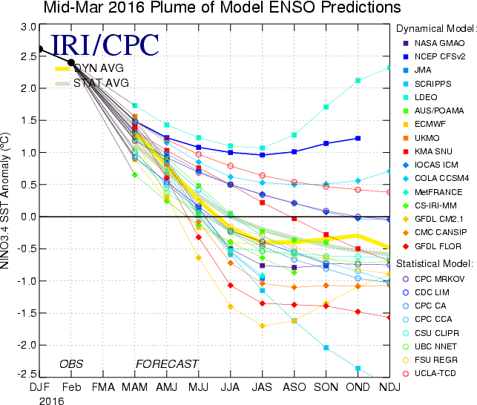
Figure 6. Forecasts of sea surface temperature (SST) anomalies for the Niño 3.4 region (5°N-5°S, 120°W-170°W). Figure updated 15 March 2016.

