EL NIÑO/SOUTHERN OSCILLATION (ENSO) DIAGNOSTIC DISCUSSION

issued by

CLIMATE PREDICTION CENTER/NCEP/NWS

and the International Research Institute for Climate and Society

12 April 2018

ENSO Alert System Status: La Niña Advisory

Synopsis: La Niña is expected to transition to ENSO-neutral during April-May, with ENSO-neutral then likely (greater than 50% chance) to continue through the Northern Hemisphere summer 2018.

During March 2018, La Niña continued to weaken, but was still reflected by below-average sea surface temperatures (SSTs) across the east-central and eastern equatorial Pacific Ocean (Fig. 1). The latest weekly index values were -0.5°C and -0.3°C in the Niño-3.4 and Niño-3 regions, respectively, -1.1°C in the Niño1+2 region, and near zero in the Niño.4 region (Fig. 2). While negative anomalies were weakening near the surface, the sub-surface temperature anomalies (averaged across 180°-100°W) warmed (Fig. 3) due to the eastward propagation of a downwelling equatorial oceanic Kelvin wave (Fig. 4). Convection was suppressed near and east of the Date Line and enhanced over the far western tropical Pacific Ocean (Fig. 5). Low-level wind anomalies were easterly over the east-central Pacific, and westerly over the far western Pacific. At upper-levels, winds were anomalously westerly over the eastern Pacific. Overall, the ocean and atmosphere system remained consistent with a weak La Niña.
Most models in the IRI/CPC plume predict La Niña will decay and return to ENSO-neutral during the current March-May season (Fig. 6). The forecaster consensus similarly favors a transition to neutral, with a continuation of ENSO-neutral conditions through the summer 2018. Thereafter, there is considerable forecast uncertainty, in part due to the lower prediction skill for forecasts made at this time of year. In summary, La Niña is expected to transition to ENSO-neutral during April-May, with ENSO-neutral then likely (greater than 50% chance) to continue through the Northern Hemisphere summer 2018 (click CPC/IRI consensus forecast for the chance of each outcome for each 3-month period).
This discussion is a consolidated effort of the National Oceanic and Atmospheric Administration (NOAA), NOAA’s National Weather Service, and their funded institutions. Oceanic and atmospheric conditions are updated weekly on the Climate Prediction Center web site (El Niño/La Niña Current Conditions and Expert Discussions). Forecasts are also updated monthly in the Forecast Forum of CPC's Climate Diagnostics Bulletin. Additional perspectives and analysis are also available in an ENSO blog. The next ENSO Diagnostics Discussion is scheduled for 10 May 2018. To receive an e-mail notification when the monthly ENSO Diagnostic Discussions are released, please send an e-mail message to: ncep.list.enso-update@noaa.gov.

Climate Prediction Center
National Centers for Environmental Prediction
NOAA/National Weather Service
College Park, MD 20740

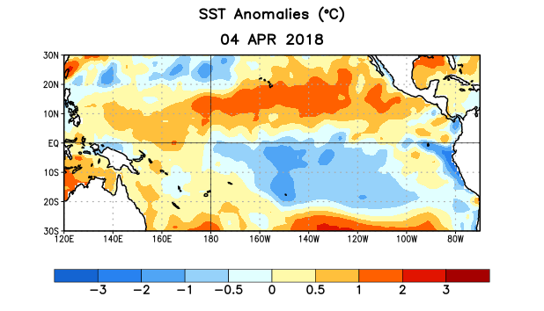
Figure 1. Average sea surface temperature (SST) anomalies (°C) for the week centered on 4 April 2018. Anomalies are computed with respect to the 1981-2010 base period weekly means.

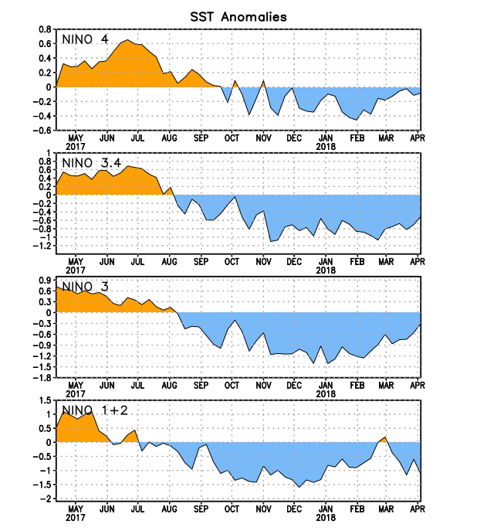
Figure 2. Time series of area-averaged sea surface temperature (SST) anomalies (°C) in the Niño regions [Niño-1+2 (0°-10°S, 90°W-80°W), Niño-3 (5°N-5°S, 150°W-90°W), Niño-3.4 (5°N-5°S, 170°W-120°W), Niño-4 (5ºN-5ºS , 150ºW-160ºE]. SST anomalies are departures from the 1981-2010 base period weekly means.
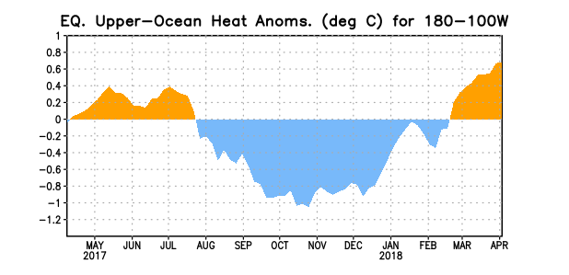
Figure 3. Area-averaged upper-ocean heat content anomaly (°C) in the equatorial Pacific (5°N-5°S, 180º-100ºW). The heat content anomaly is computed as the departure from the 1981-2010 base period pentad means.

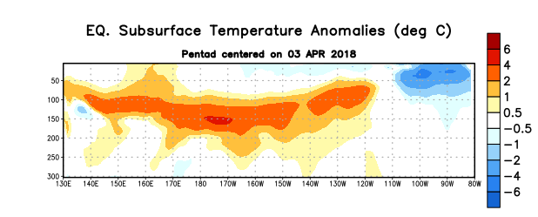
Figure 4. Depth-longitude section of equatorial Pacific upper-ocean (0-300m) temperature anomalies (°C) centered on the pentad of 3 April 2018. Anomalies are departures from the 1981-2010 base period pentad means.

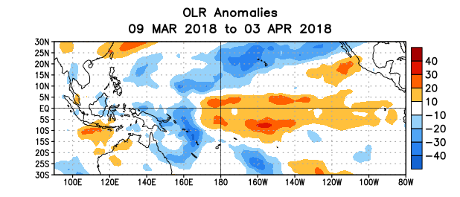
Figure 5. Average outgoing longwave radiation (OLR) anomalies (W/m²) for the period 9 March – 3 April 2018. OLR anomalies are computed as departures from the 1981-2010 base period pentad means.

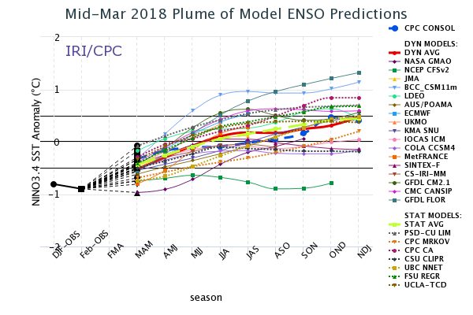
Figure 6. Forecasts of sea surface temperature (SST) anomalies for the Niño 3.4 region (5°N-5°S, 120°W-170°W). Figure updated 19 March 2018.

