EL NIÑO/SOUTHERN OSCILLATION (ENSO) DIAGNOSTIC DISCUSSION

issued by

CLIMATE PREDICTION CENTER/NCEP/NWS

and the International Research Institute for Climate and Society

9 April 2020

ENSO Alert System Status: Not Active

Synopsis: ENSO-neutral is favored for the Northern Hemisphere summer 2020 (~60% chance), remaining the most likely outcome through autumn.

During March 2020, above-average sea surface temperatures (SSTs) were observed across most of the tropical Pacific Ocean (Fig. 1). The latest weekly Niño-3.4 and Niño-3 indices were slightly elevated (+0.6°C), while the Niño-4 and Niño-1+2 index values were +0.7°C and +0.8°C, respectively (Fig. 2). Equatorial subsurface temperatures (averaged across 180°-100°W) remained above average overall, but the anomalies decreased during the month (Fig. 3) due to the expansion of below-average temperatures into the central Pacific at depth (Fig. 4). Also during the month, low-level wind anomalies were easterly in the eastern Pacific, while upper-level wind anomalies were westerly over the central and eastern portions of the basin. Tropical convection was near average around the Date Line, and slightly suppressed over parts of Indonesia (Fig. 5). Overall, the combined oceanic and atmospheric system remained consistent with ENSO-neutral.
The majority of models in the IRI/CPC plume (Fig. 6) favor ENSO-neutral (Niño-3.4 index between -0.5°C and +0.5°C) through the Northern Hemisphere autumn. While the Niño 3.4 index values remained elevated during March, the consensus of forecasters expects these values to decrease between the spring and summer. In summary, ENSO-neutral is favored for the Northern Hemisphere summer 2020 (~60% chance), remaining the most likely outcome through autumn (click CPC/IRI consensus forecast for the chance of each outcome for each 3-month period).
This discussion is a consolidated effort of the National Oceanic and Atmospheric Administration (NOAA), NOAA’s National Weather Service, and their funded institutions. Oceanic and atmospheric conditions are updated weekly on the Climate Prediction Center web site (El Niño/La Niña Current Conditions and Expert Discussions). Forecasts are also updated monthly in the Forecast Forum of CPC's Climate Diagnostics Bulletin. Additional perspectives and analysis are also available in an ENSO blog. The next ENSO Diagnostics Discussion is scheduled for 14 May 2020. To receive an e-mail notification when the monthly ENSO Diagnostic Discussions are released, please send an e-mail message to: ncep.list.enso-update@noaa.gov.

Climate Prediction Center
National Centers for Environmental Prediction
NOAA/National Weather Service
College Park, MD 20740

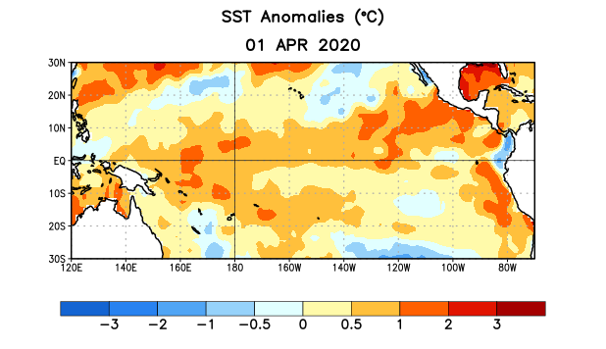
Figure 1. Average sea surface temperature (SST) anomalies (°C) for the week centered on 1 April 2020. Anomalies are computed with respect to the 1981-2010 base period weekly means.

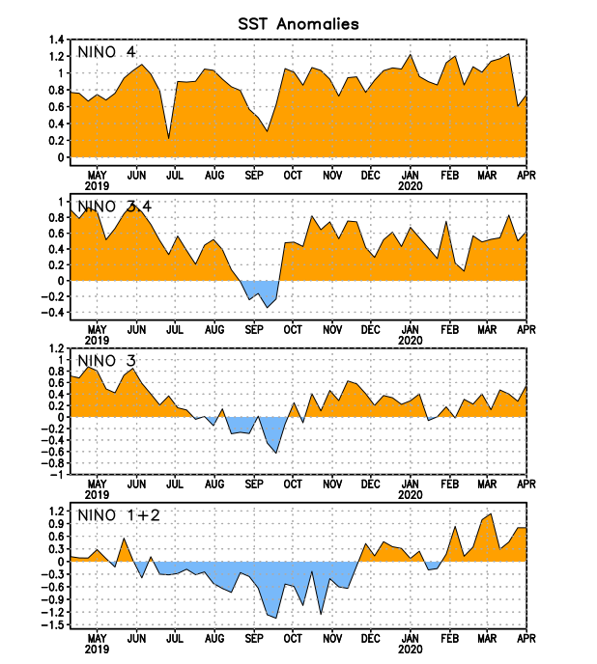
Figure 2. Time series of area-averaged sea surface temperature (SST) anomalies (°C) in the Niño regions [Niño-1+2 (0°-10°S, 90°W-80°W), Niño-3 (5°N-5°S, 150°W-90°W), Niño-3.4 (5°N-5°S, 170°W-120°W), Niño-4 (5ºN-5ºS , 150ºW-160ºE)]. SST anomalies are departures from the 1981-2010 base period weekly means.
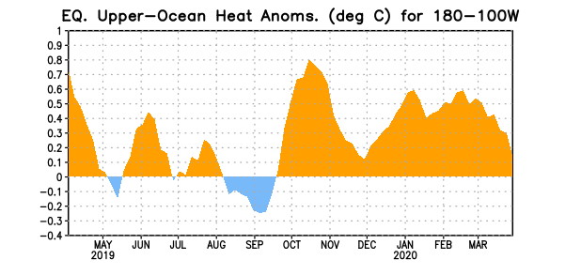
Figure 3. Area-averaged upper-ocean heat content anomaly (°C) in the equatorial Pacific (5°N-5°S, 180º-100ºW). The heat content anomaly is computed as the departure from the 1981-2010 base period pentad means.

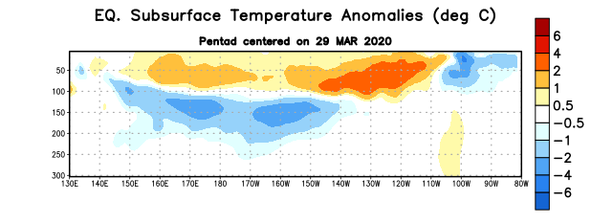
Figure 4. Depth-longitude section of equatorial Pacific upper-ocean (0-300m) temperature anomalies (°C) centered on the pentad of 29 March 2020. Anomalies are departures from the 1981-2010 base period pentad means.

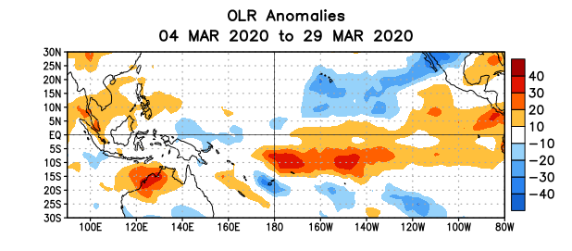
Figure 5. Average outgoing longwave radiation (OLR) anomalies (W/m²) for the period 4 – 29 March 2020. OLR anomalies are computed as departures from the 1981-2010 base period pentad means.

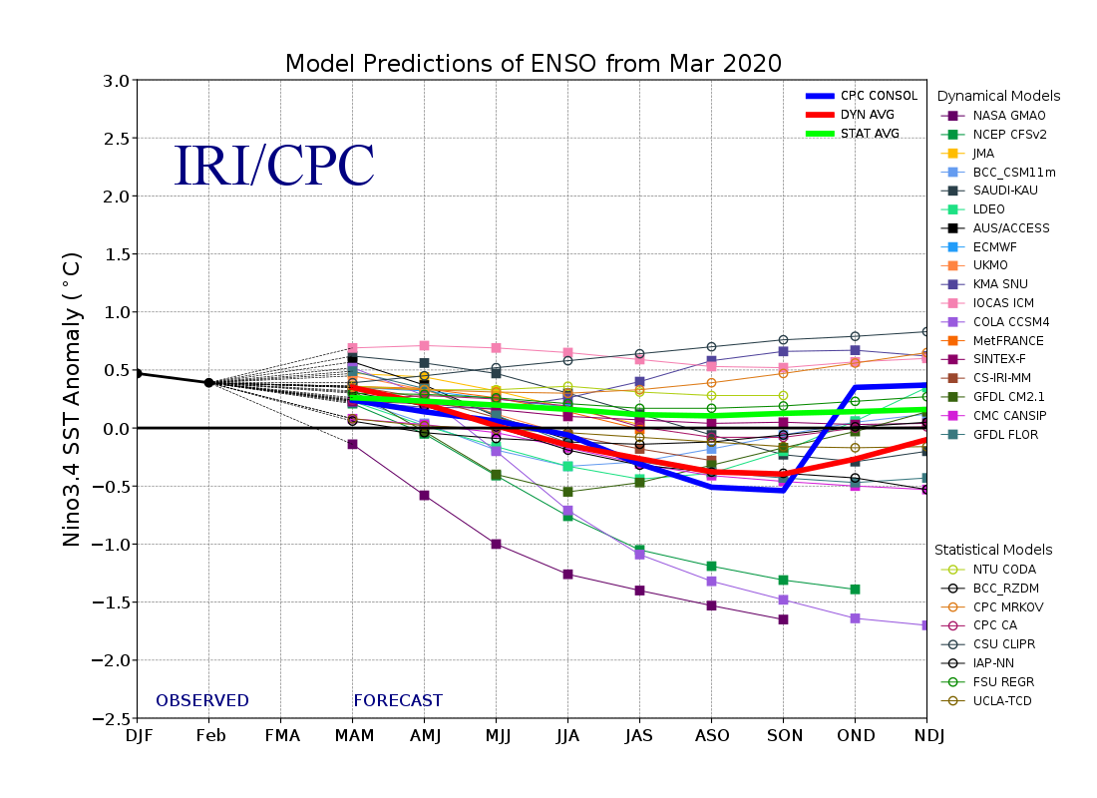
Figure 6. Forecasts of sea surface temperature (SST) anomalies for the Niño 3.4 region (5°N-5°S, 120°W-170°W). Figure updated 19 March 2020.

