EL NIÑO/SOUTHERN OSCILLATION (ENSO) DIAGNOSTIC DISCUSSION

issued by

CLIMATE PREDICTION CENTER/NCEP/NWS

and the International Research Institute for Climate and Society

8 April 2021

ENSO Alert System Status: La Niña Advisory

Synopsis: A transition from La Niña to ENSO-Neutral is likely in the next month or so, with an 80% chance of ENSO-neutral during May-July 2021.

La Niña continued during March, reflected by negative sea surface temperatures (SST) anomalies, which extended across much of the equatorial Pacific Ocean (Fig. 1). SST anomalies weakened but continue to oscillate week-to-week in most of the Niño index regions, particularly in the eastern Pacific Ocean (Fig. 2). Except for Niño-1+2, the latest weekly Niño index values were at or near
-0.5ºC. Sub-surface ocean temperatures also weakened during the month, with the integrated anomalies averaged between the 180-100°W becoming positive during the middle of the month (Fig. 3). Currently, negative subsurface temperature anomalies are present from the surface to approximately ~100m below the surface only in the eastern Pacific between 110°W and 80°W (Fig. 4). Low-level easterly wind anomalies are present but weak across the equatorial Pacific, and are most notable in the far western Pacific. Upper-level wind anomalies were westerly across most of the tropical Pacific. The suppression of tropical convection over the western and central Pacific persisted during March, although the enhancement of rainfall around the Philippines and Indonesia weakened (Fig. 5). The Southern Oscillation and Equatorial Southern Oscillation were weakly positive in March. Overall, the trend in the coupled ocean-atmosphere system is consistent with a weakening La Niña.
Most of the models in the IRI/CPC plume predict a transition to ENSO-neutral during the Northern Hemisphere spring 2021 (Fig. 6). The forecaster consensus agrees that a transition is imminent, with a 50-50% chance of La Niña or ENSO-neutral for the March-May average, and then predicts ENSO-neutral to continue at least through the Northern Hemisphere summer. In part, due to the uncertainty in predictions made at this time of year, the forecast for the Northern Hemisphere Fall 2021 has lower confidence with a 40-50% chance of either La Niña or ENSO-Neutral, with a small chance for El Niño. In summary, a transition from La Niña to ENSO-Neutral is likely in the next month or so, with an 80% chance of ENSO-neutral during May-July 2021 (click CPC/IRI consensus forecast for the chances in each 3-month period).
This discussion is a consolidated effort of the National Oceanic and Atmospheric Administration (NOAA), NOAA’s National Weather Service, and their funded institutions. Oceanic and atmospheric conditions are updated weekly on the Climate Prediction Center web site (El Niño/La Niña Current Conditions and Expert Discussions). Additional perspectives and analysis are also available in an ENSO blog. A probabilistic strength forecast is available here. The next ENSO Diagnostics Discussion is scheduled for 13 May 2021. To receive an e-mail notification when the monthly ENSO Diagnostic Discussions are released, please send an e-mail message to: ncep.list.enso-update@noaa.gov.

Climate Prediction Center
National Centers for Environmental Prediction
NOAA/National Weather Service
College Park, MD 20740

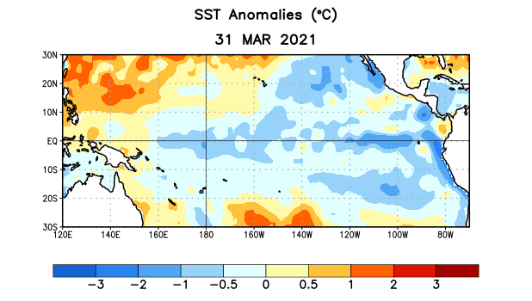
Figure 1. Average sea surface temperature (SST) anomalies (°C) for the week centered on 31 March 2021. Anomalies are computed with respect to the 1991-2020 base period weekly means.

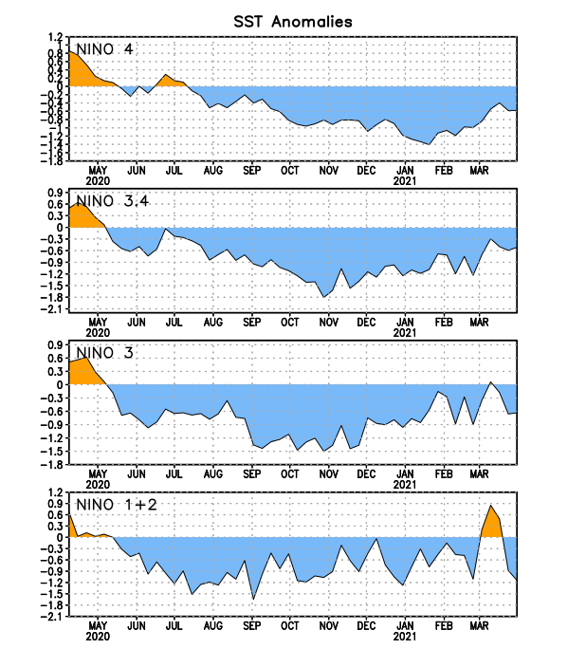
Figure 2. Time series of area-averaged sea surface temperature (SST) anomalies (°C) in the Niño regions [Niño-1+2 (0°-10°S, 90°W-80°W), Niño-3 (5°N-5°S, 150°W-90°W), Niño-3.4 (5°N-5°S, 170°W-120°W), Niño-4 (5ºN-5ºS , 150ºW-160ºE)]. SST anomalies are departures from the 1991-2020 base period weekly means.
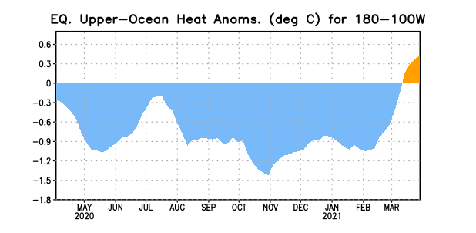
Figure 3. Area-averaged upper-ocean heat content anomaly (°C) in the equatorial Pacific (5°N-5°S, 180º-100ºW). The heat content anomaly is computed as the departure from the 1991-2020 base period pentad means.

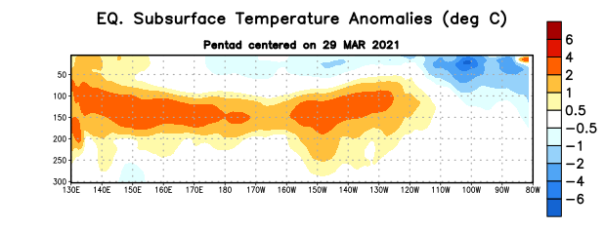
Figure 4. Depth-longitude section of equatorial Pacific upper-ocean (0-300m) temperature anomalies (°C) centered on the pentad of 29 March 2021. Anomalies are departures from the 1991-2020 base period pentad means.

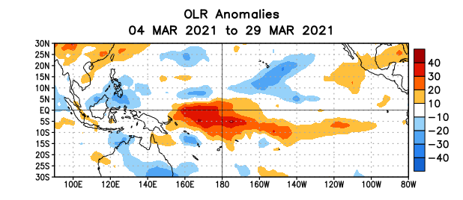
Figure 5. Average outgoing longwave radiation (OLR) anomalies (W/m²) for the period 4 – 29 March 2021. OLR anomalies are computed as departures from the 1981-2010 base period pentad means.

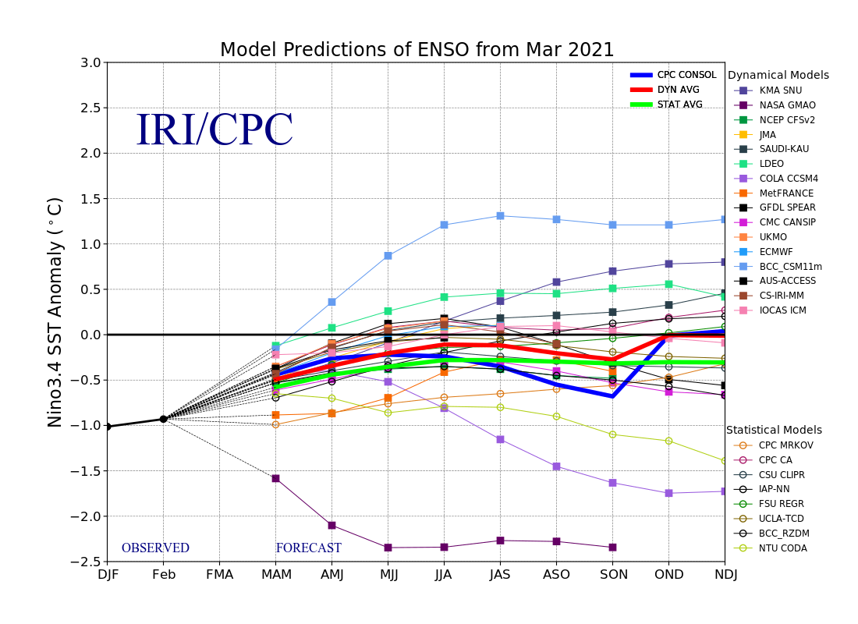
Figure 6. Forecasts of sea surface temperature (SST) anomalies for the Niño 3.4 region (5°N-5°S, 120°W-170°W). Figure updated 19 March 2021.

