EL NIÑO/SOUTHERN OSCILLATION (ENSO) DIAGNOSTIC DISCUSSION

issued by

CLIMATE PREDICTION CENTER/NCEP/NWS

and the International Research Institute for Climate and Society

14 April 2022

ENSO Alert System Status: La Niña Advisory

Synopsis: La Niña is favored to continue through the Northern Hemisphere summer (59% chance during June-August 2022), with a 50-55% chance through the fall.

During March 2022, La Niña continued with below-average sea surface temperatures (SSTs) across the central and eastern equatorial Pacific Ocean (Fig. 1). In the past week, all of the Niño index regions were between -0.7ºC and -1.1ºC (Fig. 2). Subsurface temperatures anomalies (averaged between 180º-100ºW and 0-300m depth) decreased and were negative the entire month (Fig. 3) due to the expansion of below-average temperatures from the surface to 200 meters depth in the east-central equatorial Pacific Ocean (Fig. 4). For the monthly average, low-level easterly wind anomalies prevailed across the western and central Pacific, and upper-level westerly wind anomalies remained over the east-central Pacific. Suppressed convection remained significant around the Date Line and was enhanced over the Philippines and Southeast Asia (Fig. 5). Overall, the coupled ocean-atmosphere system reflected the continuation of La Niña.
The most recent IRI/CPC plume average for the Niño-3.4 SST index forecasts a transition to ENSO-neutral during the Northern Hemisphere summer (Fig. 6). This month, the forecaster consensus predicts Niño-3.4 index values to weaken into the summer but remain below the threshold of La Niña (Niño-3.4 values equal to or less than -0.5ºC). The change in the consensus forecast to slightly favoring the continuation of La Nina is primarily based on recent model runs from the North American Multi-Model Ensemble (NMME) and the persistence of atmosphere-ocean coupling, which remains fairly strong for this time of year. While La Niña is slightly favored through the fall, there is still a considerable amount of uncertainty, given the combined 45-50% chance for ENSO-neutral or El Niño from July-September onwards. In summary, La Niña is favored to continue through the Northern Hemisphere summer (59% chance during June-August 2022), with a 50-55% chance through the fall; click CPC/IRI consensus forecast for the chances in each 3-month period).
This discussion is a consolidated effort of the National Oceanic and Atmospheric Administration (NOAA), NOAA’s National Weather Service, and their funded institutions. Oceanic and atmospheric conditions are updated weekly on the Climate Prediction Center web site (El Niño/La Niña Current Conditions and Expert Discussions). Additional perspectives and analysis are also available in an ENSO blog. A probabilistic strength forecast is available here. The next ENSO Diagnostics Discussion is scheduled for 12 May 2022. To receive an e-mail notification when the monthly ENSO Diagnostic Discussions are released, please send an e-mail message to: ncep.list.enso-update@noaa.gov.

Climate Prediction Center
National Centers for Environmental Prediction
NOAA/National Weather Service
College Park, MD 20740

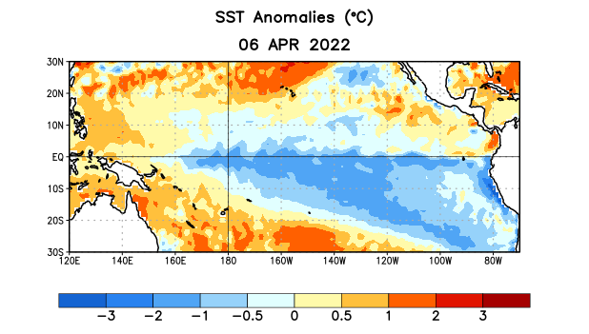
Figure 1. Average sea surface temperature (SST) anomalies (°C) for the week centered on 6 April 2022. Anomalies are computed with respect to the 1991-2020 base period weekly means.

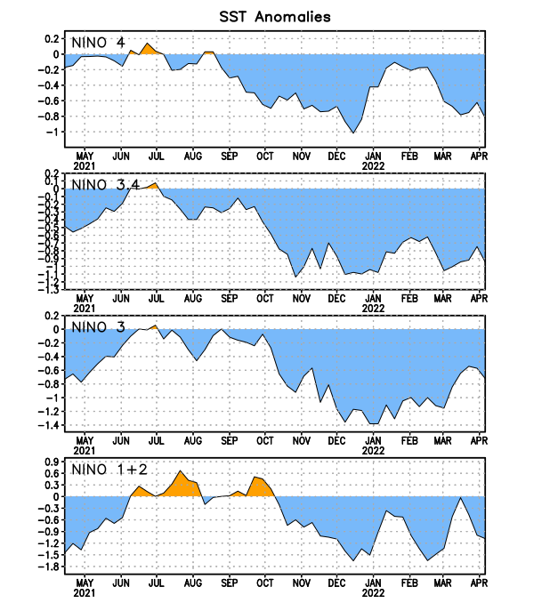
Figure 2. Time series of area-averaged sea surface temperature (SST) anomalies (°C) in the Niño regions [Niño-1+2 (0°-10°S, 90°W-80°W), Niño-3 (5°N-5°S, 150°W-90°W), Niño-3.4 (5°N-5°S, 170°W-120°W), Niño-4 (5ºN-5ºS, 150ºW-160ºE)]. SST anomalies are departures from the 1991-2020 base period weekly means.
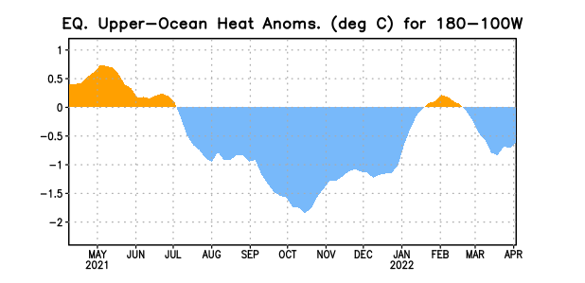
Figure 3. Area-averaged upper-ocean heat content anomaly (°C) in the equatorial Pacific (5°N-5°S, 180º-100ºW). The heat content anomaly is computed as the departure from the 1991-2020 base period pentad means.

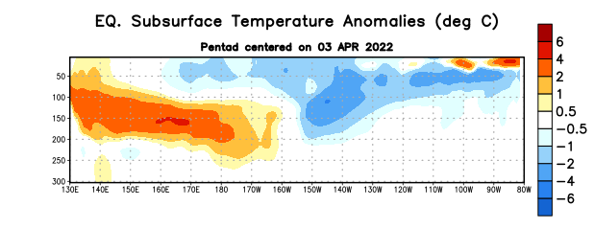

Figure 4. Depth-longitude section of equatorial Pacific upper-ocean (0-300m) temperature anomalies (°C) centered on the pentad of 3 April 2022. Anomalies are departures from the 1991-2020 base period pentad means.

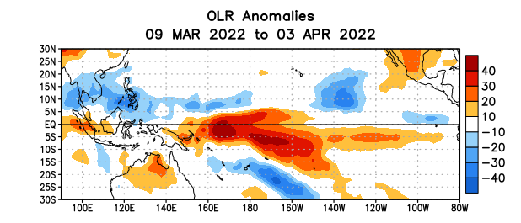

Figure 5. Average outgoing longwave radiation (OLR) anomalies (W/m²) for the period 9 March – 3 April 2022. OLR anomalies are computed as departures from the 1991-2020 base period pentad means.

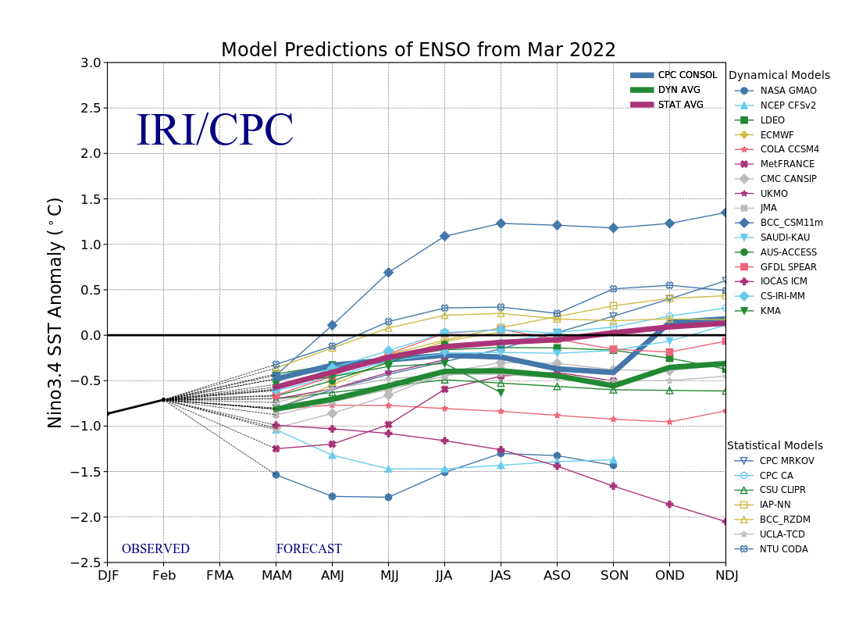
Figure 6. Forecasts of sea surface temperature (SST) anomalies for the Niño 3.4 region (5°N-5°S, 120°W-170°W). Figure updated 18 March 2022.

