EL NIÑO/SOUTHERN OSCILLATION (ENSO) DIAGNOSTIC DISCUSSION

issued by

CLIMATE PREDICTION CENTER/NCEP/NWS

13 April 2023

ENSO Alert System Status: El Niño Watch

Synopsis: ENSO-neutral conditions are expected to continue through the Northern Hemisphere spring, followed by a 62% chance of El Niño developing during May-July 2023.

During the last month, above-average sea surface temperatures (SSTs) became more prominent in the western and far eastern equatorial Pacific Ocean (Fig. 1). The latest weekly Niño-3.4 index value was 0.0ºC, but the Niño1+2 index value was +2.7ºC, indicating significant warming along the South American coast (Fig. 2). Area-averaged subsurface temperatures also increased over the past month (Fig. 3), reflecting the dominance of above-average subsurface temperatures across the equatorial Pacific Ocean (Fig. 4). For the monthly average, upper-level and low-level winds were near normal across most of the equatorial Pacific Ocean. However, low-level westerly wind anomalies were evident in the first half of March associated with sub-seasonal activity. Suppressed convection was evident over the central tropical Pacific and over parts of Indonesia (Fig. 5). While the warming near coastal South America was striking, the basin-wide coupled ocean-atmosphere system was consistent with ENSO-neutral.
The most recent IRI plume favors a transition to El Niño, beginning June-August 2023 and persisting into the winter (Fig. 6). While the lower accuracy of forecasts during the spring can result in surprises, the recent oceanic Kelvin wave plus recurring westerly wind anomalies are anticipated to further warm the tropical Pacific Ocean. The coastal warming in the eastern Pacific may foreshadow changes across the Pacific basin. Therefore, an El Niño Watch has been issued, and the range of possibilities toward the end of the year includes a strong El Niño (4 in 10 chance of Niño-3.4 ≥ 1.5°C) to no El Niño (1 in 10 chance). In summary, ENSO-neutral conditions are expected to continue through the Northern Hemisphere spring, followed by a 62% chance of El Niño developing during May-July 2023 (Fig. 7).
This discussion is a consolidated effort of the National Oceanic and Atmospheric Administration (NOAA), NOAA’s National Weather Service, and their funded institutions. Oceanic and atmospheric conditions are updated weekly on the Climate Prediction Center website (El Niño/La Niña Current Conditions and Expert Discussions). Additional perspectives and analyses are also available in an ENSO blog. A probabilistic strength forecast is available here. The next ENSO Diagnostics Discussion is scheduled for 11 May 2023. To receive an e-mail notification when the monthly ENSO Diagnostic Discussions are released, please send an e-mail message to: ncep.list.enso-update@noaa.gov.

Climate Prediction Center
National Centers for Environmental Prediction
NOAA/National Weather Service
College Park, MD 20740
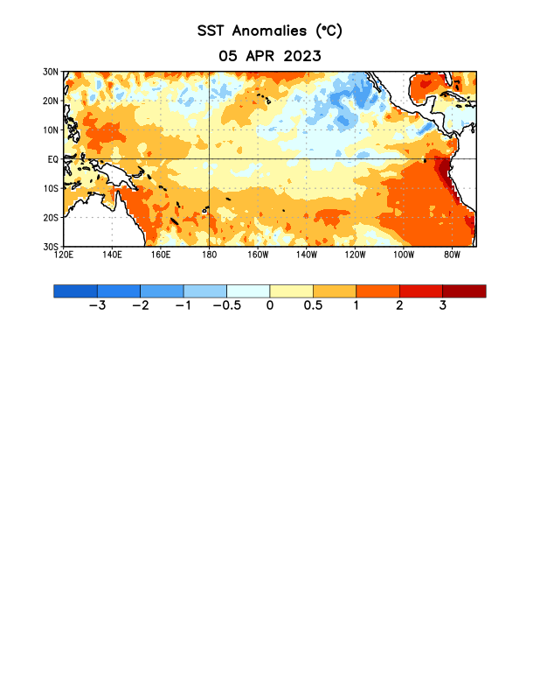
Figure 1. Average sea surface temperature (SST) anomalies (°C) for the week centered on 5 April 2023. Anomalies are computed with respect to the 1991-2020 base period weekly means.

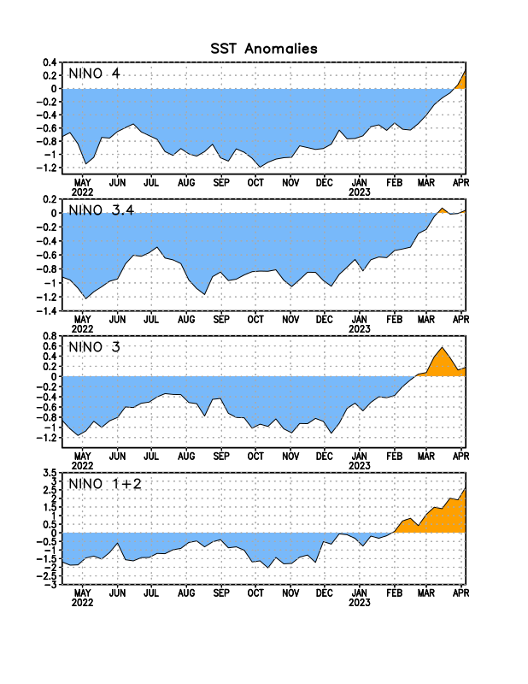
Figure 2. Time series of area-averaged sea surface temperature (SST) anomalies (°C) in the Niño regions [Niño-1+2 (0°-10°S, 90°W-80°W), Niño-3 (5°N-5°S, 150°W-90°W), Niño-3.4 (5°N-5°S, 170°W-120°W), Niño-4 (5ºN-5ºS, 150ºW-160ºE)]. SST anomalies are departures from the 1991-2020 base period weekly means.

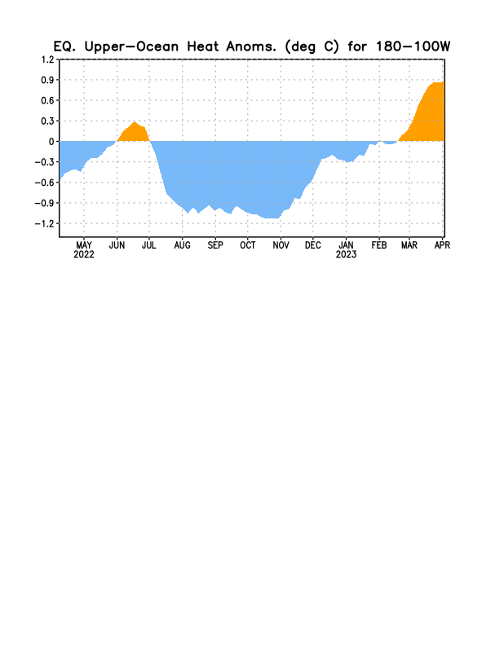

Figure 3. Area-averaged upper-ocean heat content anomaly (°C) in the equatorial Pacific (5°N-5°S, 180º-100ºW). The heat content anomaly is computed as the departure from the 1991-2020 base period pentad means.

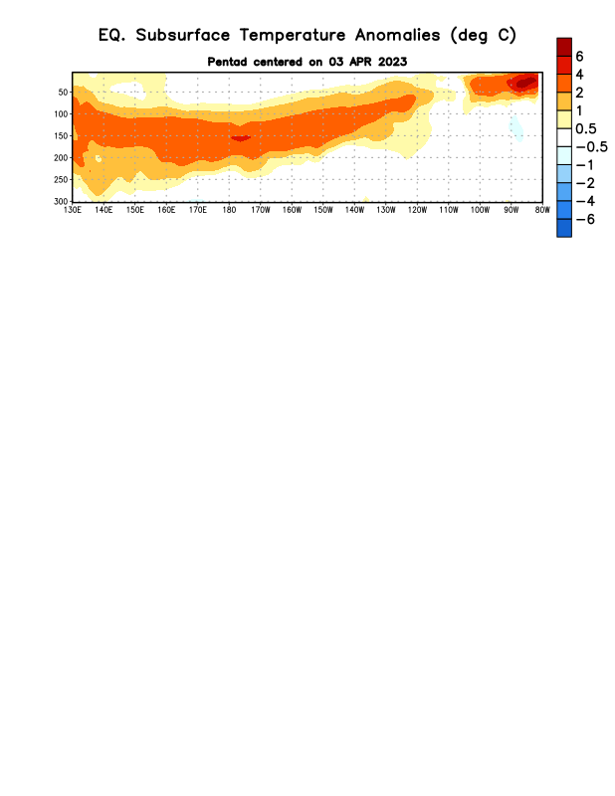
Figure 4. Depth-longitude section of equatorial Pacific upper-ocean (0-300m) temperature anomalies (°C) centered on the pentad of 3 April 2023. Anomalies are departures from the 1991-2020 base period pentad means.

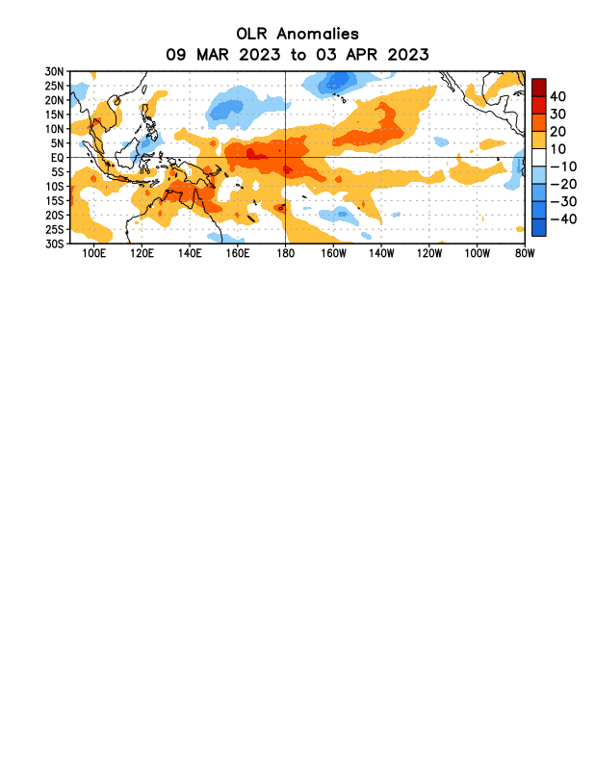

Figure 5. Average outgoing longwave radiation (OLR) anomalies (W/m²) for the period 9 March – 3 April 2023. OLR anomalies are computed as departures from the 1991-2020 base period pentad means.

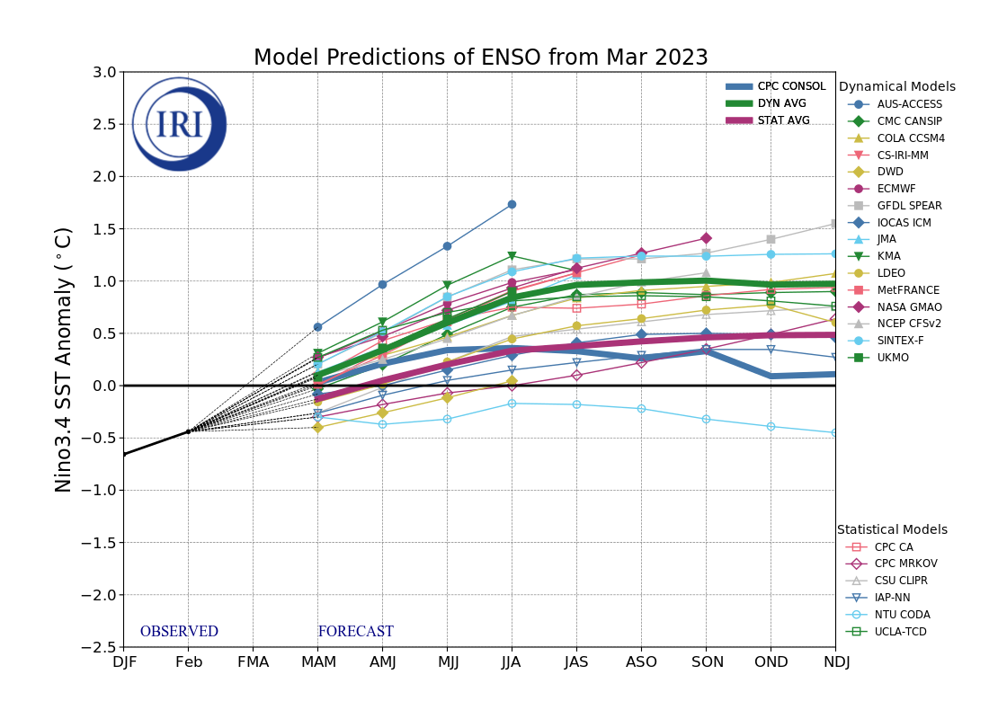
Figure 6. Forecasts of sea surface temperature (SST) anomalies for the Niño 3.4 region (5°N-5°S, 120°W-170°W). Figure updated 20 March 2023 by the International Research Institute (IRI) for Climate and Society.
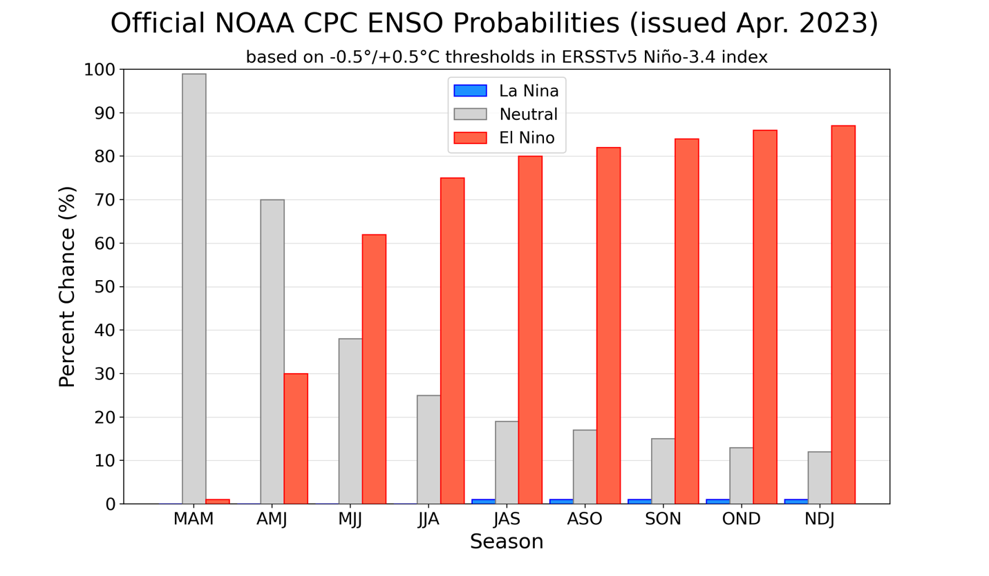
Figure 7. Official ENSO probabilities for the Niño 3.4 sea surface temperature index (5°N-5°S,
120°W-170°W). Figure updated 13 April 2023.

