EL NIÑO/SOUTHERN OSCILLATION (ENSO) DIAGNOSTIC DISCUSSION

issued by

CLIMATE PREDICTION CENTER/NCEP/NWS

11 April 2024

ENSO Alert System Status: El Niño Advisory / La Niña Watch

Synopsis: A transition from El Niño to ENSO-neutral is likely by April-June 2024 (85% chance), with the odds of La Niña developing by June-August 2024 (60% chance).

During March 2024, sea surface temperature (SST) anomalies continued to weaken across most of the equatorial Pacific Ocean. SST anomalies were coolest in the far eastern Pacific Ocean (Fig. 1), with the latest weekly Niño-1+2 value at -0.1°C (Fig. 2). Weekly SST index values in the other Niño regions were between +0.9°C and +1.2°C. Below-average subsurface temperatures strengthened (area-averaged index in Fig. 3), reflecting the expansion of negative subsurface anomalies associated with an upwelling Kelvin wave (Fig. 4). Low-level wind anomalies were easterly over the west-central equatorial Pacific, while upper-level wind anomalies were mostly near average. Equatorial convection was slightly suppressed around the Date Line and was near average around Indonesia (Fig. 5). Collectively, the coupled ocean-atmosphere system reflected the continued weakening of El Niño.
The most recent IRI plume indicates a transition to ENSO-neutral during spring 2024, with La Niña potentially developing during late summer 2024 (Fig. 6). The forecast team continues to favor the dynamical model guidance, which is slightly more accurate than statistical models during this time of year. La Niña tends to follow strong El Niño events, which also provides added confidence in the model guidance favoring La Niña. In summary, a transition from El Niño to ENSO-neutral is likely by April-June 2024 (85% chance), with the odds of La Niña developing by June-August 2024 (60% chance; Fig. 7).
This discussion is a consolidated effort of the National Oceanic and Atmospheric Administration (NOAA), NOAA’s National Weather Service, and their funded institutions. Oceanic and atmospheric conditions are updated weekly on the Climate Prediction Center website (El Niño/La Niña Current Conditions and Expert Discussions). Additional perspectives and analyses are also available in an ENSO blog. A probabilistic strength forecast is available here. The next ENSO Diagnostics Discussion is scheduled for 9 May 2024. To receive an e-mail notification when the monthly ENSO Diagnostic Discussions are released, please send an e-mail message to: ncep.list.enso-update@noaa.gov.

Climate Prediction Center
National Centers for Environmental Prediction
NOAA/National Weather Service
College Park, MD 20740
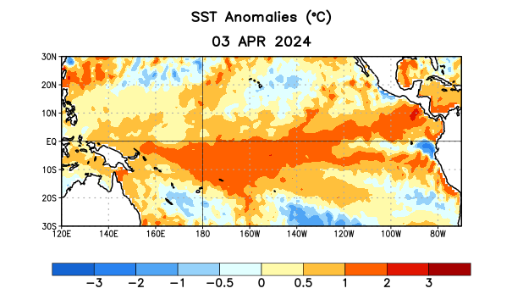
Figure 1. Average sea surface temperature (SST) anomalies (°C) for the week centered on 3 April 2024. Anomalies are computed with respect to the 1991-2020 base period weekly means.

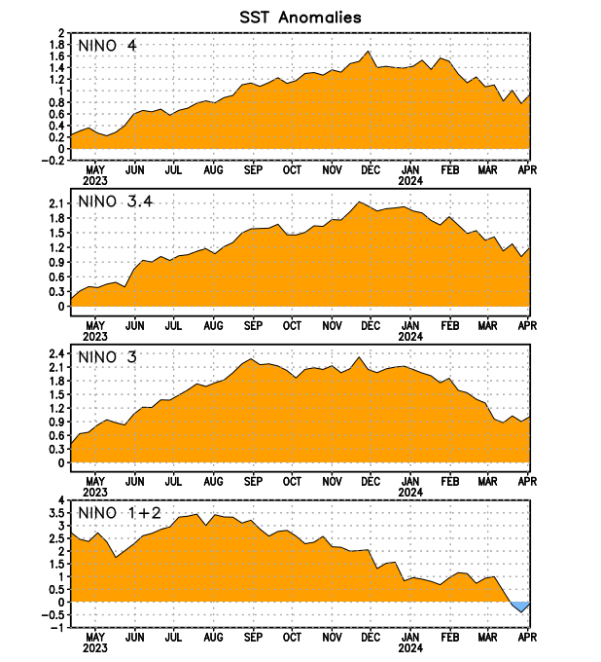
Figure 2. Time series of area-averaged sea surface temperature (SST) anomalies (°C) in the Niño regions [Niño-1+2 (0°-10°S, 90°W-80°W), Niño-3 (5°N-5°S, 150°W-90°W), Niño-3.4 (5°N-5°S, 170°W-120°W), Niño-4 (5ºN-5ºS, 150ºW-160ºE)]. SST anomalies are departures from the 1991-2020 base period weekly means.

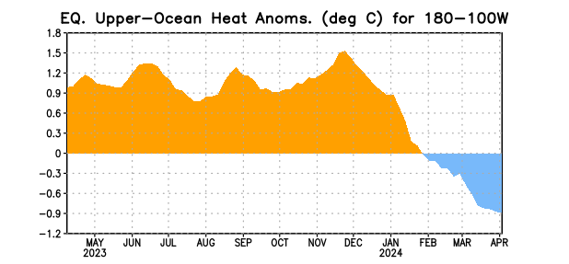

Figure 3. Area-averaged upper-ocean heat content anomaly (°C) in the equatorial Pacific (5°N-5°S, 180º-100ºW). The heat content anomaly is computed as the departure from the 1991-2020 base period pentad means.

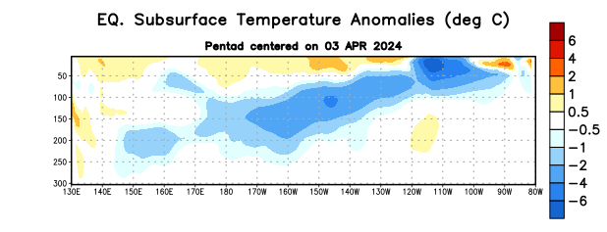
Figure 4. Depth-longitude section of equatorial Pacific upper-ocean (0-300m) temperature anomalies (°C) centered on the pentad of 3 April 2024. Anomalies are departures from the 1991-2020 base period pentad means.

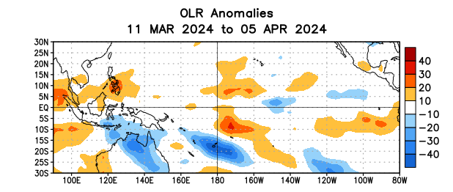

Figure 5. Average outgoing longwave radiation (OLR) anomalies (W/m²) for the period 11 March – 5 April 2024. OLR anomalies are computed as departures from the 1991-2020 base period pentad means.

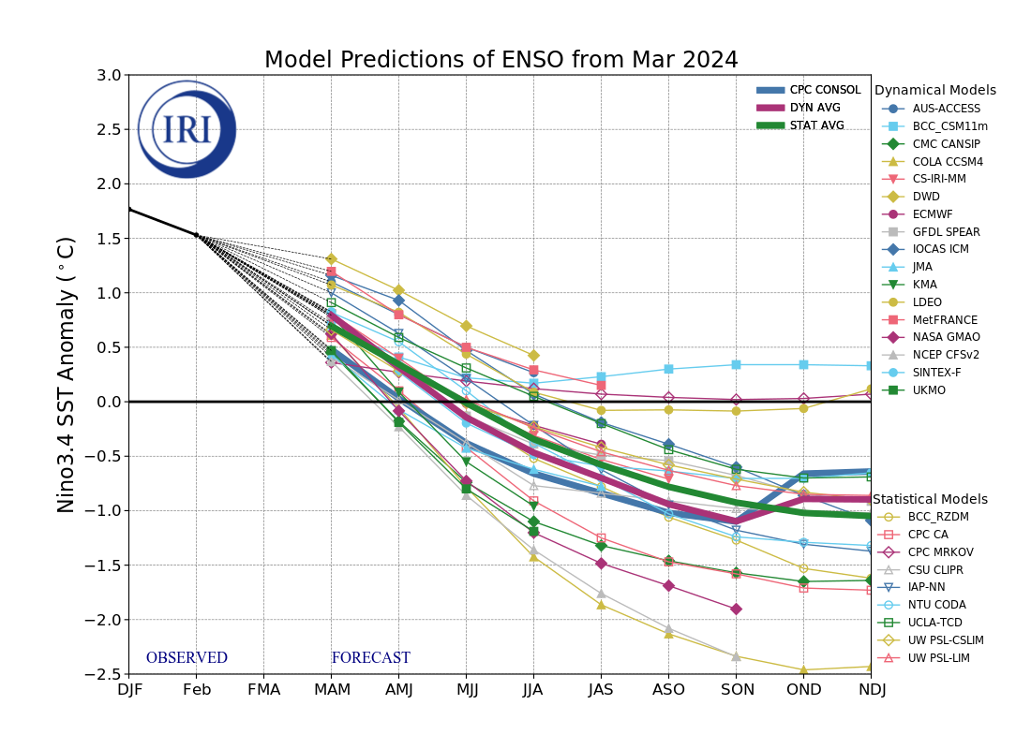
Figure 6. Forecasts of sea surface temperature (SST) anomalies for the Niño 3.4 region (5°N-5°S, 120°W-170°W). Figure updated 19 March 2024 by the International Research Institute (IRI) for Climate and Society.
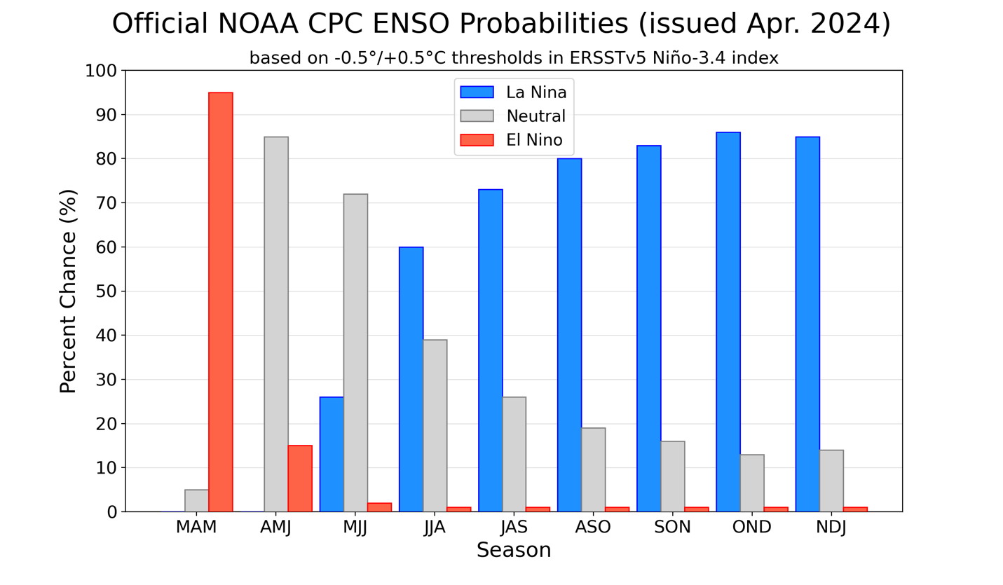
Figure 7. Official ENSO probabilities for the Niño 3.4 sea surface temperature index (5°N-5°S, 120°W-170°W). Figure updated 11 April 2024.

