EL NIÑO/SOUTHERN OSCILLATION (ENSO) DIAGNOSTIC DISCUSSION

issued by

CLIMATE PREDICTION CENTER/NCEP/NWS

10 April 2025

ENSO Alert System Status: Final La Niña Advisory

Synopsis: ENSO-neutral is favored during the Northern Hemisphere summer, with a greater than 50% chance through August-October 2025.

In March 2025, ENSO-neutral conditions returned, with below-average sea surface temperatures (SSTs) weakening in the central and east-central equatorial Pacific Ocean (Fig. 1). The westernmost Niño index values were near zero, while positive index values persisted in the easternmost Niño-3 and Niño-1+2 regions (Fig. 2). Below-average subsurface temperatures weakened (Fig. 3), but negative anomalies continued in the central equatorial Pacific, extending to 250m depth (Fig. 4). A shallow layer of above-average subsurface temperatures continued in the far eastern equatorial Pacific. Low-level wind anomalies remained easterly over the western and central Pacific, while upper-level wind anomalies were westerly over the central Pacific. Convection was suppressed around the Date Line and was enhanced near Indonesia (Fig. 5). The traditional and equatorial Southern Oscillation indices were positive. Collectively, the coupled ocean-atmosphere system reflected ENSO-neutral conditions.
The IRI and North American multi-model ensemble indicate ENSO-neutral will continue through the summer (Fig. 6). The forecast team also favors ENSO-neutral, with chances well over 50% through summer 2025. Because of reduced forecast accuracy in the spring, the uncertainty increases at longer time horizons, with a 43% chance of ENSO-neutral and a 38% chance of La Niña during November 2025 - January 2026 (chances of El Niño are under 20%). In summary, ENSO-neutral is favored during the Northern Hemisphere summer, with a greater than 50% chance through August-October 2025 (Fig. 7).
This discussion is a consolidated effort of the National Oceanic and Atmospheric Administration (NOAA), NOAA’s National Weather Service, and their funded institutions. Oceanic and atmospheric conditions are updated weekly on the Climate Prediction Center website (El Niño/La Niña Current Conditions and Expert Discussions). Additional perspectives and analyses are also available in an ENSO blog. A probabilistic strength forecast is available here. The next ENSO Diagnostics Discussion is scheduled for 8 May 2025. To receive an e-mail notification when the monthly ENSO Diagnostic Discussions are released, please send an e-mail message to: ncep.list.enso-update@noaa.gov.

Climate Prediction Center
National Centers for Environmental Prediction
NOAA/National Weather Service
College Park, MD 20740

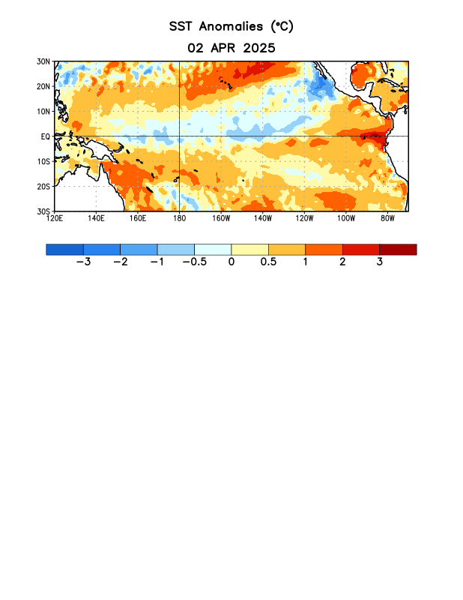
Figure 1. Average sea surface temperature (SST) anomalies (°C) for the week centered on 2 April 2025. Anomalies are computed with respect to the 1991-2020 base period weekly means.

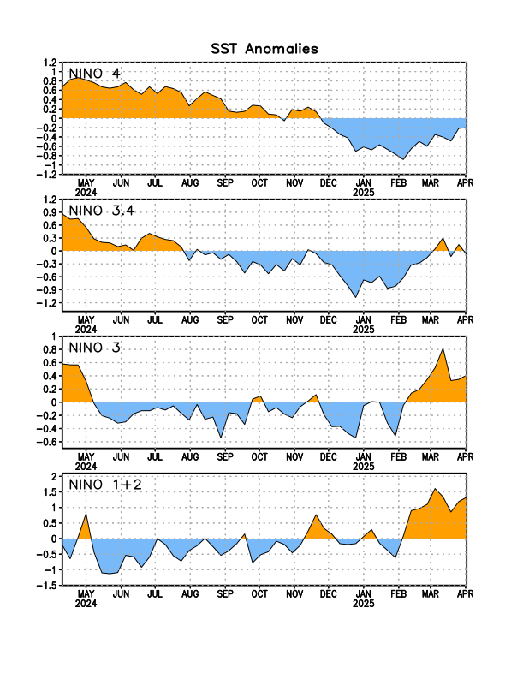
Figure 2. Time series of area-averaged sea surface temperature (SST) anomalies (°C) in the Niño regions [Niño-4 (5ºN-5ºS, 150ºW-160ºE), Niño-3.4 (5°N-5°S, 170°W-120°W), Niño-3 (5°N-5°S, 150°W-90°W), Niño-1+2 (0°-10°S, 90°W-80°W)]. SST anomalies are departures from the 1991-2020 base period weekly means.

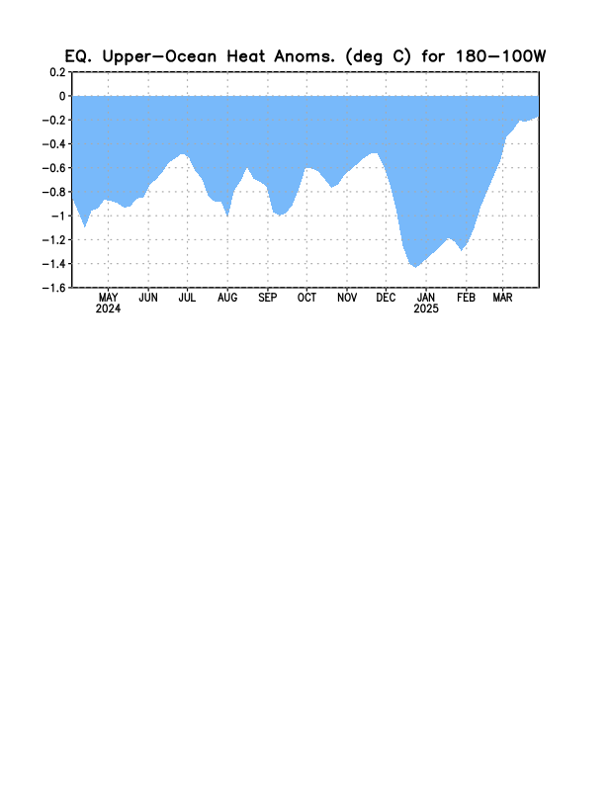
Figure 3. Area-averaged upper-ocean heat content anomaly (°C) in the equatorial Pacific (5°N-5°S, 180º-100ºW). The heat content anomaly is computed as the departure from the 1991-2020 base period pentad means.

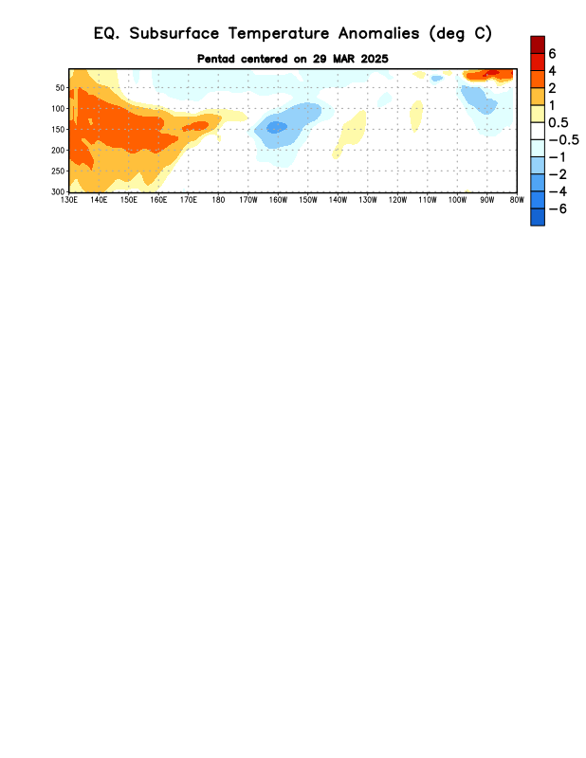
Figure 4. Depth-longitude section of equatorial Pacific upper-ocean (0-300m) temperature anomalies (°C) centered on the pentad of 29 March 2025. Anomalies are departures from the 1991-2020 base period pentad means.

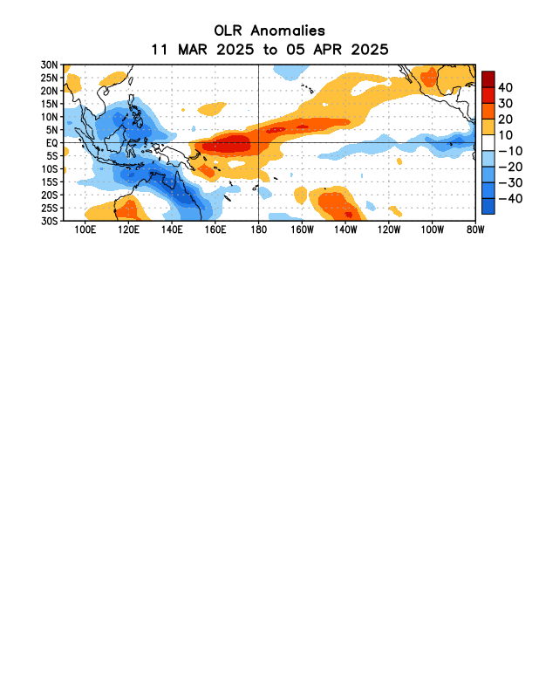
Figure 5. Average outgoing longwave radiation (OLR) anomalies (W/m²) for the period 11 March – 5 April 2025. OLR anomalies are computed as departures from the 1991-2020 base period pentad means. 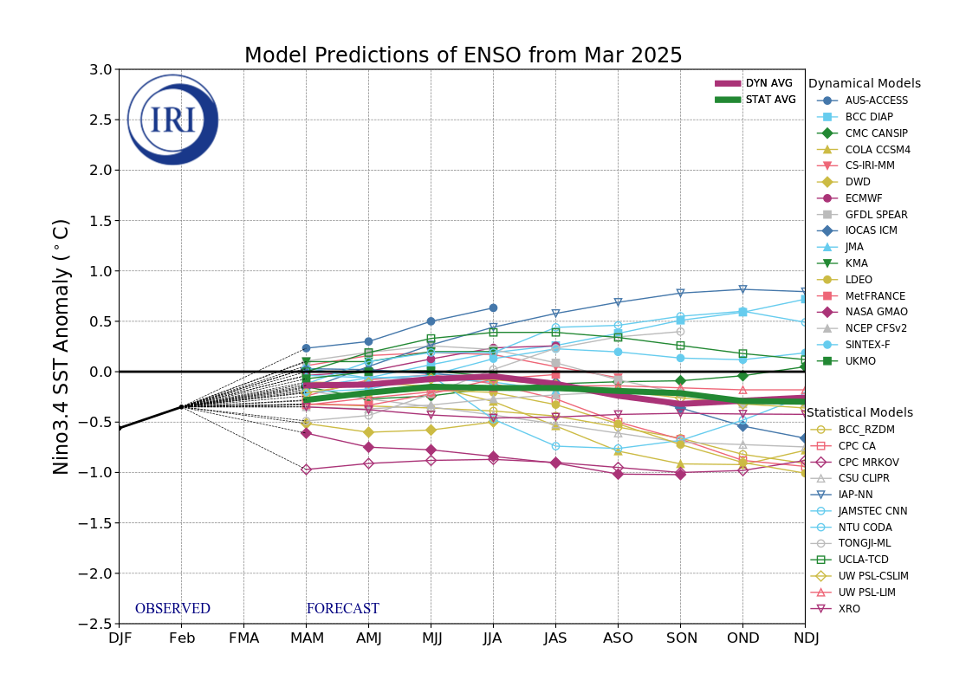Figure 6. Forecasts of sea surface temperature (SST) anomalies for the Niño 3.4 region (5°N-5°S, 120°W-170°W). Figure updated 19 March 2025 by the International Research Institute (IRI) for Climate and Society.

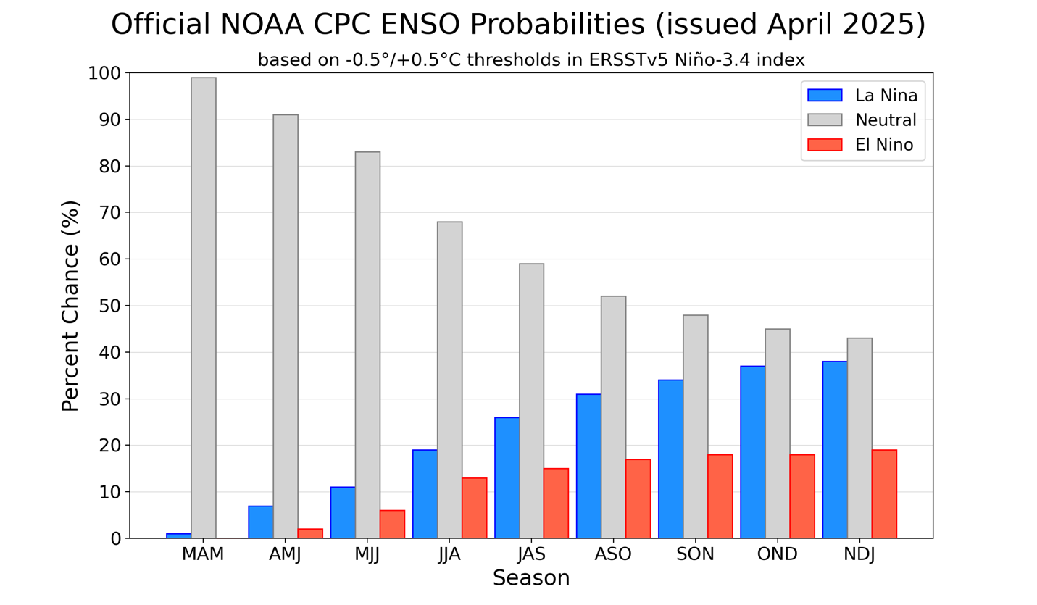
Figure 7. Official ENSO probabilities for the Niño 3.4 sea surface temperature index (5°N-5°S, 120°W-170°W). Figure updated 10 April 2025.

