EL NIÑO/SOUTHERN OSCILLATION (ENSO) DIAGNOSTIC DISCUSSION
issued by
CLIMATE PREDICTION CENTER/NCEP/NWS
9 August 2007

Synopsis: ENSO-neutral conditions are expected to continue through August 2007, with a slightly greater than 50% chance of La Niña developing during the next couple of months.
ENSO-neutral conditions continued in the tropical Pacific during July 2007, with average to below-average sea surface temperatures (SSTs) extending from the date line to the west coast of South America (Fig. 1). The latest weekly SST departures remained negative in the Niño 1+2 (−1.7ºC), Niño 3 (−1.2 ºC), and Niño 3.4 (−0.5 ºC) regions, and positive in the Niño 4 (+0.2ºC) region (Fig. 2). Thus, while SSTs in the eastern equatorial Pacific have been cooler than average for the last six months, the departures continue to fall short of the threshold for La Niña (3-month running mean value of −0.5 ºC for the Niño 3.4 region: 5°N-5°S, 120-170°W).
Despite not meeting the SST threshold for La Niña, recent atmospheric circulation and tropical convection patterns are consistent with the evolution toward La Niña conditions. For example, the low-level easterly winds remained stronger than average in the west-central equatorial Pacific, convection remained suppressed across most of the equatorial Pacific, and a weak area of enhanced convection covered parts of Indonesia and the far western equatorial Pacific. Also, the upper-ocean heat content (average temperatures in the upper 300 m of the ocean) in the central and east-central equatorial Pacific remained below-average, but the magnitude of the departures continued to exhibit intraseasonal fluctuations (Fig. 3). Collectively, the oceanic and atmospheric conditions reflect a continuation of ENSO-neutral conditions.
Nearly all of the ENSO models predict below-average SSTs in the Niño 3.4 region for the remainder of the year (Fig 4). The spread of the recent model forecasts range from ENSO-neutral to La Niña, with a majority of dynamical models indicating a more immediate transition to La Niña. However, over the last several months, the dynamical models have consistently predicted a stronger and more rapid cooling than has actually occurred. In contrast, a majority of the statistical models indicate a continuation of ENSO-neutral conditions, but some forecast weak La Niña conditions during the fall or winter. When considered collectively, recent atmospheric conditions and model forecasts suggest a slightly greater than 50% chance of La Niña developing during the next couple of months. Historically, the early fall season (August-September-October) has been a critical period for the onset of La Niña events.
This discussion is a consolidated effort of the National Atmospheric and Oceanic Administration (NOAA), NOAA’s National Weather Service, and their funded institutions. Oceanic and atmospheric conditions are updated weekly on the Climate Prediction Center web site (El Niño/La Niña Current Conditions and Expert Discussions). Forecasts for the evolution of El Niño/La Niña are updated monthly in the Forecast Forum section of CPC's Climate Diagnostics Bulletin. The next ENSO Diagnostics Discussion is scheduled for 6 September 2007. To receive an e-mail notification when the monthly ENSO Diagnostic Discussions are released, please send an e-mail message to: ncep.list.enso-update@noaa.gov.
Climate Prediction Center
National Centers for Environmental Prediction
NOAA/National Weather Service
Camp Springs, MD 20746-4304
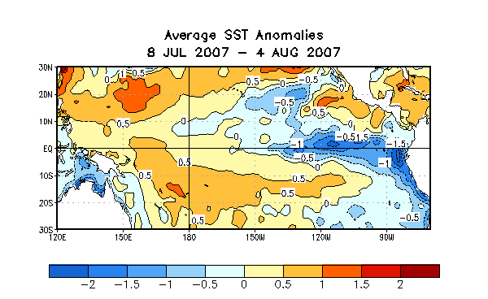
Figure 1. Sea surface temperature (SST) anomalies (°C) during the four-week period 8 July-4 August 2007. SST anomalies are computed with respect to the 1971-2000 base period weekly means (Xue et al. 2003, J. Climate, 16, 1601-1612).

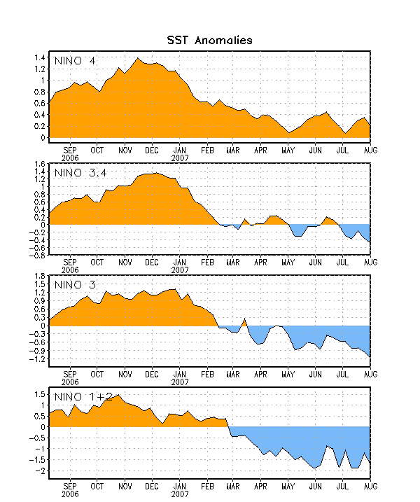
Figure 2. Time series of area-averaged sea surface temperature (SST) anomalies (°C) in the Niño regions [Niño-1+2 (0°-10°S, 90°-80°W), Niño 3 (5°N-5°S, 150°W-90°W), Niño-3.4 (5°N-5°S, 170°W-120°W), Niño-4 (150ºW-160ºE and 5ºN-5ºS)]. SST anomalies are departures are from the 1971-2000 base period means (Xue et al. 2003, J. Climate, 16, 1601-1612).

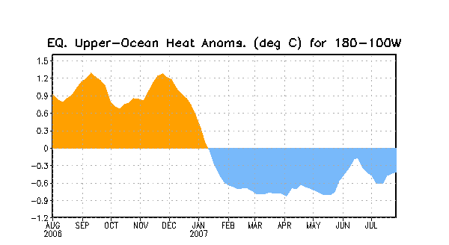

Figure 3. Area-averaged upper-ocean heat content anomalies in the equatorial Pacific (5°N-5°S, 180º-100ºW). Heat content anomalies are computed as departures from the 1982-2004 base period means.

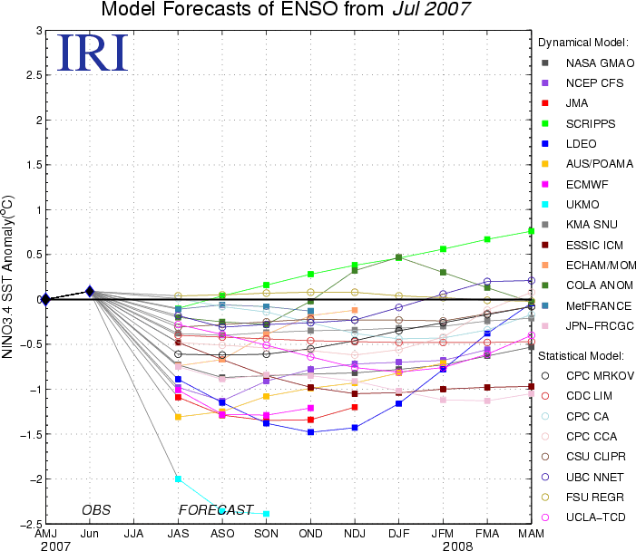
Figure 4. Forecasts of sea surface temperature (SST) anomalies for the Niño 3.4 region (5°N-5°S, 120°W-170°W). Figure courtesy of the International Research Institute (IRI) for Climate and Society.

