EL NIÑO/SOUTHERN OSCILLATION (ENSO) DIAGNOSTIC DISCUSSION
issued by
CLIMATE PREDICTION CENTER/NCEP/NWS
7 August 2008

Synopsis: ENSO-neutral conditions are expected to continue through the Northern Hemisphere Fall 2008.
ENSO-neutral conditions continued during July 2008, as sea surface temperatures (SSTs) in the central equatorial Pacific Ocean remained near-average (Fig. 1, bottom). As is typical with ENSO-neutral conditions, atmospheric and oceanic indicators were mixed, with certain areas in the equatorial Pacific Ocean suggesting a lingering influence of La Niña and others reflecting an increase in above-average temperatures, particularly in the eastern Pacific.
From west to east, the latest weekly SST index values range from −0.3°C in the Niño-4 region to +0.9°C in the Niño 1+2 region (Fig. 2). The subsurface oceanic heat content (average temperatures in the upper 300m of the ocean, Fig. 3) has also increased in response to positive temperature anomalies along the thermocline (Fig. 4). However, a weak, shallow region of below-average temperatures still remains near the International Date Line.
The atmospheric circulation over the western and central tropical Pacific continues to reflect some aspects of La Niña. Enhanced low-level easterly winds and upper-level westerly winds persist in this region, while convection remains generally suppressed over the central Pacific. In contrast, the eastern equatorial Pacific features weak-to-average low-level easterly winds and average precipitation. Despite recent increases in SST anomalies, the actual SSTs are not warm enough to support convection (Fig. 1, top). Collectively, these atmospheric and oceanic anomalies are consistent with ENSO-neutral conditions.
Most of the recent dynamical and statistical SST forecasts for the Niño 3.4 region indicate ENSO-neutral conditions (−0.5 to 0.5 in the Niño-3.4 region) will continue into the Northern Hemisphere Spring 2009 (Fig. 5). However, due to the positive heat content anomalies in the Pacific Ocean, the development of El Niño cannot be ruled out during the later part of the year, although chances remain low. Based on current atmospheric and oceanic conditions, recent trends, and model forecasts, ENSO-neutral conditions are expected to continue through the Northern Hemisphere Fall 2008.
This discussion is a consolidated effort of the National Atmospheric and Oceanic Administration (NOAA), NOAA’s National Weather Service, and their funded institutions. Oceanic and atmospheric conditions are updated weekly on the Climate Prediction Center web site (El Niño/La Niña Current Conditions and Expert Discussions). Forecasts for the evolution of El Niño/La Niña are updated monthly in the Forecast Forum section of CPC's Climate Diagnostics Bulletin. The next ENSO Diagnostics Discussion is scheduled for 11 September 2008. To receive an e-mail notification when the monthly ENSO Diagnostic Discussions are released, please send an e-mail message to: ncep.list.enso-update@noaa.gov.
Climate Prediction Center
National Centers for Environmental Prediction
NOAA/National Weather Service
Camp Springs, MD 20746-4304

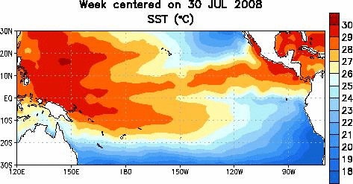

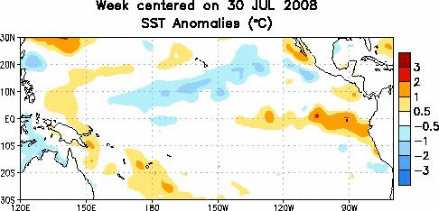

Figure 1. (top) Weekly sea surface temperature (SST) (°C) centered on 30 July 2008.
(bottom) Same as the top except for SST anomalies. Anomalies are computed with respect to the 1971-2000 base period weekly means (Xue et al. 2003, J. Climate, 16, 1601-1612).

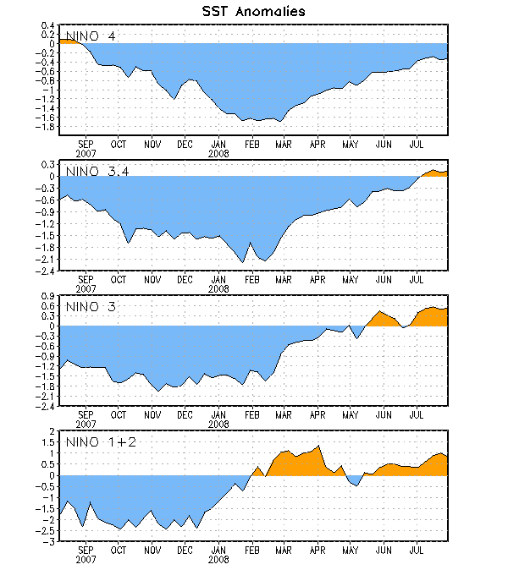

Figure 2. Time series of area-averaged sea surface temperature (SST) anomalies (°C) in the Niño regions [Niño-1+2 (0°-10°S, 90°W-80°W), Niño 3 (5°N-5°S, 150°W-90°W), Niño-3.4 (5°N-5°S, 170°W-120°W), Niño-4 (150ºW-160ºE and 5ºN-5ºS)]. SST anomalies are departures are from the 1971-2000 base period weekly means (Xue et al. 2003, J. Climate, 16, 1601-1612).

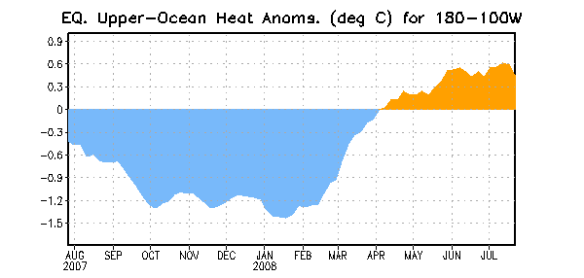
Figure 3. Area-averaged upper-ocean heat content anomalies (°C) in the equatorial Pacific (5°N-5°S, 180º-100ºW). Heat content anomalies are computed as departures from the 1982-2004 base period pentad means.

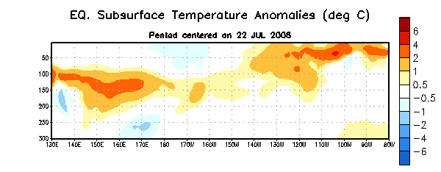
Figure 4. Depth-longitude section of equatorial Pacific upper-ocean (0-300m) temperature anomalies (°C) centered on the week of 22 July 2008. The anomalies are averaged between 5°N-5°S. Anomalies are departures from the 1982-2004 base period pentad means.

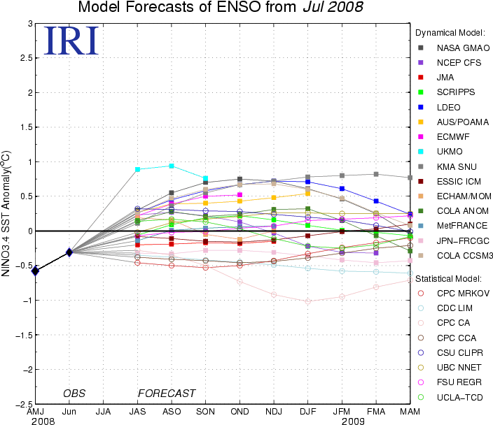

Figure 5. Forecasts of sea surface temperature (SST) anomalies for the Niño 3.4 region (5°N-5°S, 120°W-170°W). Figure courtesy of the International Research Institute (IRI) for Climate and Society. Figure updated 15 July 2008.

