EL NIÑO/SOUTHERN OSCILLATION (ENSO) DIAGNOSTIC DISCUSSION

issued by

CLIMATE PREDICTION CENTER/NCEP/NWS
and the International Research Institute for Climate and Society
9 August 2012

ENSO Alert System Status: El Niño Watch

Synopsis: El Niño conditions are likely to develop during August or September 2012.
ENSO-neutral conditions continued during July 2012 despite above-average sea surface temperatures (SST) across the eastern Pacific Ocean (Fig. 1). Reflecting this warmth, most of the weekly Niño index values remained near or greater than +0.5°C (Fig. 2). The oceanic heat content anomalies (average temperature in the upper 300m of the ocean) also remained elevated during the month (Fig. 3), consistent with a large region of above-average temperatures at depth across the equatorial Pacific (Fig. 4). Although sub-surface and surface temperatures were above average, many aspects of the tropical atmosphere were inconsistent with El Niño conditions. Upper-level and low-level trade winds were near average along the equator, while tropical convection remained enhanced over Indonesia (Fig. 5). However, convection increased near and just west of the International Date Line, which may eventually reflect a progression towards El Niño. The lack of a clear atmospheric response to the positive oceanic anomalies indicates ongoing ENSO-neutral conditions.
Nearly all of the dynamical models favor the onset of El Niño beginning in July- September 2012 (Fig. 6). As in previous months, several statistical models predict ENSO-neutral conditions through the remainder of the year, but the average statistical forecast of Niño-3.4 increased compared to last month. Supported by model forecasts and the continued warmth across the Pacific Ocean, there is increased confidence for a weak-to-moderate El Niño during the Northern Hemisphere fall and winter 2012-13. El Niño conditions are likely to develop during August or September 2012 (see CPC/IRI consensus forecast).
This discussion is a consolidated effort of the National Oceanic and Atmospheric Administration (NOAA), NOAA’s National Weather Service, and their funded institutions. Oceanic and atmospheric conditions are updated weekly on the Climate Prediction Center web site (El Niño/La Niña Current Conditions and Expert Discussions). Forecasts for the evolution of El Niño/La Niña are updated monthly in the Forecast Forum section of CPC's Climate Diagnostics Bulletin. The next ENSO Diagnostics Discussion is scheduled for 6 September 2012. To receive an e-mail notification when the monthly ENSO Diagnostic Discussions are released, please send an e-mail message to: ncep.list.enso-update@noaa.gov.
Climate Prediction Center
National Centers for Environmental Prediction
NOAA/National Weather Service
Camp Springs, MD 20746-4304

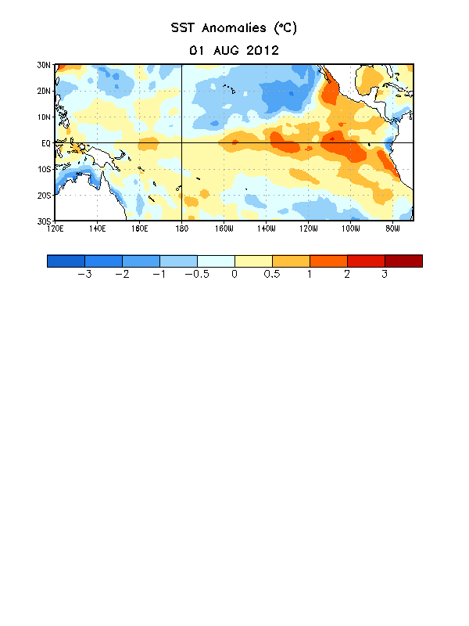
Figure 1. Average sea surface temperature (SST) anomalies (°C) for the week centered on 1 August 2012. Anomalies are computed with respect to the 1981-2010 base period weekly means.

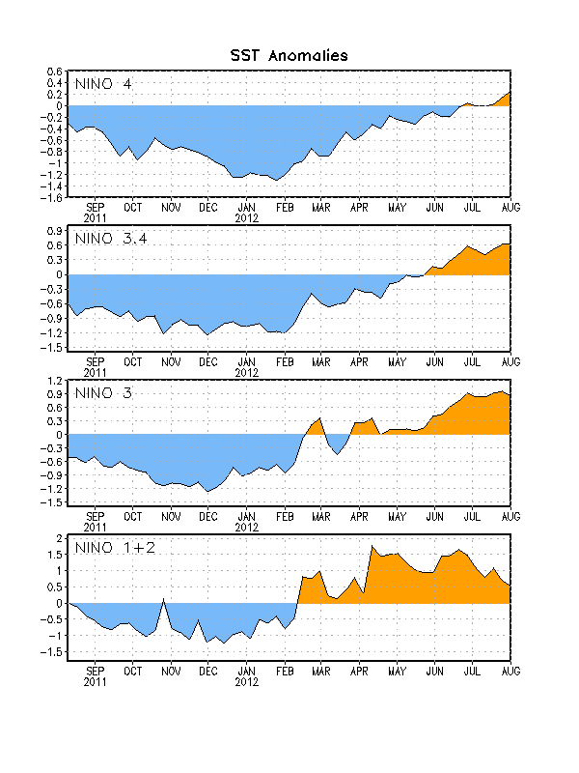
Figure 2. Time series of area-averaged sea surface temperature (SST) anomalies (°C) in the Niño regions [Niño-1+2 (0°-10°S, 90°W-80°W), Niño 3 (5°N-5°S, 150°W-90°W), Niño-3.4 (5°N-5°S, 170°W-120°W), Niño-4 (150ºW-160ºE and 5ºN-5ºS)]. SST anomalies are departures from the 1981-2010 base period weekly means.

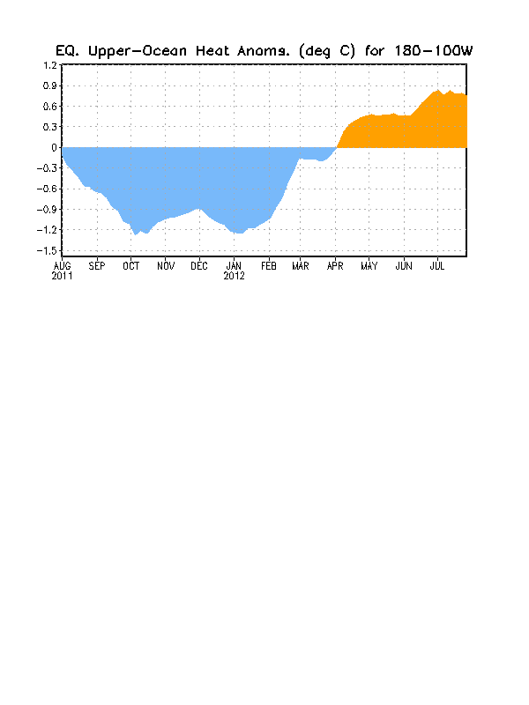
Figure 3. Area-averaged upper-ocean heat content anomaly (°C) in the equatorial Pacific (5°N-5°S, 180º-100ºW). The heat content anomaly is computed as the departure from the 1982-2010 base period pentad means.

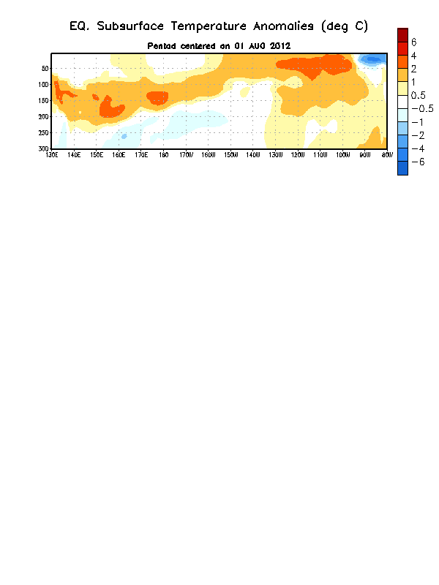
Figure 4. Depth-longitude section of equatorial Pacific upper-ocean (0-300m) temperature anomalies (°C) centered on the pentad of 1 August 2012. The anomalies are averaged between 5°N-5°S. Anomalies are departures from the 1982-2010 base period pentad means.

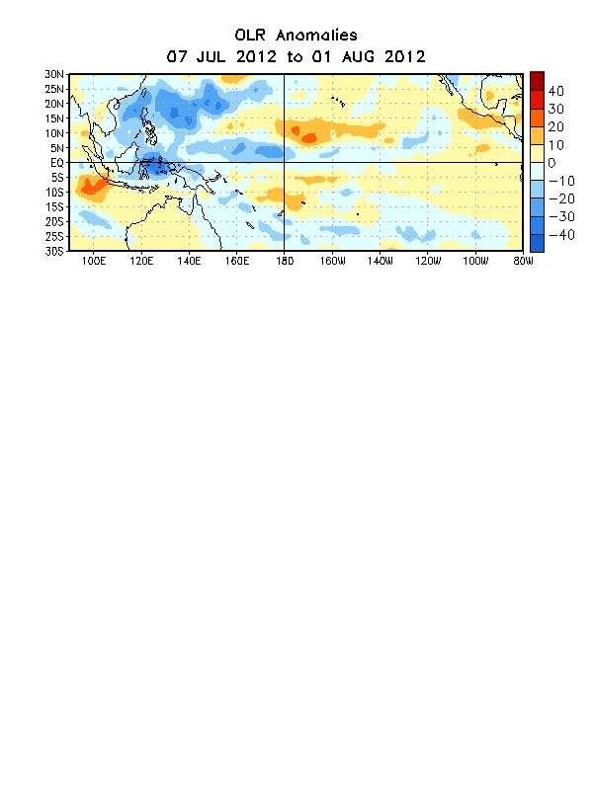

Figure 5. Average outgoing longwave radiation (OLR) anomalies (W/m²) for the four-week period 7 July – 1 August 2012. OLR anomalies are computed as departures from the 1979-1995 base period pentad means.

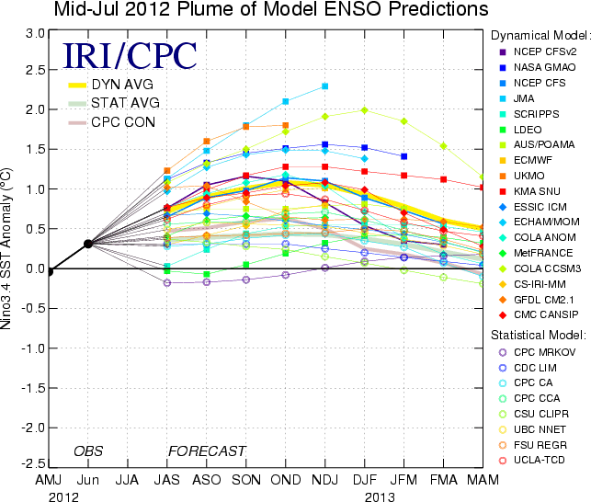
Figure 6. Forecasts of sea surface temperature (SST) anomalies for the Niño 3.4 region (5°N-5°S, 120°W-170°W). Figure courtesy of the International Research Institute (IRI) for Climate and Society. Figure updated 19 July 2012.

