EL NIÑO/SOUTHERN OSCILLATION (ENSO) DIAGNOSTIC DISCUSSION

issued by

CLIMATE PREDICTION CENTER/NCEP/NWS
and the International Research Institute for Climate and Society
8 August 2013

ENSO Alert System Status: Not Active

Synopsis: ENSO-neutral is favored into the Northern Hemisphere fall 2013.
ENSO-neutral conditions persisted during July 2013, as reflected by near-average sea surface temperatures (SSTs) across the central and east-central equatorial Pacific and below-average SSTs in the eastern Pacific (Fig. 1). Consistent with this pattern, weekly Niño-4 and Niño-3.4 values were between -0.5° and 0°C, while Niño-3 and Niño-1+2 indices remained cooler than -0.5°C (Fig. 2). The oceanic heat content (average temperature in the upper 300m of the ocean) anomalies continued to be slightly above average during July (Fig. 3), due to the persistence of above-average sub-surface temperatures in most of the eastern half of the Pacific (Fig. 4). The low-level winds remained near average across the equatorial Pacific, while weak upper-level westerly anomalies persisted in the western Pacific. Convection continued to be enhanced over Indonesia and suppressed in the central part of the basin (Fig. 5). Collectively, these atmospheric and oceanic conditions reflect ENSO-neutral.
Most model forecasts continue to predict ENSO-neutral (Niño-3.4 index between -0.5°C and 0.5°C) into the Northern Hemisphere spring 2014 (Fig. 6). The statistical model forecasts remain cooler in the Niño-3.4 region relative to the dynamical model forecasts. Similar to last month, the forecast consensus favors ENSO-neutral (60% chance or greater) through October – December 2013 (see CPC/IRI consensus forecast).
This discussion is a consolidated effort of the National Oceanic and Atmospheric Administration (NOAA), NOAA’s National Weather Service, and their funded institutions. Oceanic and atmospheric conditions are updated weekly on the Climate Prediction Center web site (El Niño/La Niña Current Conditions and Expert Discussions). Forecasts for the evolution of El Niño/La Niña are updated monthly in the Forecast Forum section of CPC's Climate Diagnostics Bulletin. The next ENSO Diagnostics Discussion is scheduled for 5 September 2013. To receive an e-mail notification when the monthly ENSO Diagnostic Discussions are released, please send an e-mail message to: ncep.list.enso-update@noaa.gov.
Climate Prediction Center
National Centers for Environmental Prediction
NOAA/National Weather Service
College Park, MD 20740

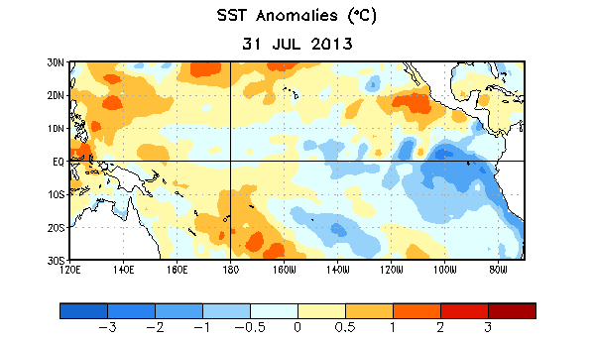
Figure 1. Average sea surface temperature (SST) anomalies (°C) for the week centered on 31 July 2013. Anomalies are computed with respect to the 1981-2010 base period weekly means.

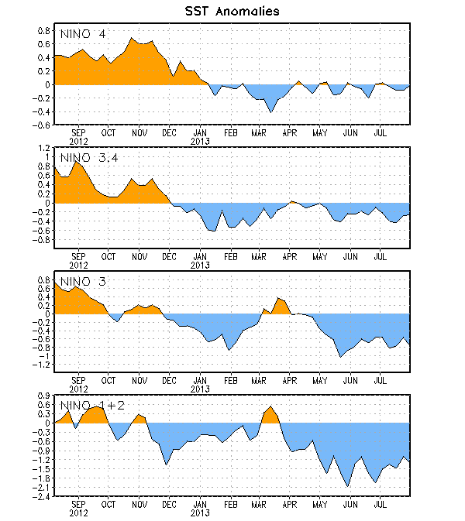
Figure 2. Time series of area-averaged sea surface temperature (SST) anomalies (°C) in the Niño regions [Niño-1+2 (0°-10°S, 90°W-80°W), Niño 3 (5°N-5°S, 150°W-90°W), Niño-3.4 (5°N-5°S, 170°W-120°W), Niño-4 (150ºW-160ºE and 5ºN-5ºS)]. SST anomalies are departures from the 1981-2010 base period weekly means.

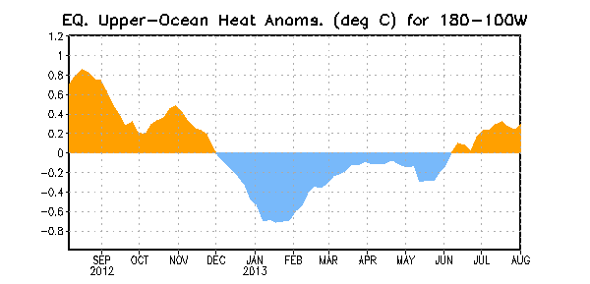
Figure 3. Area-averaged upper-ocean heat content anomaly (°C) in the equatorial Pacific (5°N-5°S, 180º-100ºW). The heat content anomaly is computed as the departure from the 1981-2010 base period pentad means.

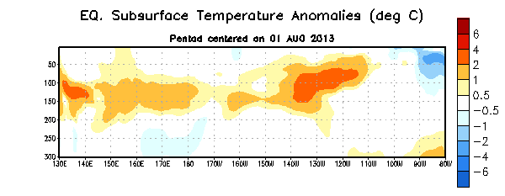
Figure 4. Depth-longitude section of equatorial Pacific upper-ocean (0-300m) temperature anomalies (°C) centered on the pentad of 1 August 2013. The anomalies are averaged between 5°N-5°S. Anomalies are departures from the 1981-2010 base period pentad means.

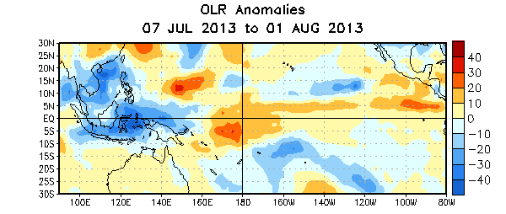

Figure 5. Average outgoing longwave radiation (OLR) anomalies (W/m²) for the four-week period 7 July – 1 August 2013. OLR anomalies are computed as departures from the 1979-1995 base period pentad means.

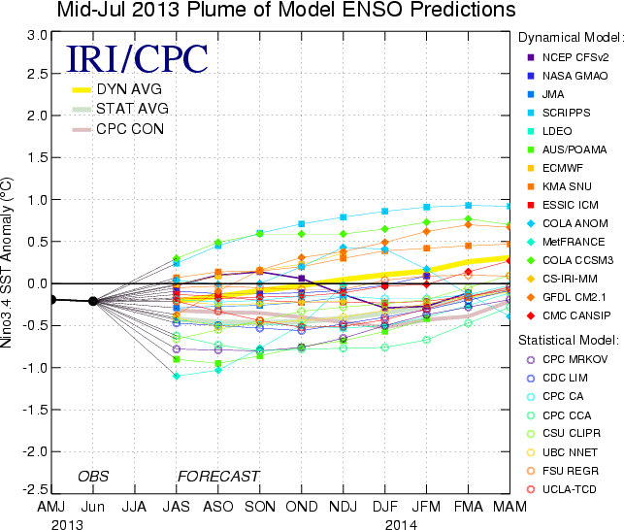
Figure 6. Forecasts of sea surface temperature (SST) anomalies for the Niño 3.4 region (5°N-5°S, 120°W-170°W). Figure courtesy of the International Research Institute (IRI) for Climate and Society. Figure updated 16 July 2013.

