EL NIÑO/SOUTHERN OSCILLATION (ENSO) DIAGNOSTIC DISCUSSION

issued by

CLIMATE PREDICTION CENTER/NCEP/NWS
and the International Research Institute for Climate and Society
11 August 2016

ENSO Alert System Status: La Niña Watch

Synopsis: La Niña is slightly favored to develop during August - October 2016, with about a 55-60% chance of La Niña during the fall and winter 2016-17.
ENSO-neutral conditions were observed during the past month, featuring slightly below average sea surface temperatures (SSTs) close to the equator across the eastern tropical Pacific Ocean (Fig. 1). While the weekly Niño-1+2 and Niño-4 regions were near average, the Niño-3 and Niño-3.4 indices were slightly below average (approaching -0.5ºC) during July (Fig. 2). Although below-average subsurface temperatures continued, they weakened during the past month (Fig. 3) but remained near the surface in parts of the central and eastern equatorial Pacific (Fig. 4). Atmospheric anomalies over the tropical Pacific Ocean also indicated ENSO-neutral conditions. Both the traditional Southern Oscillation index and the equatorial Southern Oscillation index were near average during July, while the upper and lower-level winds also were near average across most of the tropical Pacific. Convection was suppressed over portions of the western and central tropical Pacific and enhanced over part of Indonesia (Fig. 5). Overall, the combined ocean and atmosphere system is reflective of ENSO-neutral.
Many models favor La Niña (3-month average Niño-3.4 index less than or equal to -0.5°C) by the beginning of the Northern Hemisphere fall, continuing into winter (Fig. 6). Statistical models predict a slightly later onset time (i.e., mid- to late fall) than dynamical models, and also predict a slightly weaker event. The forecaster consensus favors La Niña onset during the August-October season, and predicts a weak event (Niño-3.4 index between -0.5°C and -1.0°C) if La Niña forms. Overall, La Niña is slightly favored to develop during August - October 2016, with about a 55-60% chance of La Niña during the fall and winter 2016-17 (click CPC/IRI consensus forecast for the chance of each outcome for each 3-month period).
This discussion is a consolidated effort of the National Oceanic and Atmospheric Administration (NOAA), NOAA’s National Weather Service, and their funded institutions. Oceanic and atmospheric conditions are updated weekly on the Climate Prediction Center web site (El Niño/La Niña Current Conditions and Expert Discussions). Forecasts are also updated monthly in the Forecast Forum of CPC's Climate Diagnostics Bulletin. Additional perspectives and analysis are also available in an ENSO blog. The next ENSO Diagnostics Discussion is scheduled for 8 September 2016. To receive an e-mail notification when the monthly ENSO Diagnostic Discussions are released, please send an e-mail message to: ncep.list.enso-update@noaa.gov.

Climate Prediction Center
National Centers for Environmental Prediction
NOAA/National Weather Service
College Park, MD 20740

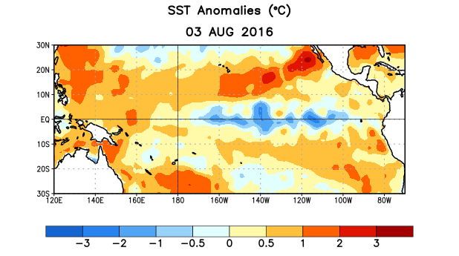
Figure 1. Average sea surface temperature (SST) anomalies (°C) for the week centered on 3 August 2016. Anomalies are computed with respect to the 1981-2010 base period weekly means.

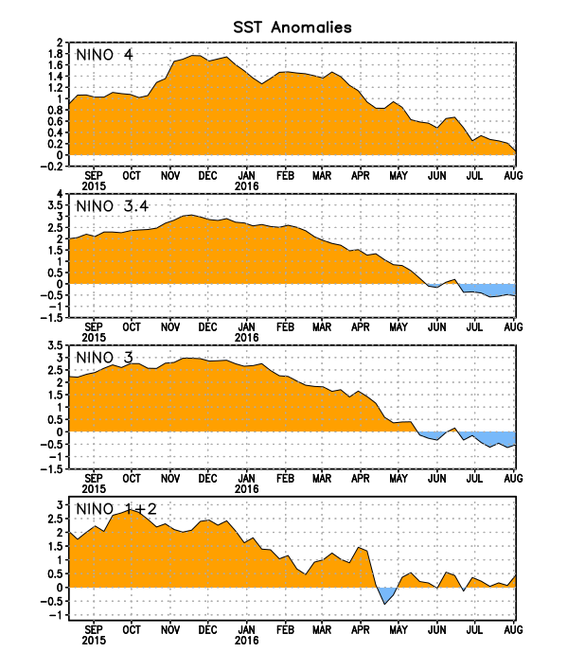
Figure 2. Time series of area-averaged sea surface temperature (SST) anomalies (°C) in the Niño regions [Niño-1+2 (0°-10°S, 90°W-80°W), Niño 3 (5°N-5°S, 150°W-90°W), Niño-3.4 (5°N-5°S, 170°W-120°W), Niño-4 (5ºN-5ºS , 150ºW-160ºE]. SST anomalies are departures from the 1981-2010 base period weekly means.
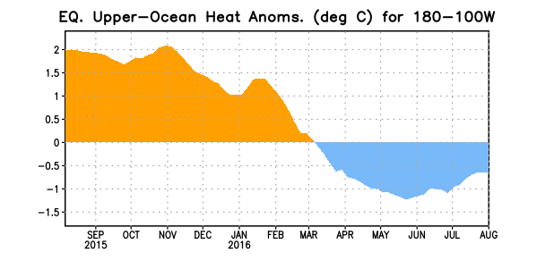
Figure 3. Area-averaged upper-ocean heat content anomaly (°C) in the equatorial Pacific (5°N-5°S, 180º-100ºW). The heat content anomaly is computed as the departure from the 1981-2010 base period pentad means.

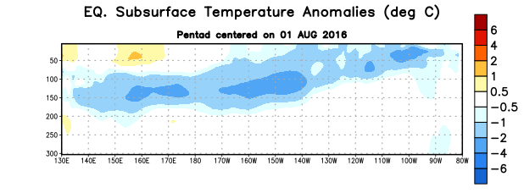
Figure 4. Depth-longitude section of equatorial Pacific upper-ocean (0-300m) temperature anomalies (°C)
centered on the pentad of 1 August 2016. The anomalies are averaged between 5°N-5°S. Anomalies are departures from the 1981-2010 base period pentad means.

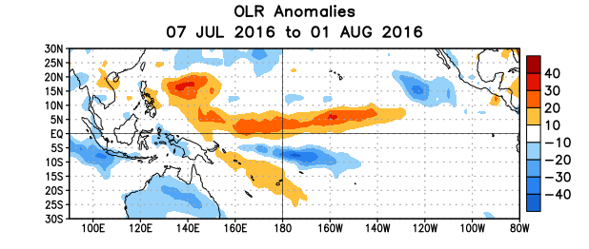
Figure 5. Average outgoing longwave radiation (OLR) anomalies (W/m²) for the period 7 July – 1 August 2016. OLR anomalies are computed as departures from the 1981-2010 base period pentad means.

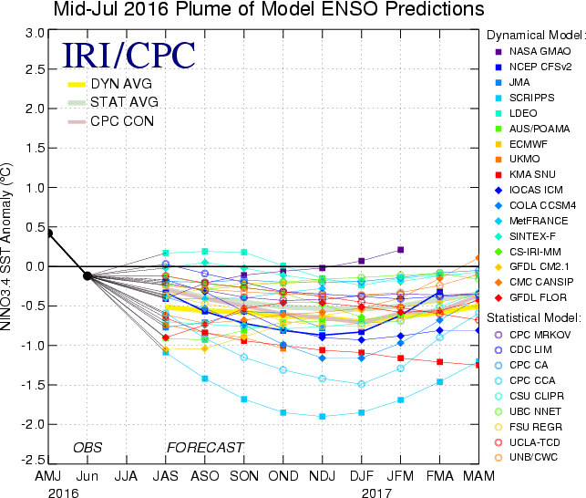
Figure 6. Forecasts of sea surface temperature (SST) anomalies for the Niño 3.4 region (5°N-5°S, 120°W-170°W). Figure updated 18 July 2016.

