EL NIÑO/SOUTHERN OSCILLATION (ENSO) DIAGNOSTIC DISCUSSION

issued by

CLIMATE PREDICTION CENTER/NCEP/NWS
and the International Research Institute for Climate and Society
10 August 2017

ENSO Alert System Status: Not Active

Synopsis: ENSO-neutral is favored (~85% chance during Jul-Sep, decreasing to ~55% during Dec-Feb) through the Northern Hemisphere winter 2017-18.
During July, ENSO-neutral continued, as equatorial sea surface temperatures (SSTs) were near average across most of the Pacific Ocean (Fig. 1). The latest weekly Niño SST index values were close to zero in all four Niño regions (Fig. 2), having recently decreased from higher levels in the Niño-4 and Niño-3.4 regions. The upper-ocean heat content anomaly was near average during July (Fig. 3), reflecting below-average temperatures along the thermocline across the central and eastern Pacific overlain by slightly above-average temperatures (Fig. 4). Tropical convection was near average over the eastern half of the Pacific and enhanced over the western Pacific and the Maritime Continent (Fig. 5). The lower-level trade winds were slightly enhanced near the International Date Line, and upper-level winds were near average over most of the tropical Pacific. Overall, the ocean and atmosphere system remains consistent with ENSO-neutral.

The majority of models favor ENSO-neutral through the remainder of 2017 (Fig. 6). These predictions, along with the demise of the recent Pacific warmth and continued near-average atmospheric conditions over the Pacific, lead forecasters to favor ENSO-neutral through the winter. However, some chance for El Niño (15-20%) or La Niña (25-30%) remains during the winter. Also, ENSO-neutral conditions are predicted for the upcoming peak months (August-October) of the Atlantic hurricane season. In summary, ENSO-neutral is favored (~85% chance during Jul-Sep, decreasing to ~55% during Dec-Feb) through the Northern Hemisphere winter 2017-18 (click CPC/IRI consensus forecast for the chance of each outcome for each 3-month period).

This discussion is a consolidated effort of the National Oceanic and Atmospheric Administration (NOAA), NOAA’s National Weather Service, and their funded institutions. Oceanic and atmospheric conditions are updated weekly on the Climate Prediction Center web site (El Niño/La Niña Current Conditions and Expert Discussions). Forecasts are also updated monthly in the Forecast Forum of CPC's Climate Diagnostics Bulletin. Additional perspectives and analysis are also available in an ENSO blog. The next ENSO Diagnostics Discussion is scheduled for 14 September 2017. To receive an e-mail notification when the monthly ENSO Diagnostic Discussions are released, please send an e-mail message to: ncep.list.enso-update@noaa.gov.

Climate Prediction Center
National Centers for Environmental Prediction
NOAA/National Weather Service
College Park, MD 20740

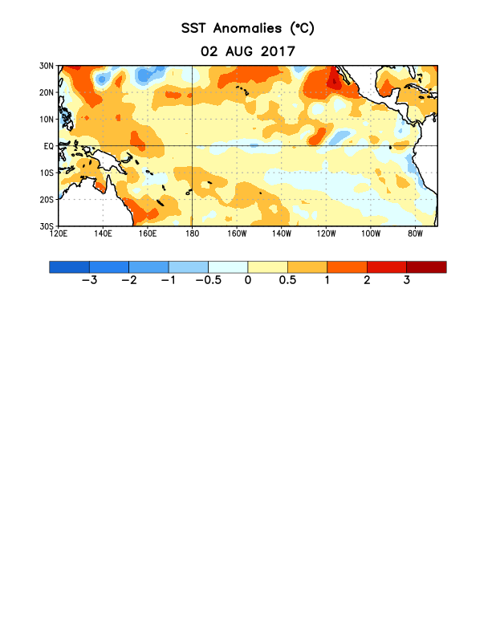
Figure 1. Average sea surface temperature (SST) anomalies (°C) for the week centered on 2 August 2017. Anomalies are computed with respect to the 1981-2010 base period weekly means.

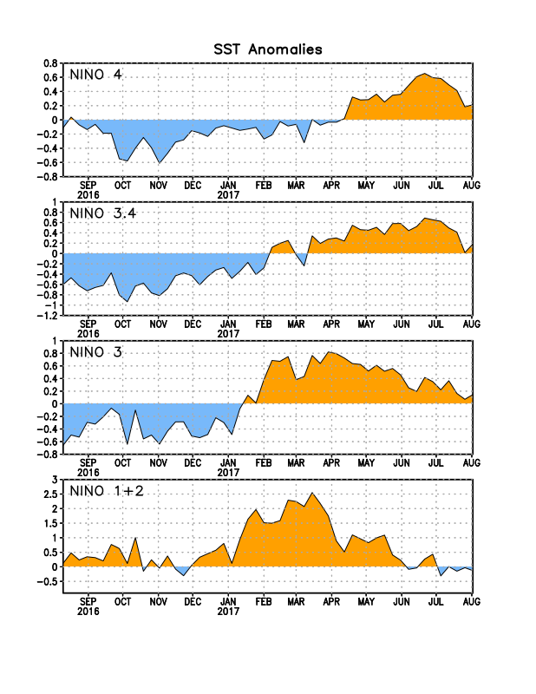
Figure 2. Time series of area-averaged sea surface temperature (SST) anomalies (°C) in the Niño regions [Niño-1+2 (0°-10°S, 90°W-80°W), Niño-3 (5°N-5°S, 150°W-90°W), Niño-3.4 (5°N-5°S, 170°W-120°W), Niño-4 (5ºN-5ºS , 150ºW-160ºE]. SST anomalies are departures from the 1981-2010 base period weekly means.
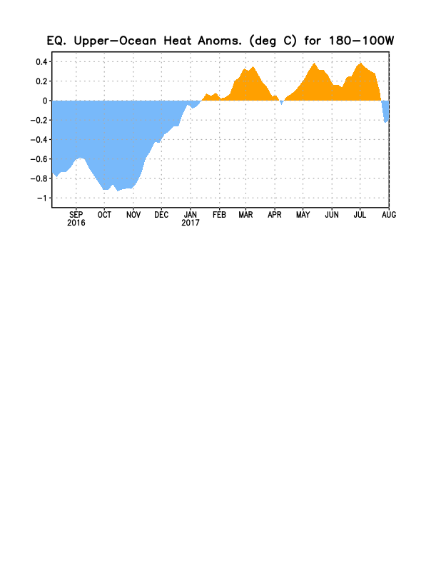
Figure 3. Area-averaged upper-ocean heat content anomaly (°C) in the equatorial Pacific (5°N-5°S, 180º-100ºW). The heat content anomaly is computed as the departure from the 1981-2010 base period pentad means.

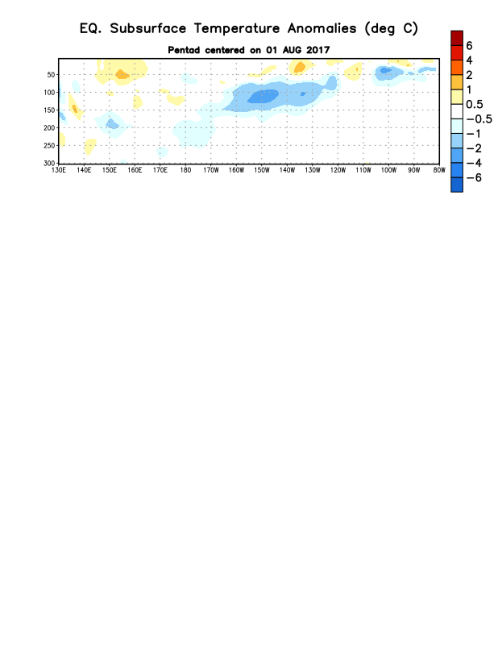
Figure 4. Depth-longitude section of equatorial Pacific upper-ocean (0-300m) temperature anomalies (°C) centered on the pentad of 1 August 2017. Anomalies are departures from the 1981-2010 base period pentad means.

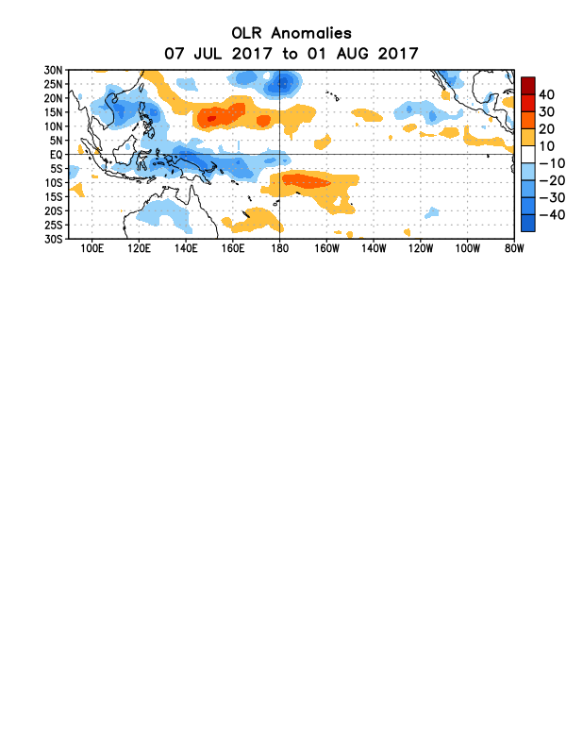
Figure 5. Average outgoing longwave radiation (OLR) anomalies (W/m²) for the period 7 July – 1 August 2017. OLR anomalies are computed as departures from the 1981-2010 base period pentad means.

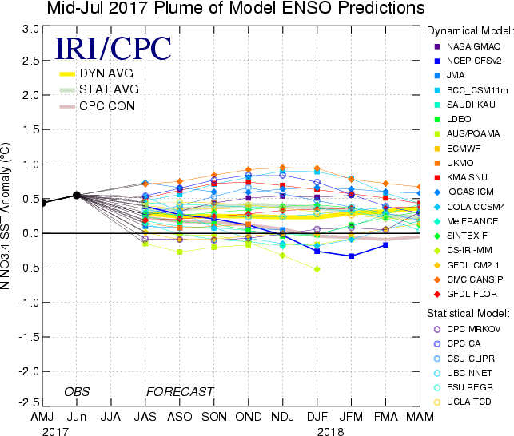

Figure 6. Forecasts of sea surface temperature (SST) anomalies for the Niño 3.4 region (5°N-5°S, 120°W-170°W). Figure updated 19 July 2017.

