EL NIÑO/SOUTHERN OSCILLATION (ENSO) DIAGNOSTIC DISCUSSION

issued by

CLIMATE PREDICTION CENTER/NCEP/NWS

and the International Research Institute for Climate and Society

12 August 2021

ENSO Alert System Status: La Niña Watch

Synopsis: ENSO-neutral is favored for the remainder of summer (~60% chance in the July-September season), with La Niña possibly emerging during the August-October season and lasting through the 2021-22 winter (~70% chance during November-January).

Recently, sea surface temperatures (SSTs) were near-to-below average in the central and east-central equatorial Pacific, with above-average SSTs in the far eastern Pacific (Fig. 1). In the last week, most Niño indices were slightly negative (-0.2ºC to -0.3ºC) except for the Niño-1+2 index, which was +0.7ºC (Fig. 2). Subsurface temperatures cooled considerably in July, becoming quite negative (averaged from 180-100ºW; Fig. 3), reflecting the emergence of below-average subsurface temperatures east of the Date Line (Fig. 4). Low-level wind anomalies were easterly over the east-central Pacific Ocean, while upper-level wind anomalies were westerly across the eastern Pacific. Tropical convection was suppressed over the western Pacific Ocean and enhanced over a small region near Indonesia (Fig. 5). Given the surface conditions, the ocean-atmosphere system reflected ENSO-neutral.
Compared to last month, forecasts from the IRI/CPC plume are generally cooler in the Niño-3.4 SST region during the fall and winter 2021-22 (Fig. 6). Recent model runs from the NCEP CFSv2 and the North American Multi-Model Ensemble suggest the onset of a weak La Niña in the coming months, persisting through winter 2021-22. The forecaster consensus continues to favor these models, which is also supported by the noticeable decrease in the observed subsurface temperature anomalies this past month. In summary, ENSO-neutral is favored for the remainder of summer (~60% chance in the July-September season), with La Niña possibly emerging during the August-October season and lasting through the 2021-22 winter (~70% chance during November-January; click CPC/IRI consensus forecast for the chances in each 3-month period).
This discussion is a consolidated effort of the National Oceanic and Atmospheric Administration (NOAA), NOAA’s National Weather Service, and their funded institutions. Oceanic and atmospheric conditions are updated weekly on the Climate Prediction Center web site (El Niño/La Niña Current Conditions and Expert Discussions). Additional perspectives and analysis are also available in an ENSO blog. A probabilistic strength forecast is available here. The next ENSO Diagnostics Discussion is scheduled for 9 September 2021. To receive an e-mail notification when the monthly ENSO Diagnostic Discussions are released, please send an e-mail message to: ncep.list.enso-update@noaa.gov.

Climate Prediction Center
National Centers for Environmental Prediction
NOAA/National Weather Service
College Park, MD 20740

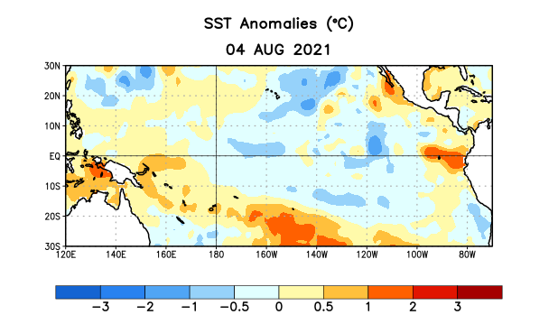
Figure 1. Average sea surface temperature (SST) anomalies (°C) for the week centered on 4 August 2021. Anomalies are computed with respect to the 1991-2020 base period weekly means.

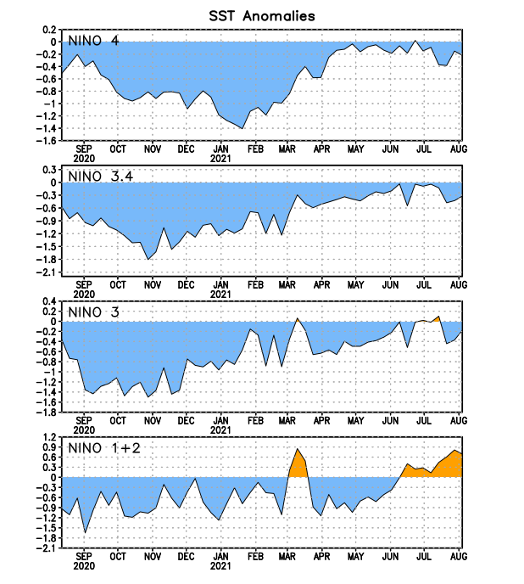
Figure 2. Time series of area-averaged sea surface temperature (SST) anomalies (°C) in the Niño regions [Niño-1+2 (0°-10°S, 90°W-80°W), Niño-3 (5°N-5°S, 150°W-90°W), Niño-3.4 (5°N-5°S, 170°W-120°W), Niño-4 (5ºN-5ºS, 150ºW-160ºE)]. SST anomalies are departures from the 1991-2020 base period weekly means.
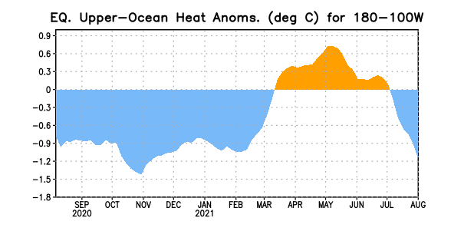
Figure 3. Area-averaged upper-ocean heat content anomaly (°C) in the equatorial Pacific (5°N-5°S, 180º-100ºW). The heat content anomaly is computed as the departure from the 1991-2020 base period pentad means.

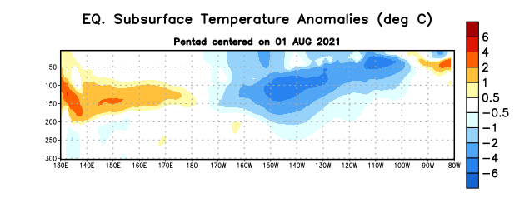

Figure 4. Depth-longitude section of equatorial Pacific upper-ocean (0-300m) temperature anomalies (°C) centered on the pentad of 1 August 2021. Anomalies are departures from the 1991-2020 base period pentad means.

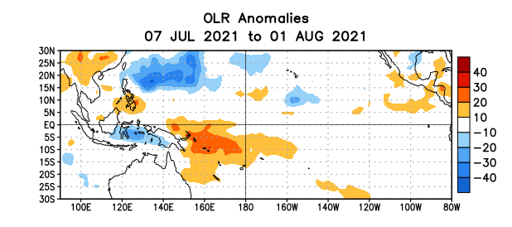
Figure 5. Average outgoing longwave radiation (OLR) anomalies (W/m²) for the period 7 July – 1 August 2021. OLR anomalies are computed as departures from the 1991-2020 base period pentad means.

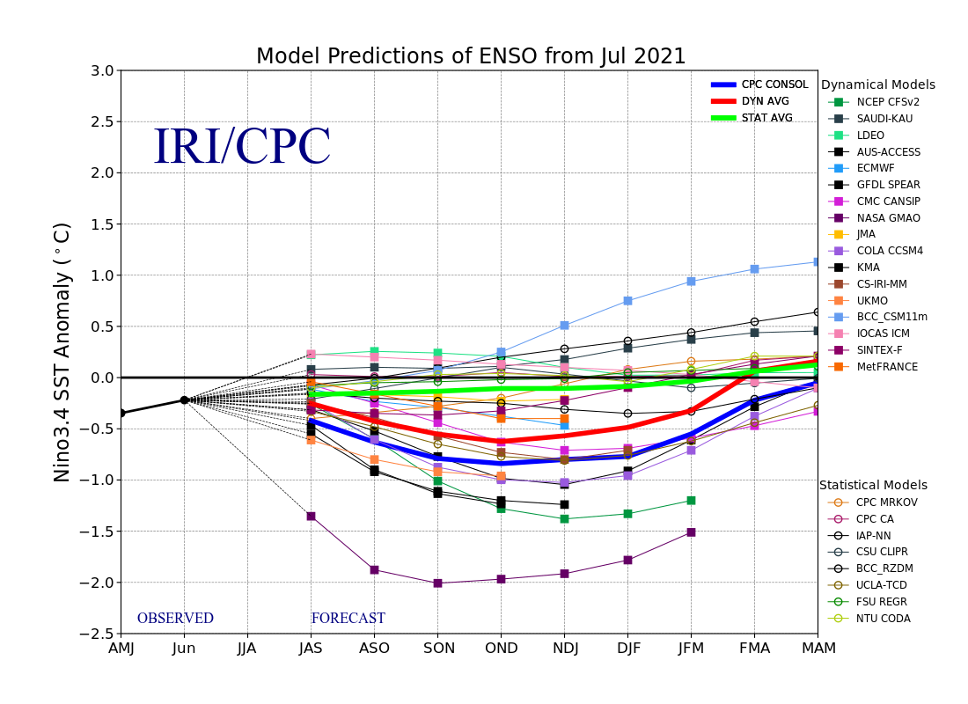
Figure 6. Forecasts of sea surface temperature (SST) anomalies for the Niño 3.4 region (5°N-5°S, 120°W-170°W). Figure updated 19 July 2021.

