EL NIÑO/SOUTHERN OSCILLATION (ENSO) DIAGNOSTIC DISCUSSION

issued by

CLIMATE PREDICTION CENTER/NCEP/NWS

11 August 2022

ENSO Alert System Status: La Niña Advisory

Synopsis: La Niña is expected to continue, with chances for La Niña gradually decreasing from 86% in the coming season to 60% during December-February 2022-23.

During the past month, below-average sea surface temperatures (SSTs) expanded across the central and eastern equatorial Pacific Ocean (Fig. 1). The weekly Niño indices indicated renewed cooling, with the latest Niño-3.4 and Niño-4 indices reaching -1.0ºC (Fig. 2). Subsurface temperature anomalies also decreased rapidly in the past month (Fig. 3), reflecting the reemergence of below-average subsurface temperatures across the east-central Pacific Ocean due to an upwelling Kelvin wave propagating eastward (Fig. 4). Low-level easterly wind anomalies and upper-level westerly wind anomalies persisted across most of the equatorial Pacific. Convection and rainfall remained suppressed over the western and central tropical Pacific and enhanced over Indonesia (Fig. 5). Overall, the coupled ocean-atmosphere system remained consistent with an ongoing La Niña.
The most recent IRI plume average for the Niño-3.4 SST index forecasts La Niña to persist into the Northern Hemisphere winter 2022-23 (Fig. 6). The forecaster consensus, supplemented with the latest models from the North American Multi-Model Ensemble (NMME), concurs that La Niña is the most likely outcome during the fall and winter. While a majority of NMME models suggest that La Niña will transition to ENSO-neutral in January-March 2023, forecasters are split on this outcome resulting in equal forecast probabilities for that season. In summary, La Niña is expected to continue, with chances for La Niña gradually decreasing from 86% in the coming season to 60% during December-February 2022-23 (Fig. 7).
This discussion is a consolidated effort of the National Oceanic and Atmospheric Administration (NOAA), NOAA’s National Weather Service, and their funded institutions. Oceanic and atmospheric conditions are updated weekly on the Climate Prediction Center web site (El Niño/La Niña Current Conditions and Expert Discussions). Additional perspectives and analysis are also available in an ENSO blog. A probabilistic strength forecast is available here. The next ENSO Diagnostics Discussion is scheduled for 8 September 2022. To receive an e-mail notification when the monthly ENSO Diagnostic Discussions are released, please send an e-mail message to: ncep.list.enso-update@noaa.gov.

Climate Prediction Center
National Centers for Environmental Prediction
NOAA/National Weather Service
College Park, MD 20740

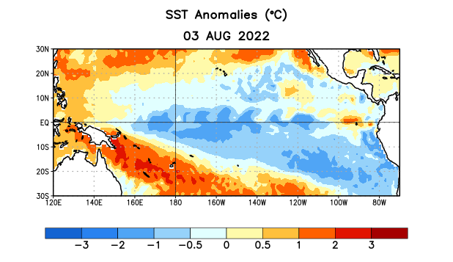
Figure 1. Average sea surface temperature (SST) anomalies (°C) for the week centered on 3 August 2022. Anomalies are computed with respect to the 1991-2020 base period weekly means.

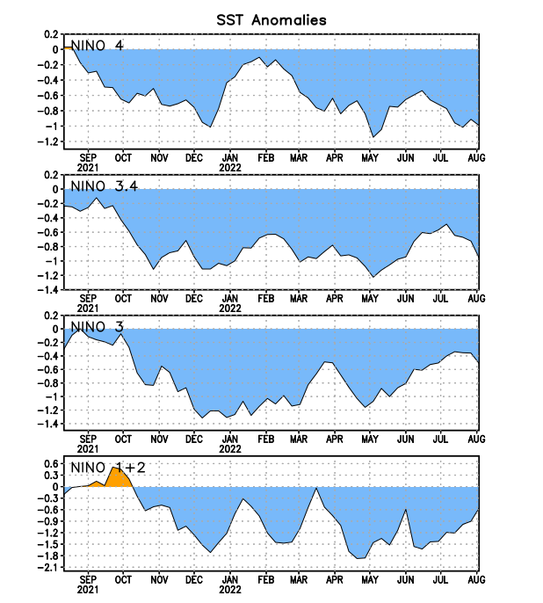
Figure 2. Time series of area-averaged sea surface temperature (SST) anomalies (°C) in the Niño regions [Niño-1+2 (0°-10°S, 90°W-80°W), Niño-3 (5°N-5°S, 150°W-90°W), Niño-3.4 (5°N-5°S, 170°W-120°W), Niño-4 (5ºN-5ºS, 150ºW-160ºE)]. SST anomalies are departures from the 1991-2020 base period weekly means.

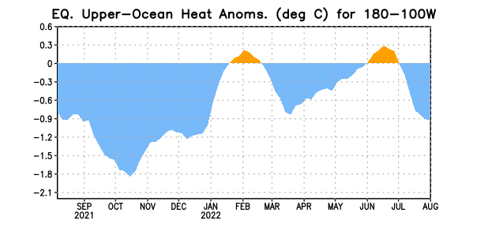

Figure 3. Area-averaged upper-ocean heat content anomaly (°C) in the equatorial Pacific (5°N-5°S, 180º-100ºW). The heat content anomaly is computed as the departure from the 1991-2020 base period pentad means.

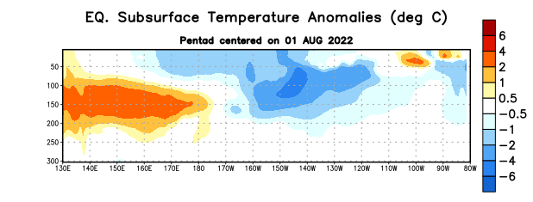

Figure 4. Depth-longitude section of equatorial Pacific upper-ocean (0-300m) temperature anomalies (°C) centered on the pentad of 1 August 2022. Anomalies are departures from the 1991-2020 base period pentad means.

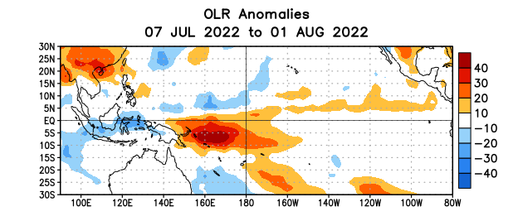

Figure 5. Average outgoing longwave radiation (OLR) anomalies (W/m²) for the period 7 July – 1 August 2022. OLR anomalies are computed as departures from the 1991-2020 base period pentad means.

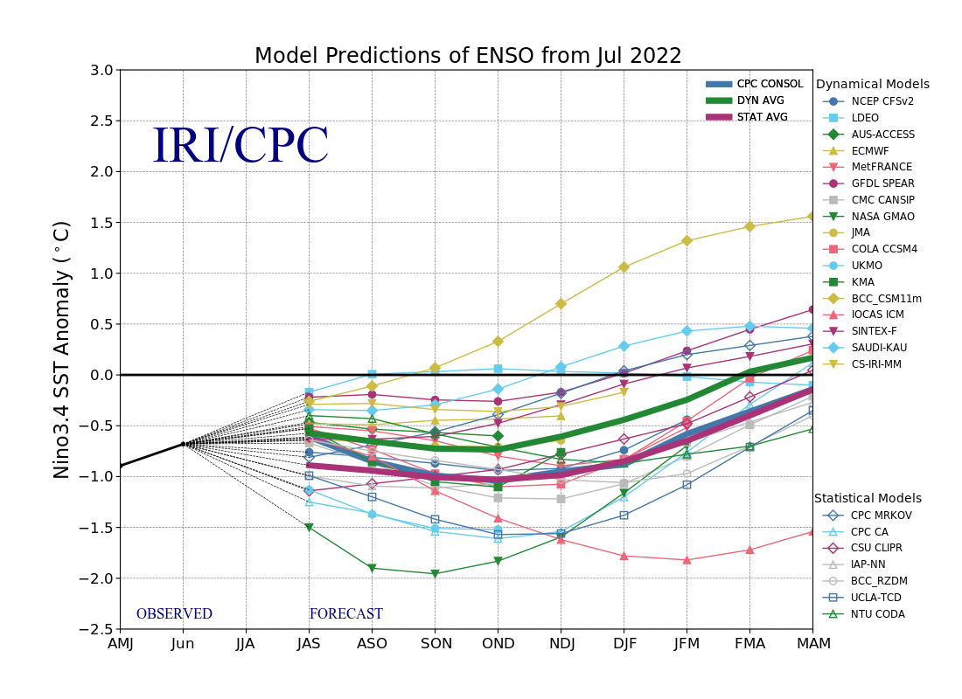
Figure 6. Forecasts of sea surface temperature (SST) anomalies for the Niño 3.4 region (5°N-5°S, 120°W-170°W). Figure updated 19 July 2022.
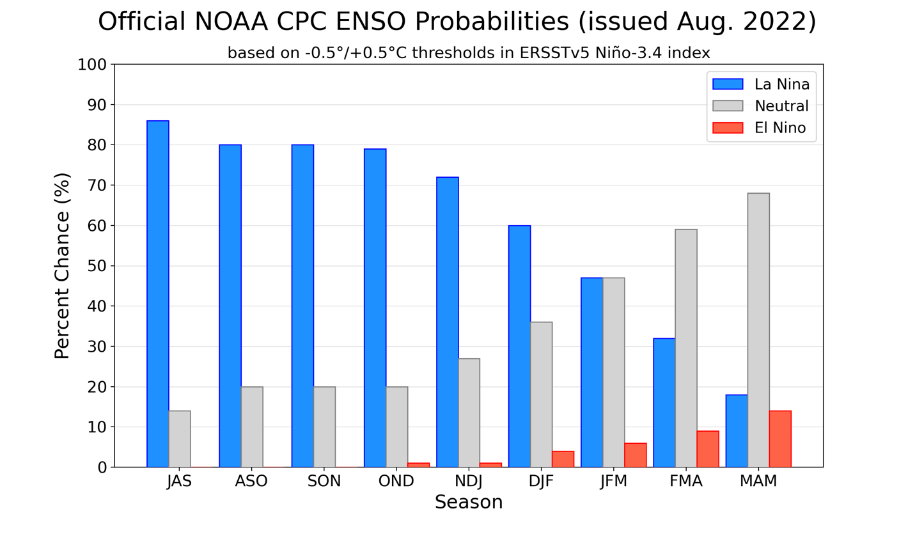
Figure 7. Official ENSO probabilities for the Niño 3.4 sea surface temperature index (5°N-5°S,
120°W-170°W). Figure updated 11 August 2022.

