EL NIÑO/SOUTHERN OSCILLATION (ENSO) DIAGNOSTIC DISCUSSION

issued by

CLIMATE PREDICTION CENTER/NCEP/NWS

10 August 2023

ENSO Alert System Status: El Niño Advisory

Synopsis: El Niño is anticipated to continue through the Northern Hemisphere winter (with greater than 95% chance through December 2023 -February 2024).

In July, El Niño continued as indicated by above-average sea surface temperatures (SSTs) across the equatorial Pacific Ocean (Fig. 1). Nearly all of the weekly Niño indices in the central and eastern Pacific were in excess of +1.0ºC: Niño-3.4 was +1.1ºC, Niño-3 was +1.8ºC, and Niño1+2 was +3.4ºC (Fig. 2). Area-averaged subsurface temperatures anomalies decreased compared to June (Fig. 3), but remained positive, in association with anomalous warmth across the equatorial Pacific Ocean (Fig. 4). Tropical atmospheric anomalies were also consistent with El Niño. Starting in mid-July, low-level winds were anomalously westerly over the western equatorial Pacific, while anomalous easterlies prevailed over the eastern Pacific. Upper-level wind anomalies were westerly over the eastern Pacific. Convection continued to be enhanced around the International Date Line and was weakly suppressed in the vicinity of Indonesia (Fig. 5). The equatorial Southern Oscillation Index (SOI) and the traditional SOI were both negative. Collectively, the coupled ocean-atmosphere system reflected El Niño.
The most recent IRI plume indicates El Niño will persist through the Northern Hemisphere winter 2023-24 (Fig. 6). Given recent developments, forecasters are more confident in a “strong” El Niño event, with roughly 2 in 3 odds of an event reaching or exceeding 1.5°C for the November-January seasonal average in Niño-3.4. Note that a strong El Niño does not necessarily equate to strong El Niño impacts locally, with the odds of related climate anomalies often lower than the chances of El Niño itself (e.g., CPC’s seasonal outlooks). In summary, El Niño is anticipated to continue through the Northern Hemisphere winter (with greater than 95% chance through December 2023 -February 2024; Fig. 7).
This discussion is a consolidated effort of the National Oceanic and Atmospheric Administration (NOAA), NOAA’s National Weather Service, and their funded institutions. Oceanic and atmospheric conditions are updated weekly on the Climate Prediction Center website (El Niño/La Niña Current Conditions and Expert Discussions). Additional perspectives and analyses are also available in an ENSO blog. A probabilistic strength forecast is available here. The next ENSO Diagnostics Discussion is scheduled for 14 September 2023. To receive an e-mail notification when the monthly ENSO Diagnostic Discussions are released, please send an e-mail message to: ncep.list.enso-update@noaa.gov.

Climate Prediction Center
National Centers for Environmental Prediction
NOAA/National Weather Service
College Park, MD 20740
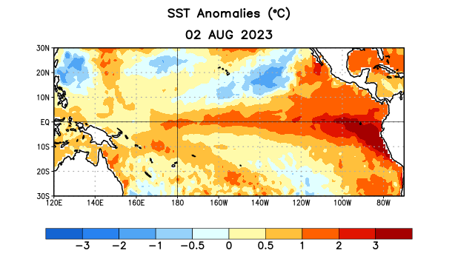
Figure 1. Average sea surface temperature (SST) anomalies (°C) for the week centered on 2 August 2023. Anomalies are computed with respect to the 1991-2020 base period weekly means.

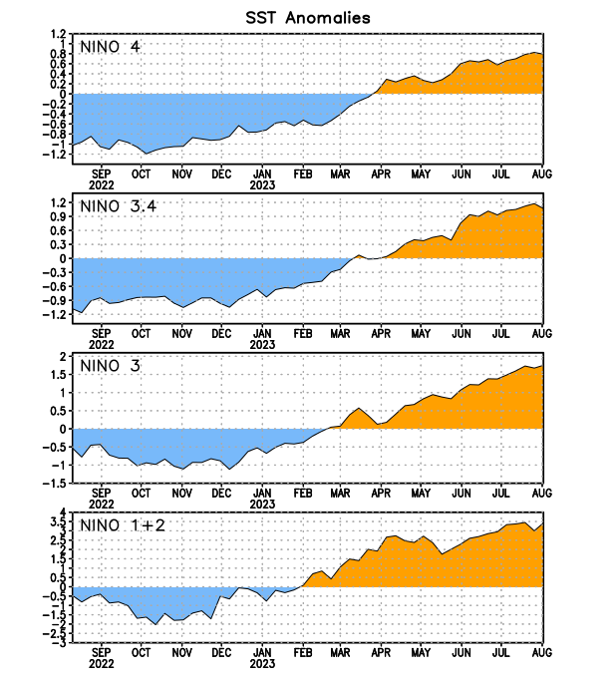
Figure 2. Time series of area-averaged sea surface temperature (SST) anomalies (°C) in the Niño regions [Niño-1+2 (0°-10°S, 90°W-80°W), Niño-3 (5°N-5°S, 150°W-90°W), Niño-3.4 (5°N-5°S, 170°W-120°W), Niño-4 (5ºN-5ºS, 150ºW-160ºE)]. SST anomalies are departures from the 1991-2020 base period weekly means.

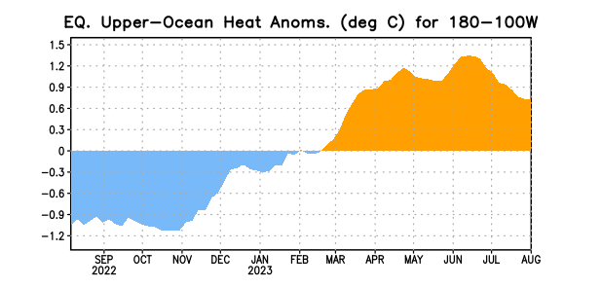

Figure 3. Area-averaged upper-ocean heat content anomaly (°C) in the equatorial Pacific (5°N-5°S, 180º-100ºW). The heat content anomaly is computed as the departure from the 1991-2020 base period pentad means.

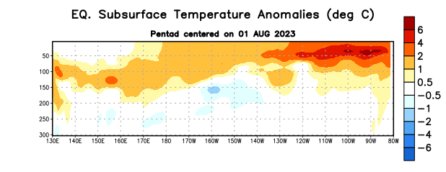
Figure 4. Depth-longitude section of equatorial Pacific upper-ocean (0-300m) temperature anomalies (°C) centered on the pentad of 1 August 2023. Anomalies are departures from the 1991-2020 base period pentad means.

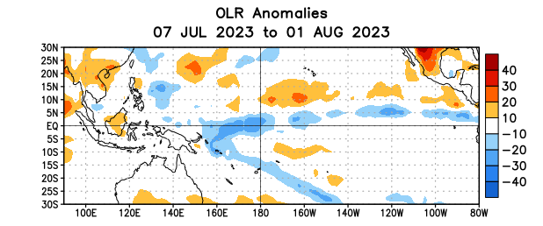

Figure 5. Average outgoing longwave radiation (OLR) anomalies (W/m²) for the period 7 July – 1 August 2023. OLR anomalies are computed as departures from the 1991-2020 base period pentad means.

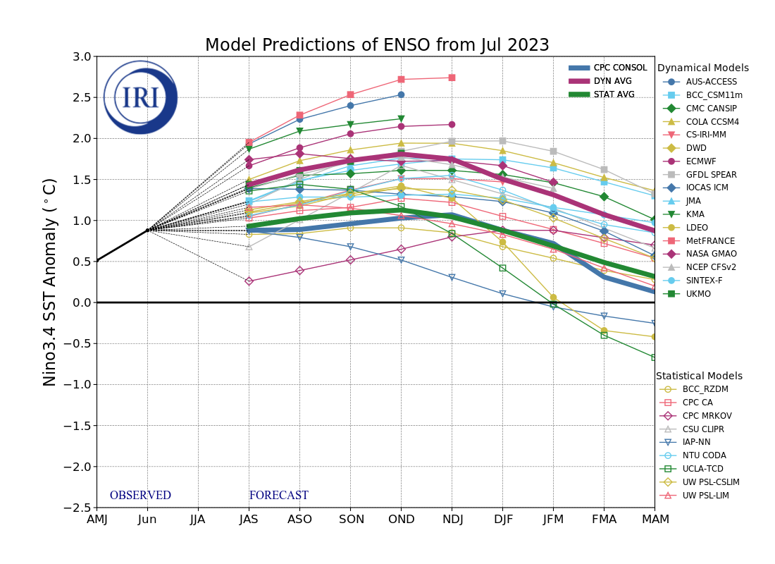
Figure 6. Forecasts of sea surface temperature (SST) anomalies for the Niño 3.4 region (5°N-5°S, 120°W-170°W). Figure updated 19 July 2023 by the International Research Institute (IRI) for Climate and Society.
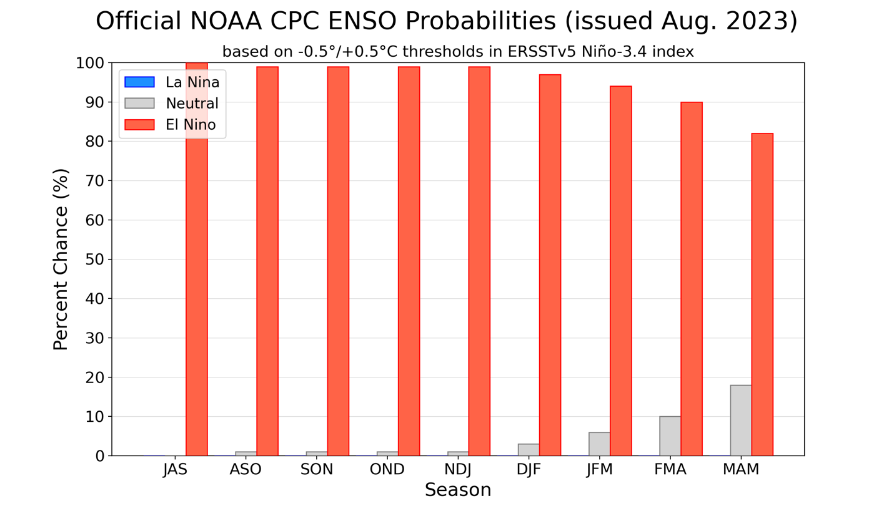
Figure 7. Official ENSO probabilities for the Niño 3.4 sea surface temperature index (5°N-5°S, 120°W-170°W). Figure updated 10 August 2023.

