EL NIÑO/SOUTHERN OSCILLATION (ENSO) DIAGNOSTIC DISCUSSION
issued by
CLIMATE PREDICTION CENTER/NCEP/NWS
6 December 2007

Synopsis: La Niña is expected to continue into Northern Hemisphere spring 2008.
La Niña reached moderate strength during November 2007, with below-average sea surface temperatures (SSTs) extending from 160ºE to the South American coast (Fig. 1). All of the Niño region indices remained cooler than −1.0°C (Fig. 2), with the most substantial cooling occurring in the Niño-4 region located in the central equatorial Pacific Ocean (150ºW-160ºE and 5ºN-5ºS). The upper-ocean heat content (average temperatures in the upper 300 m of the ocean) in the central and east-central equatorial Pacific remained below average (Fig. 3), with temperatures ranging from 2°C to 5°C below average at thermocline depth (Fig. 4). Consistent with these oceanic conditions, low-level easterly winds and upper-level westerly winds strengthened across the central equatorial Pacific, convection remained suppressed throughout the central and eastern equatorial Pacific, and an area of enhanced convection covered the far western Pacific. Collectively, these oceanic and atmospheric conditions reflect La Niña.
The recent SST forecasts (dynamical and statistical models) for the Niño 3.4 region indicate a continuation of La Niña into Northern Hemisphere spring 2008 (Fig. 5). Over half of the models indicate a moderate-to-strong La Niña through February, followed by a gradual weakening thereafter. Current atmospheric and oceanic conditions and recent trends are consistent with the model forecasts.
Expected La Niña impacts during December – February include a continuation of above-average precipitation over Indonesia and below-average precipitation over the central and eastern equatorial Pacific. For the contiguous United States, potential impacts include above-average precipitation in the Northern Rockies, the Pacific Northwest, the Ohio and Tennessee Valleys, and parts of the Great Lakes region. Below-average precipitation is expected across the South, particularly in the southwestern and southeastern states.
This discussion is a consolidated effort of the National Atmospheric and Oceanic Administration (NOAA), NOAA’s National Weather Service, and their funded institutions. Oceanic and atmospheric conditions are updated weekly on the Climate Prediction Center web site (El Niño/La Niña Current Conditions and Expert Discussions). Forecasts for the evolution of El Niño/La Niña are updated monthly in the Forecast Forum section of CPC's Climate Diagnostics Bulletin. The next ENSO Diagnostics Discussion is scheduled for 10 January 2008. To receive an e-mail notification when the monthly ENSO Diagnostic Discussions are released, please send an e-mail message to: ncep.list.enso-update@noaa.gov.
Climate Prediction Center
National Centers for Environmental Prediction
NOAA/National Weather Service
Camp Springs, MD 20746-4304

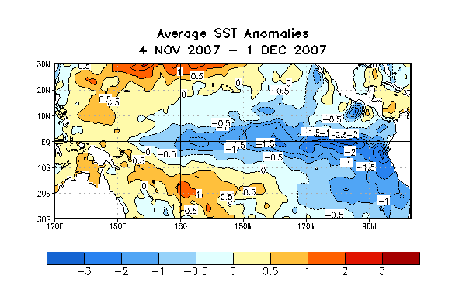
Figure 1. Sea surface temperature (SST) anomalies (°C) during the period 4 November- 1 December 2007. SST anomalies are computed with respect to the 1971-2000 base period weekly means (Xue et al. 2003, J. Climate, 16, 1601-1612).

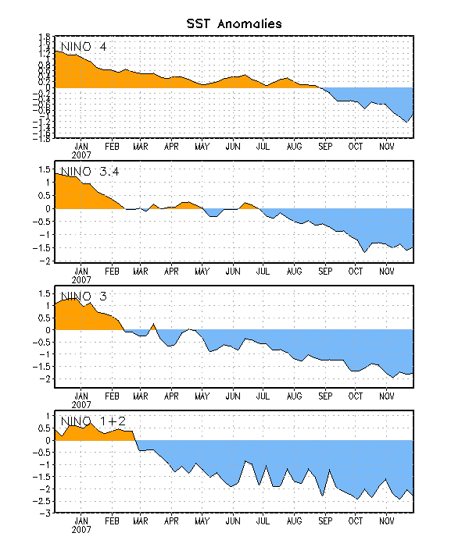

Figure 2. Time series of area-averaged sea surface temperature (SST) anomalies (°C) in the Niño regions [Niño-1+2 (0°-10°S, 90°-80°W), Niño 3 (5°N-5°S, 150°W-90°W), Niño-3.4 (5°N-5°S, 170°W-120°W), Niño-4 (150ºW-160ºE and 5ºN-5ºS)]. SST anomalies are departures are from the 1971-2000 base period weekly means (Xue et al. 2003, J. Climate, 16, 1601-1612).
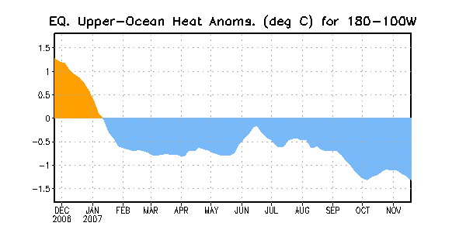

Figure 3. Area-averaged upper-ocean heat content anomalies (°C) in the equatorial Pacific (5°N-5°S, 180º-100ºW). Heat content anomalies are computed as departures from the 1982-2004 base period weekly means.

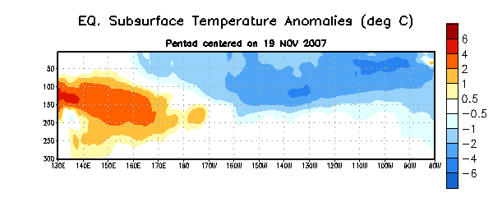
Figure 4. Depth-longitude section of equatorial Pacific upper-ocean (0-300m) temperature anomalies (°C) centered on the week of 19 November. The anomalies are averaged between 5°N-5°S. Anomalies are departures from the 1982-2004 base period weekly means.

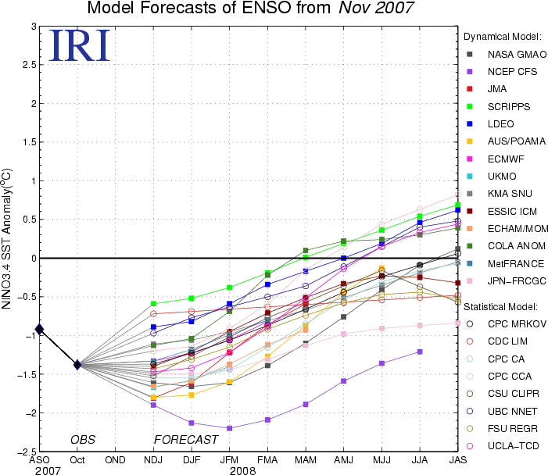

Figure 5. Forecasts of sea surface temperature (SST) anomalies for the Niño 3.4 region (5°N-5°S, 120°W-170°W). Figure courtesy of the International Research Institute (IRI) for Climate and Society. Figure updated 17 November 2007.

