EL NIÑO/SOUTHERN OSCILLATION (ENSO) DIAGNOSTIC DISCUSSION
issued by
CLIMATE PREDICTION CENTER/NCEP/NWS
11 December 2008

Synopsis: ENSO-neutral or La Niña conditions are equally likely through early 2009.
ENSO-neutral conditions continued during November 2008, although equatorial sea surface temperatures (SSTs) remained below-average across much of the central and eastern Pacific Ocean (Fig. 1). Correspondingly, the latest weekly SST index values were -0.9°C in Niño-1+2, -0.3°C in Niño 3, -0.5°C in Niño 3.4, and -0.4°C in Niño 4 (Fig. 2). The subsurface oceanic heat content anomalies (average temperatures in the upper 300m of the ocean, Fig. 3) became increasingly negative as below-average temperatures at thermocline depth expanded throughout the central and eastern Pacific (Fig. 4).
Low-level easterly winds and upper-level westerly winds expanded and strengthened across the equatorial Pacific Ocean during the month. Also, convection remained enhanced near Indonesia and suppressed near the International Date Line. However, in recent months intraseasonal variability has contributed to episodic strengthening and weakening of convection over Indonesia. Overall, the ocean-atmosphere system during November remained consistent with ENSO-neutral conditions, but exhibited several atmospheric characteristics typical of weak La Niña conditions.
A majority of the SST forecasts indicate ENSO-neutral conditions (Niño-3.4 index of −0.5°C to 0.5°C) will continue into the first half of 2009. Several models, including the NOAA Climate Forecast System (CFS), suggest the development of La Niña during December 2008- March 2009 (Fig. 5). The recent strengthening of the low-level easterlies over the equatorial Pacific suggests the possibility of additional anomalous cooling of the SSTs. However, the magnitude of cooling remains uncertain and it is possible the La Niña threshold will not be met (3-month average of the Niño-3.4 index less than or equal to −0.5°C). Therefore, based on current observations and recent trends, ENSO-neutral or La Niña conditions are equally likely through early 2009.
This discussion is a consolidated effort of the National Atmospheric and Oceanic Administration (NOAA), NOAA’s National Weather Service, and their funded institutions. Oceanic and atmospheric conditions are updated weekly on the Climate Prediction Center web site (El Niño/La Niña Current Conditions and Expert Discussions). Forecasts for the evolution of El Niño/La Niña are updated monthly in the Forecast Forum section of CPC's Climate Diagnostics Bulletin. The next ENSO Diagnostics Discussion is scheduled for 8 January 2009. To receive an e-mail notification when the monthly ENSO Diagnostic Discussions are released, please send an e-mail message to: ncep.list.enso-update@noaa.gov.
Climate Prediction Center
National Centers for Environmental Prediction
NOAA/National Weather Service
Camp Springs, MD 20746-4304

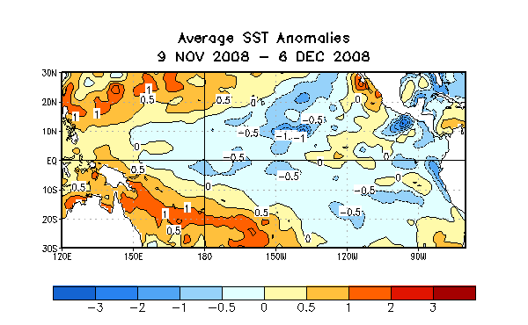

Figure 1. Average sea surface temperature (SST) anomalies (°C) for the four-week period 9 November - 6 December 2008. Anomalies are computed with respect to the 1971-2000 base period weekly means (Xue et al. 2003, J. Climate, 16, 1601-1612).

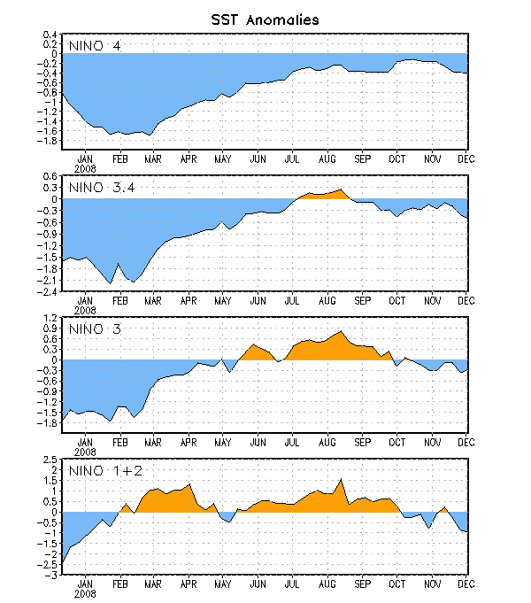
Figure 2. Time series of area-averaged sea surface temperature (SST) anomalies (°C) in the Niño regions [Niño-1+2 (0°-10°S, 90°W-80°W), Niño 3 (5°N-5°S, 150°W-90°W), Niño-3.4 (5°N-5°S, 170°W-120°W), Niño-4 (150ºW-160ºE and 5ºN-5ºS)]. SST anomalies are departures from the 1971-2000 base period weekly means (Xue et al. 2003, J. Climate, 16, 1601-1612).

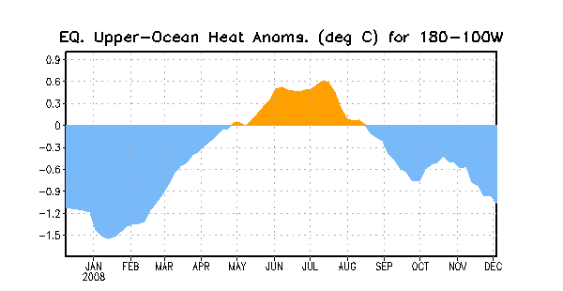
Figure 3. Area-averaged upper-ocean heat content anomalies (°C) in the equatorial Pacific (5°N-5°S, 180º-100ºW). Heat content anomalies are computed as departures from the 1982-2004 base period pentad means.

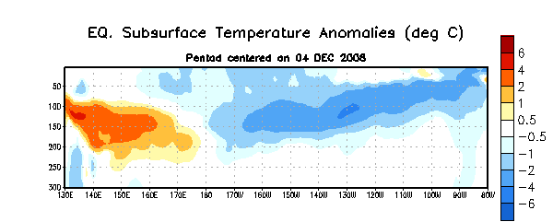
Figure 4. Depth-longitude section of equatorial Pacific upper-ocean (0-300m) temperature anomalies (°C) centered on the week of 4 December 2008. The anomalies are averaged between 5°N-5°S. Anomalies are departures from the 1982-2004 base period pentad means.

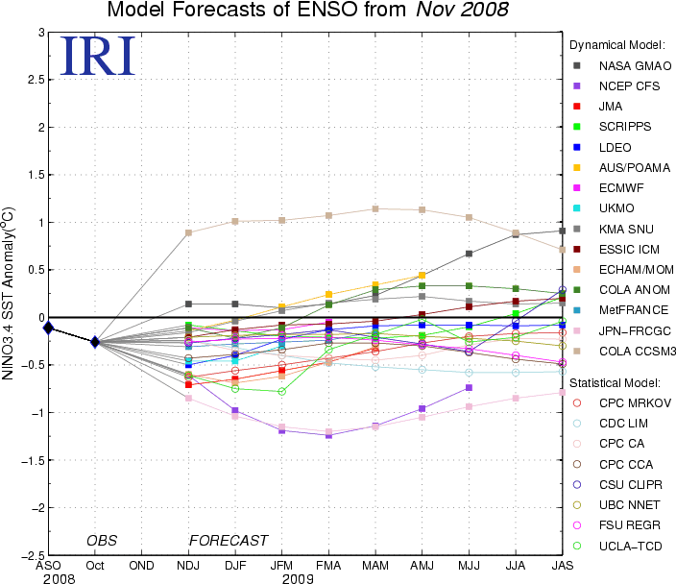

Figure 5. Forecasts of sea surface temperature (SST) anomalies for the Niño 3.4 region (5°N-5°S, 120°W-170°W). Figure courtesy of the International Research Institute (IRI) for Climate and Society. Figure updated 20 November 2008.

