EL NIÑO/SOUTHERN OSCILLATION (ENSO) DIAGNOSTIC DISCUSSION

issued by

CLIMATE PREDICTION CENTER/NCEP/NWS
10 December 2009

ENSO Alert System Status: El Niño Advisory

Synopsis: El Niño is expected to continue and last at least into the Northern Hemisphere spring 2010.
El Niño strengthened from October to November 2009, as sea surface temperature (SST) anomalies increased across the central and eastern equatorial Pacific Ocean (Figs. 1 and 2). The Niño-3.4 index value remained steady during November with the most recent weekly value at +1.7°C (Fig. 2). Consistent with this warmth, upper-ocean heat content anomalies remained positive (Fig. 3) and subsurface temperature anomalies shifted eastward across the eastern Pacific, with the largest departures exceeding +4°C by the end of the month (Fig. 4). Also, the low-level and upper-level wind anomalies over the equatorial Pacific were highly variable during the month due to the Madden-Julian Oscillation (MJO). The MJO also contributed to anomalous convection over Indonesia and the west-central equatorial Pacific (110°E to 180°; Fig. 5). Collectively, these oceanic and atmospheric anomalies reflect a moderate strength El Niño.
Substantial disagreement remains among the models as to the eventual peak strength of El Niño (Fig. 6). Even at short lead times (e.g. November-December-January), SST forecasts for the Niño-3.4 region range from +0.5 to +2.0°C. At this point, it seems equally likely that El Niño will either strengthen further or remain at moderate strength (3-month Niño-3.4 SST index of +1.0 to +1.4°C) during the next few months. Regardless of the precise peak strength, El Niño is expected to exert a significant influence on the global weather and climate in the coming months. Most models indicate that SST anomalies in the Niño-3.4 region will begin to decrease in early 2010, but El Niño will persist through March-April-May 2010.
Expected El Niño impacts during December 2009-February 2010 include enhanced precipitation over the central tropical Pacific Ocean and a continuation of drier-than-average conditions over Indonesia. Also, warming in the far eastern equatorial Pacific is likely in the coming months with the associated potential for enhanced rainfall in portions of Peru and Ecuador. For the contiguous United States, potential impacts include above-average precipitation for the southern tier of the country, with below-average precipitation in the Pacific Northwest and the Ohio and Tennessee Valleys. Below-average snowfall and above-average temperatures are most likely across the northern tier of states (excluding New England), while below-average temperatures are favored for the southeastern states.
This discussion is a consolidated effort of the National Oceanic and Atmospheric Administration (NOAA), NOAA’s National Weather Service, and their funded institutions. Oceanic and atmospheric conditions are updated weekly on the Climate Prediction Center web site (El Niño/La Niña Current Conditions and Expert Discussions). Forecasts for the evolution of El Niño/La Niña are updated monthly in the Forecast Forum section of CPC's Climate Diagnostics Bulletin. The next ENSO Diagnostics Discussion is scheduled for 7 January 2010. To receive an e-mail notification when the monthly ENSO Diagnostic Discussions are released, please send an e-mail message to: ncep.list.enso-update@noaa.gov.
Climate Prediction Center
National Centers for Environmental Prediction
NOAA/National Weather Service
Camp Springs, MD 20746-4304
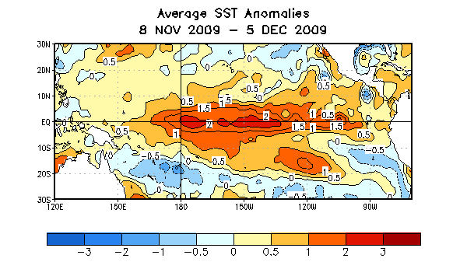
Figure 1. Average sea surface temperature (SST) anomalies (°C) for the four-week period 8 November 2009 – 5 December 2009. Anomalies are computed with respect to the 1971-2000 base period weekly means (Xue et al. 2003, J. Climate, 16, 1601-1612).

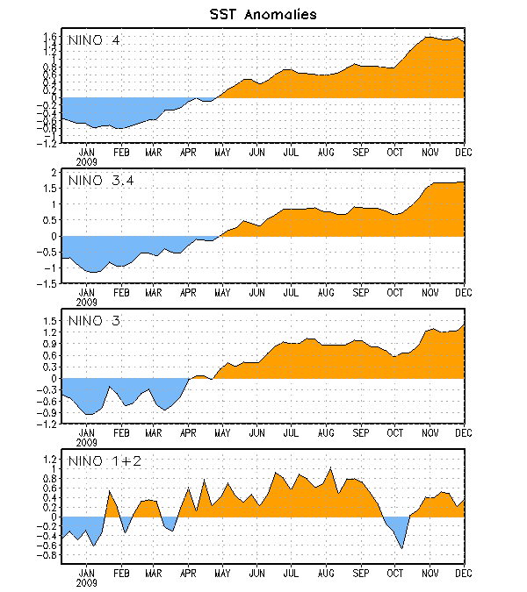

Figure 2. Time series of area-averaged sea surface temperature (SST) anomalies (°C) in the Niño regions [Niño-1+2 (0°-10°S, 90°W-80°W), Niño 3 (5°N-5°S, 150°W-90°W), Niño-3.4 (5°N-5°S, 170°W-120°W), Niño-4 (150ºW-160ºE and 5ºN-5ºS)]. SST anomalies are departures from the 1971-2000 base period weekly means (Xue et al. 2003, J. Climate, 16, 1601-1612).

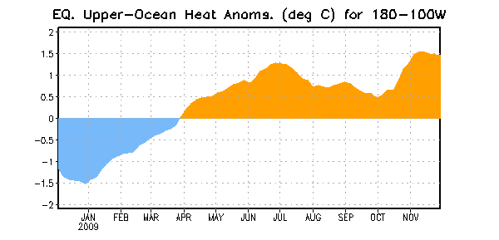
Figure 3. Area-averaged upper-ocean heat content anomalies (°C) in the equatorial Pacific (5°N-5°S, 180º-100ºW). Heat content anomalies are computed as departures from the 1982-2004 base period pentad means.

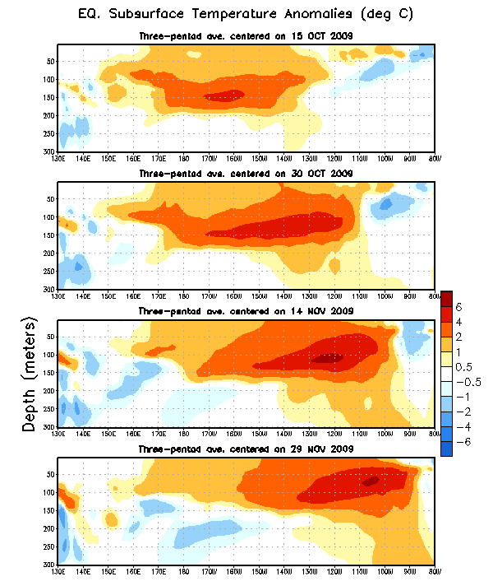
Figure 4. Depth-longitude section of equatorial Pacific upper-ocean (0-300m) temperature anomalies (°C) for centered three-pentad averages from 15 October 2009 to 29 November 2009. The anomalies are averaged between 5°N-5°S. Anomalies are departures from the 1982-2004 base period pentad means.

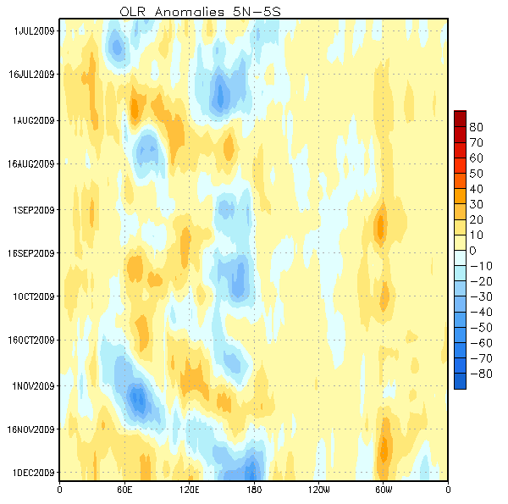
Figure 5. Equatorially averaged (5°N-5°S) outgoing longwave radiation (OLR) anomalies (W/m²) across the global tropics. Blue shading indicates below-average OLR (above-average convection) and orange shading represents above-average OLR (below-average convection). OLR anomalies are computed as departures from the 1979-1995 base period pentad means.

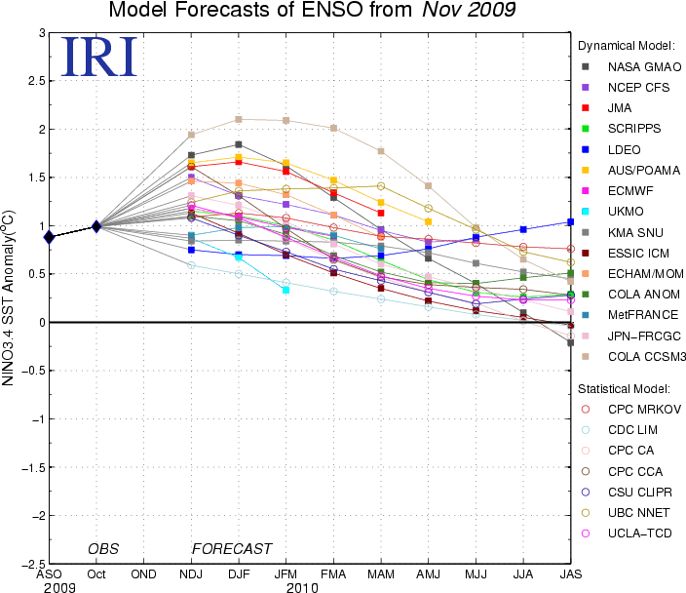

Figure 6. Forecasts of sea surface temperature (SST) anomalies for the Niño 3.4 region (5°N-5°S, 120°W-170°W). Figure courtesy of the International Research Institute (IRI) for Climate and Society. Figure updated 17 November 2009.

