EL NIÑO/SOUTHERN OSCILLATION (ENSO) DIAGNOSTIC DISCUSSION

issued by

CLIMATE PREDICTION CENTER/NCEP/NWS
9 December 2010

ENSO Alert System Status: La Niña Advisory

Synopsis: La Niña is expected to last at least into the Northern Hemisphere spring 2011.
During November 2010, the ongoing La Niña was reflected by below-average sea surface temperatures (SSTs) across the equatorial Pacific Ocean (Fig. 1). For the second straight month, only small changes were evident in the Niño SST indices, which ranged from –1.3°C to –1.7°C at the end of the month (Fig. 2). The subsurface oceanic heat content (average temperatures in the upper 300m of the ocean, Fig. 3) also remained well below-average in association with a shallower-than-average thermocline across the central and eastern equatorial Pacific (Fig. 4). Convection remained enhanced over Indonesia and suppressed over the western and central equatorial Pacific (Fig. 5). Enhanced low-level easterly trade winds and anomalous upper-level westerly winds continued over the equatorial Pacific. Collectively, these oceanic and atmospheric anomalies reflect a moderate-to-strong La Niña.
Consistent with nearly all ENSO forecast models (Fig. 6), La Niña is expected to peak during November-January and to continue into the Northern Hemisphere spring 2011. Thereafter, the fate of La Niña is more uncertain. The majority of forecast models and all of the multi-model combinations (thicker lines) indicate a return to ENSO-neutral conditions during the Northern Hemisphere spring and early summer. However, a smaller number of models, including the NCEP Climate Forecast System, suggest that La Niña could persist into the summer. Historically, there are more multi-year La Niña episodes than El Niño episodes, but other than support from a few model runs, there is no consensus for a multi-year La Niña at this time. Consequently, La Niña is anticipated to continue into the Northern Hemisphere spring, with no particular outcome favored thereafter.
Likely La Niña impacts during December 2010-February 2011 include suppressed convection over the central tropical Pacific Ocean, and enhanced convection over Indonesia. Impacts in the United States include an enhanced chance of above-average precipitation in the Pacific Northwest, Northern Rockies (along with a concomitant increase in snowfall), Great Lakes, and Ohio Valley. Below-average precipitation is most likely across the southern states, extending into the Mid-Atlantic region. An increased chance of below-average temperatures is predicted for the northernmost western and central states, and a higher possibility of above-average temperatures is forecast for much of the southern and central U.S. (see 3-month seasonal outlook released on November 18th, 2010).
This discussion is a consolidated effort of the National Oceanic and Atmospheric Administration (NOAA), NOAA’s National Weather Service, and their funded institutions. Oceanic and atmospheric conditions are updated weekly on the Climate Prediction Center web site (El Niño/La Niña Current Conditions and Expert Discussions). Forecasts for the evolution of El Niño/La Niña are updated monthly in the Forecast Forum section of CPC's Climate Diagnostics Bulletin. The next ENSO Diagnostics Discussion is scheduled for 6 January 2011. To receive an e-mail notification when the monthly ENSO Diagnostic Discussions are released, please send an e-mail message to: ncep.list.enso-update@noaa.gov.
Climate Prediction Center
National Centers for Environmental Prediction
NOAA/National Weather Service
Camp Springs, MD 20746-4304
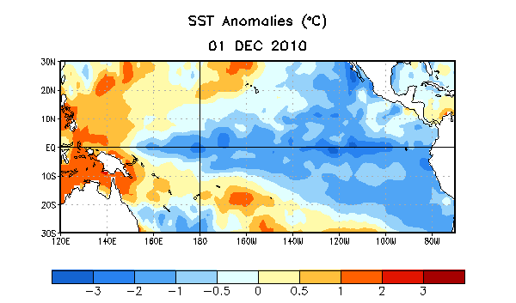
Figure 1. Average sea surface temperature (SST) anomalies (°C) for the week centered on 1 December 2010. Anomalies are computed with respect to the 1971-2000 base period weekly means (Xue et al. 2003, J. Climate, 16, 1601-1612).

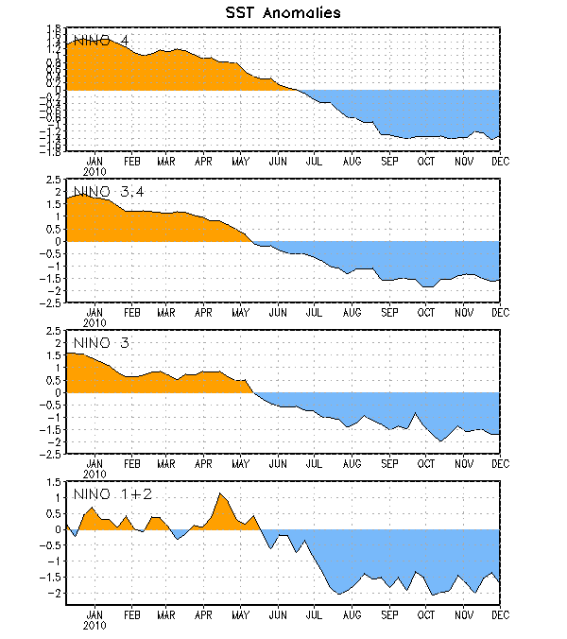
Figure 2. Time series of area-averaged sea surface temperature (SST) anomalies (°C) in the Niño regions [Niño-1+2 (0°-10°S, 90°W-80°W), Niño 3 (5°N-5°S, 150°W-90°W), Niño-3.4 (5°N-5°S, 170°W-120°W), Niño-4 (150ºW-160ºE and 5ºN-5ºS)]. SST anomalies are departures from the 1971-2000 base period weekly means (Xue et al. 2003, J. Climate, 16, 1601-1612).

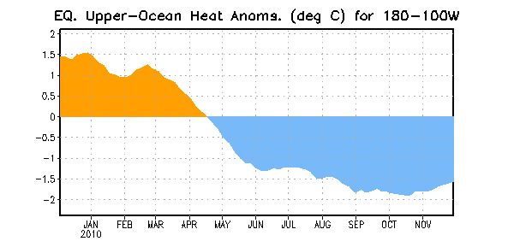
Figure 3. Area-averaged upper-ocean heat content anomalies (°C) in the equatorial Pacific (5°N-5°S, 180º-100ºW). Heat content anomalies are computed as departures from the 1982-2004 base period pentad means.

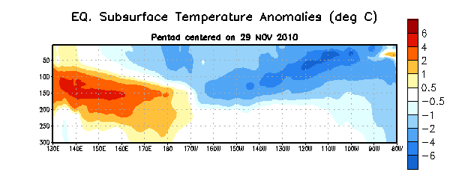
Figure 4. Depth-longitude section of equatorial Pacific upper-ocean (0-300m) temperature anomalies (°C) centered on the week of 29 November 2010. The anomalies are averaged between 5°N-5°S. Anomalies are departures from the 1982-2004 base period pentad means.

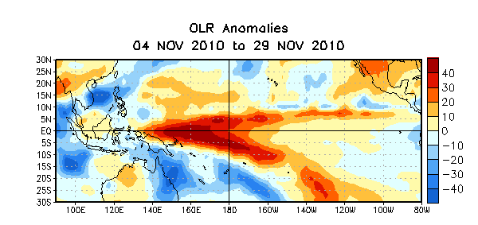
Figure 5. Average outgoing longwave radiation (OLR) anomalies (W/m²) for the four-week period 4 Nov – 29 November 2010. OLR anomalies are computed as departures from the 1979-1995 base period pentad means.

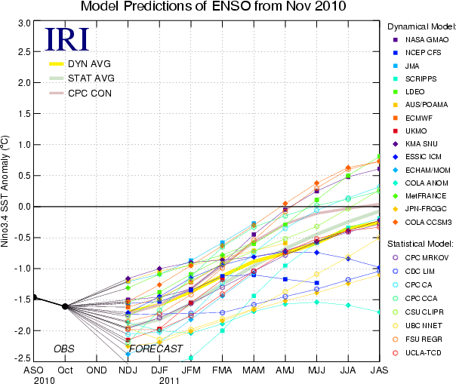
Figure 6. Forecasts of sea surface temperature (SST) anomalies for the Niño 3.4 region (5°N-5°S, 120°W-170°W). Figure courtesy of the International Research Institute (IRI) for Climate and Society. Figure updated 17 November 2010.

