EL NIÑO/SOUTHERN OSCILLATION (ENSO) DIAGNOSTIC DISCUSSION

issued by

CLIMATE PREDICTION CENTER/NCEP/NWS
and the International Research Institute for Climate and Society
6 December 2012

ENSO Alert System Status: Not Active

Synopsis: ENSO-neutral is favored for Northern Hemisphere winter 2012-13 and into spring 2013.
During November 2012, the Pacific Ocean reflected ENSO-neutral conditions. Equatorial sea surface temperatures (SST) anomalies were slightly positive across all of the tropical Pacific Ocean except for the far eastern portion (Fig. 1), as also indicated in the Niño indices (Fig. 2). The oceanic heat content (average temperature in the upper 300m of the ocean) was also slightly above average (Fig. 3), with largest amplitude in the east-central part of the basin (Fig. 4). Despite the subsurface and surface Pacific Ocean being slightly warmer than average, the tropical atmosphere remained in an ENSO-neutral state. Upper-level and lower-level zonal winds were near average, and convection was slightly suppressed over the eastern and central tropical Pacific (Fig. 5). Thus, both the atmosphere and ocean indicated ENSO-neutral conditions.
Relative to last month, the SST model predictions increasingly favor ENSO-neutral, with many remaining just slightly above average in the Niño-3.4 region through the Northern Hemisphere winter 2012-13 and into spring 2013 (Fig. 6). While the tropical atmosphere and especially the ocean suggested borderline ENSO-neutral/ weak El Niño conditions at times from July to September, these signs have now largely dissipated. Therefore, it is considered unlikely that a fully coupled El Niño will develop during the next several months. ENSO-neutral is now favored through the Northern Hemisphere winter 2012-13 and into spring 2013 (see CPC/IRI consensus forecast).
This discussion is a consolidated effort of the National Oceanic and Atmospheric Administration (NOAA), NOAA’s National Weather Service, and their funded institutions. Oceanic and atmospheric conditions are updated weekly on the Climate Prediction Center web site (El Niño/La Niña Current Conditions and Expert Discussions). Forecasts for the evolution of El Niño/La Niña are updated monthly in the Forecast Forum section of CPC's Climate Diagnostics Bulletin. The next ENSO Diagnostics Discussion is scheduled for 10 January 2013. To receive an e-mail notification when the monthly ENSO Diagnostic Discussions are released, please send an e-mail message to: ncep.list.enso-update@noaa.gov.
Climate Prediction Center
National Centers for Environmental Prediction
NOAA/National Weather Service
Camp Springs, MD 20746-4304

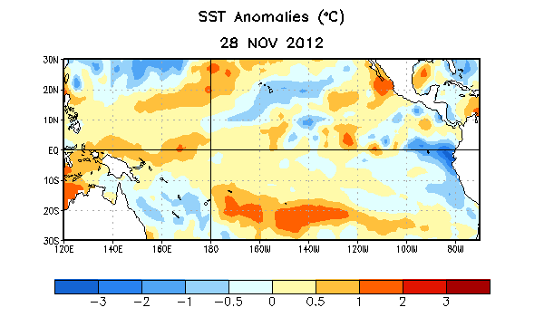
Figure 1. Average sea surface temperature (SST) anomalies (°C) for the week centered on 28 November 2012. Anomalies are computed with respect to the 1981-2010 base period weekly means.

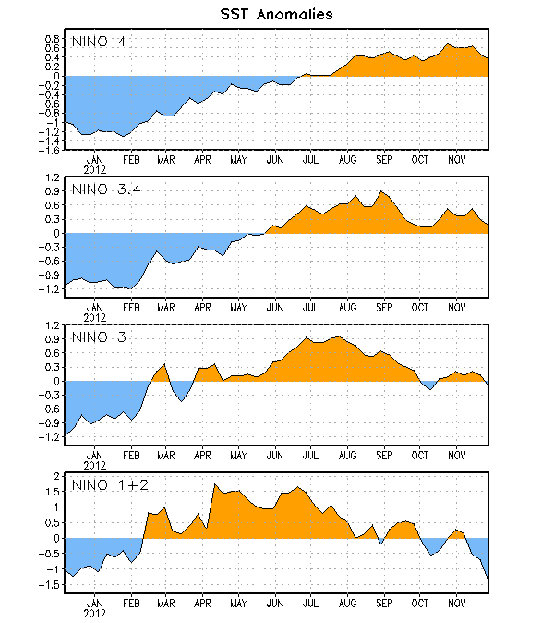
Figure 2. Time series of area-averaged sea surface temperature (SST) anomalies (°C) in the Niño regions [Niño-1+2 (0°-10°S, 90°W-80°W), Niño 3 (5°N-5°S, 150°W-90°W), Niño-3.4 (5°N-5°S, 170°W-120°W), Niño-4 (150ºW-160ºE and 5ºN-5ºS)]. SST anomalies are departures from the 1981-2010 base period weekly means.

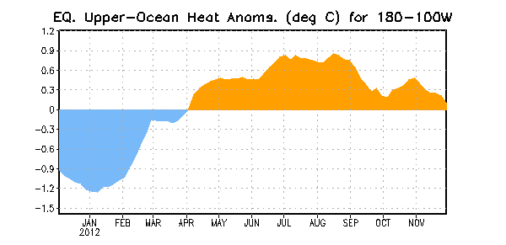
Figure 3. Area-averaged upper-ocean heat content anomaly (°C) in the equatorial Pacific (5°N-5°S, 180º-100ºW). The heat content anomaly is computed as the departure from the 1981-2010 base period pentad means.

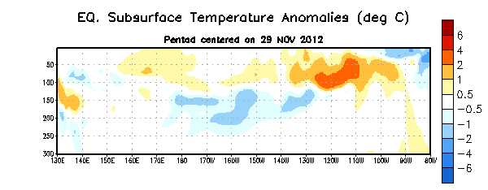
Figure 4. Depth-longitude section of equatorial Pacific upper-ocean (0-300m) temperature anomalies (°C) centered on the pentad of 29 November 2012. The anomalies are averaged between 5°N-5°S. Anomalies are departures from the 1981-2010 base period pentad means.

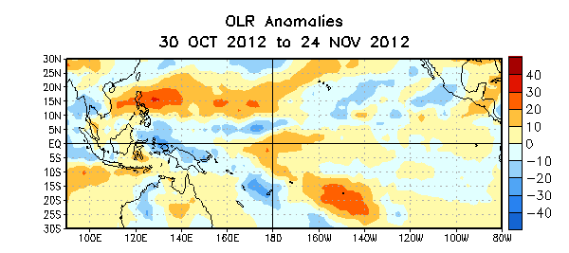

Figure 5. Average outgoing longwave radiation (OLR) anomalies (W/m²) for the four-week period 30 October – 24 November 2012. OLR anomalies are computed as departures from the 1979-1995 base period pentad means.

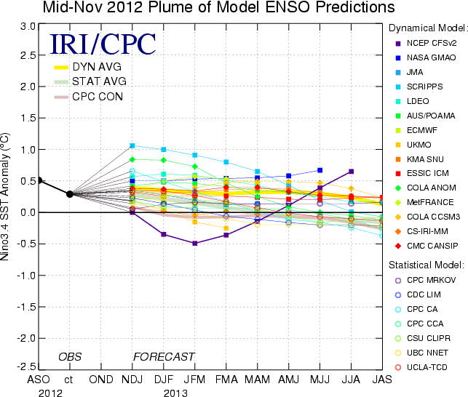
Figure 6. Forecasts of sea surface temperature (SST) anomalies for the Niño 3.4 region (5°N-5°S, 120°W-170°W). Figure courtesy of the International Research Institute (IRI) for Climate and Society. Figure updated 13 November 2012.

