EL NIÑO/SOUTHERN OSCILLATION (ENSO) DIAGNOSTIC DISCUSSION

issued by

CLIMATE PREDICTION CENTER/NCEP/NWS
and the International Research Institute for Climate and Society
10 December 2015

ENSO Alert System Status: El Niño Advisory

Synopsis: El Niño is expected to remain strong through the Northern Hemisphere winter 2015-16, with a transition to ENSO-neutral anticipated during late spring or early summer 2016.
A strong El Niño continued during November as indicated by well above-average sea surface temperatures (SSTs) across the central and eastern equatorial Pacific Ocean (Fig. 1). The Niño-4, Niño-3.4 and Niño-3 indices rose to their highest levels so far during this event, while the Niño-1+2 index remained approximately steady (Fig. 2). The subsurface temperatures in the central and eastern Pacific, while still well above average, decreased slightly (Fig. 3) due to the eastward push of the upwelling phase of an equatorial oceanic Kelvin wave (Fig. 4). Low-level westerly wind anomalies and upper-level easterly wind anomalies continued over the most of the tropical Pacific. The traditional and equatorial Southern Oscillation Index (SOI) values remained negative. These conditions are associated with enhanced convection over the central tropical Pacific and suppressed convection over Indonesia (Fig. 5). Collectively, these atmospheric and oceanic anomalies reflect a strong El Niño episode that has matured.
Most models indicate that a strong El Niño will continue through the Northern Hemisphere winter 2015-16, followed by weakening and a transition to ENSO-neutral during the late spring or early summer (Fig. 6). The forecaster consensus remains nearly unchanged from last month, with the expectation that this El Niño will rank among the three strongest episodes as measured by the 3-month SST departures in the Niño 3.4 region dating back to 1950. El Niño is expected to remain strong through Northern Hemisphere winter 2015-16, with a transition to ENSO-neutral anticipated during the late spring or early summer 2016 (click CPC/IRI consensus forecast for the chance of each outcome for each 3-month period).
El Niño has already produced significant global impacts and is expected to affect temperature and precipitation patterns across the United States during the upcoming months (the 3-month seasonal outlook will be updated on Thursday December 17th). Seasonal outlooks indicate an increased likelihood of above-median precipitation across the southern tier of the United States, and below-median precipitation over the northern tier of the United States. Above-average temperatures are favored in the West and northern half of the country with below-average favored in the southern Plains and along the Gulf Coast.
This discussion is a consolidated effort of the National Oceanic and Atmospheric Administration (NOAA), NOAA’s National Weather Service, and their funded institutions. Oceanic and atmospheric conditions are updated weekly on the Climate Prediction Center web site (El Niño/La Niña Current Conditions and Expert Discussions). Forecasts are also updated monthly in the Forecast Forum of CPC's Climate Diagnostics Bulletin. Additional perspectives and analysis are also available in an ENSO blog. The next ENSO Diagnostics Discussion is scheduled for 14 January 2016. To receive an e-mail notification when the monthly ENSO Diagnostic Discussions are released, please send an e-mail message to: ncep.list.enso-update@noaa.gov.

Climate Prediction Center
National Centers for Environmental Prediction
NOAA/National Weather Service
College Park, MD 20740

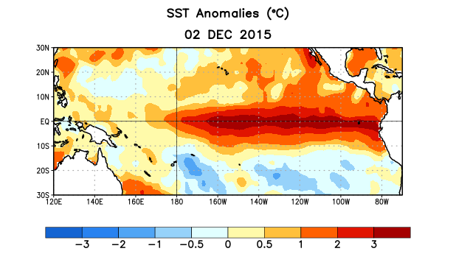
Figure 1. Average sea surface temperature (SST) anomalies (°C) for the week centered on 2 December 2015. Anomalies are computed with respect to the 1981-2010 base period weekly means.

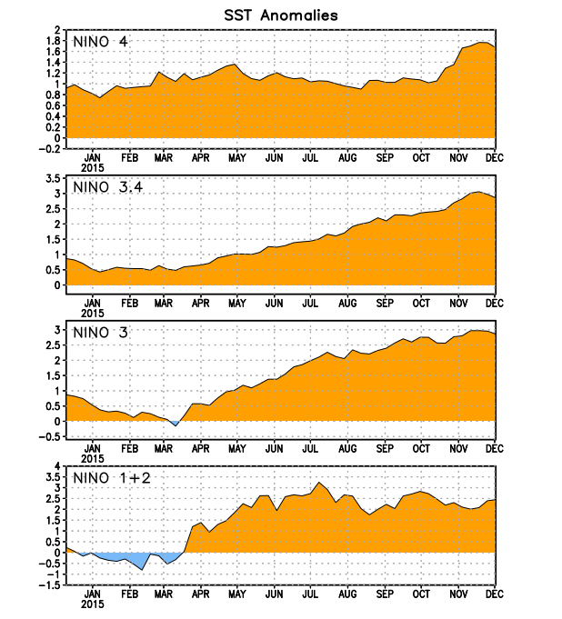
Figure 2. Time series of area-averaged sea surface temperature (SST) anomalies (°C) in the Niño regions [Niño-1+2 (0°-10°S, 90°W-80°W), Niño 3 (5°N-5°S, 150°W-90°W), Niño-3.4 (5°N-5°S, 170°W-120°W), Niño-4 (5ºN-5ºS , 150ºW-160ºE]. SST anomalies are departures from the 1981-2010 base period weekly means.
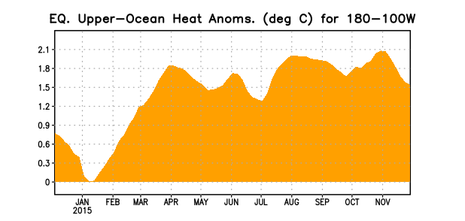
Figure 3. Area-averaged upper-ocean heat content anomaly (°C) in the equatorial Pacific (5°N-5°S, 180º-100ºW). The heat content anomaly is computed as the departure from the 1981-2010 base period pentad means.

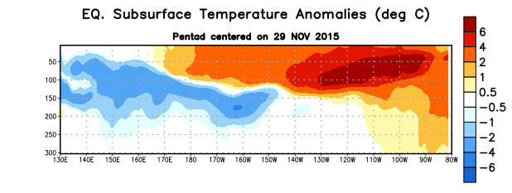
Figure 4. Depth-longitude section of equatorial Pacific upper-ocean (0-300m) temperature anomalies (°C)
centered on the pentad of 29 November 2015. The anomalies are averaged between 5°N-5°S. Anomalies are departures from the 1981-2010 base period pentad means.

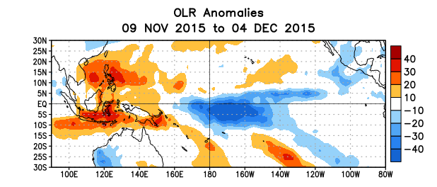
Figure 5. Average outgoing longwave radiation (OLR) anomalies (W/m²) for the period 9 November – 4 December 2015. OLR anomalies are computed as departures from the 1979-1995 base period pentad means.

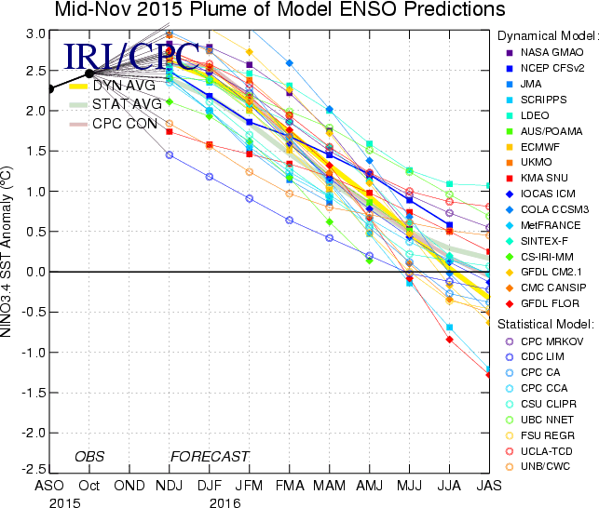

Figure 6. Forecasts of sea surface temperature (SST) anomalies for the Niño 3.4 region (5°N-5°S, 120°W-170°W). Figure updated 17 November 2015.

