EL NIÑO/SOUTHERN OSCILLATION (ENSO) DIAGNOSTIC DISCUSSION

issued by

CLIMATE PREDICTION CENTER/NCEP/NWS
and the International Research Institute for Climate and Society
8 December 2016

ENSO Alert System Status: La Niña Advisory

Synopsis: La Niña conditions are present, with a transition to ENSO-neutral favored during January-March 2017.
La Niña conditions persisted during November, with negative sea surface temperature (SST) anomalies present across most of the central and eastern equatorial Pacific (Fig. 1). The Niño indices remained negative during November, except for the Niño1+2 index which reflected near-average SSTs in the extreme eastern Pacific late in the month (Fig. 2). Also, the upper-ocean heat content remained below average (Fig. 3) in association with cooler temperatures at depth (Fig. 4), although this cooling lessened somewhat during the month. Atmospheric convection remained suppressed over the central tropical Pacific and enhanced over part of Indonesia (Fig. 5). The low-level easterly winds remained enhanced in the west-central tropical Pacific, and upper-level westerly winds persisted across the tropical Pacific. However, these signals were masked at times by intra-seasonal activity. Overall, the ocean and atmosphere system during November reflected a continuation of weak La Niña conditions.

The multi-model averages favor La Niña (3-month average Niño-3.4 index ≤ -0.5°C) to continue through December – February (DJF) 2016-17 (Fig. 6). Given the current conditions and the model forecasts, the forecaster consensus also favors the continuation of weak La Niña conditions through DJF 2016-17. In summary, La Niña conditions are present, with a transition to ENSO-neutral favored during January – March 2017 (click CPC/IRI consensus forecast for the chance of each outcome for each 3-month period).

La Niña is anticipated to affect temperature and precipitation across the United States during the upcoming months (NOAA’s 3-month seasonal outlook will be updated on Thursday December 15th). The current seasonal outlook for DJF 2016-17 favors above-average temperatures and below-median precipitation across much of the southern tier of the U.S., and below-average temperatures and above-median precipitation in portions of the northern tier of the U.S.

This discussion is a consolidated effort of the National Oceanic and Atmospheric Administration (NOAA), NOAA’s National Weather Service, and their funded institutions. Oceanic and atmospheric conditions are updated weekly on the Climate Prediction Center web site (El Niño/La Niña Current Conditions and Expert Discussions). Forecasts are also updated monthly in the Forecast Forum of CPC's Climate Diagnostics Bulletin. Additional perspectives and analysis are also available in an ENSO blog. The next ENSO Diagnostics Discussion is scheduled for 12 January 2017. To receive an e-mail notification when the monthly ENSO Diagnostic Discussions are released, please send an e-mail message to: ncep.list.enso-update@noaa.gov.

Climate Prediction Center
National Centers for Environmental Prediction
NOAA/National Weather Service
College Park, MD 20740

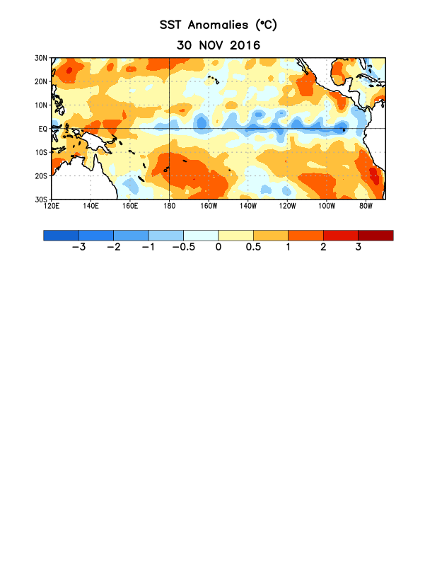
Figure 1. Average sea surface temperature (SST) anomalies (°C) for the week centered on 30 November 2016. Anomalies are computed with respect to the 1981-2010 base period weekly means.

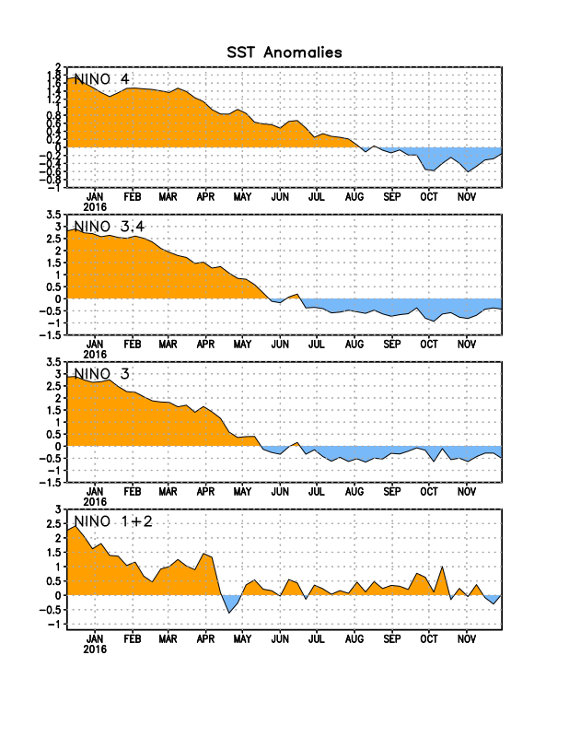
Figure 2. Time series of area-averaged sea surface temperature (SST) anomalies (°C) in the Niño regions [Niño-1+2 (0°-10°S, 90°W-80°W), Niño 3 (5°N-5°S, 150°W-90°W), Niño-3.4 (5°N-5°S, 170°W-120°W), Niño-4 (5ºN-5ºS , 150ºW-160ºE]. SST anomalies are departures from the 1981-2010 base period weekly means.
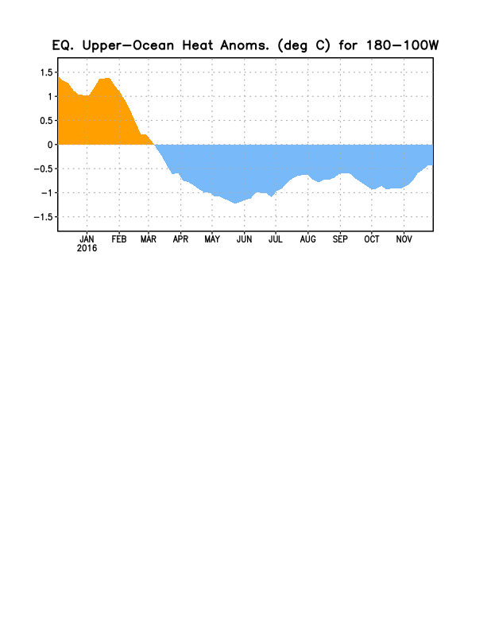
Figure 3. Area-averaged upper-ocean heat content anomaly (°C) in the equatorial Pacific (5°N-5°S, 180º-100ºW). The heat content anomaly is computed as the departure from the 1981-2010 base period pentad means.

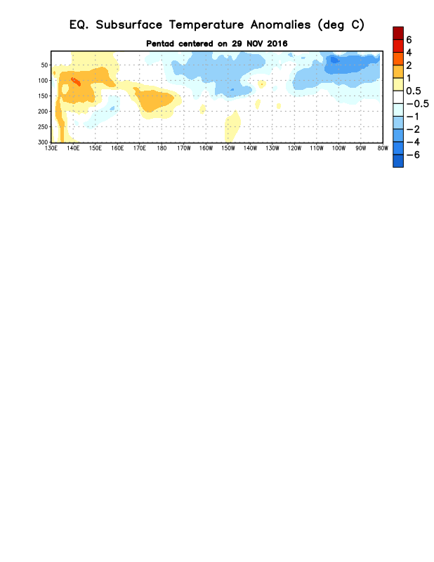
Figure 4. Depth-longitude section of equatorial Pacific upper-ocean (0-300m) temperature anomalies (°C) centered on the pentad of 29 November 2016. The anomalies are averaged between 5°N-5°S. Anomalies are departures from the 1981-2010 base period pentad means.

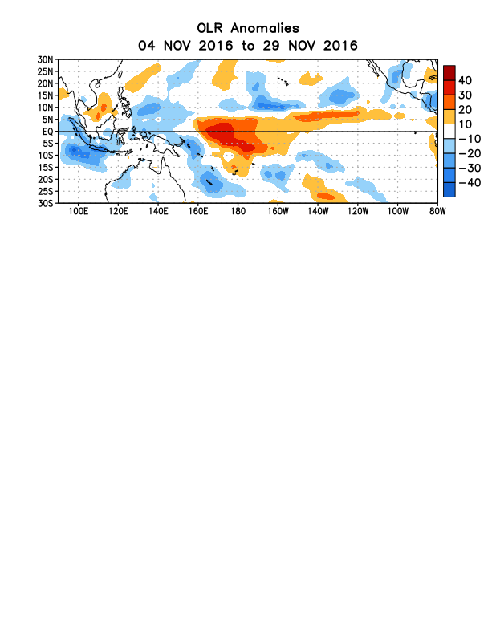
Figure 5. Average outgoing longwave radiation (OLR) anomalies (W/m²) for the period 4– 29 November 2016. OLR anomalies are computed as departures from the 1981-2010 base period pentad means.

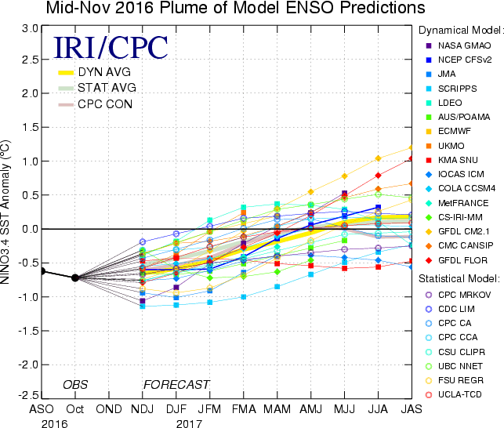

Figure 6. Forecasts of sea surface temperature (SST) anomalies for the Niño 3.4 region (5°N-5°S, 120°W-170°W). Figure updated 15 November 2016.

