EL NIÑO/SOUTHERN OSCILLATION (ENSO) DIAGNOSTIC DISCUSSION

issued by

CLIMATE PREDICTION CENTER/NCEP/NWS
and the International Research Institute for Climate and Society
14 December 2017

ENSO Alert System Status: La Niña Advisory

Synopsis: La Niña is likely (exceeding ~80%) through the Northern Hemisphere winter 2017-18, with a transition to ENSO-neutral most likely during the mid-to-late spring.
La Niña strengthened during the past month, as indicated by an increasingly prominent pattern of below-average sea surface temperatures (SSTs) across the central and eastern equatorial Pacific Ocean (Fig. 1). The latest weekly Niño-3.4 index value was -0.8°C, with the easternmost Niño-3 and Niño-1+2 indices at or below -1.0°C during much of the month (Fig. 2). Sub-surface temperature anomalies weakened slightly during November, but remained significantly negative (Fig. 3) due to the anomalously shallow depth of the thermocline across the central and eastern Pacific (Fig. 4). The atmospheric circulation over the tropical Pacific Ocean also reflected La Niña, with convection suppressed near the International Date Line and enhanced over Indonesia (Fig. 5). The low-level trade winds were stronger than average over the western and central Pacific, with anomalous westerly winds at upper-levels. Overall, the ocean and atmosphere system reflects La Niña.
La Niña is predicted to persist through the Northern Hemisphere winter 2017-18 by nearly all models in the IRI/CPC plume (Fig. 6) and in the North American Multi-Model Ensemble (NMME; Fig. 7). Based on the latest observations and forecast guidance, forecasters favor the peak of a weak-to-moderate La Niña during the winter (3-month Niño-3.4 values between -0.5°C and -1.5°C). In summary, La Niña is likely (exceeding ~80%) through the Northern Hemisphere winter 2017-18, with a transition to ENSO-neutral most likely during the mid-to-late spring (click CPC/IRI consensus forecast for the chance of each outcome for each 3-month period).
La Niña is anticipated to affect temperature and precipitation across the United States during the upcoming months (the 3-month seasonal temperature and precipitation outlooks will be updated on Thursday December 21st). The outlooks generally favor above-average temperatures and below-median precipitation across the southern tier of the United States, and below-average temperatures and above-median precipitation across the northern tier of the United States.
This discussion is a consolidated effort of the National Oceanic and Atmospheric Administration (NOAA), NOAA’s National Weather Service, and their funded institutions. Oceanic and atmospheric conditions are updated weekly on the Climate Prediction Center web site (El Niño/La Niña Current Conditions and Expert Discussions). Forecasts are also updated monthly in the Forecast Forum of CPC's Climate Diagnostics Bulletin. Additional perspectives and analysis are also available in an ENSO blog. The next ENSO Diagnostics Discussion is scheduled for 11 January 2018. To receive an e-mail notification when the monthly ENSO Diagnostic Discussions are released, please send an e-mail message to: ncep.list.enso-update@noaa.gov.

Climate Prediction Center
National Centers for Environmental Prediction
NOAA/National Weather Service
College Park, MD 20740

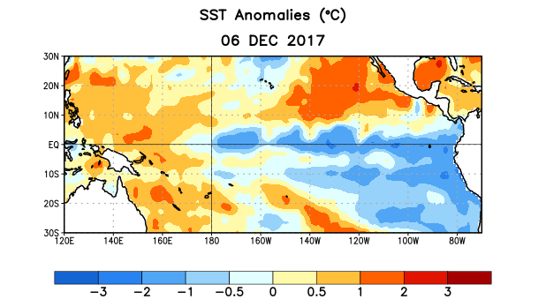
Figure 1. Average sea surface temperature (SST) anomalies (°C) for the week centered on 6 December 2017. Anomalies are computed with respect to the 1981-2010 base period weekly means.

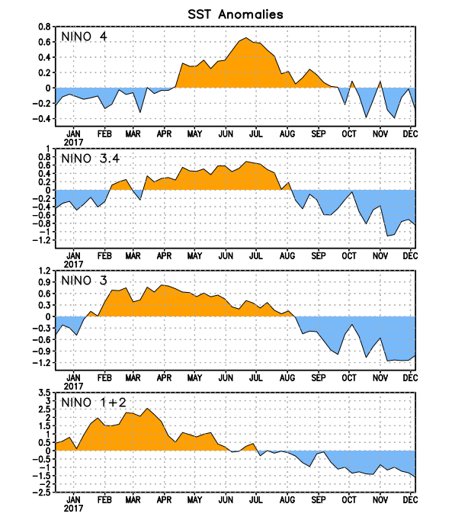
Figure 2. Time series of area-averaged sea surface temperature (SST) anomalies (°C) in the Niño regions [Niño-1+2 (0°-10°S, 90°W-80°W), Niño-3 (5°N-5°S, 150°W-90°W), Niño-3.4 (5°N-5°S, 170°W-120°W), Niño-4 (5ºN-5ºS , 150ºW-160ºE]. SST anomalies are departures from the 1981-2010 base period weekly means.
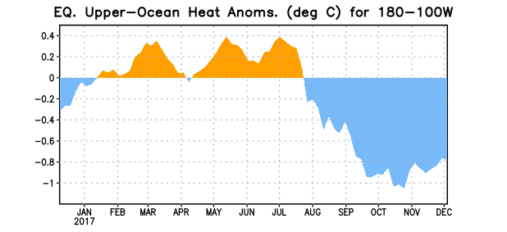
Figure 3. Area-averaged upper-ocean heat content anomaly (°C) in the equatorial Pacific (5°N-5°S, 180º-100ºW). The heat content anomaly is computed as the departure from the 1981-2010 base period pentad means.

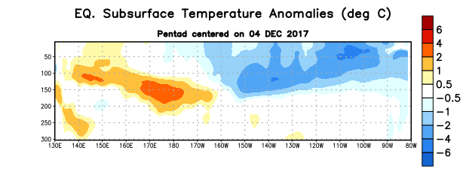
Figure 4. Depth-longitude section of equatorial Pacific upper-ocean (0-300m) temperature anomalies (°C) centered on the pentad of 4 December 2017. Anomalies are departures from the 1981-2010 base period pentad means.

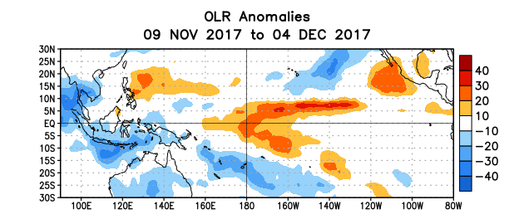
Figure 5. Average outgoing longwave radiation (OLR) anomalies (W/m²) for the period 9 November – 4 December 2017. OLR anomalies are computed as departures from the 1981-2010 base period pentad means.

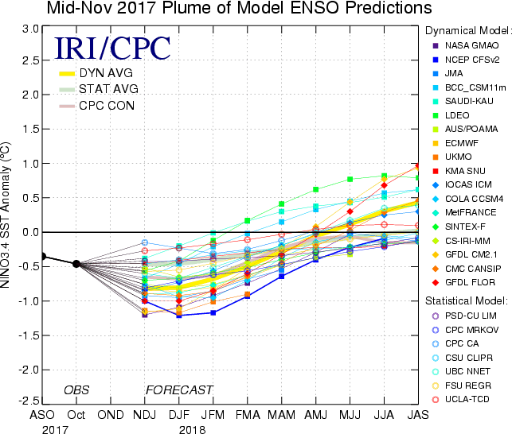

Figure 6. Forecasts of sea surface temperature (SST) anomalies for the Niño 3.4 region (5°N-5°S, 120°W-170°W). Figure updated 17 November 2017.
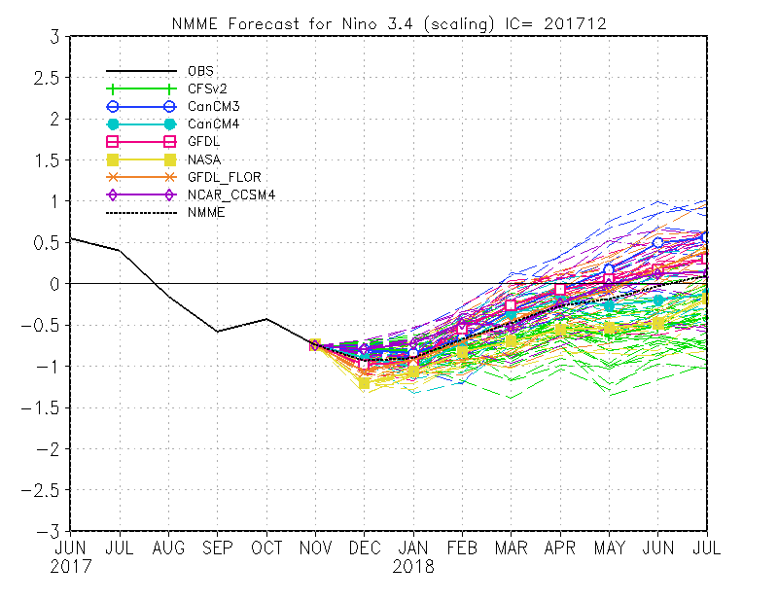
Figure 7. Forecasts of sea surface temperature (SST) anomalies for the Niño 3.4 region (5°N-5°S, 120°W-170°W) from the North American Multi-Model Ensemble. Figure updated 6 December 2017.

