EL NIÑO/SOUTHERN OSCILLATION (ENSO) DIAGNOSTIC DISCUSSION

issued by

CLIMATE PREDICTION CENTER/NCEP/NWS

and the International Research Institute for Climate and Society

13 December 2018

ENSO Alert System Status: El Niño Watch

Synopsis: El Niño is expected to form and continue through the Northern Hemisphere winter 2018-19 (~90% chance) and through spring (~60% chance).

ENSO-neutral continued during November, despite the continuation of above-average sea surface temperatures (SSTs) across the equatorial Pacific Ocean (Fig. 1). The latest weekly SST indices for all four Niño regions were near +1.0°C (Fig. 2). Positive subsurface temperature anomalies (averaged across 180°-100°W) weakened slightly (Fig. 3), but above-average temperatures persist at depth across the central and eastern equatorial Pacific Ocean (Fig. 4). However, the atmospheric anomalies largely reflected intra-seasonal variability related to the Madden-Julian Oscillation, and have not yet shown a clear coupling to the above-average ocean temperatures. For the month as a whole, atmospheric convection remained close to average near the Date Line and suppressed over Indonesia (Fig. 5). Also, the low-level and upper level winds were mostly near average across the equatorial Pacific. The equatorial Southern Oscillation index (SOI) was negative, while the traditional SOI was near zero. Despite the above-average ocean temperatures, the overall coupled ocean-atmosphere system remained ENSO-neutral.
The majority of models in the IRI/CPC plume predict a Niño3.4 index of +0.5°C or greater to continue through the winter and spring (Fig. 6). The official forecast favors the formation of a weak El Niño, with the expectation that the atmospheric circulation will eventually couple to the anomalous equatorial Pacific warmth. In summary, El Niño is expected to form and continue through the Northern Hemisphere winter 2018-19 (~90% chance) and spring (~60% chance; click CPC/IRI consensus forecast for the chance of each outcome for each 3-month period).
This discussion is a consolidated effort of the National Oceanic and Atmospheric Administration (NOAA), NOAA’s National Weather Service, and their funded institutions. Oceanic and atmospheric conditions are updated weekly on the Climate Prediction Center web site (El Niño/La Niña Current Conditions and Expert Discussions). Forecasts are also updated monthly in the Forecast Forum of CPC's Climate Diagnostics Bulletin. Additional perspectives and analysis are also available in an ENSO blog. The next ENSO Diagnostics Discussion is scheduled for 10 January 2019. To receive an e-mail notification when the monthly ENSO Diagnostic Discussions are released, please send an e-mail message to: ncep.list.enso-update@noaa.gov.

Climate Prediction Center
National Centers for Environmental Prediction
NOAA/National Weather Service
College Park, MD 20740

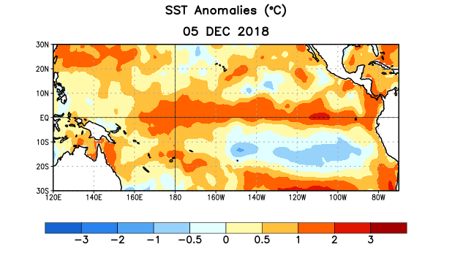
Figure 1. Average sea surface temperature (SST) anomalies (°C) for the week centered on 5 December 2018. Anomalies are computed with respect to the 1981-2010 base period weekly means.

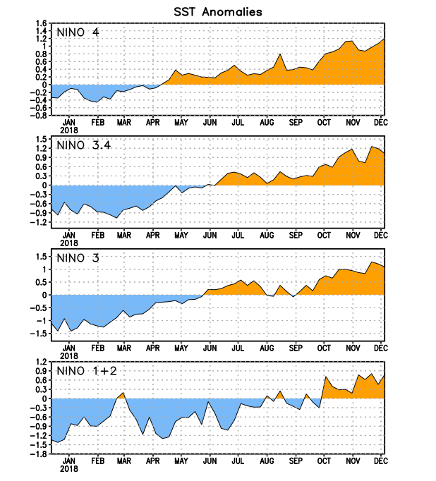
Figure 2. Time series of area-averaged sea surface temperature (SST) anomalies (°C) in the Niño regions [Niño-1+2 (0°-10°S, 90°W-80°W), Niño-3 (5°N-5°S, 150°W-90°W), Niño-3.4 (5°N-5°S, 170°W-120°W), Niño-4 (5ºN-5ºS , 150ºW-160ºE)]. SST anomalies are departures from the 1981-2010 base period weekly means.
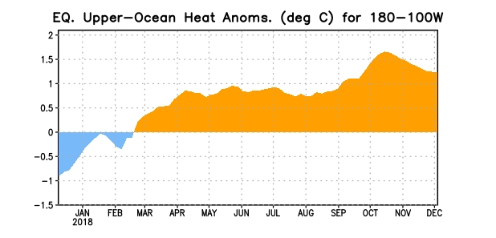
Figure 3. Area-averaged upper-ocean heat content anomaly (°C) in the equatorial Pacific (5°N-5°S, 180º-100ºW). The heat content anomaly is computed as the departure from the 1981-2010 base period pentad means.

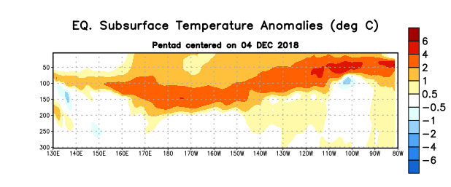
Figure 4. Depth-longitude section of equatorial Pacific upper-ocean (0-300m) temperature anomalies (°C) centered on the pentad of 4 December 2018. Anomalies are departures from the 1981-2010 base period pentad means.

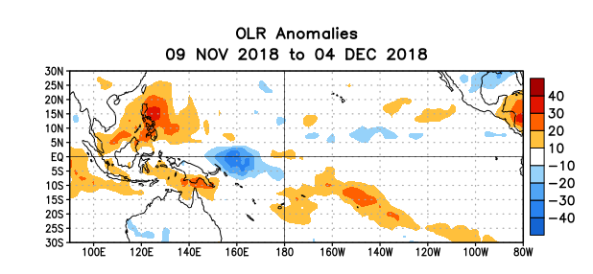
Figure 5. Average outgoing longwave radiation (OLR) anomalies (W/m²) for the period 9 November – 4 December 2018. OLR anomalies are computed as departures from the 1981-2010 base period pentad means.

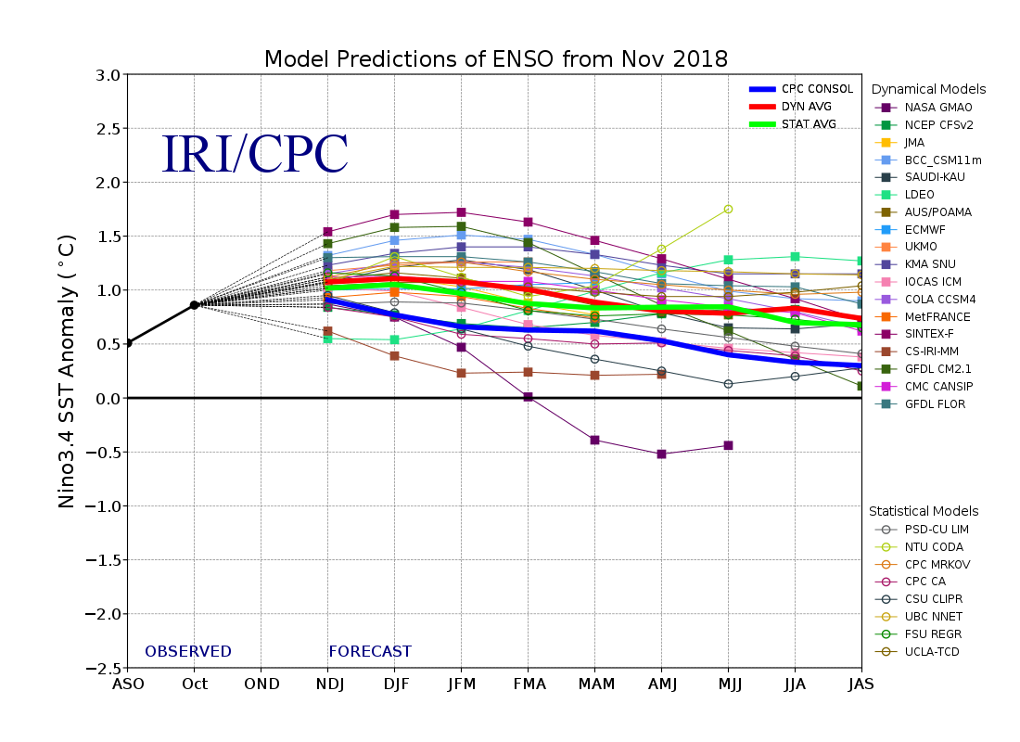
Figure 6. Forecasts of sea surface temperature (SST) anomalies for the Niño 3.4 region (5°N-5°S, 120°W-170°W). Figure updated 19 November 2018.

