EL NIÑO/SOUTHERN OSCILLATION (ENSO) DIAGNOSTIC DISCUSSION

issued by

CLIMATE PREDICTION CENTER/NCEP/NWS

and the International Research Institute for Climate and Society

12 December 2019

ENSO Alert System Status: Not Active

Synopsis: ENSO-neutral is favored during the Northern Hemisphere winter 2019-20 (70% chance), continuing through spring 2020 (~65% chance).

Above-average sea surface temperatures (SSTs) were observed in the central tropical Pacific Ocean during November, with regions of above and below average SSTs observed farther east (Fig. 1). In the most recent week, the SST indices were near average in the east-central and eastern Niño regions (+0.1°C to +0.3°C) and were above average in the westernmost Niño-4 region (+0.9°C; Fig. 2). The equatorial subsurface temperature anomalies (averaged across 180°-100°W) returned to near zero during the month (Fig. 3), reflecting the progression of Kelvin waves to the east (Fig. 4). The low-level winds were near average during November, while easterly upper-level wind anomalies were observed over the western Pacific. Finally, tropical convection was suppressed near and east of the Date Line and also over Indonesia, and somewhat enhanced over the western Pacific northeast of Papua New Guinea (Fig. 5). The overall oceanic and atmospheric system was consistent with ENSO-neutral.
The majority of models in the IRI/CPC plume (Fig. 6) continue to favor ENSO-neutral (Niño-3.4 index between -0.5°C and +0.5°C) through the Northern Hemisphere summer. Many dynamical model forecasts suggest Niño-3.4 SST index values may remain near +0.5°C into December before decreasing toward zero. Forecasters agree with this consensus and believe the chances for El Niño to be 25-30% during the winter and spring. In summary, ENSO-neutral is favored during the Northern Hemisphere winter 2019-20 (70% chance), continuing through spring 2020 (~65% chance; click CPC/IRI consensus forecast for the chance of each outcome for each 3-month period).
This discussion is a consolidated effort of the National Oceanic and Atmospheric Administration (NOAA), NOAA’s National Weather Service, and their funded institutions. Oceanic and atmospheric conditions are updated weekly on the Climate Prediction Center web site (El Niño/La Niña Current Conditions and Expert Discussions). Forecasts are also updated monthly in the Forecast Forum of CPC's Climate Diagnostics Bulletin. Additional perspectives and analysis are also available in an ENSO blog. The next ENSO Diagnostics Discussion is scheduled for 9 January 2020. To receive an e-mail notification when the monthly ENSO Diagnostic Discussions are released, please send an e-mail message to: ncep.list.enso-update@noaa.gov.

Climate Prediction Center
National Centers for Environmental Prediction
NOAA/National Weather Service
College Park, MD 20740

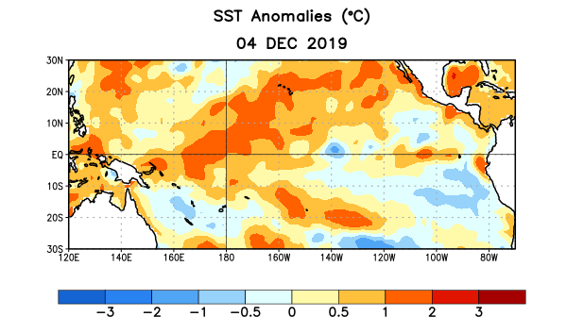
Figure 1. Average sea surface temperature (SST) anomalies (°C) for the week centered on 4 December 2019. Anomalies are computed with respect to the 1981-2010 base period weekly means.

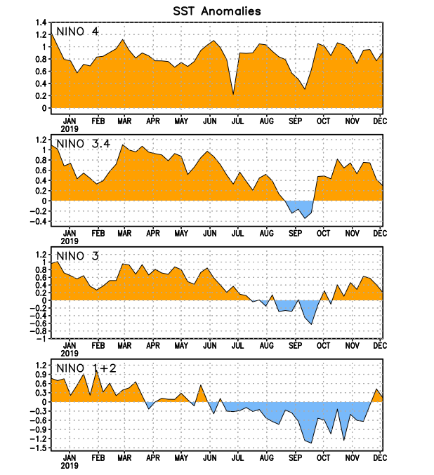
Figure 2. Time series of area-averaged sea surface temperature (SST) anomalies (°C) in the Niño regions [Niño-1+2 (0°-10°S, 90°W-80°W), Niño-3 (5°N-5°S, 150°W-90°W), Niño-3.4 (5°N-5°S, 170°W-120°W), Niño-4 (5ºN-5ºS , 150ºW-160ºE)]. SST anomalies are departures from the 1981-2010 base period weekly means.
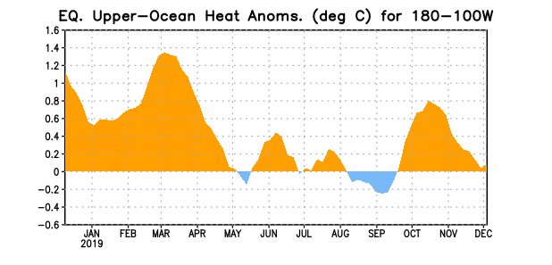
Figure 3. Area-averaged upper-ocean heat content anomaly (°C) in the equatorial Pacific (5°N-5°S, 180º-100ºW). The heat content anomaly is computed as the departure from the 1981-2010 base period pentad means.

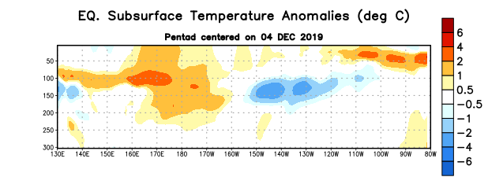
Figure 4. Depth-longitude section of equatorial Pacific upper-ocean (0-300m) temperature anomalies (°C) centered on the pentad of 4 December 2019. Anomalies are departures from the 1981-2010 base period pentad means.

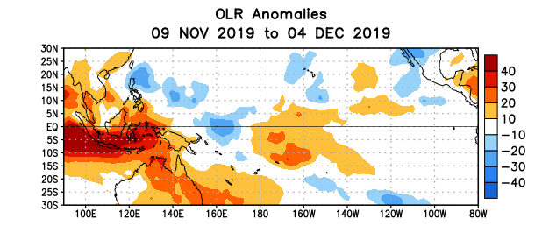
Figure 5. Average outgoing longwave radiation (OLR) anomalies (W/m²) for the period 9 November – 4 December 2019. OLR anomalies are computed as departures from the 1981-2010 base period pentad means.

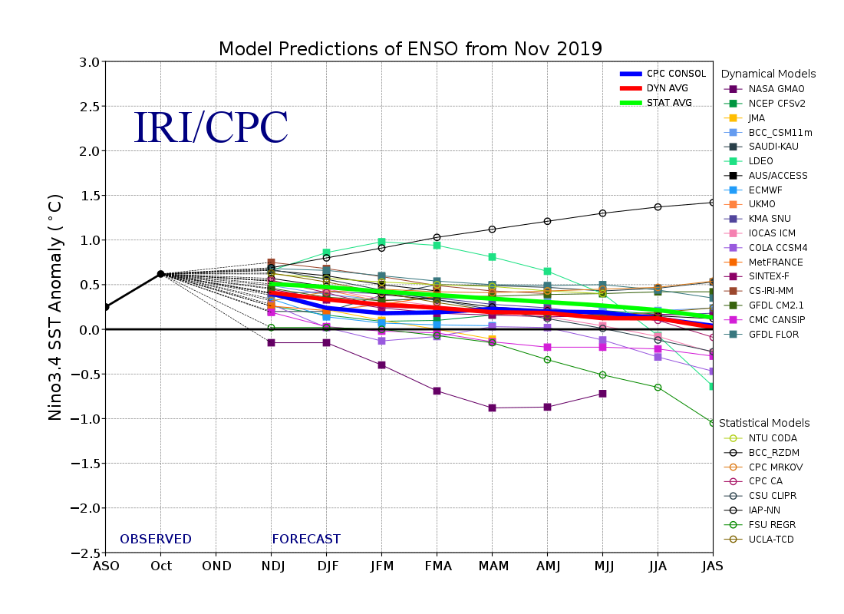
Figure 6. Forecasts of sea surface temperature (SST) anomalies for the Niño 3.4 region (5°N-5°S, 120°W-170°W). Figure updated 19 November 2019.

