EL NIÑO/SOUTHERN OSCILLATION (ENSO) DIAGNOSTIC DISCUSSION

issued by

CLIMATE PREDICTION CENTER/NCEP/NWS

and the International Research Institute for Climate and Society

10 December 2020

ENSO Alert System Status: La Niña Advisory

Synopsis: La Niña is likely to continue through the Northern Hemisphere winter 2020-21 (~95% chance during January-March), with a potential transition during the spring 2021 (~50% chance of Neutral during April-June).

La Niña persisted during November, as indicated by well below-average sea surface temperatures (SSTs) extending from the Date Line to the eastern Pacific Ocean (Fig. 1). Most of the weekly indices fluctuated through the month, with the westernmost Niño regions Niño-4 and Niño-3.4 ending up around -1.0ºC (Fig. 2). The negative equatorial subsurface temperature anomalies (averaged from 180°-100°W) weakened slightly last month (Fig. 3), but continued to reflect below-average temperatures from the surface to 200m depth in the eastern Pacific Ocean (Fig. 4). The atmospheric circulation over the tropical Pacific Ocean remained consistent with La Niña. Over the western and central tropical Pacific Ocean, low-level wind anomalies were easterly and upper-level wind anomalies were westerly. Tropical convection continued to be suppressed from the western Pacific to the Date Line (Fig. 5). Also, both the Southern Oscillation and Equatorial Southern Oscillation indices were positive. Overall, the coupled ocean-atmosphere system indicates the continuation of La Niña.
A majority of the models in the IRI/CPC plume predict La Niña (Niño-3.4 index less than -0.5°C) to persist through the Northern Hemisphere winter 2020-21 and to weaken through the spring (Fig. 6). Supported by the latest forecasts from several models, the forecaster consensus is for a moderate strength La Niña (Niño-3.4 index values between -1.0ºC and -1.5ºC) during the peak November-January season. In summary, La Niña is likely to continue through the Northern Hemisphere winter 2020-21 (~95% chance for January-March), with a potential transition during the spring 2021 (~50% chance of Neutral during Apr-Jun; click CPC/IRI consensus forecast for the chances in each 3-month period).
La Niña is anticipated to affect climate across the United States during the upcoming months. The 3-month seasonal temperature and precipitation outlooks will be updated on Thursday December 17th.
This discussion is a consolidated effort of the National Oceanic and Atmospheric Administration (NOAA), NOAA’s National Weather Service, and their funded institutions. Oceanic and atmospheric conditions are updated weekly on the Climate Prediction Center web site (El Niño/La Niña Current Conditions and Expert Discussions). Additional perspectives and analysis are also available in an ENSO blog. A probabilistic strength forecast is available here. The next ENSO Diagnostics Discussion is scheduled for 14 January 2021. To receive an e-mail notification when the monthly ENSO Diagnostic Discussions are released, please send an e-mail message to: ncep.list.enso-update@noaa.gov.

Climate Prediction Center
National Centers for Environmental Prediction
NOAA/National Weather Service
College Park, MD 20740

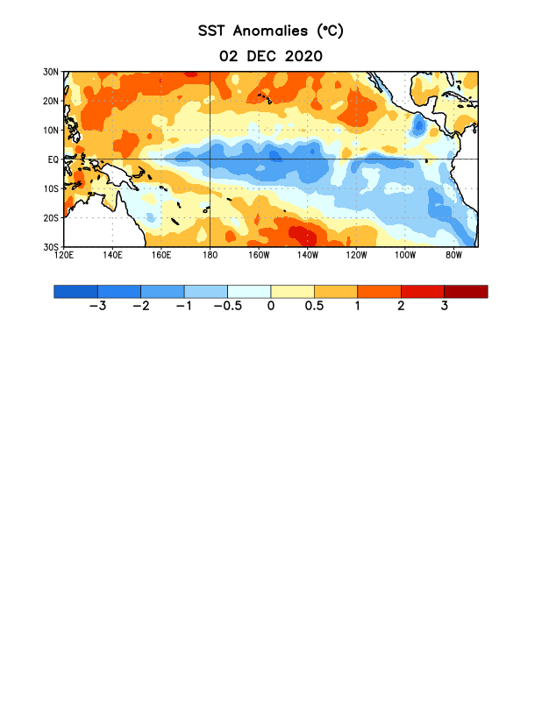
Figure 1. Average sea surface temperature (SST) anomalies (°C) for the week centered on 2 December 2020. Anomalies are computed with respect to the 1981-2010 base period weekly means.

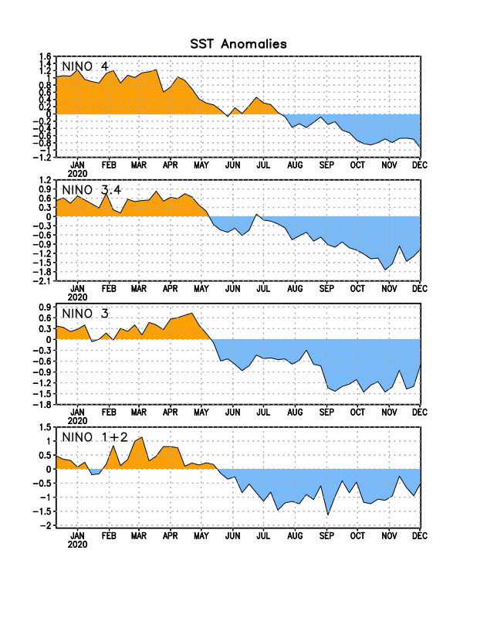
Figure 2. Time series of area-averaged sea surface temperature (SST) anomalies (°C) in the Niño regions [Niño-1+2 (0°-10°S, 90°W-80°W), Niño-3 (5°N-5°S, 150°W-90°W), Niño-3.4 (5°N-5°S, 170°W-120°W), Niño-4 (5ºN-5ºS , 150ºW-160ºE)]. SST anomalies are departures from the 1981-2010 base period weekly means.
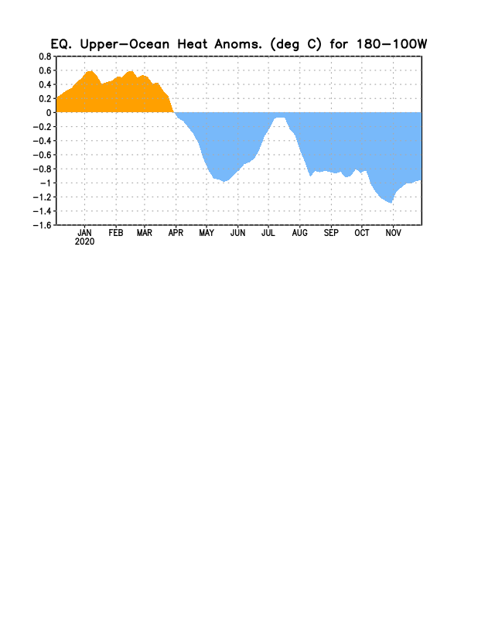
Figure 3. Area-averaged upper-ocean heat content anomaly (°C) in the equatorial Pacific (5°N-5°S, 180º-100ºW). The heat content anomaly is computed as the departure from the 1981-2010 base period pentad means.

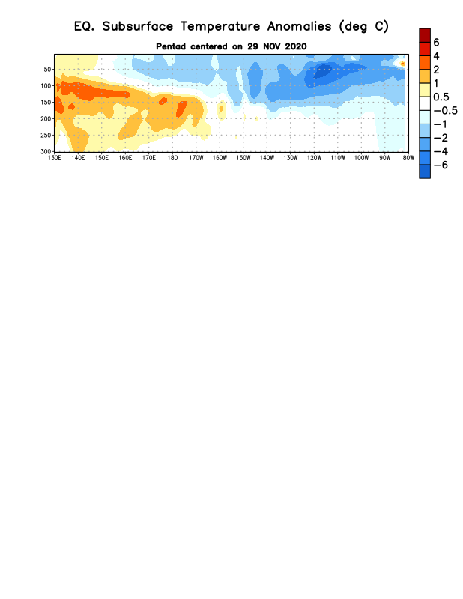
Figure 4. Depth-longitude section of equatorial Pacific upper-ocean (0-300m) temperature anomalies (°C) centered on the pentad of 29 November 2020. Anomalies are departures from the 1981-2010 base period pentad means.

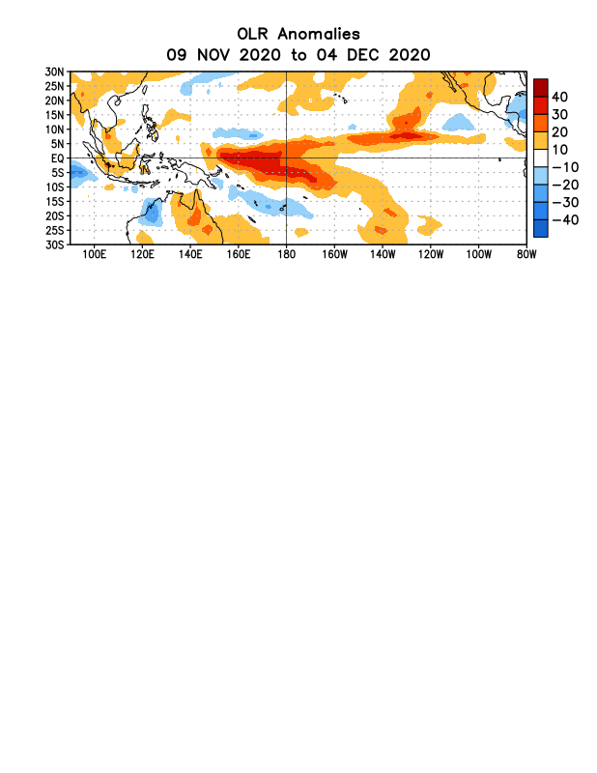
Figure 5. Average outgoing longwave radiation (OLR) anomalies (W/m²) for the period 9 November – 4 December 2020. OLR anomalies are computed as departures from the 1981-2010 base period pentad means.

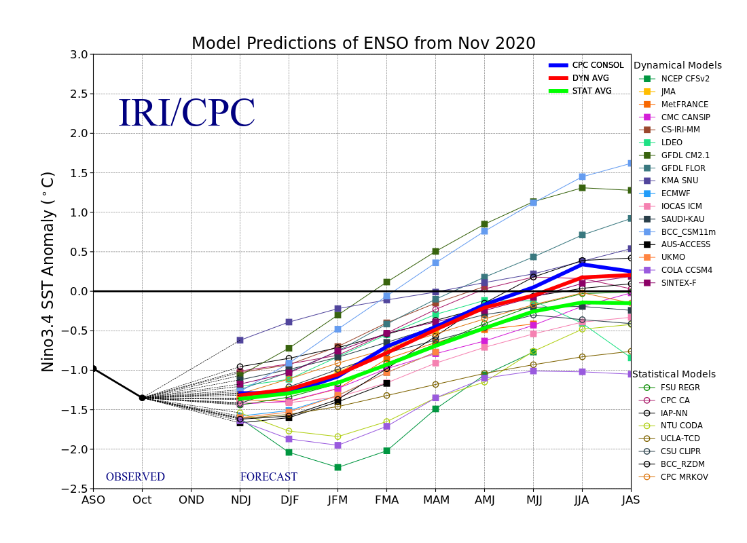
Figure 6. Forecasts of sea surface temperature (SST) anomalies for the Niño 3.4 region (5°N-5°S, 120°W-170°W). Figure updated 19 November 2020.

