EL NIÑO/SOUTHERN OSCILLATION (ENSO) DIAGNOSTIC DISCUSSION

issued by

CLIMATE PREDICTION CENTER/NCEP/NWS

and the International Research Institute for Climate and Society

9 December 2021

ENSO Alert System Status: La Niña Advisory

Synopsis: La Niña is favored to continue through the Northern Hemisphere winter 2021-22 (~95% chance) and transition to ENSO-neutral during the spring 2022 (~60% chance during April-June).

In November, the continuation of La Niña was reflected in the below-average sea surface temperatures (SSTs) extending across the equatorial Pacific Ocean (Fig. 1). In the last week, all of the Niño indices were between -0.7ºC and -1.2ºC, with the largest departures occurring in the easternmost regions of Niño-1+2 and Niño-3 (Fig. 2). Below-average subsurface temperatures weakened slightly compared to the previous month (Fig. 3), but a large pool of negative temperature anomalies still extended across the central and eastern Pacific, down to ~200m depth (Fig. 4). Low-level easterly and upper-level westerly wind anomalies persisted over most of the equatorial Pacific. Enhanced convection and rainfall were observed over Indonesia and convection was suppressed over the central and western equatorial Pacific (Fig. 5). The Southern Oscillation Index and Equatorial Southern Oscillation Index were more positive than the previous month. Overall, the coupled ocean-atmosphere system was consistent with La Niña.
The IRI/CPC plume average of forecasts for the Niño-3.4 SST index indicates La Niña will continue through the February-April 2022 season (Fig. 6). The forecaster consensus anticipates a transition to ENSO-neutral sometime during the Northern Hemisphere spring, with chances for La Niña declining below 50% after March-May 2022. The chance of a moderate-strength La Niña declined slightly from last month’s update, but there is still a 59% chance of the Niño-3.4 index reaching a value less than -1.0ºC for the November 2021 – January 2022 season. In summary, La Niña is favored to continue through the Northern Hemisphere winter 2021-22 (~95% chance) and transition to ENSO-neutral during the spring 2022 (~60% chance during April-June; click CPC/IRI consensus forecast for the chances in each 3-month period).
La Niña is anticipated to affect temperature and precipitation across the United States during the upcoming months (the 3-month seasonal temperature and precipitation outlooks will be updated on Thurs. Dec. 16th).
This discussion is a consolidated effort of the National Oceanic and Atmospheric Administration (NOAA), NOAA’s National Weather Service, and their funded institutions. Oceanic and atmospheric conditions are updated weekly on the Climate Prediction Center web site (El Niño/La Niña Current Conditions and Expert Discussions). Additional perspectives and analysis are also available in an ENSO blog. A probabilistic strength forecast is available here. The next ENSO Diagnostics Discussion is scheduled for 13 January 2022. To receive an e-mail notification when the monthly ENSO Diagnostic Discussions are released, please send an e-mail message to: ncep.list.enso-update@noaa.gov.

Climate Prediction Center
National Centers for Environmental Prediction
NOAA/National Weather Service
College Park, MD 20740

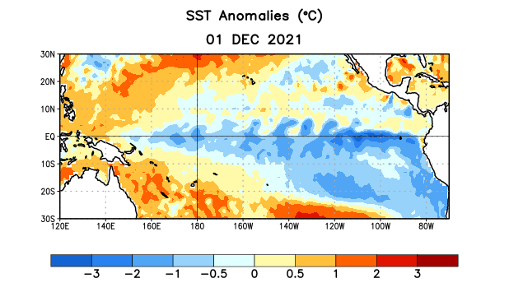
Figure 1. Average sea surface temperature (SST) anomalies (°C) for the week centered on 1 December 2021. Anomalies are computed with respect to the 1991-2020 base period weekly means.

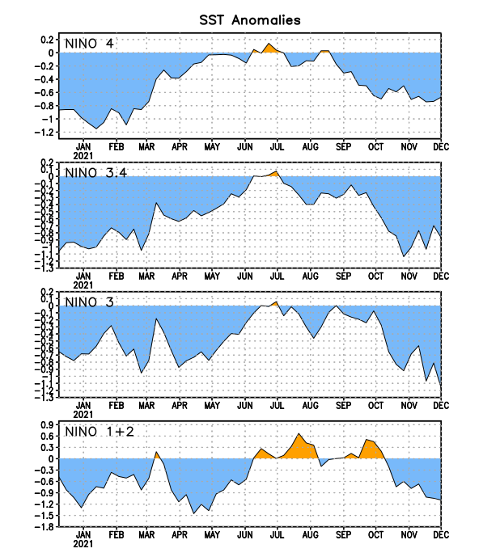
Figure 2. Time series of area-averaged sea surface temperature (SST) anomalies (°C) in the Niño regions [Niño-1+2 (0°-10°S, 90°W-80°W), Niño-3 (5°N-5°S, 150°W-90°W), Niño-3.4 (5°N-5°S, 170°W-120°W), Niño-4 (5ºN-5ºS, 150ºW-160ºE)]. SST anomalies are departures from the 1991-2020 base period weekly means.
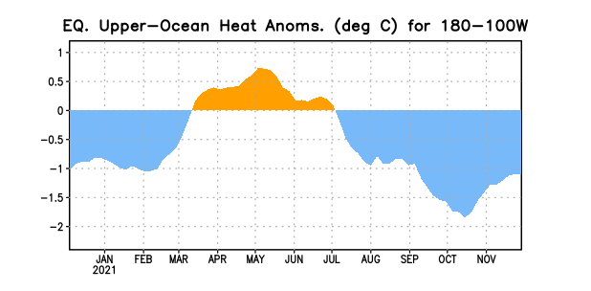
Figure 3. Area-averaged upper-ocean heat content anomaly (°C) in the equatorial Pacific (5°N-5°S, 180º-100ºW). The heat content anomaly is computed as the departure from the 1991-2020 base period pentad means.

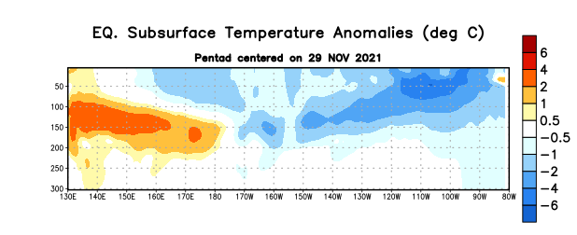

Figure 4. Depth-longitude section of equatorial Pacific upper-ocean (0-300m) temperature anomalies (°C) centered on the pentad of 29 November 2021. Anomalies are departures from the 1991-2020 base period pentad means.

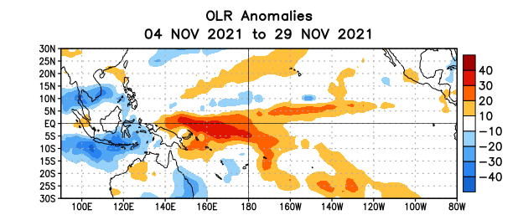
Figure 5. Average outgoing longwave radiation (OLR) anomalies (W/m²) for the period 4 – 29 November 2021. OLR anomalies are computed as departures from the 1991-2020 base period pentad means.

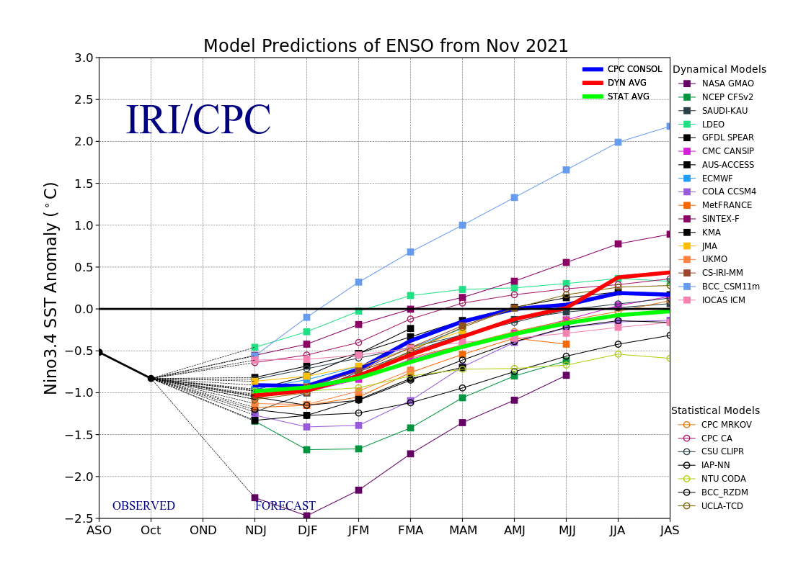
Figure 6. Forecasts of sea surface temperature (SST) anomalies for the Niño 3.4 region (5°N-5°S, 120°W-170°W). Figure updated 19 November 2021.

