EL NIÑO/SOUTHERN OSCILLATION (ENSO) DIAGNOSTIC DISCUSSION

issued by

CLIMATE PREDICTION CENTER/NCEP/NWS

8 December 2022

ENSO Alert System Status: La Niña Advisory

Synopsis: La Niña is expected to continue into the winter, with equal chances of La Niña and ENSO-neutral during January-March 2023. In February-April 2023, there is a 71% chance of ENSO-neutral.

Below-average sea surface temperatures (SSTs) persisted in the central and eastern Pacific Ocean during the past month (Fig. 1). All of the latest weekly Niño index values were near -1.0ºC, except for the Niño-1+2 index which was at -0.5ºC (Fig. 2). In November 2022, negative subsurface temperature anomalies weakened (Fig. 3), reflecting an eastward expansion of the above-average subsurface temperatures in the western and central Pacific and contraction of the below-average temperatures across the eastern Pacific (Fig. 4). Low-level easterly wind anomalies and upper-level westerly wind anomalies were evident across most of the equatorial Pacific throughout the month. The convection pattern continued to show suppressed convection over the western and central tropical Pacific and enhanced convection over Indonesia (Fig. 5). Overall, the coupled ocean-atmosphere system continued to reflect La Niña.
The most recent IRI plume indicates that La Niña will persist into the Northern Hemisphere winter 2022-23. For the dynamical model averages, ENSO-neutral is favored in January-March 2023, while the statistical model average shows the transition to ENSO-neutral occurs in February-April 2023 (Fig. 6). The forecaster consensus, which also considers the North American Multi-Model Ensemble (NMME), is split on whether La Niña or ENSO-neutral will prevail during January-March 2023. Regardless, there is higher confidence that ENSO-neutral will emerge by the Northern Hemisphere spring. In summary, La Niña is expected to continue into the winter, with equal chances of La Niña and ENSO-neutral during January-March 2023. In February-April 2023, there is a 71% chance of ENSO-neutral (Fig. 7).
This discussion is a consolidated effort of the National Oceanic and Atmospheric Administration (NOAA), NOAA’s National Weather Service, and their funded institutions. Oceanic and atmospheric conditions are updated weekly on the Climate Prediction Center website (El Niño/La Niña Current Conditions and Expert Discussions). Additional perspectives and analyses are also available in an ENSO blog. A probabilistic strength forecast is available here. The next ENSO Diagnostics Discussion is scheduled for 12 January 2023. To receive an e-mail notification when the monthly ENSO Diagnostic Discussions are released, please send an e-mail message to: ncep.list.enso-update@noaa.gov.

Climate Prediction Center
National Centers for Environmental Prediction
NOAA/National Weather Service
College Park, MD 20740

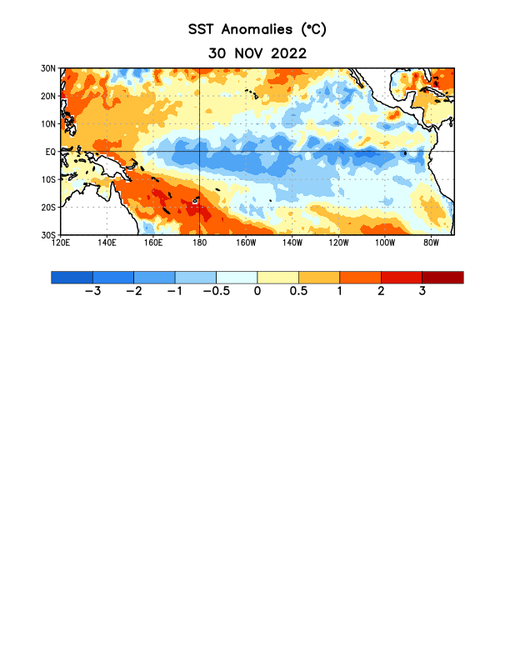
Figure 1. Average sea surface temperature (SST) anomalies (°C) for the week centered on 30 November 2022. Anomalies are computed with respect to the 1991-2020 base period weekly means.

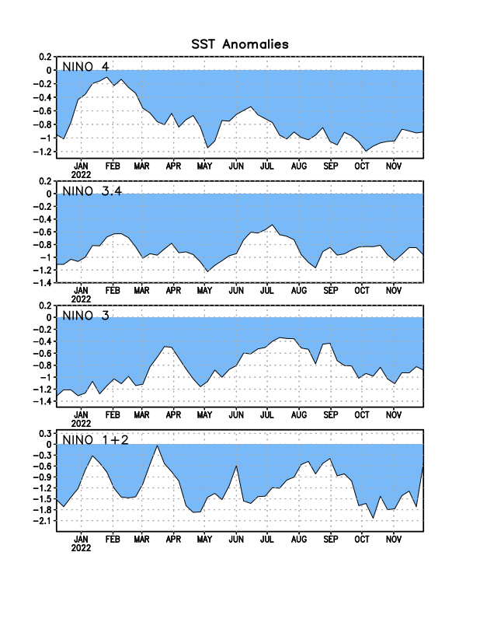
Figure 2. Time series of area-averaged sea surface temperature (SST) anomalies (°C) in the Niño regions [Niño-1+2 (0°-10°S, 90°W-80°W), Niño-3 (5°N-5°S, 150°W-90°W), Niño-3.4 (5°N-5°S, 170°W-120°W), Niño-4 (5ºN-5ºS, 150ºW-160ºE)]. SST anomalies are departures from the 1991-2020 base period weekly means.

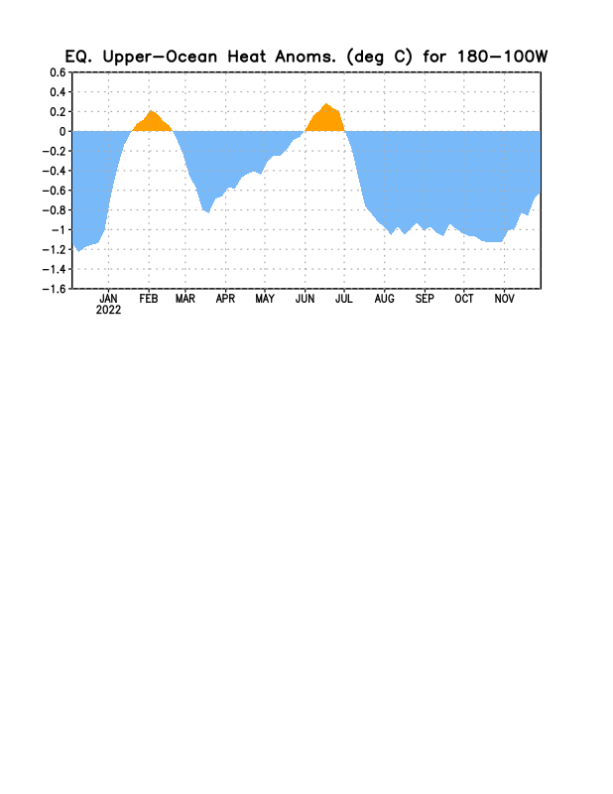

Figure 3. Area-averaged upper-ocean heat content anomaly (°C) in the equatorial Pacific (5°N-5°S, 180º-100ºW). The heat content anomaly is computed as the departure from the 1991-2020 base period pentad means.

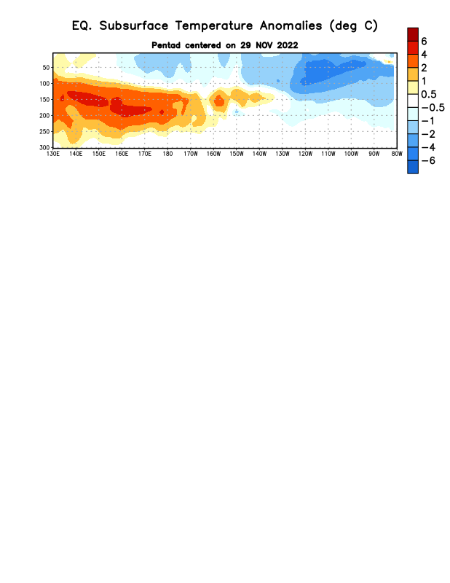
Figure 4. Depth-longitude section of equatorial Pacific upper-ocean (0-300m) temperature anomalies (°C) centered on the pentad of 29 November 2022. Anomalies are departures from the 1991-2020 base period pentad means.

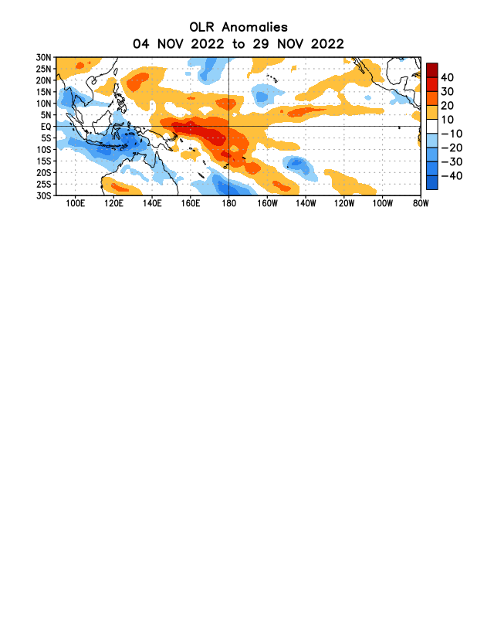

Figure 5. Average outgoing longwave radiation (OLR) anomalies (W/m²) for the period 4 November – 29 November 2022. OLR anomalies are computed as departures from the 1991-2020 base period pentad means.

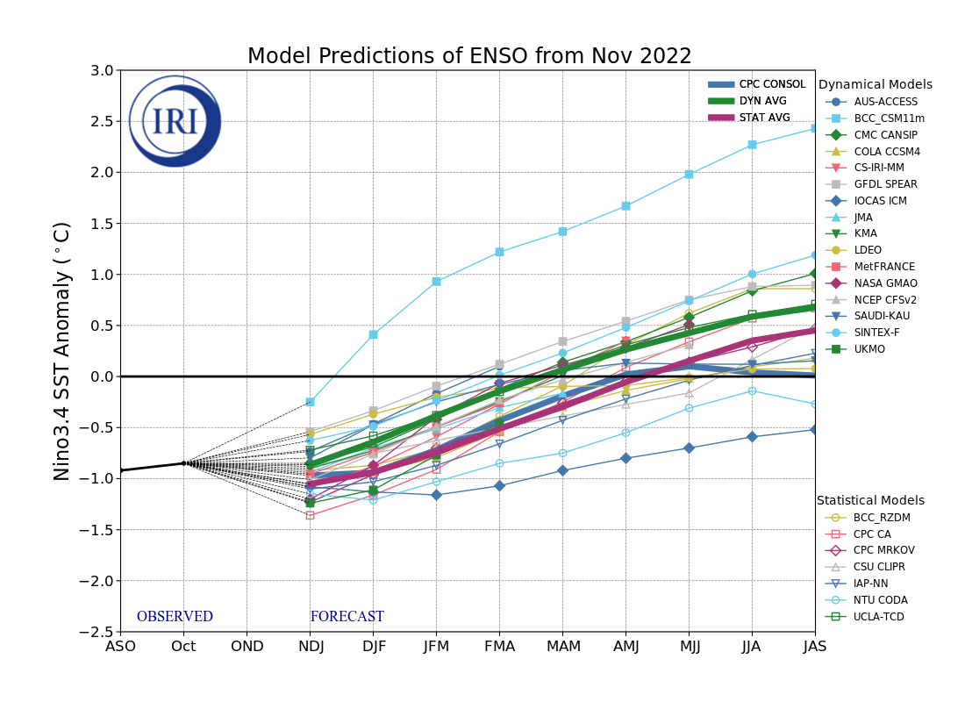
Figure 6. Forecasts of sea surface temperature (SST) anomalies for the Niño 3.4 region (5°N-5°S, 120°W-170°W). Figure updated 18 November 2022 by the International Research Institute (IRI) for Climate and Society.

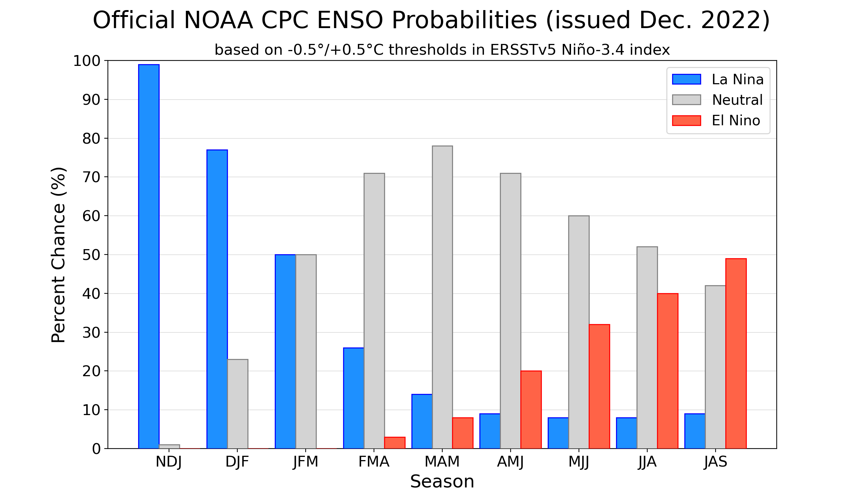Figure 7. Official ENSO probabilities for the Niño 3.4 sea surface temperature index (5°N-5°S,
120°W-170°W). Figure updated 8 December 2022.

