EL NIÑO/SOUTHERN OSCILLATION (ENSO) DIAGNOSTIC DISCUSSION
issued by
CLIMATE PREDICTION CENTER/NCEP
8 February 2007

Synopsis: A transition from weak El Niño conditions to ENSO-neutral conditions is expected by March-May 2007.
SST anomalies decreased across the entire equatorial Pacific during January (compare top and bottom panels in Fig. 1). However, positive anomalies between +0.5ºC and 1ºC remain in most of the equatorial Pacific between 170ºE and the South American coast (Fig. 1, bottom). The latest SST departures in the Niño regions are around 0.5ºC (Fig. 2). The equatorial upper-ocean heat content (average temperature departures in the upper 300 m of the ocean) peaked in late November (Fig. 3) and has been decreasing rapidly since that time, with the latest values being negative for the first time since early April 2006. These trends in surface and subsurface ocean temperatures indicate that the warm episode (El Niño) is weakening. It is still possible for some areas to experience El Niño-related effects during the next month, primarily in the region of the central tropical Pacific.
Most of the statistical and coupled models, including the NCEP Climate Forecast System (CFS), indicate that SST anomalies will continue to decrease and that ENSO-neutral conditions are likely to develop during March-May 2007 (Fig. 4). There is considerable uncertainty in the forecasts for periods after May 2007.
This discussion is a consolidated effort of NOAA and its funded institutions. Oceanic and atmospheric conditions are updated weekly on the Climate Prediction Center website (El Niño/La Niña Current Conditions and Expert Discussions). Forecasts for the evolution of El Niño/La Niña are updated monthly in the Forecast Forum section of CPC's Climate Diagnostics Bulletin. The next ENSO Diagnostics Discussion is scheduled for 8 March 2007. To receive an e-mail notification when the monthly ENSO Diagnostic Discussions are released, please send an e-mail message to: ncep.list.enso-update@noaa.gov.

Climate Prediction Center
National Centers for Environmental Prediction
NOAA/National Weather Service
Camp Springs, MD 20746-4304

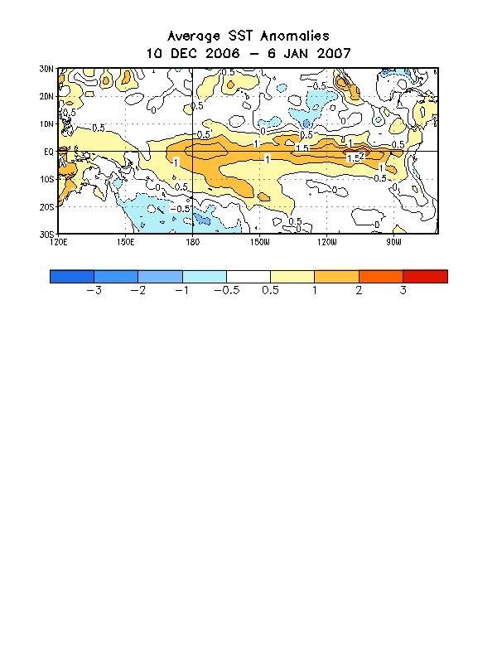
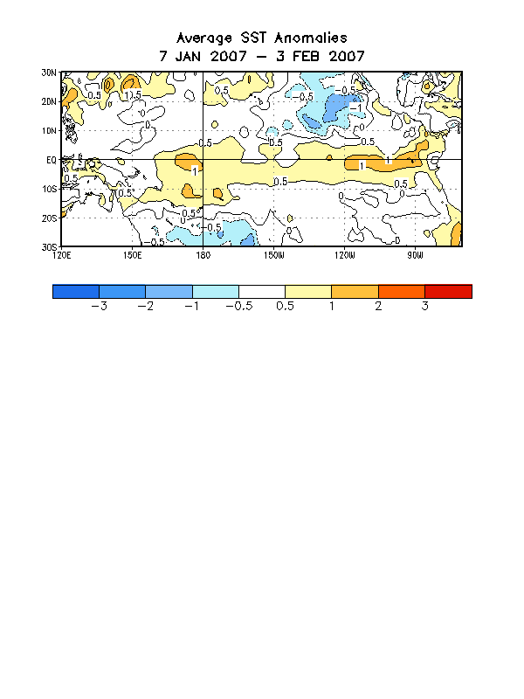
Figure 1. Average SST anomalies (°C) for the four-week period 10 December 2006-6 January 2007 (top) and for the four-week period 7 January-3 February 2007 (bottom). The SST anomalies are computed with respect to the 1971-2000 base period means
(Xue et al. 2003, J. Climate, 16, 1601-1612).

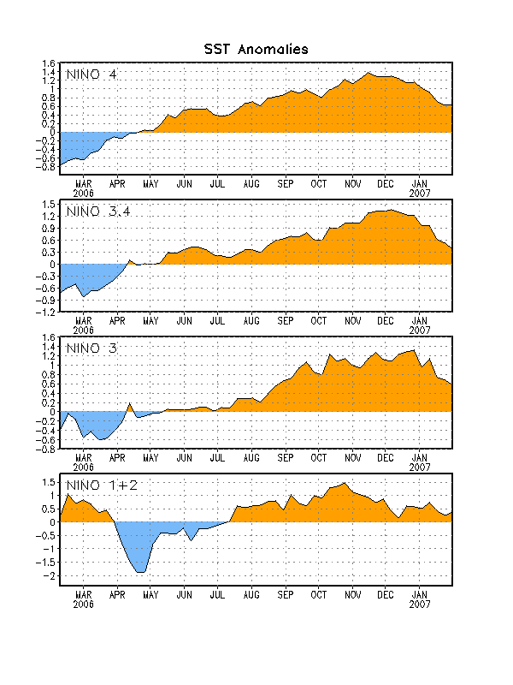
Figure 2. Time series of SST departures (°C) for the Niño regions. The SST departures are
computed with respect to the 1971-2000 base period means (Xue et al. 2003, J. Climate, 16, 1601-1612).
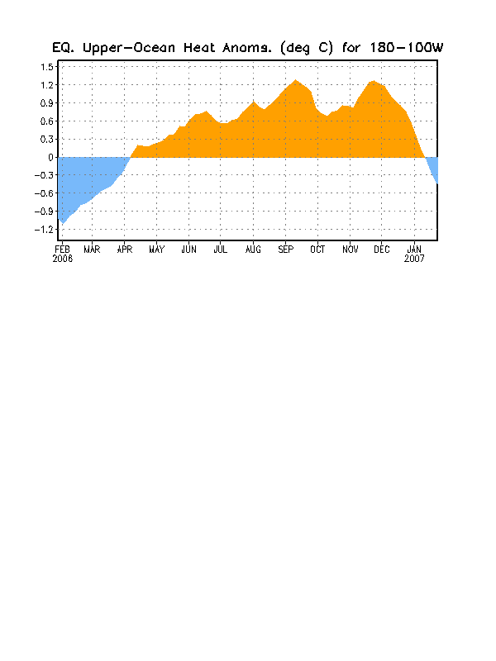
Figure 3. Anomalous equatorial upper-ocean heat content averaged over the longitude band
180º-100ºW. Heat content anomalies are computed as departures from the 1982-2004
base period means.

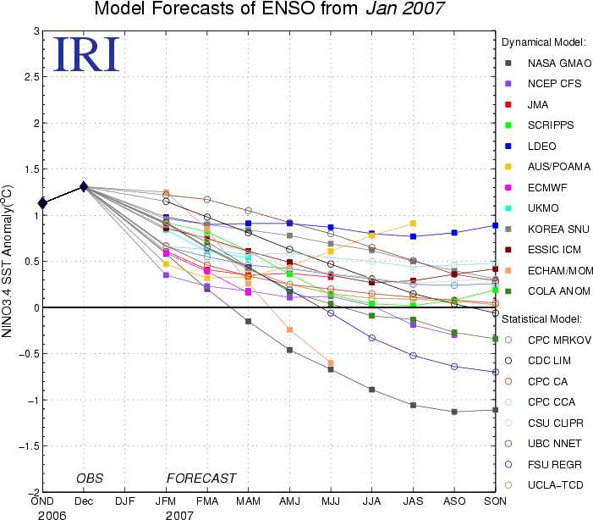
Figure 4. Forecasts of the SST anomalies for the Niño 3.4 region. Figure courtesy of the International Research Institute (IRI) for Climate and Society.

