EL NIÑO/SOUTHERN OSCILLATION (ENSO) DIAGNOSTIC DISCUSSION
issued by
CLIMATE PREDICTION CENTER/NCEP/NWS
5 February 2009

ENSO Alert System Status: La Niña Advisory

Synopsis: La Niña is expected to continue into Northern Hemisphere Spring 2009.
La Niña continued during January 2009, as evidenced by below-average equatorial sea surface temperatures (SST) across the central and east-central Pacific Ocean (Fig. 1). The Niño-4 and Niño-3.4 SST indices remained cooler than −0.5°C throughout January, although positive index values developed in the easternmost Niño-1+2 region late in the month (Fig. 2). Negative subsurface oceanic heat content anomalies (average temperatures in the upper 300m of the ocean, Fig. 3) also persisted east of the International Date Line, but weakened as positive subsurface temperature anomalies from the western Pacific expanded eastward into the central Pacific (Fig. 4). Convection remained suppressed near the Date Line, and enhanced across Indonesia. Low-level easterly winds and upper-level westerly winds also continued across the equatorial Pacific Ocean. Collectively, these oceanic and atmospheric anomalies reflect La Niña.
A majority of the model forecasts for the Niño-3.4 region indicate a gradual weakening of La Niña through February-April 2009, with an eventual transition to ENSO-neutral conditions (Fig. 5). Therefore, based on current observations, recent trends, and model forecasts, La Niña is expected to continue into the Northern Hemisphere Spring 2009.
Expected La Niña impacts during February-April 2009 include above-average precipitation over Indonesia, and below-average precipitation over the central equatorial Pacific. For the contiguous United States, potential impacts include above-average precipitation in the Ohio and Tennessee Valleys and below-average precipitation in the southwestern and southeastern states. Other potential impacts include below-average temperatures in the Pacific Northwest and above-average temperatures across much of the southern United States.
This discussion is a consolidated effort of the National Oceanic and Atmospheric Administration (NOAA), NOAA’s National Weather Service, and their funded institutions. Oceanic and atmospheric conditions are updated weekly on the Climate Prediction Center web site (El Niño/La Niña Current Conditions and Expert Discussions). Forecasts for the evolution of El Niño/La Niña are updated monthly in the Forecast Forum section of CPC's Climate Diagnostics Bulletin. The next ENSO Diagnostics Discussion is scheduled for 5 March 2009. To receive an e-mail notification when the monthly ENSO Diagnostic Discussions are released, please send an e-mail message to: ncep.list.enso-update@noaa.gov.
Climate Prediction Center
National Centers for Environmental Prediction
NOAA/National Weather Service
Camp Springs, MD 20746-4304

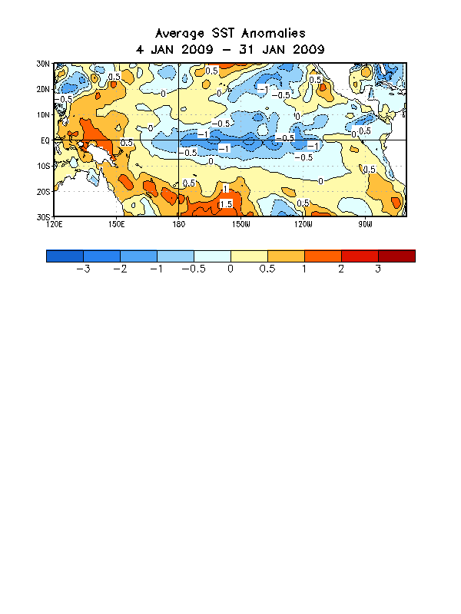

Figure 1. Average sea surface temperature (SST) anomalies (°C) for the four-week period 4 - 31 January 2009. Anomalies are computed with respect to the 1971-2000 base period weekly means (Xue et al. 2003, J. Climate, 16, 1601-1612).

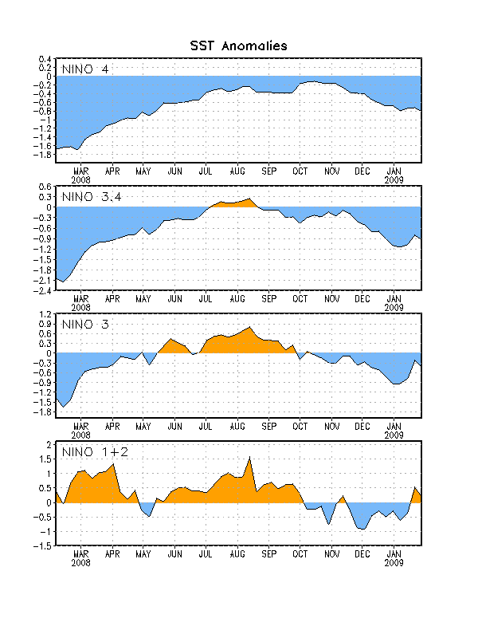
Figure 2. Time series of area-averaged sea surface temperature (SST) anomalies (°C) in the Niño regions [Niño-1+2 (0°-10°S, 90°W-80°W), Niño 3 (5°N-5°S, 150°W-90°W), Niño-3.4 (5°N-5°S, 170°W-120°W), Niño-4 (150ºW-160ºE and 5ºN-5ºS)]. SST anomalies are departures from the 1971-2000 base period weekly means (Xue et al. 2003, J. Climate, 16, 1601-1612).

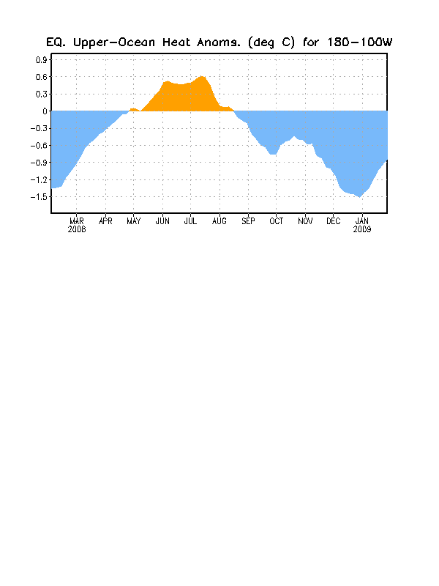
Figure 3. Area-averaged upper-ocean heat content anomalies (°C) in the equatorial Pacific (5°N-5°S, 180º-100ºW). Heat content anomalies are computed as departures from the 1982-2004 base period pentad means.

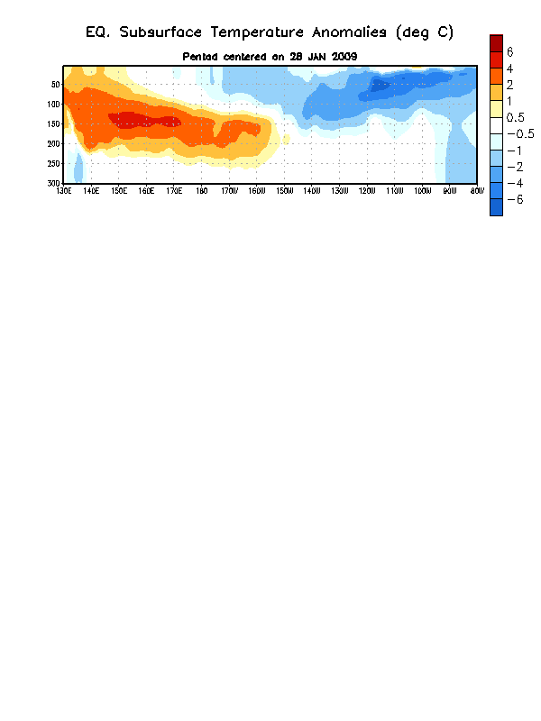
Figure 4. Depth-longitude section of equatorial Pacific upper-ocean (0-300m) temperature anomalies (°C) centered on the week of 28 January 2009. The anomalies are averaged between 5°N-5°S. Anomalies are departures from the 1982-2004 base period pentad means.

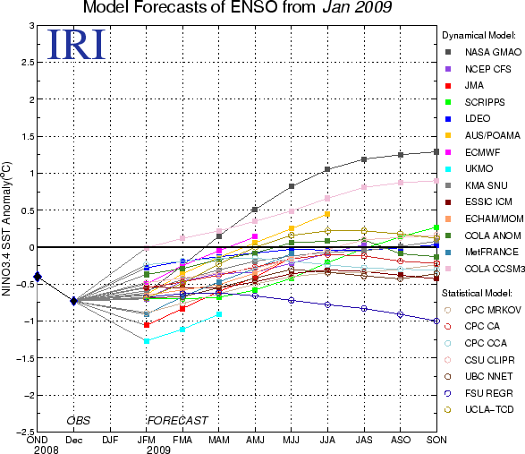

Figure 5. Forecasts of sea surface temperature (SST) anomalies for the Niño 3.4 region (5°N-5°S, 120°W-170°W). Figure courtesy of the International Research Institute (IRI) for Climate and Society. Figure updated 13 January 2009.

