EL NIÑO/SOUTHERN OSCILLATION (ENSO) DIAGNOSTIC DISCUSSION

issued by

CLIMATE PREDICTION CENTER/NCEP/NWS
4 February 2010

ENSO Alert System Status: El Niño Advisory

Synopsis: El Niño is expected to continue at least into the Northern Hemisphere spring 2010.
A significant El Niño persisted throughout the equatorial Pacific Ocean during January 2010 (Fig. 1). Although sea surface temperature (SST) departures in the Niño-3.4 region decreased to +1.2°C in late January, SSTs continued to be sufficiently warm to support deep tropical convection (Figs. 2 and 3). Over the last several months, a series of oceanic Kelvin waves contributed to the build-up of heat content anomalies in the central and eastern Pacific (Fig. 4). The latest Kelvin wave was associated with temperature departures exceeding +2°C down to 150m depth across the eastern half of the equatorial Pacific (Fig. 5). Equatorial convection over the central Pacific remained enhanced during the month, while convection over Indonesia exhibited considerable week-to-week variability. While the low-level winds have been variable, low-level westerly and upper-level easterly wind anomalies generally prevailed during January. Collectively, these oceanic and atmospheric anomalies reflect a strong and mature El Niño episode.
Nearly all models predict decreasing SST anomalies in the Niño-3.4 region through 2010, and model spread increases at longer lead times (Fig. 6). Nearly half of the models indicate the 3-month Niño-3.4 SST anomaly will drop below +0.5°C around April-May-June 2010, indicating a transition to ENSO-neutral conditions during Northern Hemisphere spring. However, predicting the timing of this transition is highly uncertain.
El Niño impacts are expected to last into the Northern Hemisphere spring, even as equatorial SST departures decrease, partly due to the typical warming that occurs between now and April/May (Fig. 3). Expected impacts during February-April 2010 include drier-than-average conditions over Indonesia and enhanced convection over the central equatorial Pacific Ocean, which will likely expand eastward and influence portions of the eastern tropical Pacific, as well as coastal sections of Peru and Ecuador. For the contiguous United States, potential El Niño impacts include above-average precipitation for the southern tier of the country, with below-average precipitation in the Pacific Northwest and Ohio Valley. Below-average snowfall and above-average temperatures are most likely across the northern tier of states (excluding New England), while below-average temperatures are favored for the south-central and southeastern states.
This discussion is a consolidated effort of the National Oceanic and Atmospheric Administration (NOAA), NOAA’s National Weather Service, and their funded institutions. Oceanic and atmospheric conditions are updated weekly on the Climate Prediction Center web site (El Niño/La Niña Current Conditions and Expert Discussions). Forecasts for the evolution of El Niño/La Niña are updated monthly in the Forecast Forum section of CPC's Climate Diagnostics Bulletin. The next ENSO Diagnostics Discussion is scheduled for 4 March 2010. To receive an e-mail notification when the monthly ENSO Diagnostic Discussions are released, please send an e-mail message to: ncep.list.enso-update@noaa.gov.
Climate Prediction Center
National Centers for Environmental Prediction
NOAA/National Weather Service
Camp Springs, MD 20746-4304
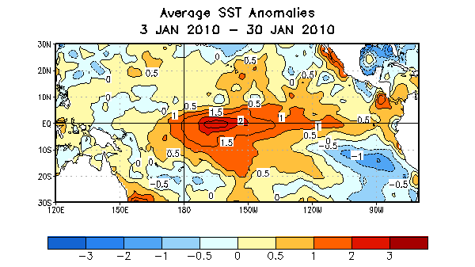
Figure 1. Average sea surface temperature (SST) anomalies (°C) for the four-week period 3 January 2010 – 30 January 2010. Anomalies are computed with respect to the 1971-2000 base period weekly means (Xue et al. 2003, J. Climate, 16, 1601-1612).

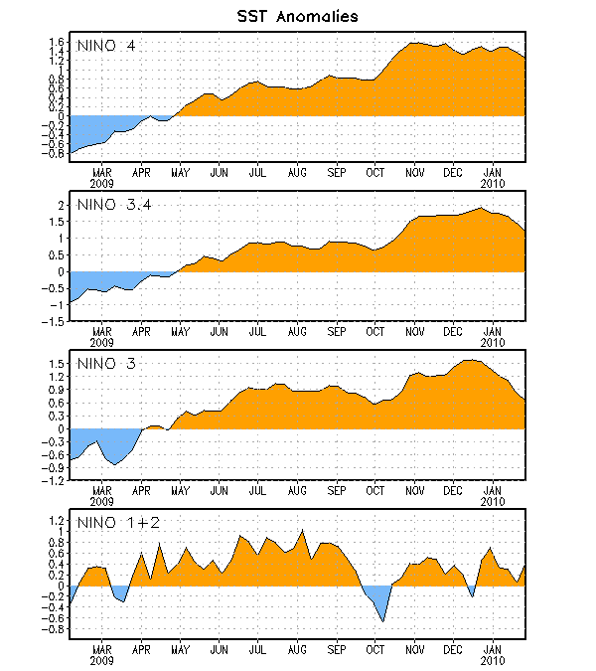
Figure 2. Time series of area-averaged sea surface temperature (SST) anomalies (°C) in the Niño regions [Niño-1+2 (0°-10°S, 90°W-80°W), Niño 3 (5°N-5°S, 150°W-90°W), Niño-3.4 (5°N-5°S, 170°W-120°W), Niño-4 (150ºW-160ºE and 5ºN-5ºS)]. SST anomalies are departures from the 1971-2000 base period weekly means (Xue et al. 2003, J. Climate, 16, 1601-1612).

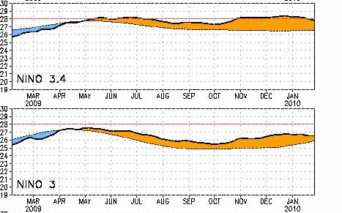
Figure 3. Time series of area-averaged sea surface temperature (SST) anomalies (solid line and shaded) and total SSTs (dashed lined) in the Niño regions [ Niño 3 (5°N-5°S, 150°W-90°W) and Niño-3.4 (5°N-5°S, 170°W-120°W)]. The red horizontal line indicates the 28°C threshold, which approximates SSTs that sustain tropical convection. SST anomalies are departures from the 1971-2000 base period weekly means (Xue et al. 2003, J. Climate, 16, 1601-1612).

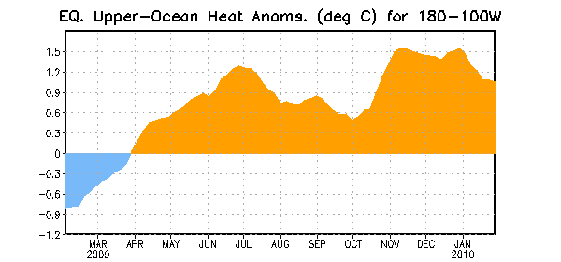
Figure 4. Area-averaged upper-ocean heat content anomalies (°C) in the equatorial Pacific (5°N-5°S, 180º-100ºW). Heat content anomalies are computed as departures from the 1982-2004 base period pentad means.

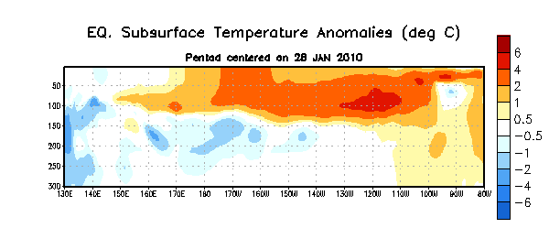
Figure 5. Depth-longitude section of equatorial Pacific upper-ocean (0-300m) temperature anomalies (°C) centered on the week of 28 January 2010. The anomalies are averaged between 5°N-5°S. Anomalies are departures from the 1982-2004 base period pentad means

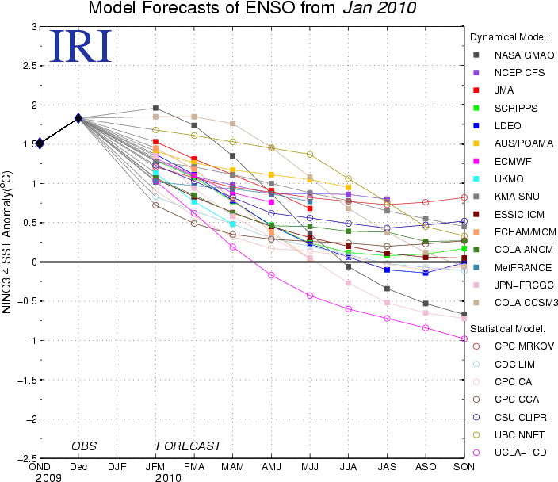

Figure 6. Forecasts of sea surface temperature (SST) anomalies for the Niño 3.4 region (5°N-5°S, 120°W-170°W). Figure courtesy of the International Research Institute (IRI) for Climate and Society. Figure updated 19 January 2010.

