EL NIÑO/SOUTHERN OSCILLATION (ENSO) DIAGNOSTIC DISCUSSION

issued by

CLIMATE PREDICTION CENTER/NCEP/NWS
and the International Research Institute for Climate and Society
9 February 2012

ENSO Alert System Status: La Niña Advisory

Synopsis: La Niña is likely to transition to ENSO-neutral conditions during March-May 2012.
A mature La Niña continued during January 2012, as below-average sea surface temperatures (SST) persisted across the equatorial Pacific Ocean (Fig. 1). The weekly SST indices remained near –1.0°C in the Niño-3.4 and Niño-4 regions (Fig. 2). However, the negative SST anomalies weakened in the far eastern Pacific, indicated by warming in the Niño-1+2 and Niño-3 regions. The oceanic heat content (average temperature in the upper 300m of the ocean) anomalies also weakened slightly (Fig. 3), but continued to reflect an extensive area of below-average subsurface temperatures east of the Date Line (Fig. 4). Also, anomalous low-level easterly and upper-level westerly winds persisted over the central and west-central Pacific. Convection remained suppressed in the western and central Pacific, and enhanced over Indonesia (Fig. 5). Collectively, the oceanic and atmospheric patterns reflect a weak-to-moderate strength La Niña.
A majority of models predict La Niña to weaken through the rest of the Northern Hemisphere winter 2011-12, and then to dissipate during the spring 2012 (Fig. 6). Also, there is evidence of a downwelling phase of an eastward-propagating oceanic Kelvin wave (red shading, Fig. 4), which may increase temperatures across the Pacific in the next couple of months. The combination of a weakening subsurface temperature anomaly, the historical seasonal evolution, and forecaster preference for the average dynamical model prediction favors a return to ENSO-neutral conditions during the Northern Hemisphere spring, which are likely to continue into the summer. Therefore La Niña is likely to transition to ENSO-neutral conditions during March-May 2012 (see CPC/IRI consensus forecast) .
Because the strength of impacts in the United States is not necessarily related to the exact strength of La Niña in the tropical Pacific, we expect La Niña impacts to continue even as the episode weakens. Over the U.S. during February - April 2012, there is an increased chance of above-average temperatures across the south-central and southeastern U.S., and below-average temperatures in the northwestern U.S. Also, above-average precipitation is favored across most of the northern tier of states (except the north-central U.S.) and in the Ohio and Tennessee Valleys, and drier-than-average conditions are more likely across the southern tier of the U.S. (see 3-month seasonal outlook released on 19 January 2012).
This discussion is a consolidated effort of the National Oceanic and Atmospheric Administration (NOAA), NOAA’s National Weather Service, and their funded institutions. Oceanic and atmospheric conditions are updated weekly on the Climate Prediction Center web site (El Niño/La Niña Current Conditions and Expert Discussions). Forecasts for the evolution of El Niño/La Niña are updated monthly in the Forecast Forum section of CPC's Climate Diagnostics Bulletin. The next ENSO Diagnostics Discussion is scheduled for 8 March 2012. To receive an e-mail notification when the monthly ENSO Diagnostic Discussions are released, please send an e-mail message to: ncep.list.enso-update@noaa.gov.

Climate Prediction Center
National Centers for Environmental Prediction
NOAA/National Weather Service
Camp Springs, MD 20746-4304
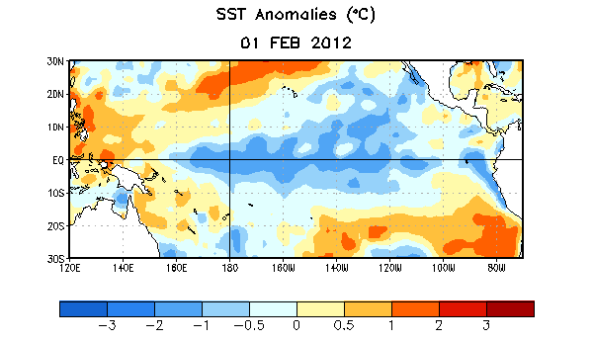
Figure 1. Average sea surface temperature (SST) anomalies (°C) for the week centered on 1 February 2012. Anomalies are computed with respect to the 1971-2000 base period weekly means (Xue et al. 2003, J. Climate, 16, 1601-1612).

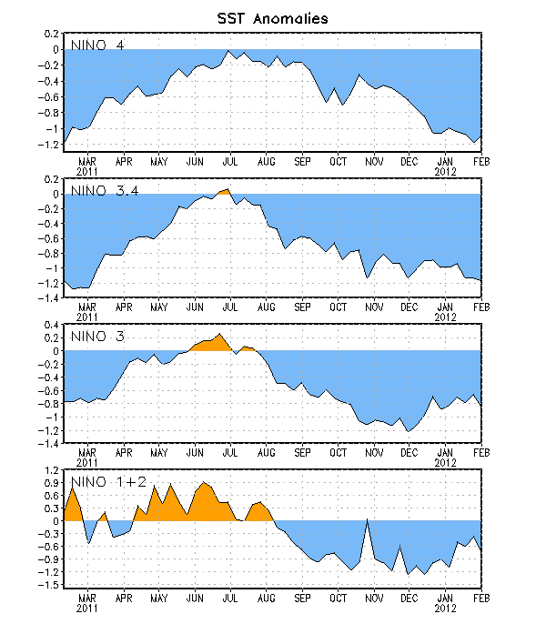
Figure 2. Time series of area-averaged sea surface temperature (SST) anomalies (°C) in the Niño regions [Niño-1+2 (0°-10°S, 90°W-80°W), Niño 3 (5°N-5°S, 150°W-90°W), Niño-3.4 (5°N-5°S, 170°W-120°W), Niño-4 (150ºW-160ºE and 5ºN-5ºS)]. SST anomalies are departures from the 1971-2000 base period weekly means (Xue et al. 2003, J. Climate, 16, 1601-1612).

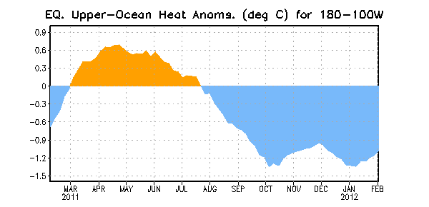
Figure 3. Area-averaged upper-ocean heat content anomaly (°C) in the equatorial Pacific (5°N-5°S, 180º-100ºW). The heat content anomaly is computed as the departure from the 1982-2004 base period pentad means.

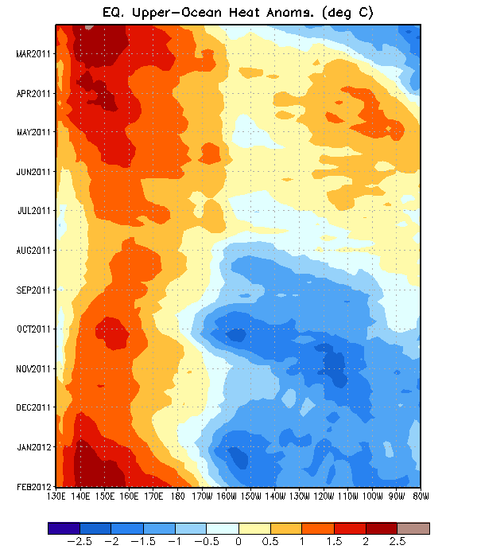
Figure 4. Time-longitude section of equatorial Pacific upper-ocean (0-300m) temperature anomalies (°C). The anomalies are averaged between 5°N-5°S. Anomalies are departures from the 1982-2004 base period pentad means.

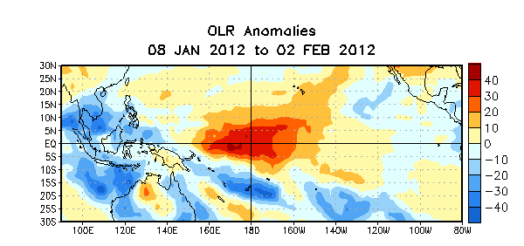

Figure 5. Average outgoing longwave radiation (OLR) anomalies (W/m²) for the four-week period 8 January – 2 February 2012. OLR anomalies are computed as departures from the 1979-1995 base period pentad means.

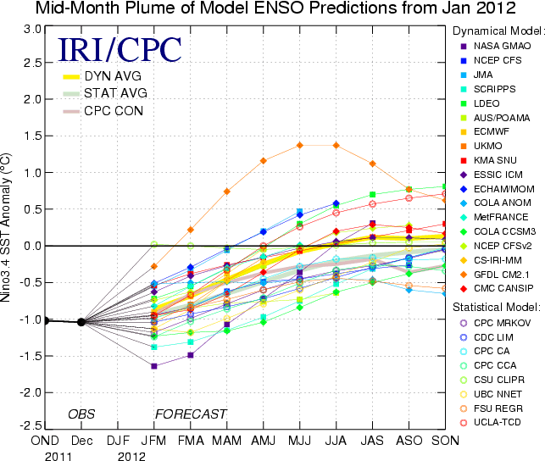
Figure 6. Forecasts of sea surface temperature (SST) anomalies for the Niño 3.4 region (5°N-5°S, 120°W-170°W). Figure courtesy of the International Research Institute (IRI) for Climate and Society. Figure updated 17 January 2012.

