EL NIÑO/SOUTHERN OSCILLATION (ENSO) DIAGNOSTIC DISCUSSION

issued by

CLIMATE PREDICTION CENTER/NCEP/NWS
and the International Research Institute for Climate and Society
7 February 2013

ENSO Alert System Status: Not Active

Synopsis: ENSO-neutral is favored through Northern Hemisphere spring 2013.
During January 2013, ENSO-neutral continued, although below-average sea surface temperatures (SST) prevailed across the eastern half of the equatorial Pacific (Fig. 1). While remaining below average, a high degree of variability in the weekly Niño 3 and 3.4 indices was apparent during the month (Fig. 2). The oceanic heat content (average temperature in the upper 300m of the ocean) was also below-average (Fig. 3), largely reflecting negative subsurface temperature anomalies in the eastern Pacific. At the same time, positive anomalies increased and expanded eastward to the central Pacific by late January (Fig. 4). The variability in both the ocean and atmosphere was enhanced during January, at least partially due to a strong Madden-Julian Oscillation (MJO). Consequently, the location of the MJO was reflected in the monthly averages of wind and convection. Anomalous upper-level winds were westerly over the eastern half of the equatorial Pacific, while low-level winds were near average. Relative to December 2012, the region of enhanced convection shifted eastward and became more prominent over Indonesia and the western equatorial Pacific (Fig. 5). Despite these transient features contributing to cool conditions, the collective atmospheric and oceanic system reflects ENSO-neutral.
The vast majority of models predict near-average SST (between -0.5°C and +0.5°C) in the Niño-3.4 region through the late Northern Hemisphere summer (Fig. 6). However, because model skill is generally low during April-June, there is less confidence in the forecast beyond the spring. Thus, ENSO-neutral is favored through Northern Hemisphere spring 2013 (see CPC/IRI consensus forecast).
This discussion is a consolidated effort of the National Oceanic and Atmospheric Administration (NOAA), NOAA’s National Weather Service, and their funded institutions. Oceanic and atmospheric conditions are updated weekly on the Climate Prediction Center web site (El Niño/La Niña Current Conditions and Expert Discussions). Forecasts for the evolution of El Niño/La Niña are updated monthly in the Forecast Forum section of CPC's Climate Diagnostics Bulletin. The next ENSO Diagnostics Discussion is scheduled for 7 March 2013. To receive an e-mail notification when the monthly ENSO Diagnostic Discussions are released, please send an e-mail message to: ncep.list.enso-update@noaa.gov.
Climate Prediction Center
National Centers for Environmental Prediction
NOAA/National Weather Service
College Park, MD 20740

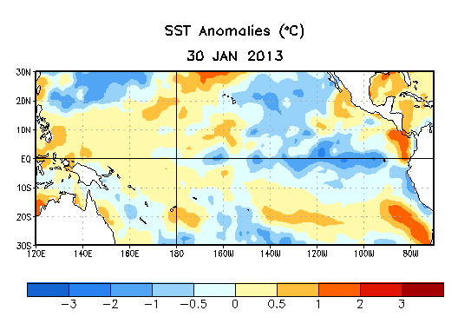
Figure 1. Average sea surface temperature (SST) anomalies (°C) for the week centered on 30 January 2013. Anomalies are computed with respect to the 1981-2010 base period weekly means.

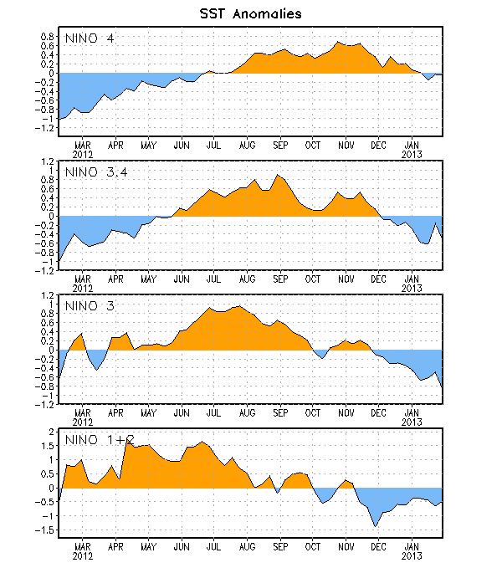
Figure 2. Time series of area-averaged sea surface temperature (SST) anomalies (°C) in the Niño regions [Niño-1+2 (0°-10°S, 90°W-80°W), Niño 3 (5°N-5°S, 150°W-90°W), Niño-3.4 (5°N-5°S, 170°W-120°W), Niño-4 (150ºW-160ºE and 5ºN-5ºS)]. SST anomalies are departures from the 1981-2010 base period weekly means.

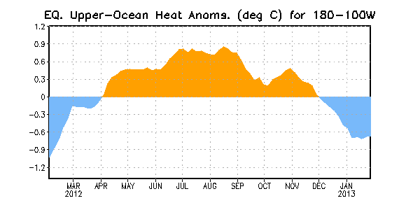
Figure 3. Area-averaged upper-ocean heat content anomaly (°C) in the equatorial Pacific (5°N-5°S, 180º-100ºW). The heat content anomaly is computed as the departure from the 1981-2010 base period pentad means.

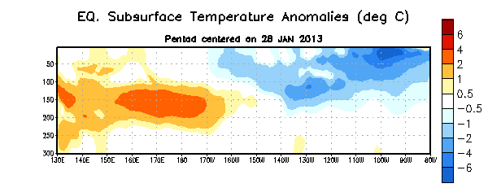
Figure 4. Depth-longitude section of equatorial Pacific upper-ocean (0-300m) temperature anomalies (°C) centered on the pentad of 28 January 2013. The anomalies are averaged between 5°N-5°S. Anomalies are departures from the 1981-2010 base period pentad means.

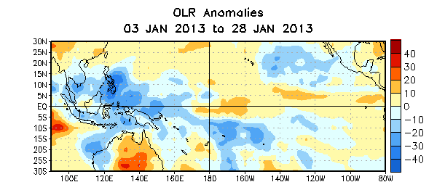

Figure 5. Average outgoing longwave radiation (OLR) anomalies (W/m²) for the four-week period 3 – 28 January 2013. OLR anomalies are computed as departures from the 1979-1995 base period pentad means.

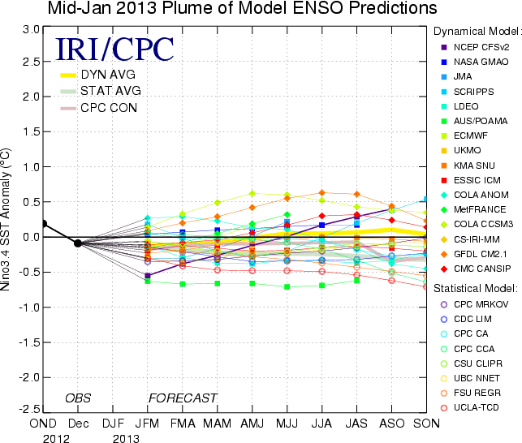
Figure 6. Forecasts of sea surface temperature (SST) anomalies for the Niño 3.4 region (5°N-5°S, 120°W-170°W). Figure courtesy of the International Research Institute (IRI) for Climate and Society. Figure updated 15 January 2013.

