EL NIÑO/SOUTHERN OSCILLATION (ENSO) DIAGNOSTIC DISCUSSION

issued by

CLIMATE PREDICTION CENTER/NCEP/NWS
and the International Research Institute for Climate and Society
6 February 2014

ENSO Alert System Status: Not Active

Synopsis: ENSO-neutral is expected to continue through the Northern Hemisphere spring 2014.
While remaining ENSO-neutral, January was characterized by the periodic emergence of below-average sea surface temperatures (SSTs) across the tropical Pacific Ocean (Fig. 1). Weekly Niño index values in Niño-3 and Niño-3.4 bounced around -0.5°C, while Niño-4 and Niño-1+2 stayed within ±0.5°C (Fig. 2). This recent cooling was associated with the upwelling phase of an oceanic Kelvin wave, which was reflected in a dip in the oceanic heat content (Fig. 3) and below-average subsurface temperatures at depth across the eastern Pacific (Fig. 4). Upper and lower-level winds were near average across most of the Pacific, except for the emergence of strong westerly winds in the western part of the basin toward the end of the month. Convection became more enhanced over eastern Indonesia and the western Pacific and remained suppressed over the central equatorial Pacific (Fig. 5). Collectively, these atmospheric and oceanic conditions reflect ENSO-neutral.
Nearly all model forecasts indicate the persistence of ENSO-neutral (Niño-3.4 index between -0.5°C and 0.5°C) through the Northern Hemisphere spring 2014, but afterwards, an increasing number of models suggest the possible onset of El Niño (Fig. 6). Strong surface westerly winds in the western Pacific and the slight eastward shift of above-average temperatures in the subsurface western Pacific potentially portend warming in the coming months. However, the spring is also historically associated with lower forecast skill, so the chance of El Niño developing after the spring is not much different from ENSO-neutral. The consensus forecast is for ENSO-neutral to continue through the Northern Hemisphere spring 2014 (see CPC/IRI consensus forecast).
This discussion is a consolidated effort of the National Oceanic and Atmospheric Administration (NOAA), NOAA’s National Weather Service, and their funded institutions. Oceanic and atmospheric conditions are updated weekly on the Climate Prediction Center web site (El Niño/La Niña Current Conditions and Expert Discussions). Forecasts for the evolution of El Niño/La Niña are updated monthly in the Forecast Forum section of CPC's Climate Diagnostics Bulletin. The next ENSO Diagnostics Discussion is scheduled for 6 March 2014. To receive an e-mail notification when the monthly ENSO Diagnostic Discussions are released, please send an e-mail message to: ncep.list.enso-update@noaa.gov.
Climate Prediction Center
National Centers for Environmental Prediction
NOAA/National Weather Service
College Park, MD 20740

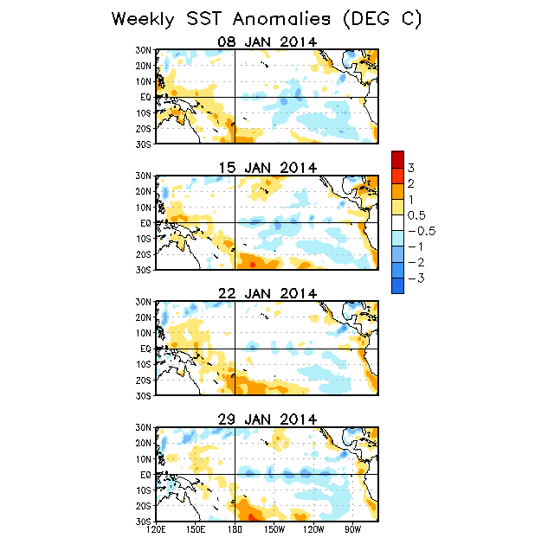
Figure 1. Average weekly sea surface temperature (SST) anomalies (°C) centered on 8 – 29 January 2014. Anomalies are computed with respect to the 1981-2010 base period weekly means.

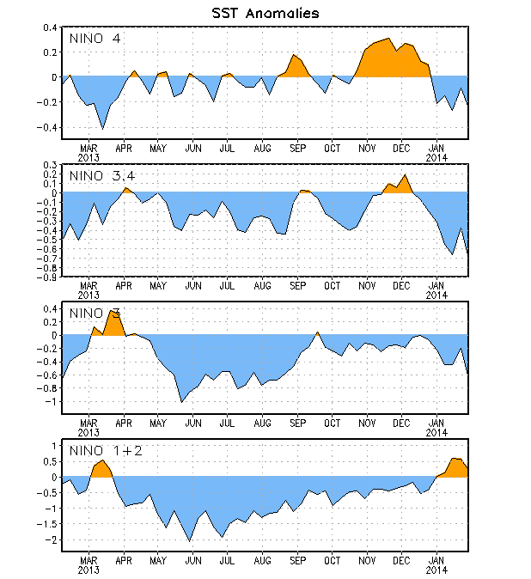
Figure 2. Time series of area-averaged sea surface temperature (SST) anomalies (°C) in the Niño regions [Niño-1+2 (0°-10°S, 90°W-80°W), Niño 3 (5°N-5°S, 150°W-90°W), Niño-3.4 (5°N-5°S, 170°W-120°W), Niño-4 (5ºN-5ºS , 150ºW-160ºE]. SST anomalies are departures from the 1981-2010 base period weekly means.

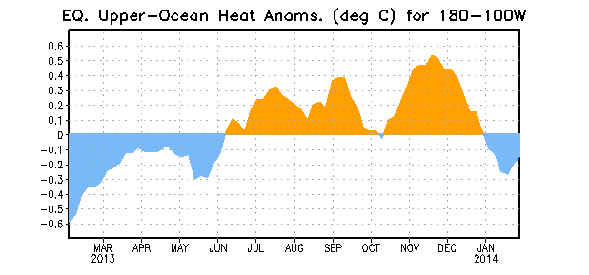
Figure 3. Area-averaged upper-ocean heat content anomaly (°C) in the equatorial Pacific (5°N-5°S, 180º-100ºW). The heat content anomaly is computed as the departure from the 1981-2010 base period pentad means.

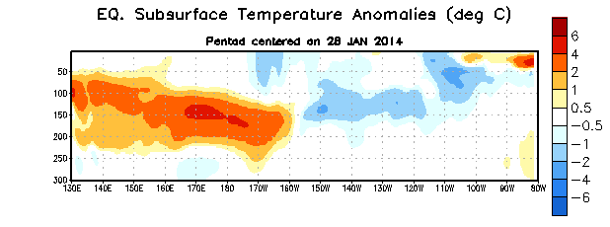
Figure 4. Depth-longitude section of equatorial Pacific upper-ocean (0-300m) temperature anomalies (°C)
centered on the pentad of 28 January 2014. The anomalies are averaged between 5°N-5°S. Anomalies are departures from the 1981-2010 base period pentad means.

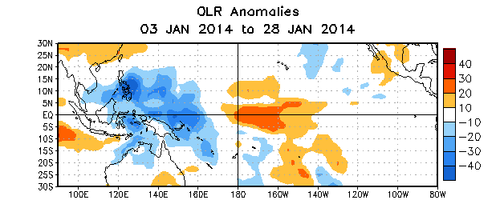
Figure 5. Average outgoing longwave radiation (OLR) anomalies (W/m²) for the period 3– 28 January 2014. OLR anomalies are computed as departures from the 1979-1995 base period pentad means.

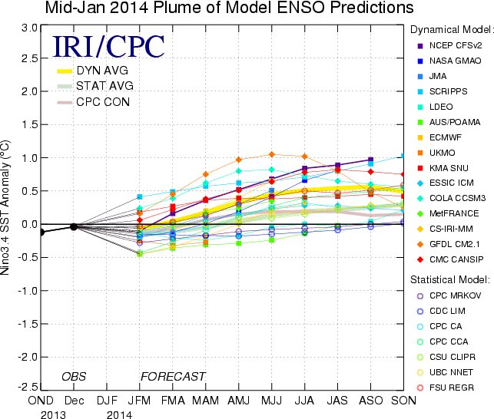
Figure 6. Forecasts of sea surface temperature (SST) anomalies for the Niño 3.4 region (5°N-5°S, 120°W-170°W). Figure updated 14 January 2014.

