EL NIÑO/SOUTHERN OSCILLATION (ENSO) DIAGNOSTIC DISCUSSION

issued by

CLIMATE PREDICTION CENTER/NCEP/NWS
and the International Research Institute for Climate and Society
5 February 2015

ENSO Alert System Status: El Niño Watch

Synopsis: There is an approximately 50-60% chance of El Niño within the late Northern Hemisphere winter and early spring, with ENSO-neutral slightly favored thereafter.
Equatorial sea surface temperatures (SST) remained above average in the western and central Pacific during January 2015 and cooled across the eastern Pacific (Fig. 1). Accordingly, the latest weekly Niño indices were +0.5°C in the Niño-3.4 region and +0.9°C in the Niño-4 region, and closer to zero in the Niño-3 and Niño-1+2 regions (Fig. 2). Subsurface temperature anomalies across the eastern half of the equatorial Pacific also averaged near zero during the month (Fig. 3). However, an extensive area of positive subsurface anomalies persisted near the Date Line, while negative anomalies were prevalent closer to the surface east of 110°W (Fig. 4). During the last couple of weeks of January, several aspects of the tropical Pacific atmosphere showed some movement toward El Niño. However, for the month as a whole, the equatorial low-level winds were mostly near average across the Pacific, while upper-level easterly anomalies continued in the east-central Pacific. Also, convection remained below average near the Date Line and enhanced in the western equatorial Pacific (Fig. 5). While the tropical Pacific Ocean is at the borderline of El Niño, the overall atmosphere-ocean system remains ENSO-neutral.
Similar to last month, most models predict a weak El Niño (3-month values of the Niño-3.4 index between 0.5°C and 0.9°C) during the Northern Hemisphere late winter and spring (Fig. 6). The forecaster consensus also favors Niño-3.4 SST index values in excess of 0.5°C within the coming season. However, climatologically, ocean-atmosphere coupling tends to weaken into the spring, which increases uncertainty over whether El Niño conditions will emerge. In summary, there is an approximately 50-60% chance of El Niño within the late Northern Hemisphere winter and early spring, with ENSO-neutral slightly favored thereafter (click CPC/IRI consensus forecast for the chance of each outcome).
This discussion is a consolidated effort of the National Oceanic and Atmospheric Administration (NOAA), NOAA’s National Weather Service, and their funded institutions. Oceanic and atmospheric conditions are updated weekly on the Climate Prediction Center web site (El Niño/La Niña Current Conditions and Expert Discussions). Forecasts are also updated monthly in the Forecast Forum of CPC's Climate Diagnostics Bulletin. Additional perspectives and analysis are also available in an ENSO blog. The next ENSO Diagnostics Discussion is scheduled for 5 March 2015. To receive an e-mail notification when the monthly ENSO Diagnostic Discussions are released, please send an e-mail message to: ncep.list.enso-update@noaa.gov.

Climate Prediction Center
National Centers for Environmental Prediction
NOAA/National Weather Service
College Park, MD 20740

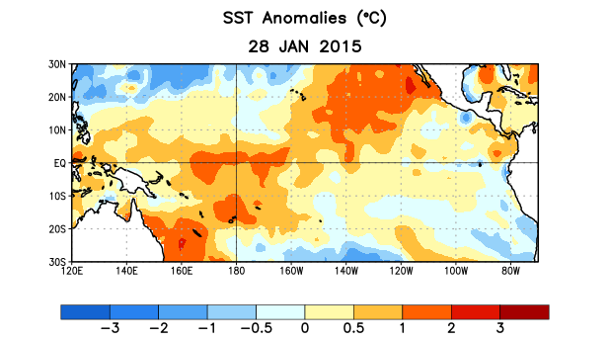
Figure 1. Average sea surface temperature (SST) anomalies (°C) for the week centered on 28 January 2015. Anomalies are computed with respect to the 1981-2010 base period weekly means.

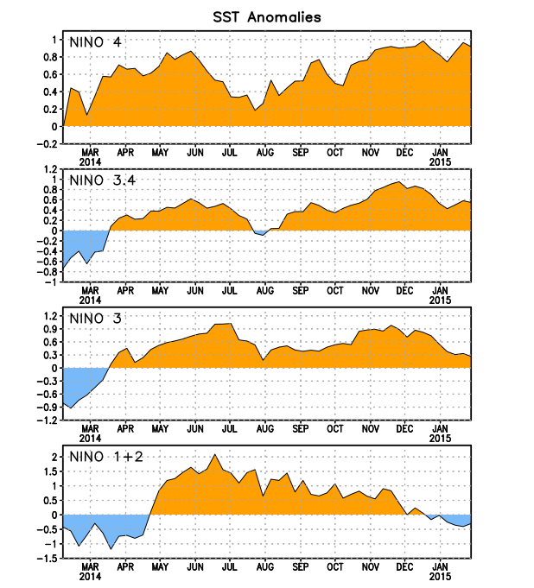
Figure 2. Time series of area-averaged sea surface temperature (SST) anomalies (°C) in the Niño regions [Niño-1+2 (0°-10°S, 90°W-80°W), Niño 3 (5°N-5°S, 150°W-90°W), Niño-3.4 (5°N-5°S, 170°W-120°W), Niño-4 (5ºN-5ºS , 150ºW-160ºE]. SST anomalies are departures from the 1981-2010 base period weekly means.
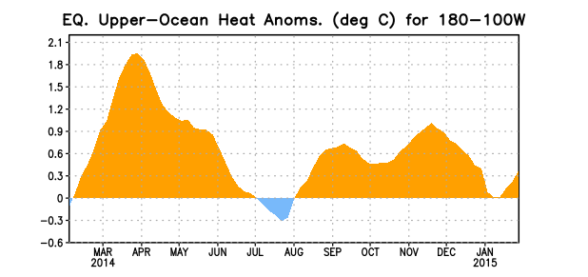
Figure 3. Area-averaged upper-ocean heat content anomaly (°C) in the equatorial Pacific (5°N-5°S, 180º-100ºW). The heat content anomaly is computed as the departure from the 1981-2010 base period pentad means.

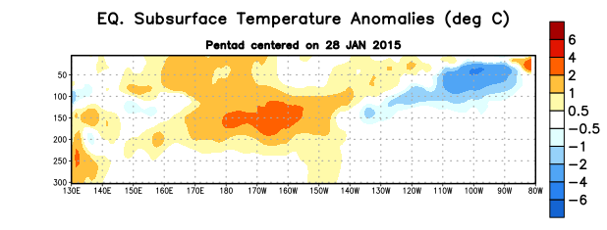
Figure 4. Depth-longitude section of equatorial Pacific upper-ocean (0-300m) temperature anomalies (°C)
centered on the pentad of 28 January 2015. The anomalies are averaged between 5°N-5°S. Anomalies are departures from the 1981-2010 base period pentad means.

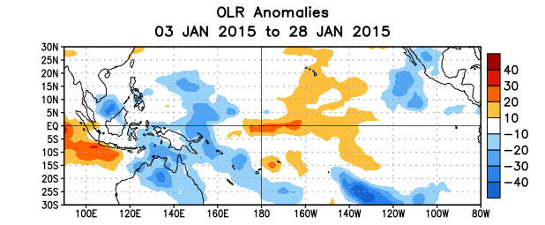
Figure 5. Average outgoing longwave radiation (OLR) anomalies (W/m²) for the period 3 – 28 January 2015. OLR anomalies are computed as departures from the 1979-1995 base period pentad means.

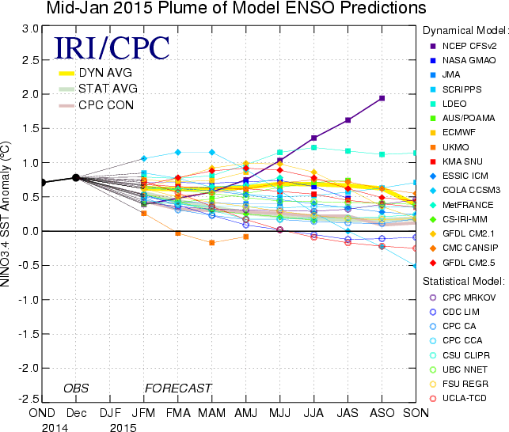

Figure 6. Forecasts of sea surface temperature (SST) anomalies for the Niño 3.4 region (5°N-5°S, 120°W-170°W). Figure updated 15 January 2015.

