EL NIÑO/SOUTHERN OSCILLATION (ENSO) DIAGNOSTIC DISCUSSION

issued by

CLIMATE PREDICTION CENTER/NCEP/NWS
and the International Research Institute for Climate and Society
11 February 2016

ENSO Alert System Status: El Niño Advisory

Synopsis: A transition to ENSO-neutral is likely during late Northern Hemisphere spring or early summer 2016, with a possible transition to La Niña conditions during the fall.
Indicative of a strong El Niño, sea surface temperature (SSTs) anomalies were in excess of 2°C across the east-central equatorial Pacific Ocean during January (Fig. 1). The Niño indices in the eastern Pacific declined, while Niño-3.4 and Niño-4 were nearly unchanged (Fig. 2). The subsurface temperatures in the central and eastern Pacific increased due to a downwelling Kelvin wave (Fig. 3), but toward the end of the month weakened again in association with the eastward shift of below-average temperatures at depth in the central Pacific (Fig. 4). Also, low-level westerly wind anomalies and upper-level easterly wind anomalies continued over much of the tropical Pacific. The traditional and equatorial Southern Oscillation Index (SOI) values remained negative but weakened relative to last month. Convection remained much enhanced over the central and east-central tropical Pacific and suppressed over Indonesia (Fig. 5). Collectively, these anomalies reflect the continuation of a strong El Niño.
Most models indicate that El Niño will weaken, with a transition to ENSO-neutral during the late spring or early summer 2016 (Fig. 6). Thereafter, the chance of La Niña conditions increases into the fall. While there is both model and physical support for La Niña following strong El Niño, considerable uncertainty remains. A transition to ENSO-neutral is likely during late Northern Hemisphere spring or early summer 2016, with a possible transition to La Niña conditions during the fall (click CPC/IRI consensus forecast for the chance of each outcome for each 3-month period).
El Niño has already produced significant global impacts and is expected to affect temperature and precipitation patterns across the United States during the upcoming months (the 3-month seasonal outlook will be updated on Thursday February 18th). The seasonal outlooks for February – April indicate an increased likelihood of above-median precipitation across the southern tier of the United States, and below-median precipitation over the northern tier. Above-average temperatures are favored in the North and West, and below-average temperatures are favored in the southern Plains and along the Gulf Coast.
This discussion is a consolidated effort of the National Oceanic and Atmospheric Administration (NOAA), NOAA’s National Weather Service, and their funded institutions. Oceanic and atmospheric conditions are updated weekly on the Climate Prediction Center web site (El Niño/La Niña Current Conditions and Expert Discussions). Forecasts are also updated monthly in the Forecast Forum of CPC's Climate Diagnostics Bulletin. Additional perspectives and analysis are also available in an ENSO blog. The next ENSO Diagnostics Discussion is scheduled for 10 March 2016. To receive an e-mail notification when the monthly ENSO Diagnostic Discussions are released, please send an e-mail message to: ncep.list.enso-update@noaa.gov.

Climate Prediction Center
National Centers for Environmental Prediction
NOAA/National Weather Service
College Park, MD 20740

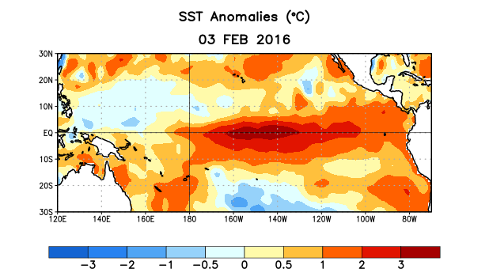
Figure 1. Average sea surface temperature (SST) anomalies (°C) for the week centered on 3 February 2016. Anomalies are computed with respect to the 1981-2010 base period weekly means.

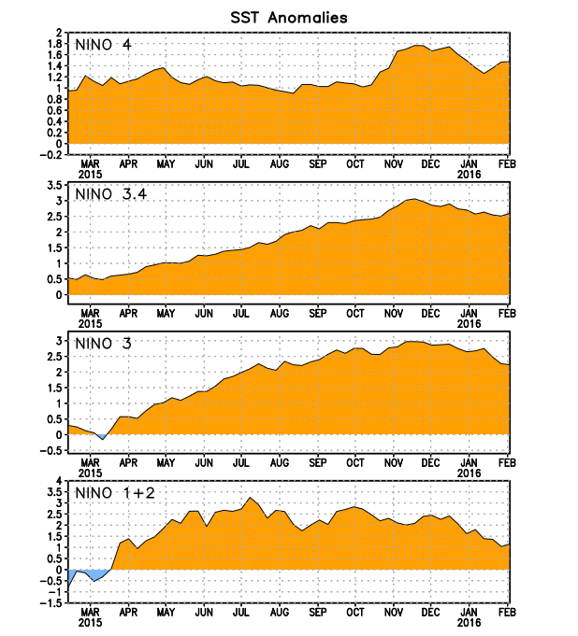
Figure 2. Time series of area-averaged sea surface temperature (SST) anomalies (°C) in the Niño regions [Niño-1+2 (0°-10°S, 90°W-80°W), Niño 3 (5°N-5°S, 150°W-90°W), Niño-3.4 (5°N-5°S, 170°W-120°W), Niño-4 (5ºN-5ºS , 150ºW-160ºE]. SST anomalies are departures from the 1981-2010 base period weekly means.
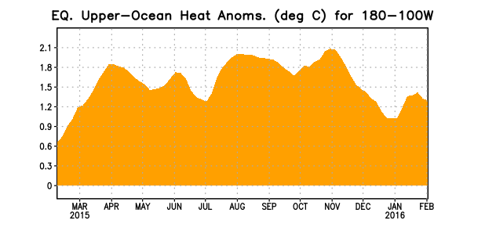
Figure 3. Area-averaged upper-ocean heat content anomaly (°C) in the equatorial Pacific (5°N-5°S, 180º-100ºW). The heat content anomaly is computed as the departure from the 1981-2010 base period pentad means.

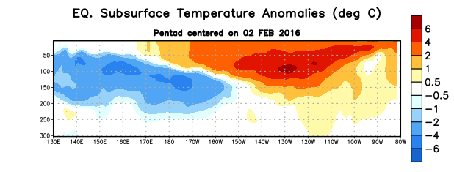
Figure 4. Depth-longitude section of equatorial Pacific upper-ocean (0-300m) temperature anomalies (°C)
centered on the pentad of 2 February 2016. The anomalies are averaged between 5°N-5°S. Anomalies are departures from the 1981-2010 base period pentad means.

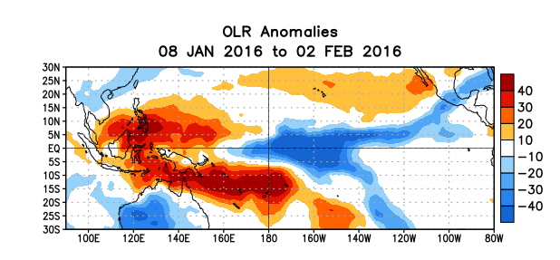
Figure 5. Average outgoing longwave radiation (OLR) anomalies (W/m²) for the period 8 January – 2 February 2016. OLR anomalies are computed as departures from the 1979-1995 base period pentad means.

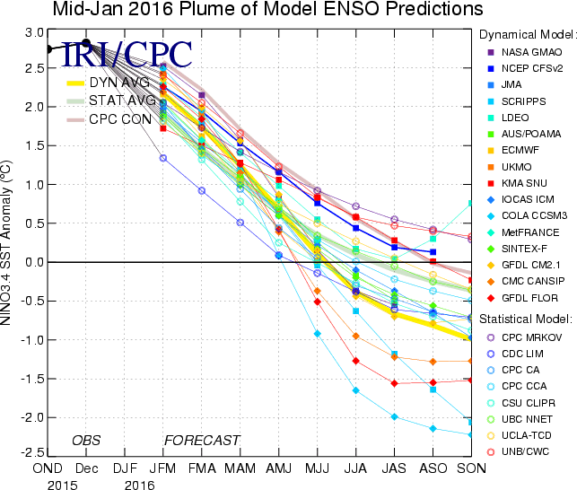

Figure 6. Forecasts of sea surface temperature (SST) anomalies for the Niño 3.4 region (5°N-5°S, 120°W-170°W). Figure updated 19 January 2016.

